**Introduction:**

**Overview of OzMart Retail Group**

An Australian retail company of modest size, OzMart Retail Group is experiencing significant company expansion. With 1,500 staff dispersed over three locations, the business is building its infrastructure to meet this increase and improve its operational capacity.

**Purpose of the Cloud Migration**

OzMart has chosen to migrate its IT infrastructure to the cloud in order to meet its growing operations and enhance IT resource management. This cloud migration project intends to develop and execute a scalable, secure, and facilitates the smooth integration of current legacy systems hybrid cloud network architecture.

**Requirements Gathering and Wifi Network Design**

The success of the cloud migration project depends on a complete awareness of OzMart's business needs and the building of a strong WiFi network.

**Requirement Gathering Analyis**

Engaging important stakeholders, evaluating the present network architecture, and recording business demands are part of this basic phase. It guarantees that the migration plan answers all important needs and fits the goals of the business.

**Wifi Network Design**

Reliable and effective wireless connectivity throughout OzMart's sites depends on a well-designed WiFi network. This stage consists on defining the required protocols and standards, deciding on coverage areas, and arranging the access point placement.

**Network Topology Design**

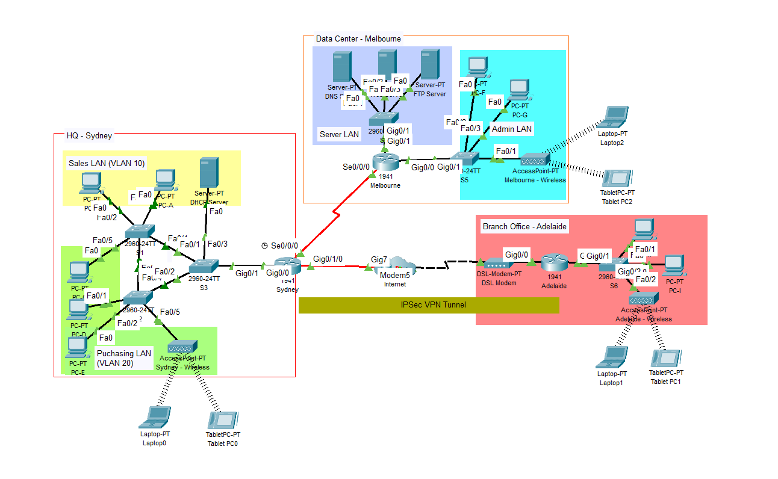

**IP Address Table**

|  |  |  |  |  |
| --- | --- | --- | --- | --- |
| **Device** | **Interface** | **IP Address** | **Subnet Mask** | **Default Gateway** |
| **Sydney** | G0/0.10 | 192.168.1.1 | 255.255.255.0 | N/A |
|  | G0/0.20 | 192.168.2.1 | 255.255.255.0 | N/A |
|  | G0/1/0 | 150.10.1.1 | 255.255.255.0 | N/A |
|  | S0/0/0 | 209.165.9.5 | 255.255.255.0 | N/A |
| **Melbourne** | G0/0 | 192.168.4.1 | 255.255.255.0 | N/A |
|  | G0/1/0 | 192.168.3.1 | 255.255.255.0 | N/A |
|  | S0/0/0 | 209.165.9.6 | 255.255.255.0 | N/A |
| **Adelaide** | G0/0 | 72.165.200.17 | 255.255.255.0 | N/A |
|  | G0/1/0 | 192.168.5.1 | 255.255.255.0 | N/A |
| **PC-A** | NIC | DHCP Assigned | 255.255.255.0 | 192.168.1.1 |
| **PC-B** | NIC | DHCP Assigned | 255.255.255.0 | 192.168.1.1 |
| **DHCP Server** | NIC | 192.168.1.100 | 255.255.255.0 | 192.168.1.1 |
| **PC-C** | NIC | DHCP Assigned | 255.255.255.0 | 192.168.2.1 |
| **PC-D** | NIC | DHCP Assigned | 255.255.255.0 | 192.168.2.1 |
| **PC-E** | NIC | DHCP Assigned | 255.255.255.0 | 192.168.2.1 |
| **Laptop0** | NIC | DHCP Assigned | 255.255.255.0 | 192.168.2.1 |
| **Tablet PC0** | NIC | DHCP Assigned | 255.255.255.0 | 192.168.2.1 |
| **PC-F** | NIC | DHCP Assigned | 255.255.255.0 | 192.168.4.1 |
| **PC-G** | NIC | DHCP Assigned | 255.255.255.0 | 192.168.4.1 |
| **Laptop2** | NIC | DHCP Assigned | 255.255.255.0 | 192.168.4.1 |
| **Tablet PC2** | NIC | DHCP Assigned | 255.255.255.0 | 192.168.4.1 |
| **PC-H** | NIC | DHCP Assigned | 255.255.255.0 | 192.168.5.1 |
| **PC-I** | NIC | DHCP Assigned | 255.255.255.0 | 192.168.5.1 |
| **Laptop1** | NIC | DHCP Assigned | 255.255.255.0 | 192.168.5.1 |
| **Tablet PC1** | NIC | DHCP Assigned | 255.255.255.0 | 192.168.5.1 |
| **DNS Server** | NIC | 192.168.3.2 | 255.255.255.0 | 192.168.3.1 |
| **WEB Server** | NIC | 192.168.3.3 | 255.255.255.0 | 192.168.3.1 |
| **FTP Server** | NIC | 192.168.3.4 | 255.255.255.0 | 192.168.3.1 |

**Wireless AP and Client Configuration Setting**

|  |  |
| --- | --- |
| **Melbourne** | |
| **Wireless AP Settings** | **Value** |
| SSID | Melbourne-Wireless |
| Security Mode | WPA2-PSK |
| Encryption | AES |
| IP Address Allocation | DHCP |
| Channel Width | Auto |
| Frequency band | Dual-band |
|  |  |
| **Client Settings** | **Value** |
| SSID | Melbourne-Wireless |
| Authentication | WPA2-PSK |
| Encryption | AES |
| IP Address Allocation | DHCP |

|  |  |
| --- | --- |
| **Sydney** | |
| **Wireless AP Settings** | **Value** |
| SSID | Sydney-Wireless |
| Security Mode | WPA2-PSK |
| Encryption | AES |
| IP Address Allocation | DHCP |
| Channel Width | Auto |
| Frequency band | Dual-band |
|  |  |
| **Client Settings** | **Value** |
| SSID | Sydney-Wireless |
| Authentication | WPA2-PSK |
| Encryption | AES |
| IP Address Allocation | DHCP |

|  |  |
| --- | --- |
| **Adelaide** | |
| **Wireless AP Settings** | **Value** |
| SSID | Adelaide-Wireless |
| Security Mode | WPA2-PSK |
| Encryption | AES |
| IP Address Allocation | DHCP |
| Channel Width | Auto |
| Frequency band | Dual-band |
|  |  |
| **Client Settings** | **Value** |
| SSID | Adelaide-Wireless |
| Authentication | WPA2-PSK |
| Encryption | AES |
| IP Address Allocation | DHCP |