# Physical diagram

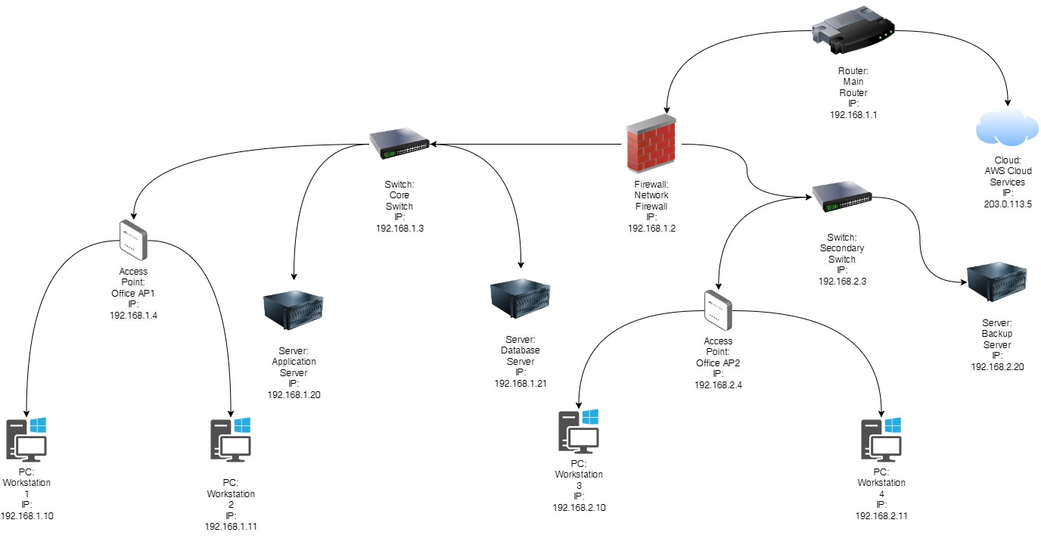

# Logical diagram

Cisco Packet tracer network issues problem diagram, will be updated soon.

The network diagram of Ozmart Retail Group’s cloud migration project shows the organization’s hybrid cloud infrastructure to handle increased business operations more efficiently and strengthen the group’s supporting IT structure.

At the centre of the network is the Main Router (IP: For instance, the intern networks have a default gateway being the 192. 168. 1. 1 as the entry point for all the internal as well as external connections. The router connects to AWS Cloud Services (IP: (203. 0. 113. 5) Cloud which has now become a normal means of flexibility and scalability helped Ozmart to improve its disaster recovery options. This connection is essential to expand the computing and storage of the company beyond the physical limitation to have strong backup for high traffic volume and strong business maintenance.

The router also interfaces with a Network Firewall (IP: Again, for (192. 168. 1. 2), which acts as a barrier to prevent both inside out and outside in traffic thus securing the network against cyber criminals. Behind the firewall, the network is segmented into different subnets, managed by the Core Switch (IP: There is Primary Switch (IP address: 192. 168. 1. 3) and Secondary Switch (IP address, 192. 168. 2. 3). These switches connect to Access Points namely AP1 and AP2 provided secure wireless access for PCs namely work stations 1 to 4 in the office.

Application, Database, and Backup servers are located at internal network to facilitate of essential business applications and data. These are connected to the switches so as to allow efficient transfer of data and fast connectivity to internal services.

This mean that Ozmart can deploy and use cloud services in conjunction with its local IT facilities to achieve flexibility in its resource usage, reduce expenses and guarantee highly secure and effective work. This design of hybrid network offers the company growth strategy since it offers a reliable, secure and flexible network environment to accommodate the growth in its business.

# Topology

Based on Ozmart Retail Group cloud migration project, the network topology adopted reflect a hybrid network topology. This works both on star and mesh topologies, and it refers to the integration of the firm’s on-site hardware and software network with cloud-based solutions for optimum functionality, security, and expansibility.

**Justification:**

The hybrid topology is best suited for Ozmart since it combines features of different topologies and thus offers the company a reliable and efficient networking solution. In this setup, the star topology is used in the on-premises network where the Main Router is the core or the center that links the other on-premises devices including the Network Firewall, the Core Switch, the Secondary Switch, the Access Points, PCs and the Servers. This means that there is easy management of the networks, as well as a possibility to monitor and control them in the best way possible; The network management is also simplified since problems can be easily detected and solved at the central point.

However, the exact mesh topology aspect is obtained with the incorporation of AWS Cloud Services. The router is connected to the cloud via a WAN link to allow different paths of transferring the traffic between the company’s internal network and the cloud. This creates a mesh like topology towards the cloud which increases system reliability and enables provision of backup functions in case of failure. Where one path is unavailable, others are available and the data goes through other paths, thereby reducing downtime of business’ cloud applications and services.

Thus, utilizing the mixed topology Ozmart gains the scalability and flexibility of cloud computing and at the same time retains the security and enterprise of on-site equipment. This approach helps in growing Ozmart business by establishing a strong and reliable network that is able to cope with dynamics of retail business.

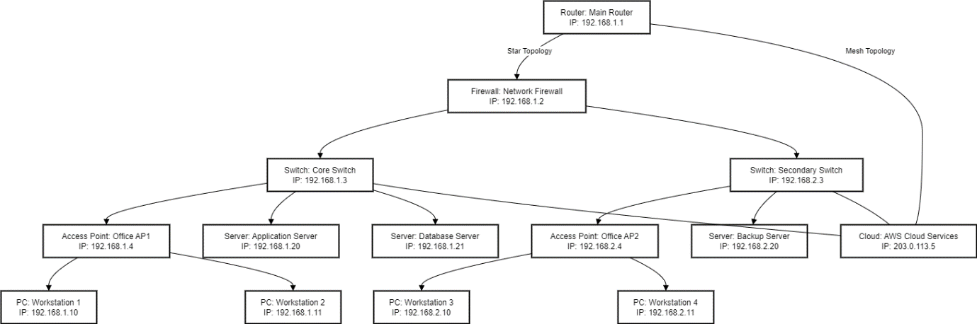

**Hybrid Topology:**

1. **Star Topology (On-Premises Network)**:
   * Router1 is connected to the Firewall1 and therefore serves as the central device within the network.
   * Firewall1 links to Switch1 as well as Switch 2 that transports networks to various devices.
   * Switch 1 and Switch 2 connect with Access Points (AP 1 & AP 2), Personal computers (workstations 1 to 4), Application, Database, and Backup Server in star topology whereby control can be administered efficiently.
2. **Mesh Topology (Cloud Connection)**:
   * Router 1, Switch 1, and Switch 2 all are connected to Cloud 1 (AWS Cloud Services) that shows multiple connections. This setup eliminates single point of failure, increases availability of networks and connectivity to cloud services.
   * Topology integration of on-premises element with the cloud strengthens the network connectivity and provides constant connectivity to the cloud system in case one path is unavailable.