Table of Contents

**Deadlock in Operating Systems** 1

**Conditions for deadlock** 2

**Deadlock prevention** 3

**Deadlock Management:** 4

**Importance of deadlock management** 5

Conclusion 6  
References 7

List of figures

**Figure 1:Dedlock management 1**

**Figure 2: Deadlock prevention 4**

i

# **Deadlock in Operating Systems**

A deadlock is a nightmare scenario in an operating system. It occurs when two or more processes become locked in a waiting game, each holding resources essential to the other's progress. Imagine a printer jam where two documents are stuck, each requiring a specific roller that the other is currently using. In the digital realm, this can bring a system to a grinding halt, impacting everything from critical business applications to user productivity.

Understanding deadlocks requires delving into the resource management dance between processes and the operating system. Processes rely on shared resources like printers, memory blocks, or devices to complete their tasks. Here's where things can go awry:

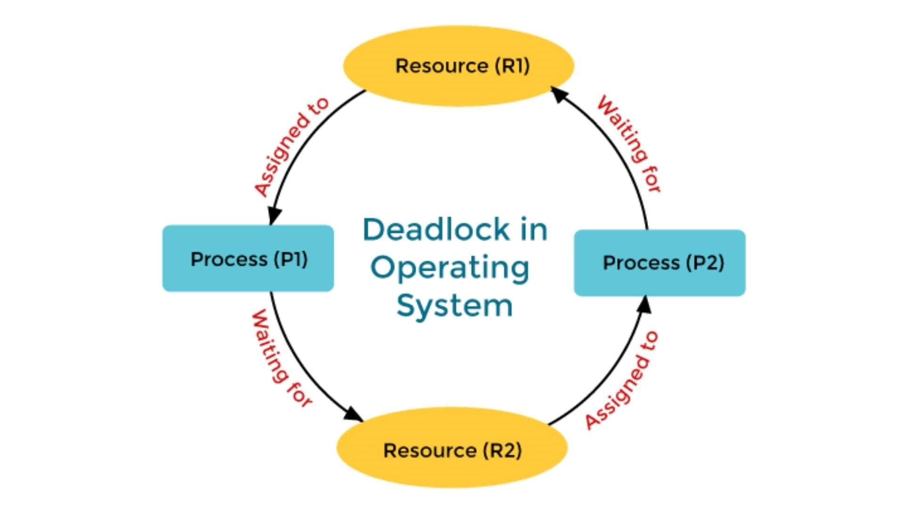

Figure 1:Dedlock management

# **Conditions for deadlock**

For a deadlock to occur, four specific conditions must be met simultaneously:

* **Mutual Exclusion**: A resource can only be owned by one process at a time. No multitasking allowed!
* **Hold and Wait**: A process can hold onto a resource while requesting another, essentially staking its claim on multiple resources.
* **No Preemption:** Once a resource is allocated, the operating system cannot force the process to relinquish it. Sharing is not mandatory!
* **Circular Wait**: A chain of processes forms where each process waits for a resource held by the next one in line. It's a catch-22 of resource dependency.

If these four conditions become a reality, deadlock rears its ugly head.

# **Deadlock prevention**

The best defense against deadlock is a good offense – prevention. Operating systems can employ various techniques to ensure that none of the four deadlock conditions ever occur. These strategies often involve regulating resource allocation:

* **Resource Ordering:** Imagine a numbered ticket system for resources. Processes request resources in a specific sequence, preventing the circular wait deadlock scenario.
* **Hold and Wait with Preemption:** If a process holding a resource needs another, the operating system can step in and reclaim the first resource, allowing the process to wait without blocking others.
* **Not Using Shared Resources:** Sometimes, a redesign is the best solution. By minimizing the need for shared resources, the system reduces the potential for conflicts altogether.

However, prevention techniques can be a double-edged sword. Imposing strict ordering or disallowing processes to hold resources while requesting others can limit system flexibility and potentially impact performance.

# **Deadlock Management:**



Figure 2: Deadlock prevention

Despite our best efforts, deadlocks can still occur due to unforeseen circumstances or complex resource interactions. This is where deadlock management becomes crucial. Operating systems need mechanisms to detect and recover from these situations. Here's how some systems tackle deadlocks:

* Deadlock Detection: The operating system actively monitors processes and resource allocation to identify deadlock situations. It's like having a system watchdog constantly on the lookout for trouble.
* Process Termination: Sometimes, the most expedient solution is to terminate one or more processes involved in the deadlock. The operating system essentially picks a victim, reclaims its resources, and allows the remaining processes to continue. This approach can be harsh, potentially leading to data loss or incomplete tasks.
* Resource Rollback: In some cases, the operating system can force processes to relinquish resources they hold. This allows the system to redistribute resources and potentially break the deadlock chain. While preferable to process termination, rollback can be complex and may require careful data recovery procedures.

# **Importance of deadlock management**

* **Ensuring System Responsiveness:** Deadlocks can bring a system to a complete standstill. Deadlock detection and recovery mechanisms ensure the system can eventually resume normal operation, preventing user frustration and lost productivity.
* **Data Loss Mitigation:** Processes stuck in a deadlock may hold partially completed tasks or crucial data. Deadlock management helps identify these processes and potentially recover the data before termination, minimizing potential losses.
* **Enhancing System Stability:** By addressing deadlocks, the system becomes more robust and adaptable to unexpected resource conflicts. This enhances overall system stability and user experience, promoting a reliable computing environment.

## **Conclusion**

Deadlock detection and recovery involve overhead and can be complex to implement. However, the importance of deadlock management in ensuring system responsiveness and data integrity outweighs these challenges. Operating systems must strike a balance between deadlock prevention and efficient resource management, creating a smooth and reliable user experience.

## **References**

1. Baeldung.com
2. en.wikipedia.org
3. GeeksforGeeks.com
4. Tutorialspoint.com