**Group 'A' Short Answer Questions:**

1. **Define Java. List out any four features of Java.**

Java is a multiplatform, network-centric, object-oriented programming language developed by a team led by James Gosling at Sun Microsystems in the USA.

Four key features of Java include:

1. Object-oriented programming nature.

2. Java programs are both compiled and interpreted.

3. Java programs are platform-independent.

4. Java is case-sensitive.

1. **Define Operator. Explain relational and arithmetic operators with an example.**

An operator is a symbol or token that performs arithmetic and logical operations and yields meaningful results.

Relational operators: These operators are used to compare the value of variables and result in 'true' or 'false'. Different types of relational operators include < (less than), > (greater than), <= (less than equal to), >= (greater than equal to), == (equal to), and != (not equal to).

Arithmetic operators: In Java, arithmetic operators are symbols used to perform mathematical operations on numerical values. Examples include +, -, *, /, ++, --, etc.

1. **Differentiate between object and class.**

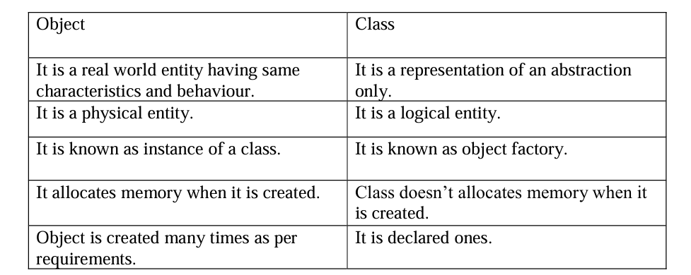

1. **WAP a Java Program to Check Whether Input Number is Even or Odd**

import java.util.Scanner;

public class Evenodd{

public static void main (String args[]){

Scanner in=new Scanner (System.in);

int n;

n=in.nextInt();

if(n%2==0)

System.out.println("It is even");

else

System.out.println("It is odd");

}

}

1. **WAP to Input Three Numbers and Find the Largest Among Them Using Scanner Class**

import java.util.Scanner;

public class Largest{

public static void main (String args[]){

Scanner in=new Scanner (System.in);

int a,b,c;

a=in.nextInt();

b=in.nextInt();

c=in.nextInt();

if(a>b&&b>c)

System.out.println("a is Largest");

else if(b>a&&b>c)

System.out.println("b is Largest");

else

System.out.println("c is Largest");

}

}

1. **Define loop. Explain for loop with an example.**

In computer programming, a loop is a sequence of instructions that is continually repeated until a certain condition is reached.

For loop: The Java For loop is used to iterate a part of the program several times. If the number of iterations is fixed, it is recommended to use a for loop.

1. **WAP to Input a Number and Calculate Factorial of a Given Number**

import java.util.Scanner;

public class FactorialCalculate{

public static void main (String args[]){

Scanner in=new Scanner (System.in);

System.out.println("Enter a number");

int num=Scanner.nextInt();

if(num<0){

System.out.println("Factorial is not defined for negative numbers");

}else{

long factorial=CalculateFactorial(int n){

System.out.println("Factorial of " +num+ "is" +factorial);

}

}

public static long CalculateFactorial(int n){

if(n==0){

return 1;

}else{

return n*CalculateFactorial(n-1);

}

}

}

1. **WAP to Input a Number and Find Multiplication Table of Given Number**

import java.util.Scanner;

class Table {

public static void main (String args[]){

int n,c;

System.out.println("Enter an integer to print it’s multiplication table");

Scanner in=new Scanner (System.in);

n=in.nextInt();

System.out.println(" multiplication table of n is:");

for(c=1;c<=10;c++)

System.out.println(n+"*"+c+ "="+(n*c));

}

}

1. **How to Calculate Area of Circle Using Object, Class, and Methods in Java**

import java.util.Scanner;

public class circle {

int r,a;

Scanner in=new Scanner (System.in);

public void inputData()

{

System.out.println(" Enter radius of circle");

r=in.nextInt();

}

void calculate()

{

a=3.14*r*r;

}

void outputData()

{

System.out.println(" The area of circle is" +a);

}

public static void main (String args[]){

circle ob=new circle();

ob.inputData();

ob.calculate();

ob.outputData()

}

}

**Group 'B' Long Answer Questions:**

1. **Define constructor. list out any four features. Explain the default constructor with an example.**

A constructor is a member function that is executed automatically when an object is created.

Four key features of a constructor include:

* + 1. A constructor name must be the same as that of its class name.
    2. Constructors are called automatically when the objects are created.
    3. Constructors should be declared in the public section to be available to all the functions.
    4. Constructors do not have a return type, not even void, and therefore they cannot return a value.

1. **WAP to Accept Length and Breadth of a Rectangle, Calculate and Display the Area and Perimeter of a Rectangle as Per the User's Choice**

import java.util.Scanner;

public class NewSwitch{

public static void main (String args[]){

Scanner in=new Scanner (System.in);

int l,b,ar,p,n;

System.out.println("Enter the length and breadth");

l=in.nextInt();

b=in.nextInt();

System.out.println("Enter 1 for area, 2 for perimeter ");

System.out.println("Enter your choice ");

n=in.nextInt();

switch(n)

{

case 1:

ar = l*b;

System.out.println("Area of rectangle =" +ar );

break;

case 2 :

p=2*(l+b);

System.out.println("perimeter of rectangle =" +p );

break;

default;

System.out.println("Your input is wrong ");

}

}

}

1. **Define array. WAP to add two 3*3 matrices using array.**

A Java array is an object which contains elements of similar data type. It is a data structure where we store similar elements.

Program to add 3*3 matrices:

*import java.util.Scanner;*

*public class MatrixSum {*

*public static void main(String[] args) {*

*Scanner in = new Scanner(System.in);*

*int i, j;*

*int m[][] = new int[3][3];*

*int n[][] = new int[3][3];*

*int s[][] = new int[3][3];*

*System.out.println("Enter the first matrix m:");*

*for (i = 0; i < 3; i++) {*

*for (j = 0; j < 3; j++) {*

*m[i][j] = in.nextInt();*

*}*

*}*

*System.out.println("Enter the second matrix n:");*

*for (i = 0; i < 3; i++) {*

*for (j = 0; j < 3; j++) {*

*n[i][j] = in.nextInt();*

*}*

*}*

*System.out.println("Sum of matrices:");*

*for (i = 0; i < 3; i++) {*

*for (j = 0; j < 3; j++) {*

*s[i][j] = m[i][j] + n[i][j];*

*System.out.print(s[i][j] + " ");*

*}*

*System.out.println();*

*}*

*}*

*}*

1. **Define string. List out any four string buffer method. Write a simple program to illustrate various string manipulation in java.**

String can be defined as a set of characters enclosed in a double quotes.

The four string buffer method are.

1. Append();
2. reverse();
3. delete();
4. insert();

*public class StringManipulationExample {*

*public static void main(String[] args) {*

*// Example 1: Using StringBuffer*

*StringBuffer buffer = new StringBuffer("Hello");*

*// Append " World!" to the buffer*

*buffer.append(" World!");*

*System.out.println("Appended string: " + buffer);*

*// Reverse the buffer*

*buffer.reverse();*

*System.out.println("Reversed string: " + buffer);*

*// Delete characters from index 5 to 10 (exclusive)*

*buffer.delete(5, 10);*

*System.out.println("After deletion: " + buffer);*

*// Insert " Java" at index 5*

*buffer.insert(5, " Java");*

*System.out.println("After insertion: " + buffer);*

*// Example 2: Using compareTo*

*String a = "Prithvi";*

*String b = "Shah";*

*int comparisonResult = a.compareTo(b);*

*if (comparisonResult < 0) {*

*System.out.println(a + " comes before " + b);*

*} else if (comparisonResult > 0) {*

*System.out.println(a + " comes after " + b);*

*} else {*

*System.out.println(a + " is equal to " + b);*

*}*

*}*

*}*

1. **What is an applet? Embed a java applet program to a HTML file.**

Applet are small Java applications that can be accessed in an internet server.

Embedding java applet program to a HTML file:

Java file code//first.java

*import java.applet.Applet;*

*import java.awt.Graphics;*

*Public class First extends Applet{*

*public void paint(Graphics g)*

*{*

*g.drawString("WELCOME",150,150);*

*}*

*}*

HTML File Code:

*First.html Embedding Applet to HTML File*

*<HTML>*

*<HEAD>*

*<TITLE>APPLET EXAMPLE</TITLE>*

*</HEAD>*

*<BODY>*

*<APPLET CODE="First.java" width="200" height="200">*

*</APPLET>*

*</BODY>*

*</HTML>*