## Copilot

**Group 'A'** Short Answer Questions:

1. **Define Java. List out any four features of java.**
   * Java is a multiplatform, network-centric, object-oriented programming language developed by a team led by James Gosling at Sun Microsystems in the USA.
   * Four key features of Java include:
     + Object-oriented programming nature.
     + Java programs are both compiled and interpreted.
     + Java programs are platform-independent.
     + Java is case-sensitive.
2. **Define Operator. Explain relational and arithmetic operator with an example.**
   * An operator is a symbol or token that performs arithmetic and logical operations and yields meaningful results.
   * Relational operators: These operators are used to compare the value of variables and result in 'true' or 'false'. Different types of relational operators include < (less than), > (greater than), <= (less than equal to), >= (greater than equal to), == (equal to), and != (not equal to).
   * Arithmetic operators: In Java, arithmetic operators are symbols used to perform mathematical operations on numerical values. Examples include +, -, *, /, ++, --, etc.
3. **Differentiate between object and class.**

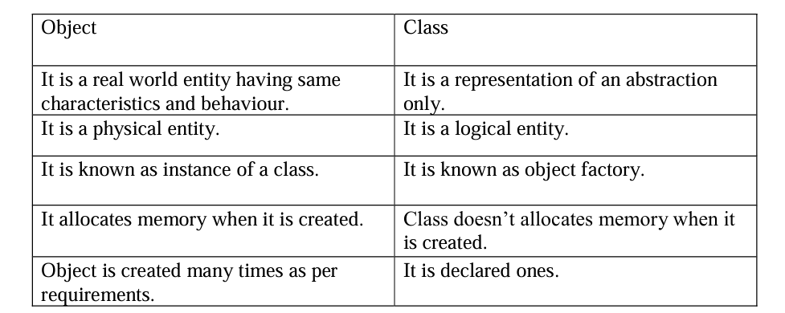

1. **WAP a Java Program to Check Whether Input Number is Even or Odd**

import java.util.Scanner;

public class Evenodd{

public static void main (String args[]){

Scanner in=new Scanner (System.in);

int n;

n=in.nextInt();

if(n%2==0)

System.out.println("It is even");

else

System.out.println("It is odd");

}

}

1. **WAP to Input Three Numbers and Find the Largest Among Them Using Scanner Class**

import java.util.Scanner;

public class Largest{

public static void main (String args[]){

Scanner in=new Scanner (System.in);

int a,b,c;

a=in.nextInt();

b=in.nextInt();

c=in.nextInt();

if(a>b&&b>c)

System.out.println("a is Largest");

else if(b>a&&b>c)

System.out.println("b is Largest");

else

System.out.println("c is Largest");

}

}

1. **Define loop. Explain for loop with example**
   * In computer programming, a loop is a sequence of instructions that is continually repeated until a certain condition is reached.
   * For loop: The Java For loop is used to iterate a part of the program several times. If the number of iterations is fixed, it is recommended to use a for loop.
2. **WAP to Input a Number and Calculate Factorial of a Given Number**

import java.util.Scanner;

public class FactorialCalculate{

public static void main (String args[]){

Scanner in=new Scanner (System.in);

System.out.println("Enter a number");

int num=Scanner.nextInt();

if(num<0){

System.out.println("Factorial is not defined for negative numbers");

}else{

long factorial=CalculateFactorial(int n){

System.out.println("Factorial of " +num+ "is" +factorial);

}

}

public static long CalculateFactorial(int n){

if(n==0){

return 1;

}else{

return n*CalculateFactorial(n-1);

}

}

}

1. **WAP to Input a Number and Find Multiplication Table of Given Number**

import java.util.Scanner;

class Table {

public static void main (String args[]){

int n,c;

System.out.println("Enter an integer to print it’s multiplication table");

Scanner in=new Scanner (System.in);

n=in.nextInt();

System.out.println(" multiplication table of n is:");

for(c=1;c<=10;c++)

System.out.println(n+"*"+c+ "="+(n*c));

}

}

1. **How to Calculate Area of Circle Using Object, Class, and Methods in Java**

import java.util.Scanner;

public class circle {

int r,a;

Scanner in=new Scanner (System.in);

public void inputData()

{

System.out.println(" Enter radius of circle");

r=in.nextInt();

}

void calculate()

{

a=3.14*r*r;

}

void outputData()

{

System.out.println(" The area of circle is" +a);

}

public static void main (String args[]){

circle ob=new circle();

ob.inputData();

ob.calculate();

ob.outputData()

}

}

**Group 'B' Long Answer Questions:**

1. **Define constructor. list out any four features. Explain default constructor with example.**
   * A constructor is a member function that is executed automatically when an object is created.
   * Four key features of a constructor include:
     + A constructor name must be the same as that of its class name.
     + Constructors are called automatically when the objects are created.
     + Constructors should be declared in the public section to be available to all the functions.
     + Constructors do not have a return type, not even void, and therefore they cannot return a value.
2. **WAP to Accept Length and Breadth of a Rectangle, Calculate and Display the Area and Perimeter of a Rectangle as Per the User's Choice**

import java.util.Scanner;

public class NewSwitch{

public static void main (String args[]){

Scanner in=new Scanner (System.in);

int l,b,ar,p,n;

System.out.println("Enter the length and breadth");

l=in.nextInt();

b=in.nextInt();

System.out.println("Enter 1 for area, 2 for perimeter ");

System.out.println("Enter your choice ");

n=in.nextInt();

switch(n)

{

case 1:

ar = l*b;

System.out.println("Area of rectangle =" +ar );

break;

case 2 :

p=2*(l+b);

System.out.println("perimeter of rectangle =" +p );

break;

default;

System.out.println("Your input is wrong ");

}

}

}

1. **Define array. WAP to add two 3*3 matrices using array.**
   * A Java array is an object which contains elements of similar data type. It is a data structure where we store similar elements.
   * Program to add 3*3 matrices:

*import java.util.Scanner;*

*public class MatrixSum {*

*public static void main(String[] args) {*

*Scanner in = new Scanner(System.in);*

*int i, j;*

*int m[][] = new int[3][3];*

*int n[][] = new int[3][3];*

*int s[][] = new int[3][3];*

*System.out.println("Enter the first matrix m:");*

*for (i = 0; i < 3; i++) {*

*for (j = 0; j < 3; j++) {*

*m[i][j] = in.nextInt();*

*}*

*}*

*System.out.println("Enter the second matrix n:");*

*for (i = 0; i < 3; i++) {*

*for (j = 0; j < 3; j++) {*

*n[i][j] = in.nextInt();*

*}*

*}*

*System.out.println("Sum of matrices:");*

*for (i = 0; i < 3; i++) {*

*for (j = 0; j < 3; j++) {*

*s[i][j] = m[i][j] + n[i][j];*

*System.out.print(s[i][j] + " ");*

*}*

*System.out.println();*

*}*

*}*

*}*

1. **Define string. List out any four string buffer method. Write a simple program to illustrate various string manipulation in java.**
   * String can be defined as a set of characters enclosed in a double quotes.
   * The four string buffer method are.
2. Append();
3. reverse();
4. delete();
5. insert();

*public class StringManipulationExample {*

*public static void main(String[] args) {*

*// Example 1: Using StringBuffer*

*StringBuffer buffer = new StringBuffer("Hello");*

*// Append " World!" to the buffer*

*buffer.append(" World!");*

*System.out.println("Appended string: " + buffer);*

*// Reverse the buffer*

*buffer.reverse();*

*System.out.println("Reversed string: " + buffer);*

*// Delete characters from index 5 to 10 (exclusive)*

*buffer.delete(5, 10);*

*System.out.println("After deletion: " + buffer);*

*// Insert " Java" at index 5*

*buffer.insert(5, " Java");*

*System.out.println("After insertion: " + buffer);*

*// Example 2: Using compareTo*

*String a = "Prithvi";*

*String b = "Shah";*

*int comparisonResult = a.compareTo(b);*

*if (comparisonResult < 0) {*

*System.out.println(a + " comes before " + b);*

*} else if (comparisonResult > 0) {*

*System.out.println(a + " comes after " + b);*

*} else {*

*System.out.println(a + " is equal to " + b);*

*}*

*}*

*}*

1. **What is an applet? Embed a java applet program to a HTML file.**

Applet are small Java applications that can be accessed in an internet server.

Embedding java applet program to a HTML file:

Java file code//first.java

*import java.applet.Applet;*

*import java.awt.Graphics;*

*Public class First extends Applet{*

*public void paint(Graphics g)*

*{*

*g.drawString("WELCOME",150,150);*

*}*

*}*

HTML File Code:

*First.html Embedding Applet to HTML File*

*<HTML>*

*<HEAD>*

*<TITLE>APPLET EXAMPLE</TITLE>*

*</HEAD>*

*<BODY>*

*<APPLET CODE="First.java" width="200" height="200">*

*</APPLET>*

*</BODY>*

*</HTML>*