Association Between ALIKA Deployment and KULA Live-Chat Volume, CSAT, and Dislike Outcomes
Comparative observational study: June 2026 versus August 2026
Prepared: 31 August 2026

Abstract
Background: ALIKA was fully operational by August 2026. This study compares KULA activity and satisfaction with June 2026, before launch. Methods: Exports were deduplicated by conversation ID and restricted to currentAccount = 3-1-robot2. Welch’s t-test compared mean ratings; chi-square tests compared CSAT (scores 4–5) and dislike (score 1) among rated conversations. Results: Unique connected users increased from 62,928 to 131,831 (+109.5%). CSAT changed from 56.88% to 57.87% (p=0.642); dislike changed from 35.89% to 35.22% (p=0.742). Conclusion: KULA volume was substantially higher after ALIKA launch, but quality differences were small and statistically nonsignificant. Observational comparison does not establish causality.
Keywords: ALIKA, KULA, chatbot, live chat, connected users, CSAT, dislike

1. Introduction
KULA is a live-chat chatbot identified by currentAccount = 3-1-robot2. June represents pre-ALIKA operation; August represents full ALIKA operation. ALIKA-origin routes are marked in changeFlag as 从Alika跳转 or 从Alika中途跳转. Study questions assess changes in connected-user volume, conversation activity, CSAT, and dislike outcomes.

2. Methods

2.1 Design and population
Retrospective observational before-after study covering 30 June days and 31 August days. Both monthly totals and daily-normalized outcomes were calculated.

2.2 Preparation and definitions
Exports were concatenated and deduplicated by id. June had 0 duplicate IDs and August had 95,917, mainly from overlapping exports. Missing scores were classified as unrated. Connected users were distinct userId values; CSAT was score 4–5; dislike was score 1.

2.3 Statistical methods
Welch’s independent-samples t-test compared mean score. Pearson chi-square tests compared CSAT and dislike proportions. Significance threshold was α = 0.05. These tests estimate association, not causal impact.

3. Results

3.1 Connected-user and conversation volume
Unique users increased by 68,903 (+109.5%), from 62,928 to 131,831. Conversations increased from 85,655 to 179,559 (+109.6%). Average daily users increased from 2,496 to 5,064 (+102.9%). Conversations per user stayed nearly constant (1.361 versus 1.362), suggesting growth came from more users, not more repeat conversations per user.
Table 1. Summary metrics.
Metric | June (before ALIKA) | August (after ALIKA) | Absolute change | Relative change (%)
Unique connected users | 62,928.000 | 131,831.000 | 68,903.000 | 109.495
KULA conversations | 85,655.000 | 179,559.000 | 93,904.000 | 109.630
Average unique users/day | 2,495.567 | 5,063.806 | 2,568.240 | 102.912
Average conversations/day | 2,855.167 | 5,792.226 | 2,937.059 | 102.868
Conversations per user | 1.361 | 1.362 | 0.001 | 0.065
Rated conversations | 872.000 | 1,417.000 | 545.000 | 62.500
Rating response rate (%) | 1.018 | 0.789 | -0.229 | -22.483
Mean score | 3.334 | 3.367 | 0.033 | 0.998
CSAT 4-5 (% rated) | 56.881 | 57.869 | 0.988 | 1.737
Dislike score 1 (% rated) | 35.894 | 35.215 | -0.679 | -1.892
Dislikes per 1,000 conversations | 3.654 | 2.779 | -0.875 | -23.950
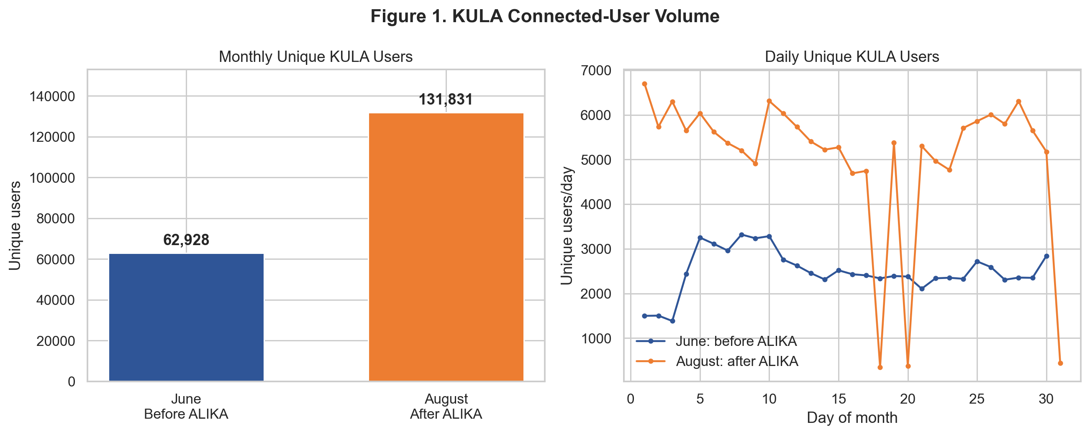

3.2 Satisfaction outcomes
Mean score changed from 3.334 to 3.367. CSAT increased 0.99 percentage points; dislike decreased 0.68 percentage points. No test was statistically significant.
Table 2. Statistical comparisons among rated conversations.
Metric | June | August | Difference | p-value
Mean score | 3.334 | 3.367 | 0.033 | 0.679
CSAT 4-5 rate | 56.881 | 57.869 | 0.988 | 0.642
Dislike score-1 rate | 35.894 | 35.215 | -0.679 | 0.742
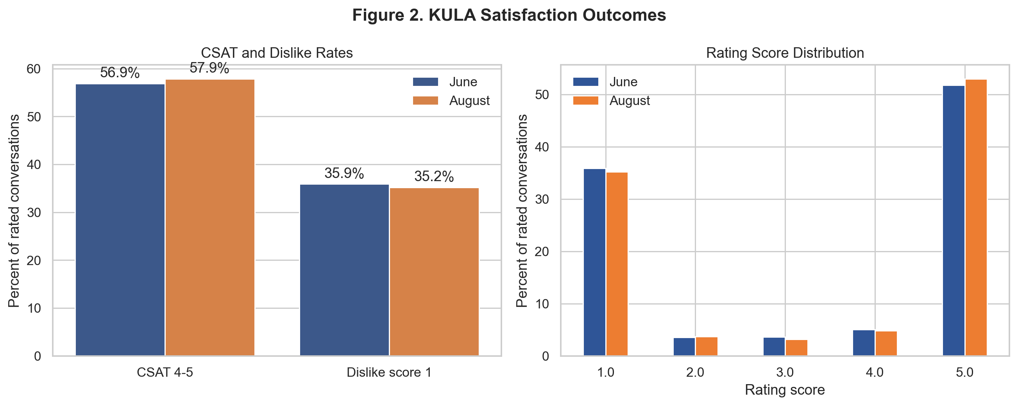

3.3 Route and transfer fields
August contained 779 explicitly ALIKA-marked KULA conversations (0.43%), but only 2 were rated. Direct ALIKA-route CSAT is therefore unstable. autoTransferType was populated in 0 KULA rows, preventing transfer-type outcome analysis.

4. Discussion
Main result is an approximately twofold increase in KULA connected-user and conversation volume during full ALIKA operation. Stable conversations per user indicate a number-of-users effect. Rated-user CSAT, dislike, and mean score remained statistically indistinguishable. Rating response declined from 1.02% to 0.79%, so satisfaction results apply only to respondents and may contain nonresponse bias.

5. Limitations
- Before-after design cannot separate ALIKA from seasonality, campaigns, product changes, staffing, or traffic-mix changes.
- Only two nonadjacent months were available; no control channel or interrupted time series was used.
- Approximately 1% of conversations were rated.
- Only two rated conversations carried explicit ALIKA-origin markers.
- autoTransferType was absent from KULA-scoped rows.
- Monthly user counts were not matched longitudinally across periods.

6. Conclusion
August KULA connected users and daily volume were approximately twice June levels. No statistically detectable CSAT, dislike, or mean-score change was found among rated conversations. Evidence supports a volume difference without measurable quality change, but does not prove ALIKA caused that difference.

7. Recommendations
- Preserve ALIKA route and auto-transfer fields end-to-end by conversation ID.
- Standardize rating prompts and improve response coverage.
- Extend analysis to multiple pre/post months.
- Use interrupted time-series or difference-in-differences with a comparable control account.
- Report respondent dislike rate together with dislikes per 1,000 conversations.

Appendix. Reproducibility
Source analysis: notebooks/alika_effect_on_kula.ipynb. Report tables and figures were generated from deduplicated source exports in dataset_wellbore. Values may change if source exports are corrected or replaced.

