Observed Association Between ALIKA Routing and KULA Service Outcomes
A four-month retrospective analysis of KULA conversations, survey quality, and routing markers
Analysis period: 1 May-31 August 2026 | Report date: 3 September 2026

Abstract
Background: This study assessed whether KULA service outcomes changed during the period in which conversations were observed to route from ALIKA. Methods: KULA records from May through August 2026 were deduplicated by conversation identifier, restricted to the account labels 3-1-robot and 3-1-robot2, and compared across complete export dates. Valid survey scores were 1-5; good surveys were scores 3-5. The primary cutoff was the first explicit ALIKA routing marker, 31 July 2026. Welch's t-test compared mean CSAT and a Pearson chi-square test compared good/bad survey composition. Results: The observed-routing period had 190,417 conversations across 29 complete days versus 643,117 across 91 days before routing. Mean CSAT increased from 3.250 to 3.361 (+0.111, p=0.038), while good-survey rate increased from 58.70% to 60.93% (+2.23 percentage points, p=0.113). Survey response rate decreased from 0.992% to 0.790%. The June 28 candidate date produced larger differences, but explicit routing markers did not validate it. Conclusion: KULA outcomes improved in the observed routing period, but the evidence does not establish that ALIKA caused the improvement. Sparse and delayed routing markers, falling response rates, temporal confounding, and low power for the good-survey endpoint limit causal interpretation.
Keywords: customer satisfaction; CSAT; chatbot routing; before-after study; service operations; observational analysis

1. Introduction
Operational teams often evaluate a conversational-system rollout by comparing customer feedback before and after routing changes. Such comparisons are useful for monitoring, but they can overstate causal effects when rollout timing is uncertain, exposure is incompletely recorded, or customer composition changes over time. This analysis examines the relationship between ALIKA routing and KULA outcomes using the available export data.
The prespecified candidate launch date supplied with the analysis was 28 June 2026. The primary analysis instead uses the earliest complete-date KULA record whose changeFlag explicitly indicates transfer from ALIKA, because that is an observable data event. The study question is therefore deliberately narrower than a causal launch evaluation: did KULA volume and survey outcomes differ after the first observed ALIKA routing marker?

2. Methods

2.1 Design and data preparation
This was a retrospective, uncontrolled before-after study. Twenty-six May-July exports and eight August exports were concatenated within month and deduplicated by id. KULA traffic was defined as currentAccount in {3-1-robot, 3-1-robot2}. Dates whose latest available record did not reach hour 23 were excluded from normalized daily and phase comparisons; 18, 20, and 31 August were incomplete and excluded. This yielded 833,534 complete-date KULA conversations across the four months.

2.2 Measures
Conversation volume was the number of unique deduplicated conversations. Survey respondents were records with numeric scores from 1 through 5. CSAT was the arithmetic mean valid score. Good-survey rate was the proportion of valid respondents scoring 3-5, and bad-survey rate was the proportion scoring 1-2. Survey response rate was valid respondents divided by conversations. The routing marker was a case-insensitive search for Alika in changeFlag.

2.3 Statistical analysis
The primary comparison used Welch's independent-samples t-test for CSAT and an uncorrected Pearson chi-square test for the 2-by-2 good/bad survey table, with alpha=0.05. Monthly differences were assessed with one-way ANOVA, Kruskal-Wallis, and a monthly good/bad chi-square test. A sensitivity analysis used 28 June as the cutoff. A post hoc two-proportion power calculation estimated the additional routing-period respondents needed to reach approximately 80% power for the observed good-survey difference, holding the pre-period sample fixed. Analyses were performed in Python with pandas, NumPy, SciPy, and Matplotlib/Seaborn.

3. Results

3.1 Data coverage and launch validation
Month | Conversations | Complete days | Respondents | CSAT | Good % | Response %
May | 240,894 | 31 | 2,551 | 3.148 | 56.10 | 1.059
June | 198,542 | 30 | 2,103 | 3.238 | 58.11 | 1.059
July | 211,595 | 31 | 1,780 | 3.417 | 63.32 | 0.841
August | 182,503 | 28 | 1,451 | 3.357 | 60.79 | 0.795

The candidate date of 28 June was not validated by the routing marker. The first ALIKA-marked KULA conversation occurred at 09:54:24 on 31 July 2026. Only 773 of the 190,417 conversations in the observed-routing period were marked from ALIKA (0.41%), and the marker was concentrated in later August records. This makes the marker a sparse exposure indicator rather than a complete treatment assignment.

3.2 Primary before-versus-observed-routing comparison
Outcome | Before (through 30 Jul) | Routing period (from 31 Jul) | Difference | p-value
Conversations/day | 7,067.2 | 6,566.1 | -501.1 (-7.1%) | Descriptive
Valid respondents | 6,380 | 1,505 | -4,875 | Descriptive
Survey response rate | 0.992% | 0.790% | -0.202 pp | Descriptive
CSAT mean | 3.250 | 3.361 | +0.111 | 0.038
Good survey rate | 58.70% | 60.93% | +2.23 pp | 0.113

The CSAT difference was statistically significant at the nominal 0.05 level. The good-survey proportion was directionally higher but did not meet that threshold. Because the analysis tested multiple related outcomes and did not adjust for multiplicity, the CSAT p-value should be interpreted as exploratory rather than confirmatory.

3.3 Monthly and sensitivity findings
Outcomes varied across months: the monthly CSAT means were 3.148, 3.238, 3.417, and 3.357 from May through August. The monthly omnibus tests were significant for CSAT by ANOVA (F=8.555, p<0.001), score distributions by Kruskal-Wallis (H=24.369, p<0.001), and good/bad composition by chi-square (chi-square=25.172, p<0.001). These findings show time variation, but they do not identify ALIKA as the cause of that variation.
Cutoff | CSAT before | CSAT after | CSAT p | Good before | Good after | Good p
28 Jun candidate | 3.183 | 3.386 | <0.001 | 56.81% | 62.15% | <0.001
31 Jul observed marker | 3.250 | 3.361 | 0.038 | 58.70% | 60.93% | 0.113

The candidate-date sensitivity result is larger, but it should not be presented as validated treatment evidence because the marker data place the first explicit ALIKA routing event on 31 July. The candidate comparison also combines June, July, and August calendar time in a way that may capture unrelated temporal changes.

3.4 Precision and power
For the observed +2.23 percentage-point good-survey difference, the available sample provided approximately 35.3% power under the notebook's two-proportion approximation. Approximately 9,316 routing-period respondents would be required for 80% power with the pre-period sample fixed; 7,811 additional respondents were estimated, equivalent to about 151 additional complete days at the observed rate of 51.9 respondents per day. Thus, one or two additional 30-day months would not be expected to reach 80% power under the same assumptions; the notebook estimates approximately six additional 30-day months.

3.5 Visual analysis
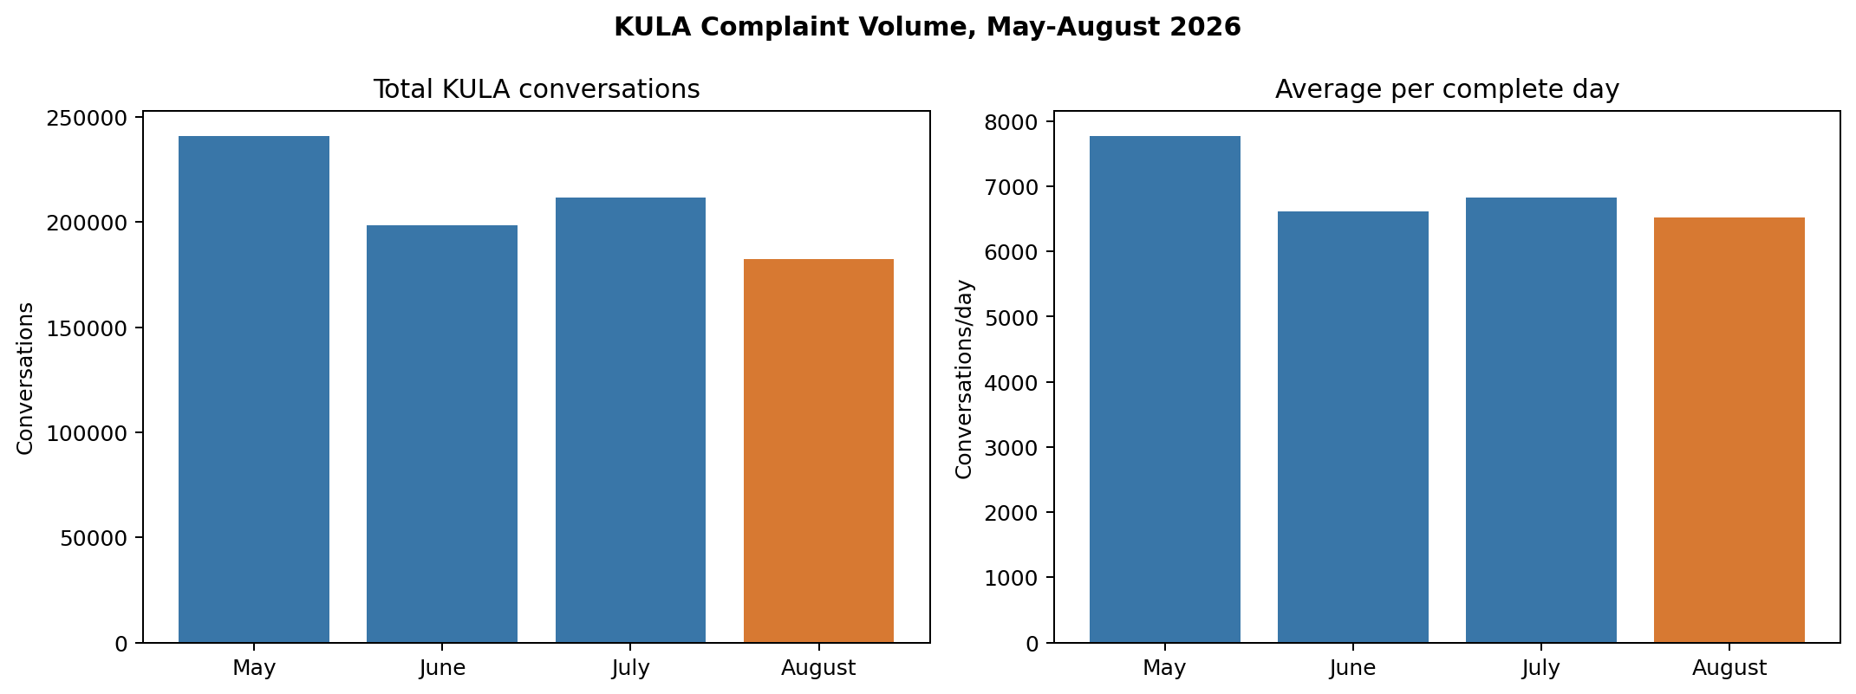
Figure 1. KULA complaint volume by month and average volume per complete day.
Volume declined from 240,894 conversations in May to 182,503 complete-date conversations in August. The daily view shows that this is not only a calendar-length effect: average volume fell from 7,771 conversations per day in May to 6,518 in August. The observed-routing period averaged 6,566 conversations per day, 7.1% below the preceding period. This operational change is a potential confounder when interpreting survey outcomes.
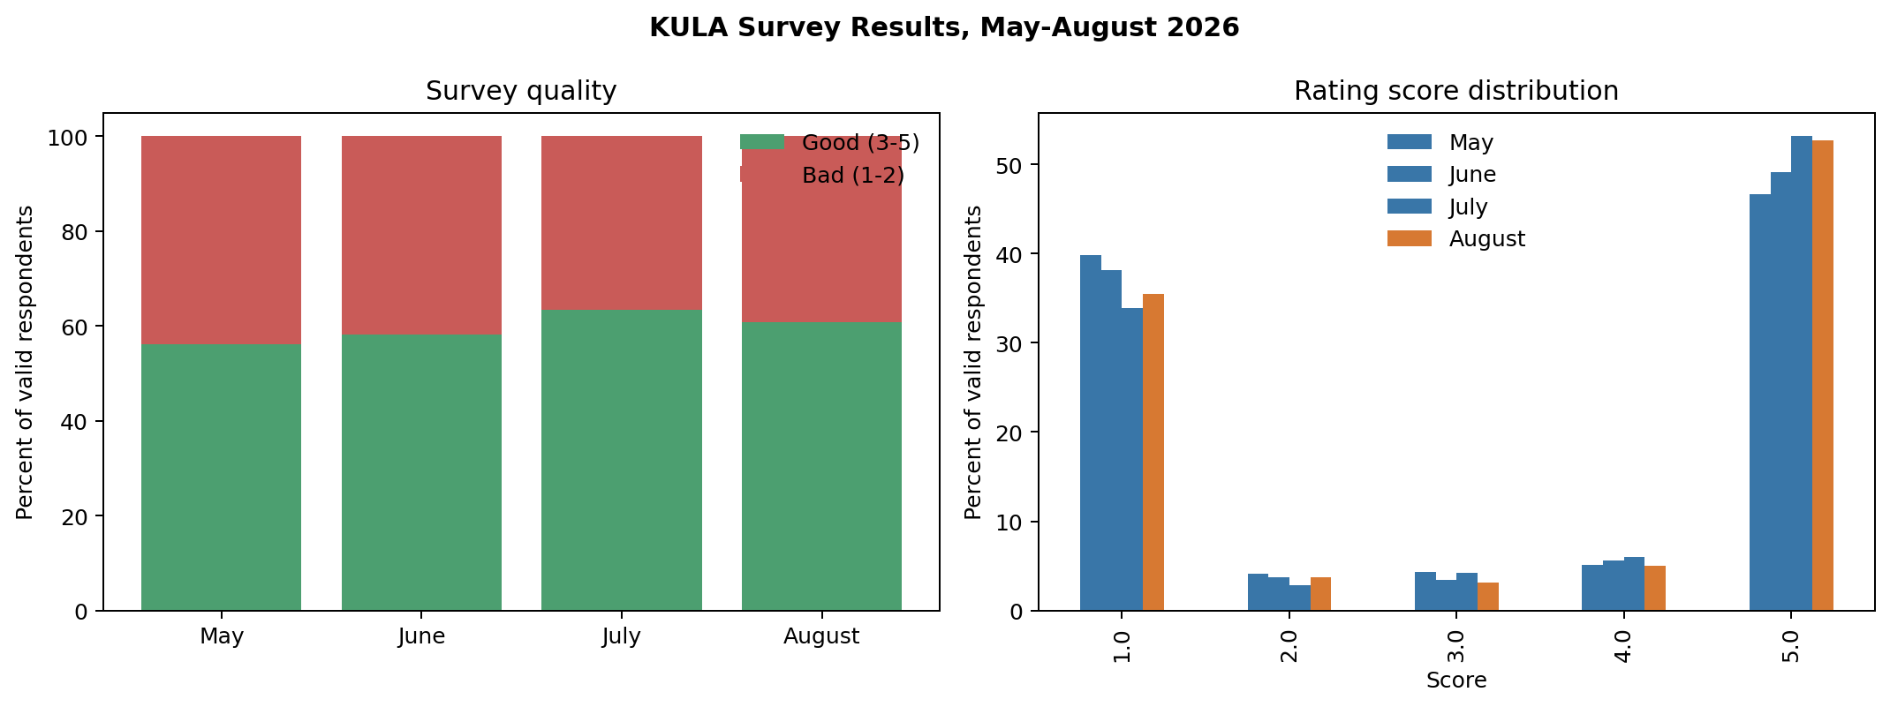
Figure 2. Monthly survey quality and valid-rating score distribution.
The share of good surveys rose from 56.10% in May to 63.32% in July, then eased to 60.79% in August. The score distribution shows that the improvement is largely reflected in a lower share of score-1 responses and a higher share of score-5 responses in July and August. Because response rates also decline over the same period, the chart describes respondents rather than all conversations and may be affected by non-response selection.
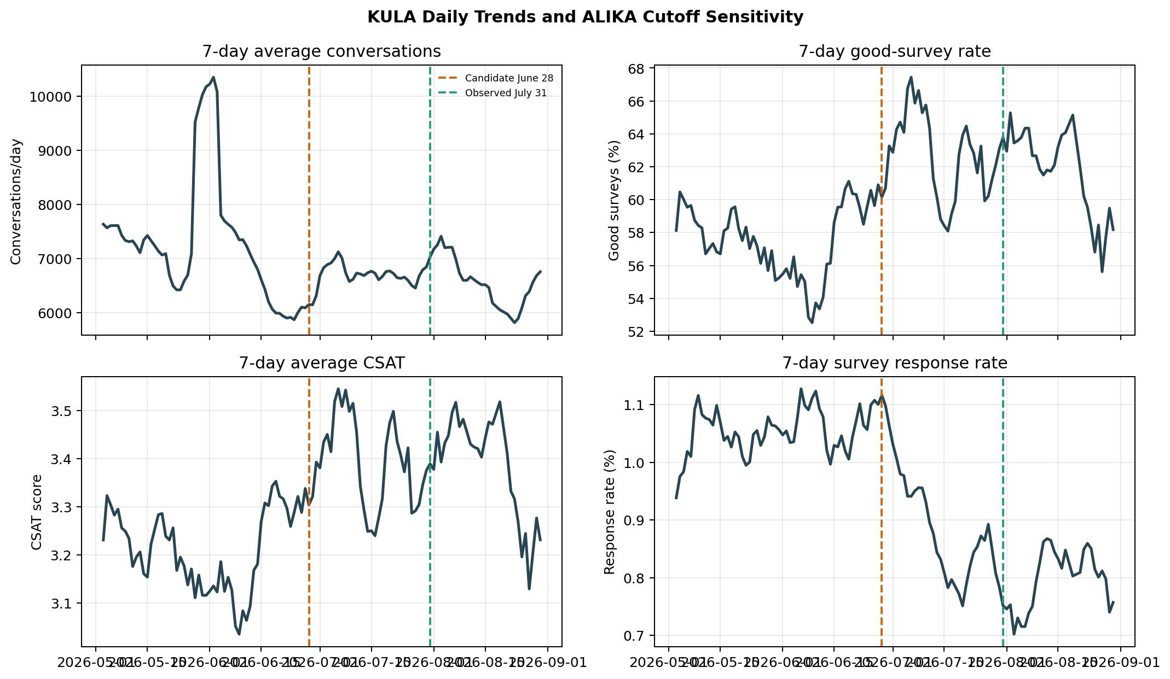
Figure 3. Seven-day rolling daily trends with candidate and observed ALIKA cutoffs.
The rolling trends provide temporal context that monthly averages conceal. The June 28 candidate line precedes the first explicit ALIKA marker on July 31; therefore, changes near the candidate line cannot be attributed to verified ALIKA routing. The observed July 31 line occurs late in the analysis window, and the marker does not correspond to a broad, immediate exposure jump. This visual supports treating the primary result as an association with a late-period regime, not a clean intervention effect.
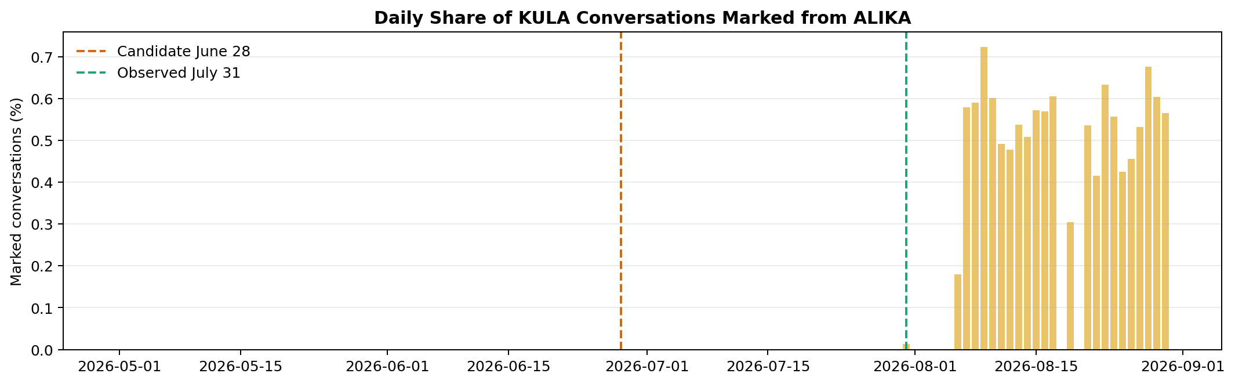
Figure 4. Daily percentage of KULA conversations explicitly marked from ALIKA.
Marker coverage is zero on most days, begins with one marked conversation on July 31, and increases only on selected later August days. The sparse, intermittent pattern means changeFlag cannot be used as a complete indicator of ALIKA exposure. In particular, the two-line cutoff comparison should not be read as evidence that every post-July-31 conversation was routed from ALIKA.

4. Discussion
The data show a modest improvement in average KULA survey score after 31 July, alongside a non-significant increase in the good-survey rate. The pattern is compatible with improved customer experience, but the design cannot separate an ALIKA effect from calendar trends, changes in traffic mix, operational changes, differences in survey participation, or regression to the mean. The concurrent 7.1% decline in daily conversation volume and 0.202 percentage-point decline in survey response rate are especially important: the observed respondents may not represent the same customer population before and after the cutoff.
The routing marker is not suitable for a direct exposed-versus-unexposed causal comparison in this extract. Marked conversations represented only 0.41% of the routing-period volume and had just two valid survey respondents; their CSAT and survey proportions are therefore unstable. The first non-null autoTransferType also appeared earlier, on 14 May, and only two such records were present, so it does not provide a reliable rollout boundary.

4.1 Strengths
Strengths include explicit deduplication, inclusion of both KULA account labels, exclusion of incomplete export dates, separation of survey quality from complaint volume, use of a routing-marker validation step, and a prespecified sensitivity analysis around the supplied candidate date.

4.2 Limitations
Limitations include the uncontrolled before-after design; uncertain and sparse exposure measurement; unequal phase lengths; possible changes in customer mix and operations; low and declining survey response; repeated observations that may not be independent at the user level; no confidence intervals or multiplicity correction in the notebook; and the stale-kernel failure of the final machine-readable conclusion cell. The numerical tables used here were generated successfully from the preceding analytical cells, but the notebook should be rerun from the top for a clean reproducibility record.

5. Conclusion
KULA CSAT was higher during the period beginning with the first observed ALIKA routing marker, while the good-survey rate showed a smaller, statistically non-significant increase. The evidence supports monitoring the result as a promising operational signal, not claiming a causal ALIKA impact. A stronger evaluation should record ALIKA exposure at conversation level, use a validated rollout timestamp, preserve a contemporaneous comparison group, and continue collecting surveys until the primary endpoint has adequate precision.

References
1. von Elm E, Altman DG, Egger M, et al. The Strengthening the Reporting of Observational Studies in Epidemiology (STROBE) statement: guidelines for reporting observational studies. Lancet. 2007;370:1453-1457.
2. Welch BL. The generalization of Student's problem when several different population variances are involved. Biometrika. 1947;34(1-2):28-35.
3. Pearson K. On the criterion that a given system of deviations from the probable in the case of a correlated system of variables is such that it can be reasonably supposed to have arisen from random sampling. Philosophical Magazine. 1900;50(302):157-175.
4. Cohen J. Statistical Power Analysis for the Behavioral Sciences. 2nd ed. Lawrence Erlbaum Associates; 1988.

Appendix A. Reproducibility note
Source notebook: notebooks/alika_effect_on_kula.ipynb. Source data: dataset_wellbore monthly exports referenced in that notebook. The report reflects the notebook's definitions and calculations as executed in the current environment on 3 September 2026. Values are rounded for presentation; p-values shown as <0.001 correspond to values below 0.001 in the executed output.

