REVISION HISTORY

|  |  |  |  |
| --- | --- | --- | --- |
| **Date** | **Version** | **Description** | **Author** |
| 21/10/2015 | 1.0 | Software Requirements Specifications (Version 1.0) | Caner Gülgeç (User Requirements Specifications, General report check)  Cengizhan Özcan (Introduction, Use Cases and Usage Scenarios)  Şevval Tan (Introduction, System Requirements Specifications) |
| 28/10/2015 | 2.0 | Software Requirements Specifications (Version 2.0) | Caner Gülgeç (User Requirements Specifications, General report check)  Cengizhan Özcan (Introduction, System Architecture, Use Cases and Usage Scenarios)  Şevval Tan (Introduction, System Requirements Specifications) |
|  |  |  |  |
|  |  |  |  |

**TABLE OF CONTENTS**

**Revision History**

**1** **INTRODUCTION**

***1.1*** ***Document overview***

***1.2 System Overview***

***1.3*** ***Abbreviations***

***1.4*** ***References***

***1.5*** ***Conventions***

**2** **REQUIREMENTS**

***2.1*** ***User Requirements Specification***

***2.2*** ***System Architecture***

***2.3*** ***Use Cases and Usage Scenarios***

***2.4*** ***System Requirements Specification***

# 1 INTRODUCTION

## Document overview

This document presents the software requirements specifications of EHITS software development project.

It describes:

* *Requirements of functionalities, performances, interfaces with the environment.*
* *Visual presentations of what EHITS does in the background on the code basis.*

## System overview

This system shall enable the user to:

* *Log in to the LMS and SIS systems with a single password while those programs will keep working in the background in order for the user to reach the desired courses.*
* *Filter and select courses.*
* *Display all of the deadlines (both for exams and homeworks) according to the data which will be pulled from LMS and SIS systems.*
* *Add other events and reminders to the calendar provided for the deadlines.*
* *Display all of the national and religious holidays within the academic year.*
* *Display the calendar either daily, weekly, monthly or yearly.*

## Abbreviations

*SDP : Software Development Plan*

*SRS : Software Requirements Document*

*STP : Software Test Plan*

*SDD : Software Design Document*

*STR : Software Test Report*

*JSON: JavaScript Object Notation*

*UML: Unified Modeling Language*

*SIS: Student Information System*

*LMS: Learning Management System*

*EHITS: Exam & Homework Information Tracking System*

## References

|  |  |  |
| --- | --- | --- |
| # | Document Identifier | Document Title |
| [R1]  [R2]  [R3]  [R4] | 1  2  3  4 | Ozyegin LMS: https://lms.ozyegin.edu.tr  Ozyegin SIS: <https://sis.ozyegin.edu.tr>  WindowBuilder: <https://eclipse.org/windowbuilder>  SDP: Software Development Plan |

## Conventions

Requirements listed in this document are constructed according to the following structure:

* For user requirements:

*SRS-EHITS-Requirement Code (RC)*

*Title of EHITS-RC requirement*

*Description of EHITS-RC requirement*

*Version of EHITS-RC*

* For system requirements:

*SRS-EHITS-RC.1*

*Description of EHITS-RC requirement*

# REQUIREMENTS

## User Requirements Specification

* **Functional Requirements of EHITS**

*SRS-EHITS-FR01*

*Functionality*

*The EHITS shall provide a calendar which presents the dates of the exams and homeworks of the lectures either daily, weekly, monthly or yearly.*

*V1*

*SRS-EHITS-FR02*

*Security*

*User (Student) who is using the EHITS shall log in to system by entering his/her 6 digit student number and the corresponding password.*

*V1*

*SRS-EHITS-FR03*

*Storage*

*The system shall store user information including name, surname and student number.*

*V1*

*SRS-EHITS-FR04*

*Permission*

*The user who is using the system shall not change (add or delete) the approved data (which contains lectures’ exam and homework dates) which was parsed by the project members.*

*V1*

* **Nonfunctional Requirements of EHITS**

*SRS-EHITS-NFR01*

*Efficiency*

*When the user (Student) who is using the system to choose the lecture that EHITS shall provide information about that lecture within 4 seconds.*

*V1*

*SRS-EHITS-NFR02*

*Durability*

*A possible downtime in anytime shall not pass over 30 minutes in a day if one of the authorized members is available for taking care of it.*

*V1*

## System Architecture

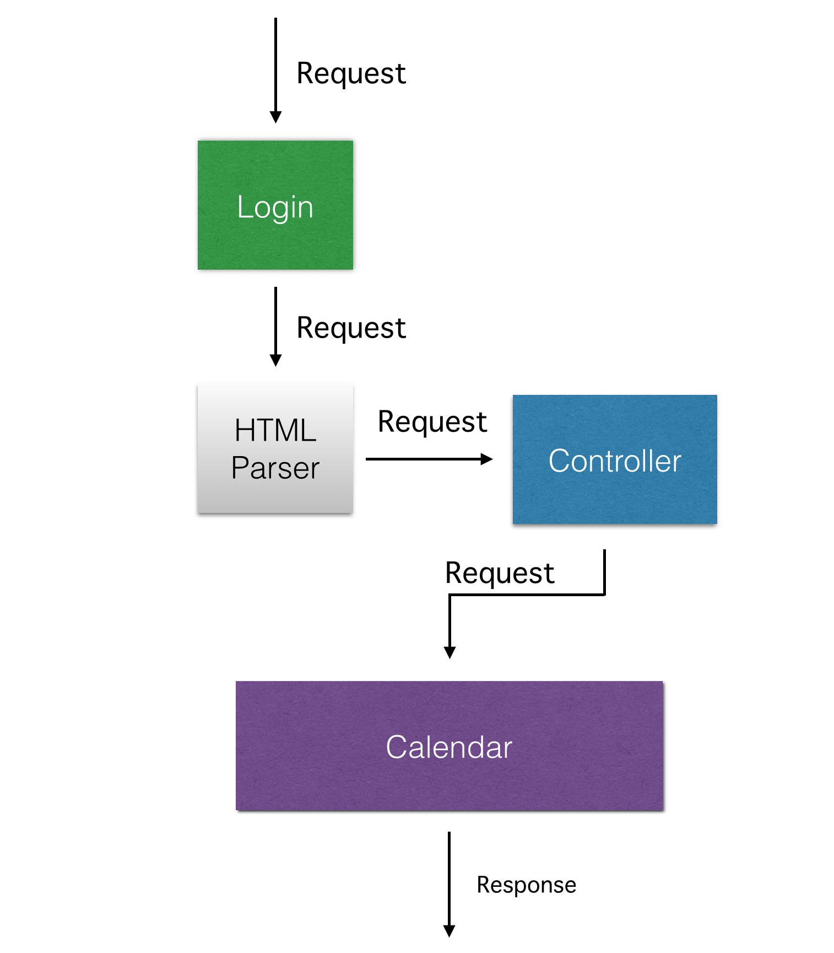

## Use Cases and Usage Scenarios

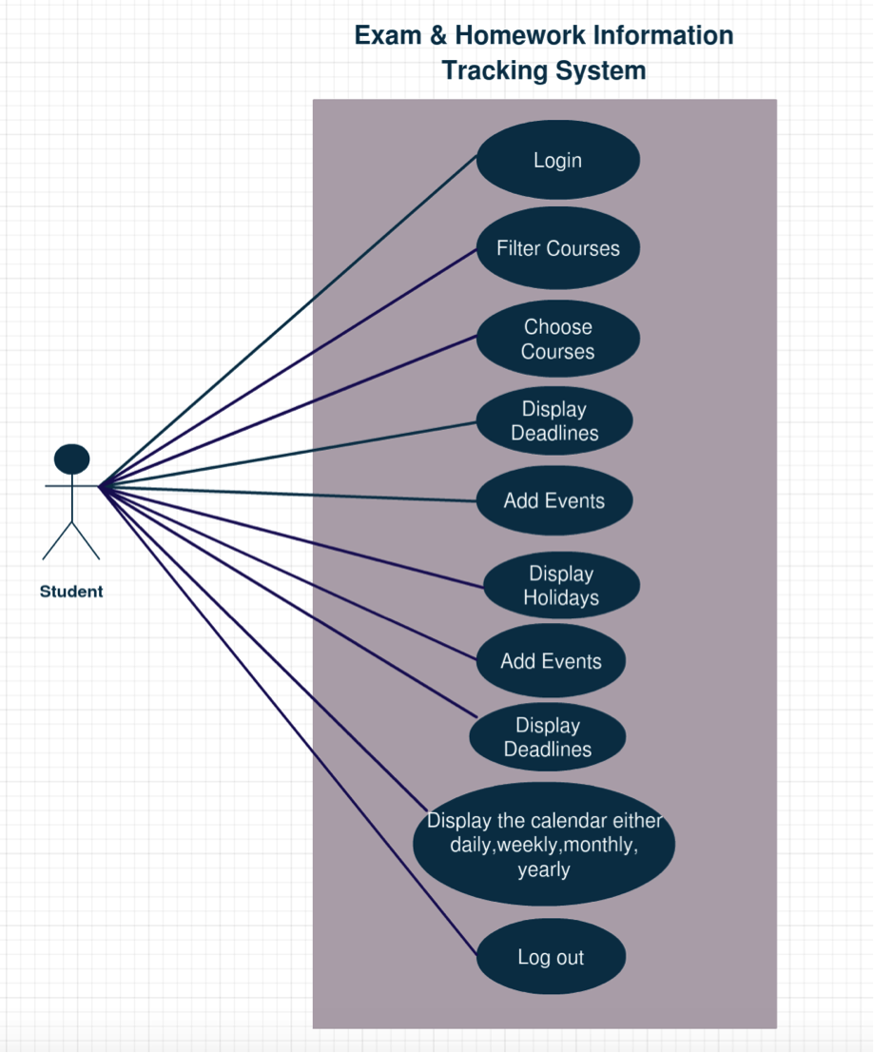

**Brief description**

The users shall access the software by log in to see all of the events data coming from LMS and SIS.

**Step-By-Step Description**

1. *The user logs in by filling the username and password.*
2. *The system displays all the courses and the user filters those courses according to their desire.*
3. *The user chooses the desired courses after filtering.*
4. *The user shall see all of the deadlines for the homeworks and the exams for the chosen courses.*
5. *The user may add some new events or reminders to the calendar.*
6. *The user can see all of the national and religious holidays by opening the calendar.*
7. *The user can also arrange the calendar daily, weekly, monthly or yearly.*
8. *After finishing their work the user can log out.*

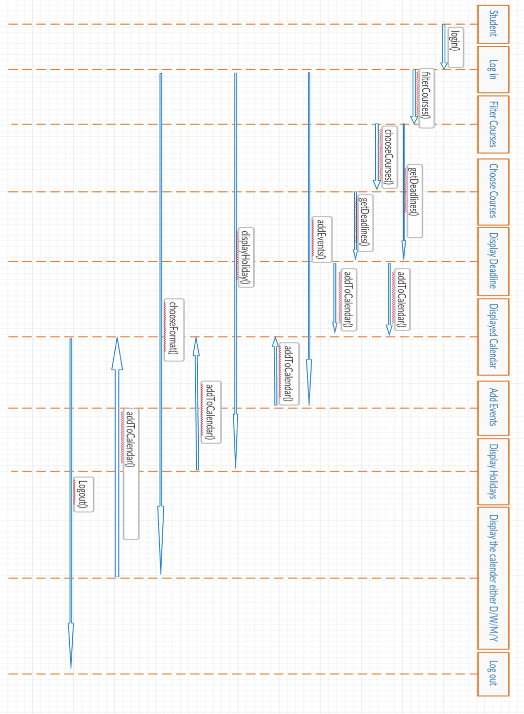

## System Requirements Specification

In this section, more information about the functional and nonfunctional requirements are provided.

* Functional Requirements
  + *SRS-EHITS-FR01*
* *SRS-EHITS-FR01.1*

*The system should provide a data consisting of list of courses for the semester.*

* *SRS-EHITS-FR01.2*

*The system should enable the user to be able to filter those courses*

*according to year, semester, faculty and code of the course.*

* *SRS-EHITS-FR01.3*

*The system should automatically create a calendar after the*

*courses are chosen by the user. Calendar should be created in four*

*different formats; daily, weekly, monthly and yearly. The system should*

*enable to user to make a choice between these options for the format.*

* + *SRS-EHITS-FR02*
* *SRS-EHITS-FR02.1*

*The system should enable the user to log in by their student*

*number and a corresponding password.*

* *SRS-EHITS-FR02.2*

*The system should recognize the student number and verify if the user is a student at Özyeğin University. If not, the user should not be able*

*to log in.*

* *SRS-EHITS-FR02.3*

*The system should remember the information (student number and password) on demand. If the user does not want them to be*

*remembered, then the system should not store the information.*

* + *SRS-EHITS-FR03*
* *SRS-EHITS-FR03.1*

*As stated in FR02.2, the system should recognize the student by*

*the information provided by them. After this task is done, the system*

*should get the user’s name, surname and student number and keep*

*those information in a log file.*

* + *SRS-EHITS-FR04*
* *SRS-EHITS-FR04.1*

*The data should include information about the courses which are*

*held at Özyeğin University. Data should include the year, semester, faculty, and the course code for filtering. It should also include exam dates and times, homework dates and times which should be visible after the*

*filtering.*

* *SRS- EHITS-FR04.2*

*The data provided by the software should be hidden. The user*

*should not be able to view the core data.*

* *SRS-EHITS-FR04.3*

*Even though the user is able to add events on the calendar, they should not be able to add a course, faculty, semester or year to the data.*

* *SRS-EHITS-FR04.4*

*The user should not be able to change the dates and times for the*

*homeworks and the exams.*

* *SRS-EHITS-FR04.5*

*The user should not be able to change a course’s corresponding*

*faculty.*

* Nonfunctional Requirements
  + *SRS-EHITS-NFR01*
* *SRS-EHITS-NFR01.1*

*The system should be able to display the list of the filtered courses*

*chosen by the user within 5 seconds.*

* *SRS-EHITS-NFR01.2*

*The system should be able to display the information about the the selected course within 4 seconds.*

* *SRS-EHITS-NFR01.3*

*After the courses are chosen, the system should enable the user to view the calendar within 5 seconds.*

* *SRS-EHITS-NFR01.4*

*The system should be able to convert the format of the calendar*

*within 2 seconds.*

* + *SRS-EHITS-NFR02*
* *SHR-EHIST-NFR02.1*

*A possible downtime should not be any longer than 30 minutes except if a new data should be parsed between two semesters, since the*

*data which contains the information about the courses (exam and homework dates) will change. If that is the case, project members may exceed that time by 4 hours.*