Revision History
Date | Version | Description | Author
07.10.2015 | 1.0 | Software Development Plan (version 1) | Caner Gülgeç
 |  |  | Şevval Tan
 |  |  | Arjen Kılıç
 |  |  | Cengizhan Özcan
 |  |  | Erke Varol

TABLE OF CONTENTS

Revision History 1
1 Identification 3
1.1 Document overview 3
1.2 Abbreviations 3
1.2.1 Abbreviations 3
1.3 References 3
1.3.1 Project References 3
2 Software Development Activities 3
2.1 Software development process 3
2.1.1 Overview of process phases 3
2.1.2 Technical documentation 3
2.1.3 Deliverables: 3
2.2 Software development tools 4
2.2.1 Workstation 4
2.2.2 Requirements management and documentation 4
2.2.3 Software Design 4
2.2.4 Coding and automated tests 4
2.2.5 Configuration management 4
2.3 Software development rules and standards 4
3 Responsibilities 4
3.1 Activities and responsibilities 4
4 Risk Assessment 5
4.1 Risk Analysis 5
4.2 Risk Planning 5

Identification

Document overview
This document contains the software development plan of Exam & Homework & Information Tracking System. It is a desktop application presenting the dates of the assignments and exams of the lectures which is chosen by students.

Abbreviations

Abbreviations
SDP : Software Development Plan
SRS : Software Requirements Document
STP : Software Test Plan
SDD : Software Design Document
STR : Software Test Report
MVC : Model View Controller
DB : Database
JSON: Java Script Object Notation

References

Project References
# | Document Identifier | Document Title
[R1] | 1 | WindowsBuilder - https://eclipse.org/windowbuilder/
[R2] | 2 | Ozyegin SIS - https://sis.ozyegin.edu.tr
[R3] | 3 | Ozyegin LMS - https://lms.ozyegin.edu.tr

Software Development Activities
The section lists and describes the software development activities of Exam & Homework & Information Tracking System software.

The software development process chosen for this project is the waterfall programming model.
The waterfall programming model was chosen for the reasons below:
- Using the waterfall model will be more efficient in order to keep up with the course schedule.
- The requirements for the project are not tentative, therefore the project won’t need much changes.

Overview of process phases
The lifecycle of the software development project is composed of
Software specification,
Software detailed design,
Software coding and unit tests,
Software integration
Software verification tests

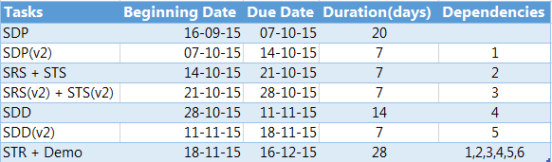

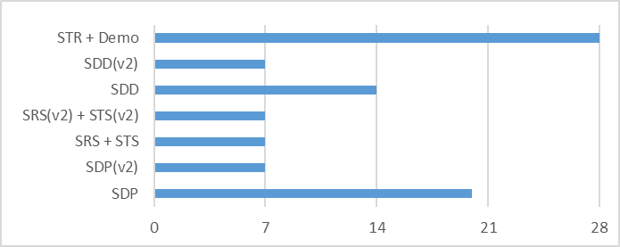

Technical documentation
The following documentation is produced during the design phases:
- Software specification: SRS, STP,
- Software detailed conception: updated SRS, SDD, updated STP, STD
- Coding and unit tests: STR of unit tests
- Software tests phrases : STR.

Deliverables:
The following items are delivered at the end of the process:
- Technical documentation,
- User documentation: user guide, administration procedures and installation procedure,
- Software and its configuration files.

Software development tools

Workstation
Caner Gülgeç : Lenovo , Intel Core i7 , 2.4Ghz , 8GB RAM , Windows 10
Erke Varol : Fujitsu , Intel Core i7 , 2.5Ghz , 8GB RAM , Windows 8
Şevval Tan : Apple , Intel Core i7 , 2.5Ghz , 16GB RAM, OS X El Capitan
Arjen Kılıç : Monster , Abra a5 v1.1 , i7 , 2.5Ghz 8GB RAM
Cengizhan Özcan : Apple , Intel Core i7 , 2.2Ghz , 16GB RAM , OS X Yosemite

Requirements management and documentation
Eclipse -> To writing and debugging the code
Microsoft Word -> To writing the necessary documents
JSON - > To hold the dates of exams, lectures and deadlines.
Github -> To update and share the documentations with the team members.
Xcode -> To writing and debugging the code for the Mac users.

Software Design
Describe tools used for software design :
- Argo UML open source tool, Microsoft Visio, Rational Rose, Together J, etc.

Coding and automated tests
Eclipse -> for coding and automated tests
Xcode -> for coding and automated tests for Mac users

Configuration management
- Github -> We will use a common repository location (on a desktop application) to keep track of the changes made about the software.

Software development rules and standards
Describe here the standards and rules used for software development, like modelling (UML), data modeling, coding rules, etc.

Responsibilities

Activities and responsibilities
Each activity has someone responsible, mandatory.
Activity | Responsibility | Comment
Project management | Arjen Kılıç
Configuration tools management | Erke Varol
Setting up the Development tools | Caner Gülgeç
Software specifications | Arjen Kılıç, Cengizhan Özcan
GUI Implementation | Şevval Tan
Parsing the JSON data | Caner Gülgeç, Arjen Kılıç

Risk Assessment

Risk Analysis

Risk Type | Potential Indicators | Probability | Effect
Technology | Some of team members use  different operating systems and tools so there can be discrepancy | Moderate | Serious
People | Group members can drop  the course | Low | Tolerable
Estimation | Failure to meet the agreed  schedule | Low | Tolerable

Risk Planning
For each risk item listed in the previous subsection, provide risk indicators and action(s) to be taken when the risk takes place.

You can examine the table above.

