Revision History
Date | Version | Description | Author
20/10/2015 | 1.0 | Software Test Plan | Erke Varol  Arjen Kılıç
28/10/2015 | 2.0 | Software Test Plan | Erke Varol  Arjen Kılıç

TABLE OF CONTENTS
Revision History 1
1 Introduction 3
1.1 Document overview 3
1.2 Abbreviations 3
1.3 References 3
1.4 Conventions 3
2 Tests preparations 4
2.1 Hardware preparation 4
2.2 Software preparation 4
2.3 Other test preparation 4
2.4 Safety, security and privacy precautions 4
3 Tests descriptions 5

Introduction

Document overview
This document describes the plan for testing the EHITS software. This document will address the different standards that will apply to system testing of the specified application.

Abbreviations
SDP : Software Development Plan
SRS : Software Requirements Document
STP : Software Test Plan
SDD : Software Design Document
STR : Software Test Report
JSON: JavaScript Object Notation
UML: Unified Modeling Language
EHITS: Exam & Homework Information Tracking System

References

# | Document Identifier | Document Title
[R1] | 1 | Software Development Plan
[R2] | 2 | Software Requirements Specifications

Conventions

Test ID | Some ID assigned according to the naming chosen convention
Test description | A description of the test
Verified Requirement | SRS-REQ-001 | Verification method: I,A,D,T  I: Inspection  A: Analysis  D: Demonstration  T: Test
Initial conditions | The state of software before test | Reference a procedure or it may be the result of previous test
Tests inputs | Input data from any test tool, input files name and location | Reference a procedure to use the test tool
Data collection actions | Recording and post processing of output data | Reference a procedure to record data with a test tool
Tests outputs | Output data files names and location, logs … | Give unique name out output data files.
Assumptions and constraints | If any, may be limited access to a tool, license …
Expected results and criteria | List here the results of test | And the criteria to evaluate the result
Test procedure
Step number | Operator actions | Expected result and evaluation criteria
1 | Start something… | Something is started…

Tests preparations
This section contains tasks and recommendations before executing tests.

Hardware preparation
To provide an optimal environment group only need a laptop for run the test on. Also a online server will be going to used for storing the JSON data in it. The specifications of that server is unknown.
Here are the computers which are going to used.
Fujitsu, Intel Core i7, 2.5Ghz, 8GB RAM, Windows 8
Apple, Intel Core i7, 2.2Ghz, 16GB RAM, OS X Yosemite

Software preparation
The required software for this project is minimal. The client machines needs the latest Java version and well configured with Chrome or Firefox for parsing purposes.
Also the Software(API) which is going to use for parsing information from the SIS or LMS should be installed on the computers.
Finally to get better results on tests a Mac and a Windows Operating Systems will be enough.
There will be both automated test and manual test. At the bottom diagram you can see a sample diagram of automated tests. How they will work. Manual tests will be based on using the functionalities of the system on behalf of the user and observation of the results.
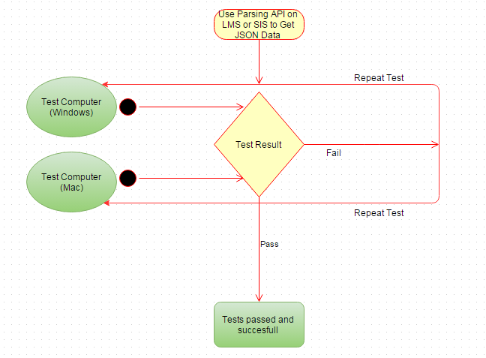

Extra preparation
Team is going to get a GitHub Students Pack for this project because its offers the online server and the some more API’s which are going to be useful on the project.

Safety, security and privacy precautions
For more testing purposes the source code requires a tool like FindBugs. It is a useful plugin for finding the bugs and prevent critical security issues.

Tests descriptions

Test ID | T-EHITS-REQ-001
Test desc. | Verify that the server gives an error for wrong username or password.
Verif. Req. | SRS-EHITS-FR02.1 | Demonstration
Init. Cond. | Running
Tests inputs | Username, password
Data collection | N/A
Tests outputs | Error message
Assum & constr | N/A
Expected results and criteria | The program should not allow to reach another users data. | N/A
Test Procedure
Step 1 | Open application. | Application opened.
Step 2 | Enter wrong username or password. | Access denied with an error message.
Step 3 | Wait for entering information again. | Re Ask the username and password.

Test ID | T-EHITS-REQ-002
Test desc. | Verify that the program shows deadlines depends on the user’s course selection and it should be provided within 5 seconds.
Verif. Req. | SRS-EHITS-FR01.1, SRS-EHITS-NFR01.1 | Test
Init. Cond. | Running
Tests inputs | Course selection
Data collection | N/A
Tests outputs | Course deadlines
Assum & constr | N/A
Expected results and criteria | The program should show all the deadlines of selected courses and it should show these within 5 seconds. | N/A
Test Procedure
Step 1 | Open application. | Application is opened.
Step 2 | Enter username and password correctly. | Access granted.
Step 3 | Look for deadlines of the courses which is selected by the user. | Showing the deadlines of the selected courses.

Test ID | T-EHITS-REQ-003
Test desc. | Verify that a possible downtime shall not pass over 30 minutes in a day if any authorized member is available.
Verif. Req. | SRS-EHITS-NFR02 | Inspection
Init. Cond. | Implemented server
Tests inputs | N/A | N/A
Data collection | N/A
Tests outputs | N/A
Assum & constr | N/A
Expected results and criteria | The program should not be crashed more than 30 minutes in a day.
Test Procedure
Step 1 | Open application. | Application opened.
Step 2 | Enter username and password correctly. | Access granted.
Step 3 | Overload the system. | System still working properly.

Test ID | T-EHITS-REQ-004
Test desc. | Verify that the system store the user information
Verif. Req. | SRS-EHITS-FR03.1 | Demonstration
Init. Cond. | Running | N/A
Tests inputs | User ID
Data collection | N/A
Tests outputs | User information
Assum & constr | N/A
Expected results and criteria | The program should keep the user information and his/her preferences
Test Procedure
Step 1 | Open application. | Application opened.
Step 2 | Enter username and password correctly. | Access granted.
Step 3 | Do some stuff on the system. | Program keeping log of the actions.
Step 4 | Choose some lessons. | Program saves the preferences of the user.

Test ID | T-EHITS-REQ-005
Test desc. | Verify that unauthorized users (excluding admins), cannot change the exams, homeworks and informations data.
Verif. Req. | SRS-EHITS-FR04.1 | Demonstration
Init. Cond. | Web Server | N/A
Tests inputs | N/A
Data collection | N/A
Tests outputs | N/A
Assum & constr | N/A
Expected results and criteria | The deadline datas, should be only changed by admins.
Test Procedure
Step 1 | Open application. | Application opened.
Step 2 | Enter username and password. | Access granted.
Step 3 | Try to access Admin Panel. | Access denied with an error message.

