**WITH** teaching **AS**(

**SELECT** teaches.teacher_id,

t_name **AS** teacher_name,

p_name **AS** pupil_name,

**SUBJECT**,

class

**FROM** teaches

**INNER** **JOIN** teacher **ON** teacher.teacher_id = teaches.teacher_id

**INNER** **JOIN** pupil **ON** pupil.pupil_id = teaches.pupil_id

)

**SELECT** *

**FROM** teaching

**WHERE** pupil_name = 'Giorgi';

// I have added the new student Giorgi in pupil table

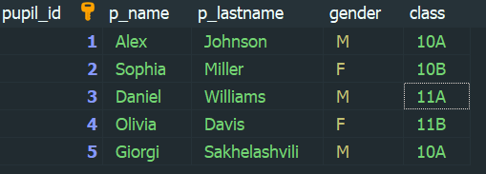

//and populated a data for teaches table, run the query and here is the result



