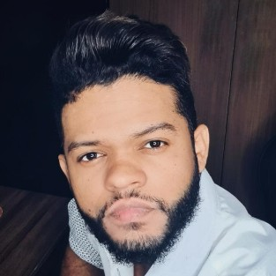  Ozeas Gomes  Data Analyst | Python Developer | Engineer  Address  São Paulo, 06447-170 Brazil  Phone  +55 11 96451-6380  E-mail  ozeas_23@hotmail.com  LinkedIn  linkedin.com/in/ozeasgomes  - Python  Excellent  - Pandas  Excellent  - Matplotlib  Excellent  - VBA - Visual Basic for Application  Very Good  - Data formatting  Excellent  - Data analysis  Excellent  - SQL  Very Good  - ETL  Very Good  - Django  Good  - R  Very Good  - Selenium  Very Good  - Java  Good  - OOP  Very Good  - English  Very Good  - Portuguese  Excellent  - Spanish  Average | Passionate about learning new technologies and general knowledge perceptive and logical Data Analyst communicates well with both technical professionals and end-users to identify and translate business requirements. Experienced driving data accuracy and integrity to exceed quality standards. Builds and leads teams of talented professionals to develop valuable process solutions and meet business objectives.
  Contact
  Skills
  Languages
  Work History
   | 2021-11 - Current |  | Data Analyst  Stefanini, São Paulo  - Working with Python and libraries to work with data like: Numpy, Pandas, MatPlotLib, Plotly and Seaborn  - Researched and resolved issues regarding integrity of data flow into databases.  - Identified and documented detailed business rules and use cases based on requirements analysis.  - Extracted and interpreted data patterns to translate findings into actionable outcomes.  - Upheld security and confidentiality of documents and data within area of responsibility.  - Developed tables, views and materialized views using SQL.  - Tested data prediction algorithms based on historical data.
   | 2020-11 - 2021-11 |  | Ecommerce Data Analyst  Chopp Brahma Express, São Paulo  - Analyzing large amounts of data with Python, Excel and Power BI  - VTEX, Google Analytics, Product Registration, Pricing and Promotions Setup, Bank Transaction Platforms.  - Collaborated with team members to achieve target results.  - Participated in team-building activities to enhance working relationships.  - Received and processed stock into inventory management system.  - Successfully maintained clean, valid driver's license and access to reliable transportation.
  Education
   | 2015-01 - 2019-12 |  | Bachelor of Science: Industrial Engineering  Centro Universitário Fieo - UNIFIEO - Osasco, São Paulo, Brazil
  Courses
   | 2022-05 |  | - Microsoft Power BI Para Data Science, Data Science Academy
   | 2022-02 |  | - Complete SQL Mastery, Code With Mosh
   | 2021-06 |  | - Python for Data Science, LinkedIn Learning
   | 2020-09 |  | - Data Visualization , Kaggle
   | 2020-09 |  | - Pandas , Kaggle
   | 2021-06 |  | - Excel 2019: Advanced Formulas and Functions, LinkedIn Learning
   | 2021-05 |  | - Big Data Fundamentals: Techniques and Concepts, LinkedIn Learning
   | 2021-05 |  | - Data Science Fundamentals: Data Mining, LinkedIn Learning
   | 2021-04 |  | - Statistical Fundamentals: Part 1, LinkedIn Learning
   | 2021-09 |  | - Intro to Machine Learning, Kaggle
.

