Setting up
Supabase and the AI
Every click, in order, assuming nothing — about 30 minutes
Version 3.0 · 19 August 2026 · Updated for Supabase's new API keys

Before you start
Two websites, one browser, nothing to install. You will not touch a command line at any point.
What | Where | Cost
Your app and website | github.com | Free
Database and the AI connection | supabase.com | Free
The AI itself | console.anthropic.com | ~£0.05 per contract analysed
Three words that sound like something else
“Edge Functions” has nothing to do with Microsoft Edge — it is Supabase's name for small pieces of server code. Chrome is completely fine. “Vault” is Supabase's built-in secret storage, not an app to install. “Cron” is a scheduler inside the same dashboard. All three are menu items you click, not software you download.
About the pictures
These are illustrations I have drawn, not photographs — I cannot log into your account to capture the real screens. Menu names and button labels match what you will see; the colours will look different.
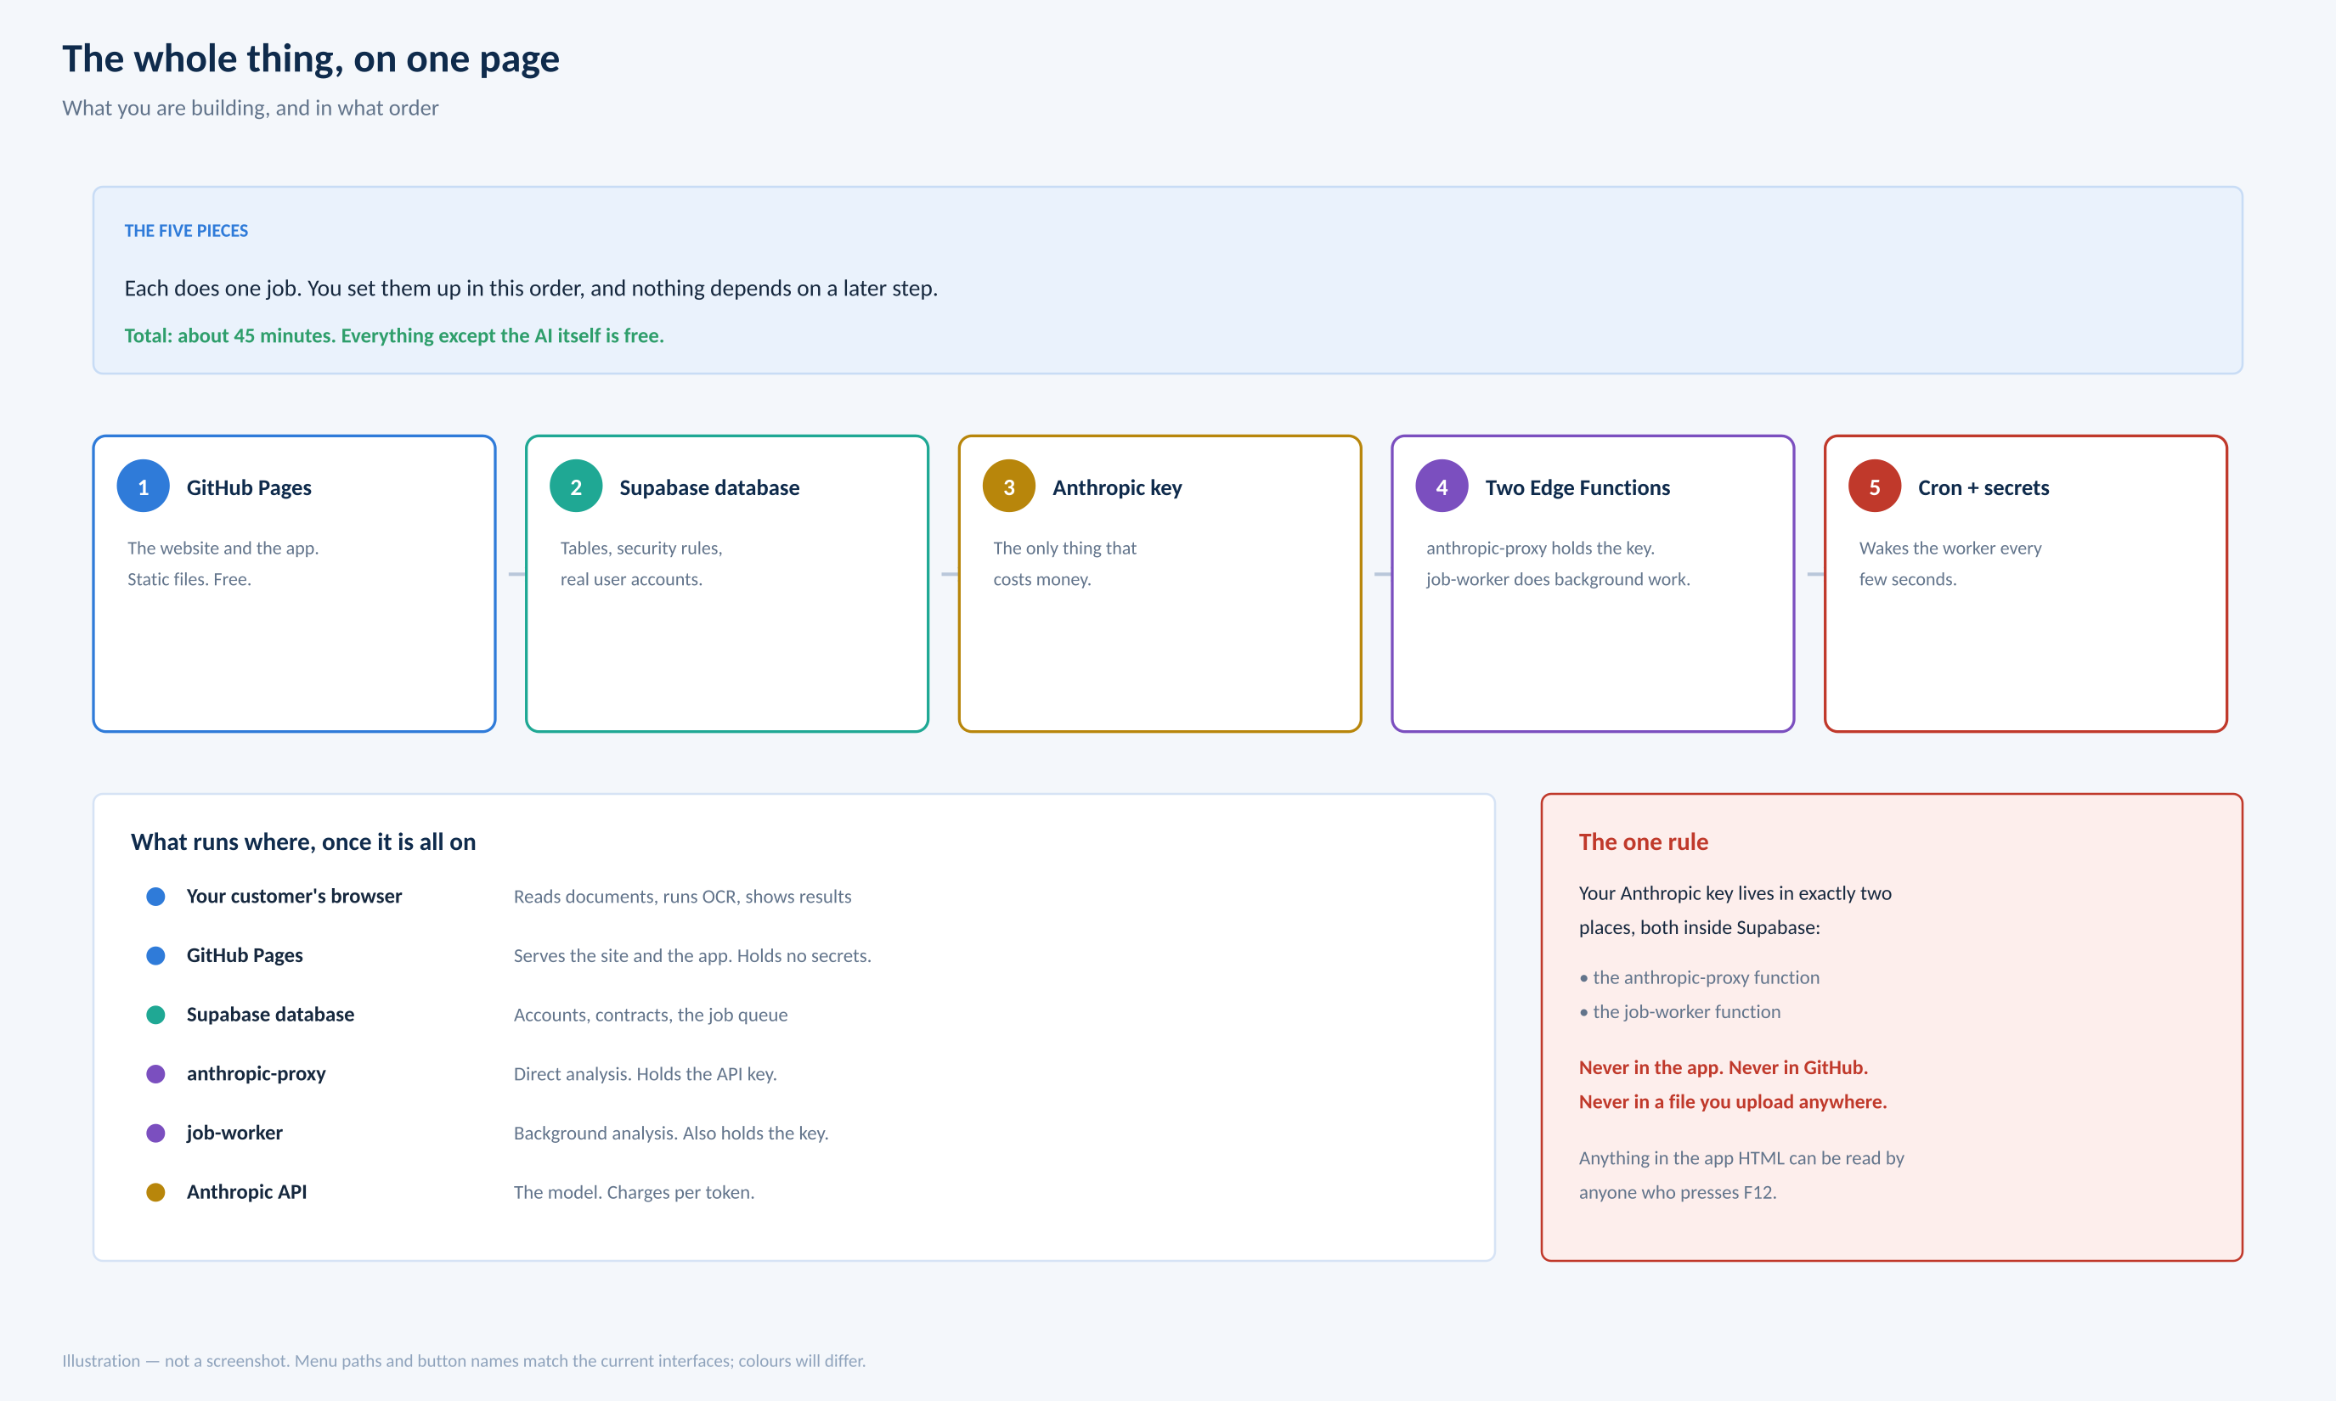

1. Step 1 — Create the database
- Go to supabase.com and sign in. Click New project.
- Give it a name, pick a region near you (London if you are UK-based), and set a database password. Save that password in your password manager — there is no recovery.
- Wait a minute or two while it builds.
- In the left sidebar click SQL Editor.
- Open contractiq_supabase_setup.sql, select all of it, copy, paste into the editor, and click Run.
How you know it worked
You get a success message rather than a red error. Click Table Editor in the sidebar and you should see contracts, documents, data_points, profiles, jobs and about a dozen others.
If it errors, nothing was created — Supabase runs the whole script as one transaction, so a failure undoes everything. Send me the error and I will look at it.

2. Step 2 — Get your Claude API key
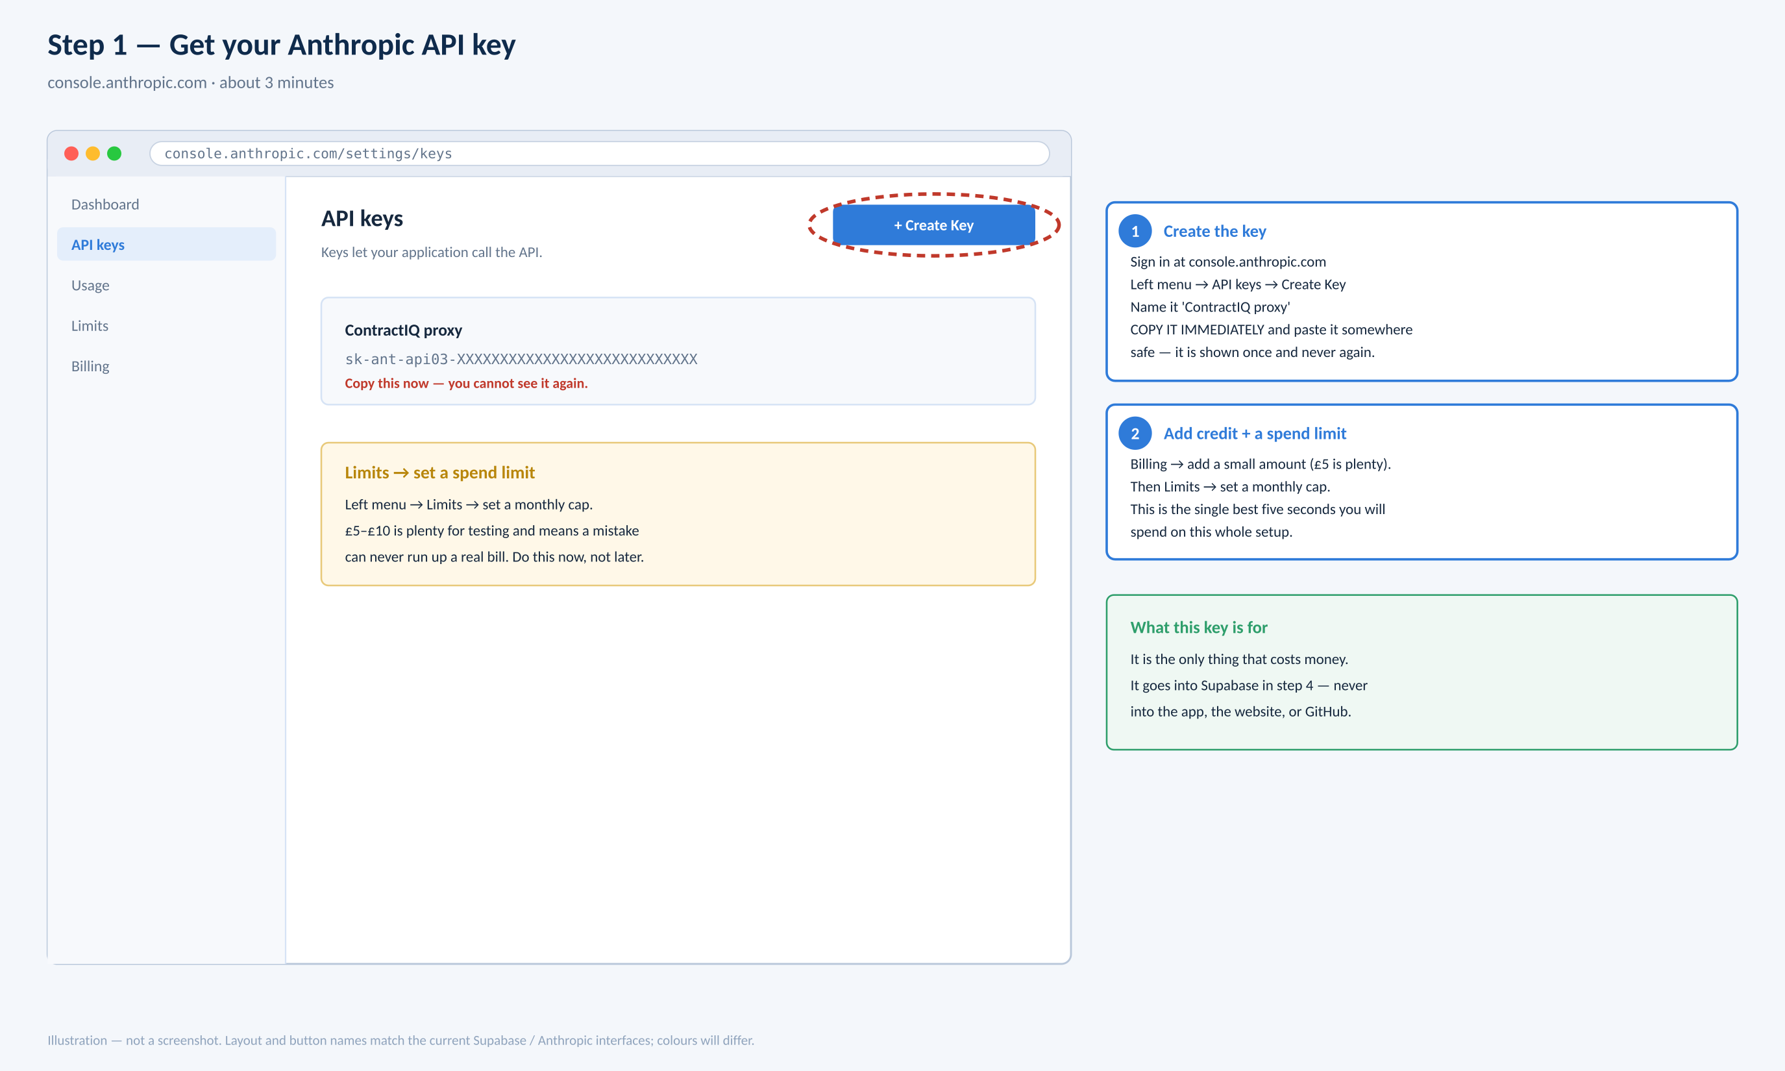
- Go to console.anthropic.com and sign in.
- In the left menu click API keys.
- Click Create Key. Name it 'ContractIQ'.
- Copy it straight away and paste it somewhere safe. It is shown once and never again. It starts sk-ant-
- Click Billing and check your $20 credit is showing.
- Click Limits and set a monthly spend cap of $20.
Do the spend limit before you go any further
It takes five seconds. With a cap set, the worst case is that analysis stops working — not that you get an unexpected bill. This is the single cheapest piece of insurance in the whole project.
That key is the only thing in this entire setup that costs money. Everything else is free.

3. Step 3 — Deploy the first function
This is the piece that lets the app talk to Claude. It exists so your API key never has to be in the app, where anyone could read it.
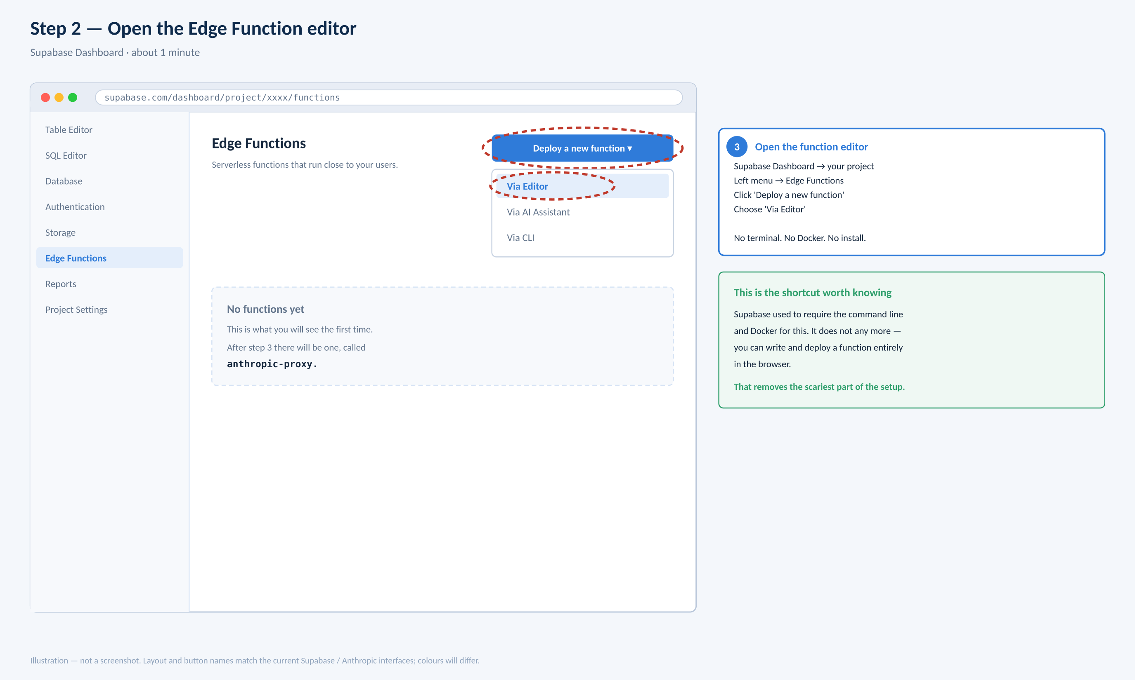
- Back in Supabase, click Edge Functions in the left sidebar.
- Click Deploy a new function.
- Choose Via Editor from the dropdown. A code editor opens in your browser.
- In the name box type exactly: anthropic-proxy
- Select all the example code that appeared and delete it.
- Open supabase_edge_function_anthropic_proxy.ts, select all, copy, and paste it in.
- Click Deploy function. It takes about twenty seconds.
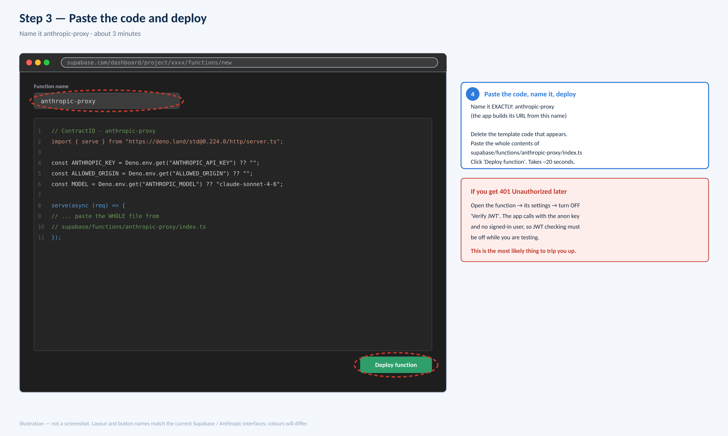
3.1 · One more click on this function
- Click into anthropic-proxy now that it exists.
- Find its settings or details panel and turn OFF 'Verify JWT'.
The app calls this function from the browser with nobody signed in, so that check has to be off or you will get 401 errors. It is a toggle, not a problem.
The name has to be exact
anthropic-proxy — all lower case, one hyphen, no spaces. The app works out the web address to call from your project URL plus that name, so anthropic_proxy or Anthropic-Proxy simply will not connect.

4. Step 4 — Deploy the second function
This one runs analysis in the background so a long run survives you closing the tab. Strictly optional — but it takes two minutes and you have already learnt the steps.
- Edge Functions → Deploy a new function → Via Editor.
- Name it exactly: job-worker
- Delete the example code, paste in supabase_edge_function_job_worker.ts, Deploy.
- LEAVE 'Verify JWT' ON for this one.
Why the opposite setting?
Different callers. anthropic-proxy is called by the browser, which has no signed-in user — so the check must be off. job-worker is called by your own database, which sends a proper key — so the check stays on. Getting these the wrong way round is the commonest mistake here.

5. Step 5 — Add your three secrets
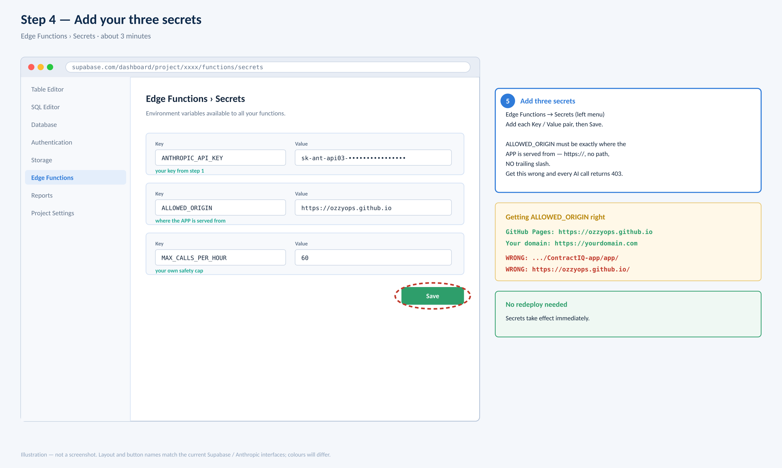
- In the left sidebar under Edge Functions, click Secrets.
- Add each of the three below as a Key and a Value.
- Click Save. They take effect immediately — no need to redeploy anything.

Key (type exactly) | Value | What it does
ANTHROPIC_API_KEY | your sk-ant-… key from step 2 | Lets the function call Claude. This is the only place this key should ever exist.
ALLOWED_ORIGIN | https://YOURNAME.github.io | Only your app may use the function. Without it, anyone who finds the address could spend your credit.
MAX_CALLS_PER_HOUR | 60 | A limit you set yourself, so nothing can run away.
ALLOWED_ORIGIN is where nearly everyone slips
It is the web address the APP is served from — the https:// part ONLY. No folder path. No slash on the end.
RIGHT: https://ozzyops.github.io
RIGHT: https://yourdomain.com
WRONG: https://ozzyops.github.io/ (slash on the end)
WRONG: https://ozzyops.github.io/repo/app/ (has a folder path)
Get it wrong and every analysis fails with a 403 error. If that happens, check this first.

6. Step 6 — Copy your project URL and key
Supabase changed this screen in 2026, so it may not match older guides.
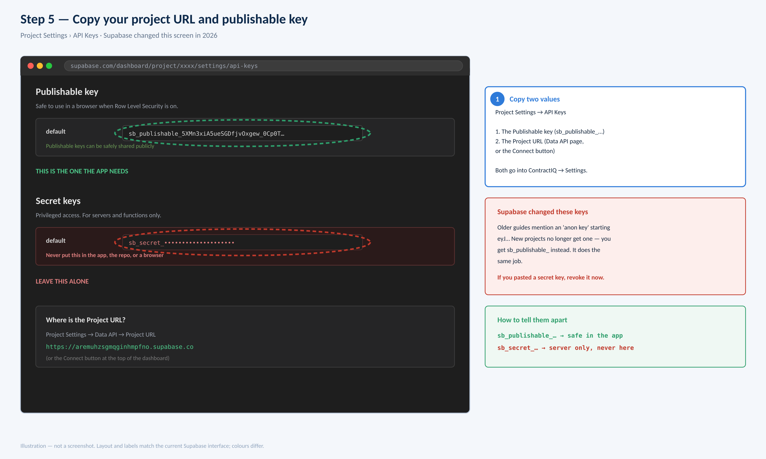
- Left sidebar → Project Settings → API Keys.
- Under Publishable key, copy the value. It starts sb_publishable_
- Now go to Project Settings → Data API and copy the Project URL. It looks like https://abcdefghijkl.supabase.co
(You can also get both from the Connect button at the top of the dashboard.)
There is a second key on that page. Do not touch it.
The Publishable key is designed to be public — it is limited by the security rules the SQL script installed, so it is safe in the app. The Secret key on the same page bypasses every one of those rules. It must never go in the app, the repository, a screenshot, or anywhere a browser can reach.
If you have already pasted or shared a secret key: click the ⋮ beside it and revoke it. Takes five seconds, and it invalidates the exposed one.
If a guide mentions an 'anon key' starting eyJ…
That was the old format. New Supabase projects no longer issue one — you get sb_publishable_ instead, and it does exactly the same job. Both work if you have an older project.

7. Step 7 — Connect the app
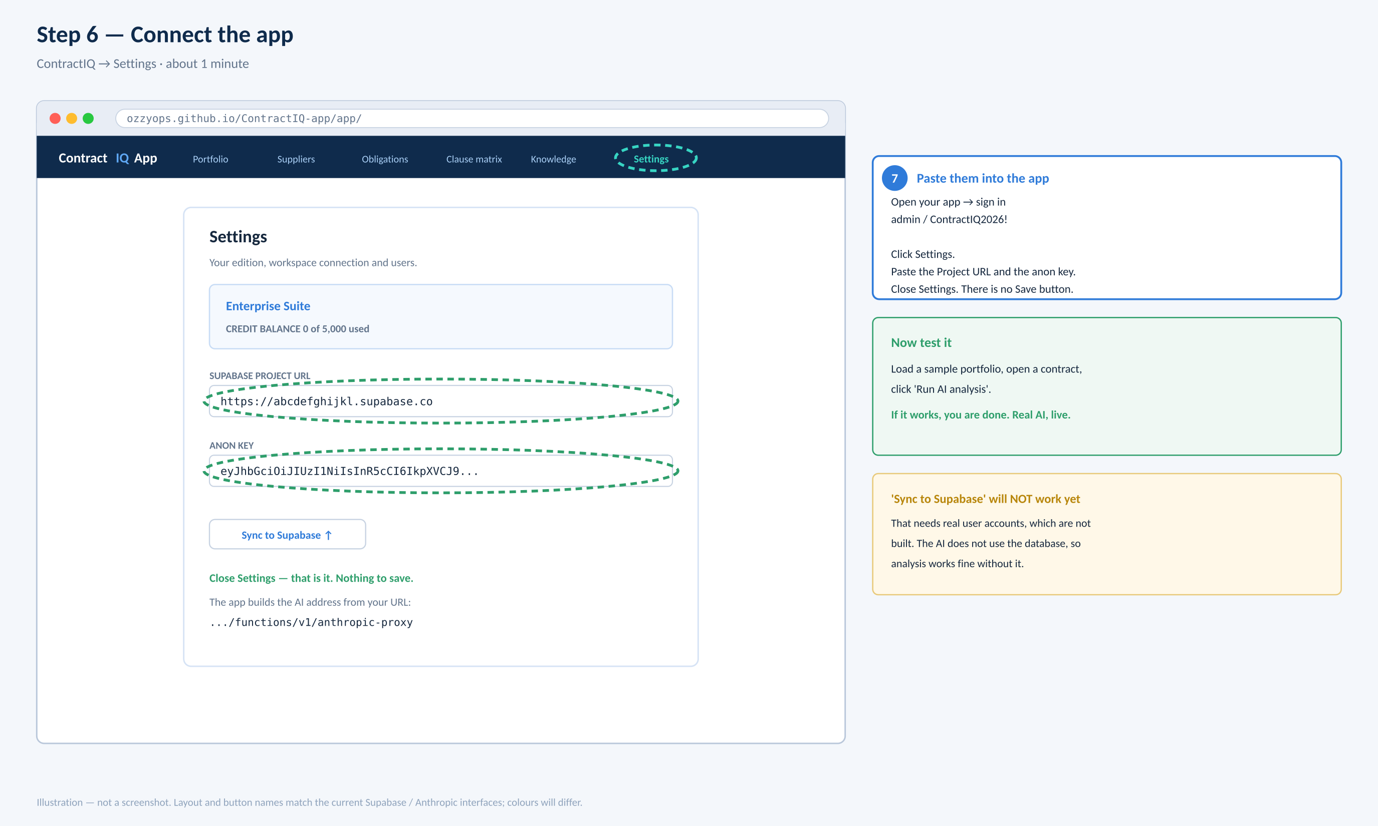
- Open your app: https://YOURNAME.github.io/YOURREPO/app/
- Sign in with admin / ContractIQ2026!
- Click the round avatar at the top right, then Settings.
- Paste the Project URL into the first box.
- Paste the Publishable key into the second box.
- Close Settings. There is no Save button — it applies as you type.
The app works out the AI address itself from your project URL. There is nothing else to configure.
The two greyed-out Sync buttons
Sync to Supabase and Load from Supabase are deliberately disabled. Saving contracts to the cloud needs real signed-in user accounts, which is a later piece of work. It has nothing to do with your keys, and it does not stop AI analysis — your work simply lives in the browser for now.
7.1 · Now test it
- On the main page click Load a sample portfolio.
- Click any contract to open it.
- Click Run AI analysis — it will be red, which means the documents are ready.
- Wait about twenty seconds.
If the tabs fill with analysis, you are finished
That is real Claude output, running through your own function, with your key safe on the server. That analysis cost you about five pence.

8. Optional — background processing
Skip this if you like. Without it analysis still works; it just runs in the browser tab and stops if you close it. With it, a forty-contract run finishes whether you are watching or not.
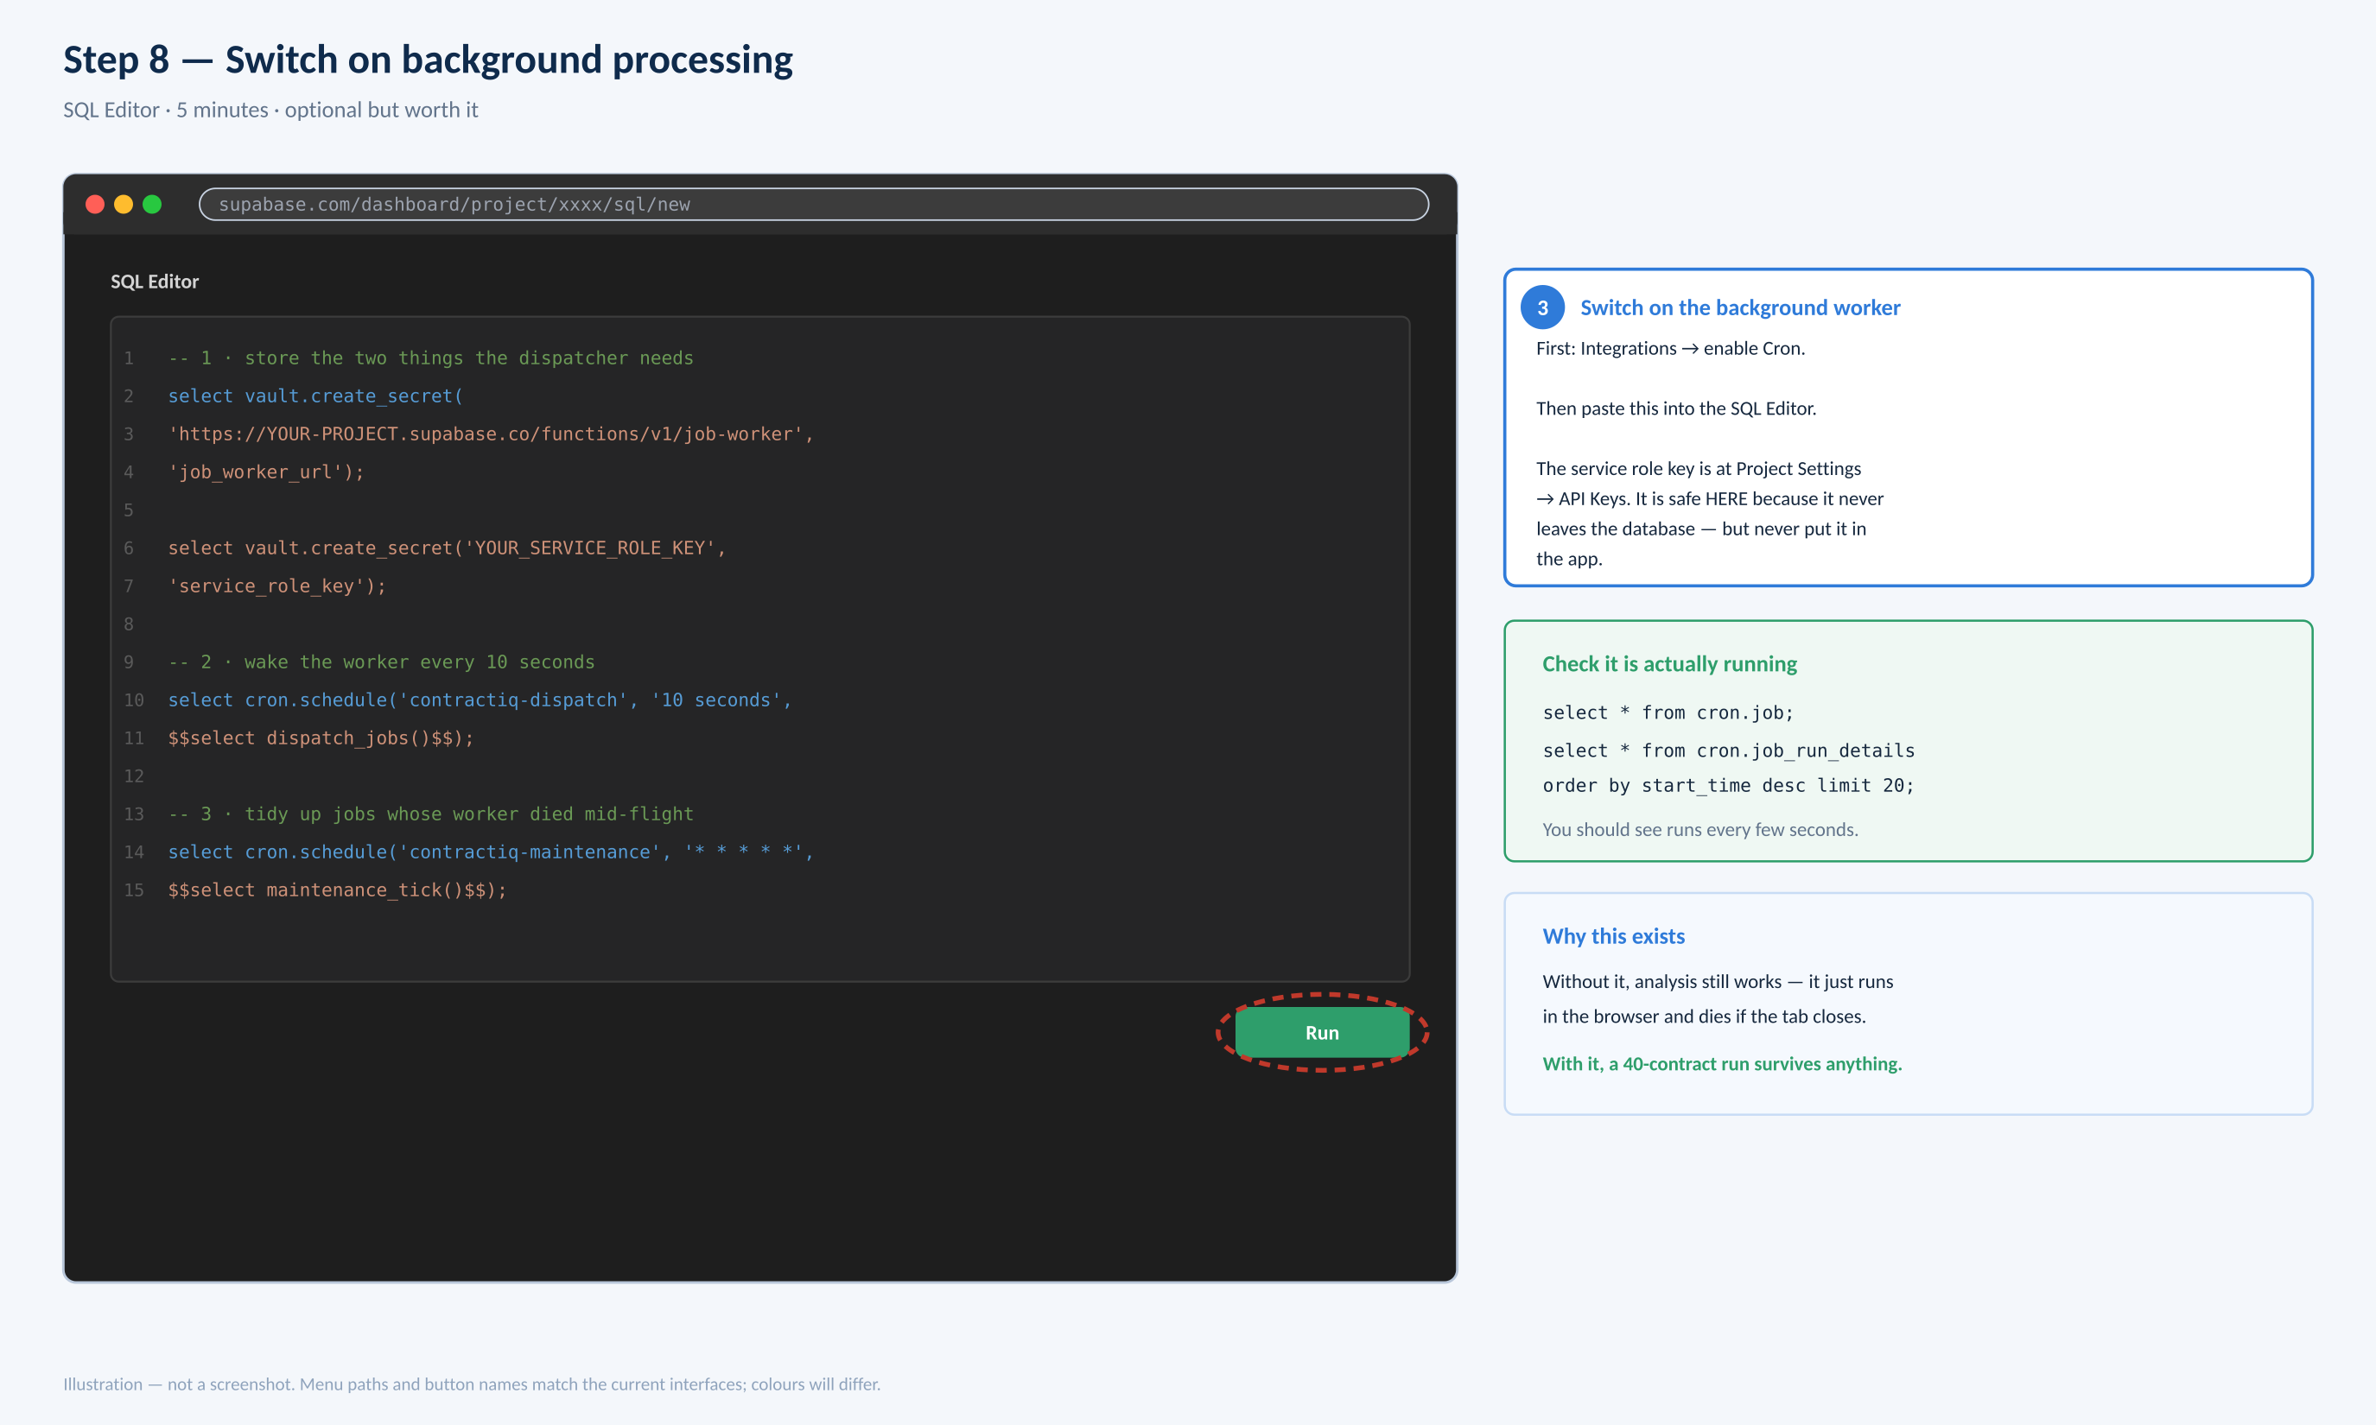
- Left sidebar → Integrations → find Cron and enable it.
- Project Settings → API Keys → copy the Secret key. It is safe here because it never leaves the database.
- SQL Editor → paste the four statements shown opposite, replacing YOUR-PROJECT and YOUR_SECRET_KEY → Run.
- Check it is ticking: select * from cron.job_run_details order by start_time desc limit 20;

If something does not work
The app tells you the actual problem rather than just failing. Match the message:

What you see | What it means | What to do
No AI endpoint configured | Settings are empty or the URL is wrong | Step 7. The URL must start https:// and end .supabase.co
AI endpoint rejected the request | 403 or 401 from Supabase | Two candidates: ALLOWED_ORIGIN does not exactly match your app's address (step 5), or Verify JWT is still on for anthropic-proxy (step 3.1)
Rate limit reached | Your own MAX_CALLS_PER_HOUR | Raise it in Secrets, or wait an hour
Analysis failed — 500 | The function cannot find your API key | Check ANTHROPIC_API_KEY is spelled exactly right in Secrets
Analysis failed — 529 | Anthropic is busy | Not yours to fix. Wait a minute and retry
Credit balance error | Out of Anthropic credit | Top up at console.anthropic.com
Nothing happens at all | You are on the /demo/ build | Use /app/ — /demo/ never calls a real AI by design
Where to look when the message is not enough
Supabase → Edge Functions → click anthropic-proxy → Logs. Every call is recorded, with its token count and roughly what it cost. If a call never appears there at all, the request is not reaching the function — which points at ALLOWED_ORIGIN or the function name.
What your $20 buys
 | Cost
One contract analysed | about £0.05
One question to Cedric | about £0.01
The whole 38-document stress pack | under £2
Hosting, database, functions | £0
Roughly 300 analyses. Far more than you need to answer the only question that matters: does it read your own contracts well?
Prices and screens were checked on 19 August 2026 and change without notice. ContractIQ is an automated screening aid, not legal advice.

