The Biot–Savart NLSQ
displacement method
Method description and user manual
TT-1 plasma column position — displacement workstream
methods_script/biot_savart
August 2026

Contents

1 What the method does
At each time sample the twelve magnetic probes report a tangential field B₁…B₁₂. A toroidal current filament displaced by (ΔR, ΔZ) from the vessel centre produces a predictable pattern across those twelve probes. The method searches over (ΔR, ΔZ) for the displacement whose predicted pattern best matches the measured one, in a weighted least-squares sense, and reports that displacement. The prediction uses the exact Biot–Savart field of a circular loop — no linearisation, no tabulation, no interpolation.
This is the same physical model the filament (Φ) method uses. The difference is purely in how the inverse problem is solved: Φ linearises the forward map, builds a lookup table of the inverse and reads the answer off it; this method solves the nonlinear problem numerically at every sample.
Scope. This is a reference implementation of the filament method with the linearisation removed. It is not a fourth independent measurement. Section 7 sets out exactly what it does and does not remove.

2 Flowcharts

2.1 Loading and setup
Configuration is validated before any data is touched, so a contradictory setting fails immediately with a message naming it. Geometry, the two forms of the forward model, the shot and the curation weights are then loaded, and four quantities are fixed for the whole shot: the probe column selection, the normalised weights, the residual scale, and the lattice of forward-model templates the grid search reuses at every sample.
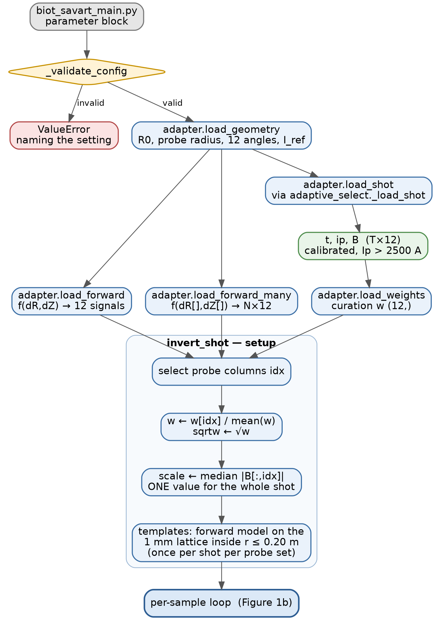
Figure 1a — Loading and setup, from the parameter block to the start of the per-sample loop.

2.2 The per-sample loop
Two early exits return NaN rather than a fitted value: the plasma-current gate, and a sample with a non-finite probe reading. Everything else goes through invert_sample. No state is carried between samples: each is solved independently of every other.
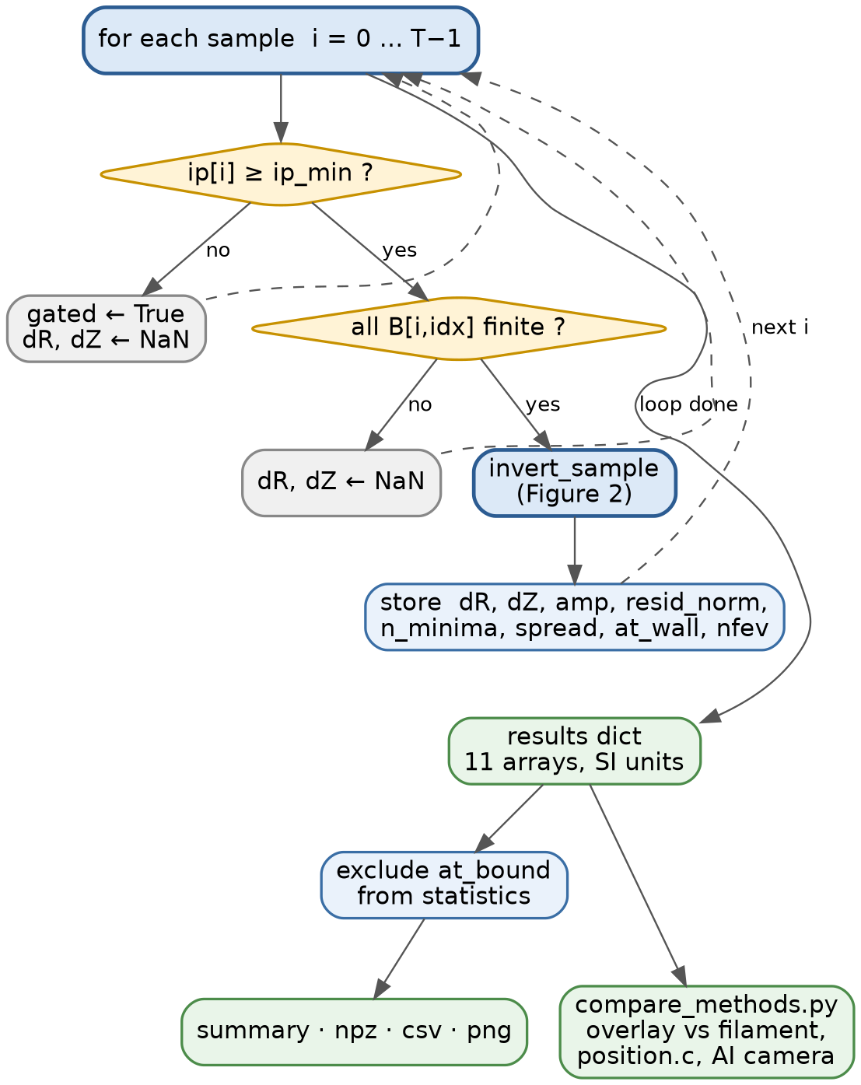
Figure 1b — The per-sample loop and the written outputs. Dashed edges are the loop-back path.

2.3 One sample: invert_sample
Every sample builds its own residual and Jacobian. The grid search evaluates that residual at every lattice point in one matrix-vector product, refines each local minimum of the resulting surface, and keeps the lowest; the phi search refines a single point, the filament method’s own answer. Either way the accepted solutions are clustered, so genuine non-uniqueness — more than one filament position reproducing the same signals — is reported rather than hidden.
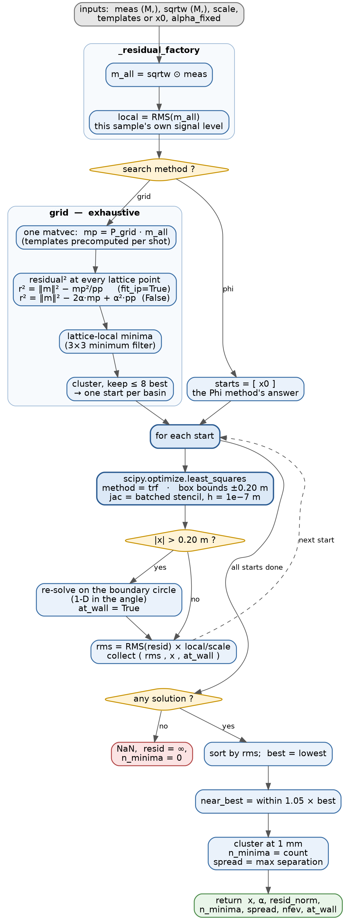
Figure 2 — Inversion of a single sample: exhaustive grid search or a single phi-seeded descent, refinement, and minima counting.

3 Algorithm
Notation: M probes selected, T samples, I_ref = parameters.I = 1e5 A.
ALGORITHM Biot-Savart NLSQ displacement

INPUT shot number; probe subset P; weight source; fit_ip; search
OUTPUT dR[t], dZ[t] in metres, plus per-sample diagnostics

-- Setup ------------------------------------------------------------
1 (R0, a_p, theta_1..theta_12, I_ref) <- parameters.py
2 (t, ip, B) <- adaptive_select._load_shot(shot) # T x 12, Ip>2500 A
3 w <- curation weights over P
4 w <- w / mean(w) # only ratios matter
5 sqrtw <- sqrt(w) # min sum(w r^2) => vector sqrt(w).r
6 scale <- median |B[:, P]| # one value, whole shot

7 if search = "grid": # once per shot per probe set
8 lattice <- {(dR,dZ) on a 1 mm grid, dR^2 + dZ^2 <= 0.20^2}
9 P_grid <- sqrtw * forward(lattice) # (Ngrid, M) templates
10 pp <- rowwise P_grid . P_grid

-- Per-sample loop --------------------------------------------------
11 for i = 0 .. T-1:
12 if ip_min set and |ip[i]| < ip_min: gated[i] <- true; continue
13 if any B[i,P] not finite: continue
14 m <- sqrtw . B[i,P]; local <- RMS(m)
15 a_fix <- none if fit_ip else ip[i]/I_ref

16 if search = "grid": # exhaustive, one matvec
17 mp <- P_grid . m
18 r2 <- |m|^2 - mp^2/pp if fit_ip
19 |m|^2 - 2*a_fix*mp + a_fix^2*pp otherwise
20 starts <- lattice-local minima of r2, clustered, best 8
21 else: # search = "phi"
22 starts <- [ the Phi method's answer for sample i ]

23 for each start s:
24 x <- least_squares(resid, s, jac=J, bounds +/-0.20)
25 if |x| > 0.20: x <- best point on the boundary circle;
at_wall <- true
26 collect ( RMS(resid(x)) * local/scale , x )

27 best <- lowest rms
28 near <- all collected with rms <= 1.05 * best rms
29 n_minima <- distinct points in `near`, merge tolerance 1 mm
30 record dR,dZ <- best.x; amp; resid_norm; n_minima; spread;
nfev; at_wall

-- Residual resid(x) -----------------------------------------------
31 p <- sqrtw . forward(x)
32 alpha <- a_fix if given else (m.p)/(p.p) # profiled amplitude
33 return (m - alpha*p) / local

-- Forward model forward(dR, dZ) -----------------------------------
34 probe positions: R_p = R0 + a_p*cos(theta), Z_p = a_p*sin(theta)
35 filament radius: a_f = R0 + dR , at height dZ
36 separation: zeta = Z_p - dZ
37 elliptic parameter m = 4*a_f*R_p / ((a_f+R_p)^2 + zeta^2)
38 B_r, B_z from K(m), E(m) # exact circular-loop field
39 return -B_r*sin(theta) + B_z*cos(theta) # tangential projection

4 The parts, one at a time

4.1 adapter.py — the boundary with the rest of the repository
Every dependency on parameters.py, signal_strength.py and adaptive_select.py is resolved in this one file, so an upstream API change breaks one place with one message rather than six.
Function | Returns | Notes
load_geometry() | Geometry(R0, probe_radius, angles, I_ref) | R0 = 0.65 m; probe_radius = 0.321 m (not position.c's 0.29 m, a different circle); angles from coil_angle_dict ordered 1…12; I_ref = 1e5 A
load_forward(kind) | f(ΔR, ΔZ) → (12,) | "internal" = field.py; "cal_signal" = the repository's own
load_forward_many() | f(ΔR[], ΔZ[]) → (N,12) | always field.py; cal_signal takes scalars only
load_shot(shot) | (t, ip, B) with B as T×12 | wraps _load_shot, which returns B as a dict and gates at Ip > 2500 A
load_weights(shot, src) | (12,) or None | wraps shot_weights; probes absent from the dict default to 1.0

Reading the shot through _load_shot is deliberate: this method inherits exactly the same calibration and vacuum-field subtraction as the Φ path. That makes the comparison between the two meaningful, and it is also the reason the comparison cannot say anything about the calibration itself.

4.2 field.py — the forward model
Probes sit on a circle of radius a_p = 0.321 m about (R₀, 0), at measured, unevenly spaced angles θᵢ, so probe i is at R_p = R₀ + a_p cos θᵢ and Z_p = a_p sin θᵢ. The filament is a circular loop of radius a_f = R₀ + ΔR at height ΔZ. The exact field of such a loop is the standard complete-elliptic-integral expression, evaluated at vertical separation ζ = Z_p − ΔZ. Projection onto the probe's circumferential axis gives −B_r sin θ + B_z cos θ.
Two implementation points matter:
- scipy.special.ellipk and ellipe take the parameter m = k², not the modulus k. Passing k yields a field that is wrong by a few percent and otherwise entirely plausible. Test T1 checks against the elementary on-axis closed form, which contains no elliptic integrals, precisely to catch this.
- The function is vectorised over displacement points. ΔR and ΔZ may be arrays; the return is (N, 12). This exists so the Jacobian's whole finite-difference stencil goes in one call.
field.py and cal_signal are two implementations of the same equations. Selftest stage 2 compares them over a grid; they currently agree to 2e-15, which fixes the conventions DZ_SIGN = −1 and TANGENTIAL_SIGN = +1.

4.3 invert.py — the solver

The residual
For one sample with measurement m and prediction p(ΔR, ΔZ):
r_i = sqrt(w_i) * ( m_i - alpha * p_i ) / local
Weights. Minimising Σ wᵢ rᵢ² means the residual vector handed to the solver is √wᵢ · rᵢ. Curation weights are inverse-variance and span four orders of magnitude, so they are rescaled to mean 1 first. Only their ratios ever affected the fit; the rescale exists so that resid_norm is comparable and so that the cold-restart trigger fires on genuinely bad fits rather than on every sample.
The amplitude α, and the fit_ip flag. cal_signal is evaluated at I_ref = 1e5 A, and adaptive_select._proxy normalises measured signals by ip/I_ref, so a filament at measured current ip should produce cal_signal(…) × ip/I_ref. fit_ip = True eliminates α analytically at every trial position, so only the ratios between probes enter the fit and α becomes an output. fit_ip = False fixes α = ip/I_ref, so the absolute level enters the fit. The flag carries the same meaning as mprobe.MProbeEstimator's fit_ip and is named for it. Degrees of freedom differ: with M probes, True leaves M − 3 and False leaves M − 2.
Comparison caveat. adaptive_select._estimator hardcodes fit_ip=False, so a |ΔR_BS − ΔR_Φ| comparison against the adaptive filament path is like-for-like only when fit_ip = False is set here too.
local. The residual is divided by this sample's own weighted RMS, not by the shot's. least_squares' ftol and gtol act on the residual's absolute size, so without this a low-signal sample — early or late in the discharge — would meet the convergence test sooner and be solved to a looser accuracy than a peak-current one. The reported resid_norm is converted back to the shot-wide scale afterwards, so it stays comparable across samples.

The Jacobian
Only two free parameters, so a finite-difference Jacobian is cheap — but the default jac="2-point" would make one forward call per column. Instead both perturbed points go through forward_many in a single batched call with step h = 1e−7 m. Verified against a much larger step (1e−5) with zero relative difference.

Finding the global minimum
The forward model at a lattice point does not depend on which sample is being solved — only the measurement does. So the model is evaluated once per shot on a 1 mm lattice covering the chamber, and the residual at every lattice point for a given sample is then one matrix-vector product. With the amplitude profiled out, minimising the residual is the same as maximising (m·p)²/(p·p), a normalised cross-correlation against each template.
Every lattice-local minimum of that surface is refined by a continuous least-squares solve, so the lattice decides which basins to examine and never limits the accuracy of the answer. Subject to it being fine enough to place a point in every basin, the result is the global minimum inside the chamber rather than whichever minimum a starting guess happened to reach. Refining the step and confirming the set of minima does not change is the way to test that.
The alternative, search = "phi", refines a single point: the filament method’s own answer. It has no fallback to the grid, because a poor fit from that start is the finding rather than something to retry away. Running both separates a Phi-versus-Biot-Savart gap into approximation error within one basin, and Phi having landed in a different basin altogether.
No state between samples. There is no warm start. Each sample is solved independently of every other, so no question of drift or start order arises.

The chamber
CHAMBER_RADIUS = 0.20 m, a disc rather than a box. The TT-1 limiter sits 0.20 m from the vessel centre, so a filament further out has no physical meaning; the probe circle at 0.321 m, where the field diverges, stays well clear. A solution on the boundary is flagged at_wall, meaning the best fit inside the chamber lies on the limiter radius — a statement about the shot, not about the solver. least_squares takes box bounds only, so a refinement that leaves the disc is re-solved on the boundary circle, where the constraint reduces to a single angle.

Counting minima
Solutions from all starts are sorted by residual. Those within 1.05× the best are clustered with a 1 mm tolerance; n_minima is the cluster count and spread_m the largest separation. n_minima > 1 means more than one filament position reproduces these signals, so the sample is ambiguous and no method can resolve it from these probes alone.
Limitation. This compares the starts against each other. If every start lands in the same wrong root, it reports one minimum. Selftest stage 3 works around this on synthetic data, where truth is known, by separating degeneracy (a different position fits equally well) from solver failure (the recovered fit is worse than truth).

5 User manual

5.1 Installation and first run
The package lives at methods_script/biot_savart/, a sibling of methods_script/toroidal_filament/. The root-level entry point biot_savart_main.py sits beside main.py. Shot data is read from data/<shot>/, the same location every other method uses.
Run the selftest at least once per checkout, before quoting any number:
python -m methods_script.biot_savart.selftest
Stage 2 is the gate. It compares field.py against cal_signal over a grid of displacements and reports whether they agree and which sign convention matches. If the adapter's expectations no longer match the repository, this is where it surfaces, with a message naming what was wanted and what was found.
The offline test battery needs neither the repository nor shot data:
python -m methods_script.biot_savart.tests
Then run a shot by whichever entry point suits:
python biot_savart_main.py # edit parameters in the file
python -m methods_script.biot_savart.cli 1641 # or pass them as flags
python compare_methods.py 1641 # overlay against other methods

5.2 Input parameters
The three entry points expose the same underlying settings under different names. The table below is the authoritative list; the two that follow give the name used by each of the other two entry points.

5.2.1 biot_savart_main.py — the parameter block
Parameter | Type / values | Default | What it does
shot_lst | list of int | [1641] | Shots to run. data/<shot>/ must exist. The commented line above it runs every numeric directory under data/.
use_probes | None or list of int (1-based) | None | Probes to fit; None uses all 12. Any subset of length ≥ 2 works and costs nothing but runtime — there is no per-set map to build. With 2 probes the fit has no degrees of freedom left, so the residual carries no information; use ≥ 4 for resid_norm to mean anything.
weights_source | "auto" | "last" | None | "auto" | Per-probe curation weights, from the same layer the filament method uses. "auto" takes this shot's own pre-plasma window; "last" inherits from the previously stored shot (what real time must use); None weights every probe equally. Weights are rescaled to mean 1 internally, so only their ratios matter.
fit_ip | bool | True | Same meaning as mprobe's fit_ip. True eliminates the overall amplitude analytically at every (ΔR, ΔZ), so only ratios between probes enter the fit and the recovered amplitude becomes an output that should equal ip/I_ref. False fixes the amplitude at ip/I_ref, so the absolute signal level enters the fit and a calibration error surfaces as a position error instead. With M probes, True leaves M − 3 degrees of freedom and False leaves M − 2 — on a 4-probe set that is 1 against 2. adaptive_select uses False.
search | "grid" | "grid" | Exhaustive 1 mm lattice over the chamber, every local minimum refined, lowest kept — the global minimum inside the 0.20 m limiter radius, subject to the lattice resolving every basin. The other method, "phi", descends from the filament method’s answer and is reached through compare_methods.py, which has that answer to seed it with.
ip_min | float [A] or None | None | Extra plasma-current gate, applied on top of the Ip > 2500 A gate already inside adaptive_select._load_shot. Gated samples return NaN and are marked gated, not fitted.
forward_model | "internal" | "cal_signal" | "internal" | "internal" is field.py, vectorised. "cal_signal" routes through the repository's scalar implementation; results are identical to ~1e-11 and it runs about 2.4× slower per call. Selftest stage 2 checks they agree.
compare_with_filament | bool | True | Overlay the adaptive Φ result and report |ΔR_BS − ΔR_Φ| per sample. Costs a full adaptive_selection() run per shot.
save_directory | path | result_plot/biot_savart | Where npz, csv and png outputs are written.
save_npz / save_csv / save_plot | bool | True | Which outputs to write. The npz holds every array in SI units; the csv converts to millimetres and appends the filament comparison columns when available.

Validation. The configuration is checked before any data is loaded. A value outside the permitted set, a non-boolean fit_ip, a probe number outside 1–12, a duplicate probe, or a probe list shorter than two entries all raise an error naming the setting and the offending value.

5.2.2 Command line — methods_script.biot_savart.cli
Flag | Equivalent parameter | Default
shot | shot_lst (one shot) | required
--probes N N N N | use_probes | all 12
--weights auto|last|none | weights_source | auto
--fit-ip / --no-fit-ip | fit_ip | --fit-ip
--search grid | search | grid
--ip-min FLOAT | ip_min | none
--forward internal|cal_signal | forward_model | internal
--data-dir PATH | — | data
--csv | save_csv | off
--quiet | — | off

The CLI writes to bs_results/ rather than result_plot/biot_savart/, and does not produce plots or the filament comparison.

5.2.3 compare_methods.py — the BS_ block
Setting | Equivalent parameter | Default
BS_PROBES | use_probes | None
BS_WEIGHTS | weights_source | "auto"
BS_FIT_IP | fit_ip | True
BS_SEARCH | search | "grid"
BS_PLOT_PHI_START | adds a second, phi-seeded curve | False
BS_FORWARD | forward_model | "internal"
BS_HIDE_AT_BOUND | — (display only) | True

BS_HIDE_AT_BOUND blanks bound-pinned samples to NaN before plotting, so a failure to fit does not appear as a plotted position. Set it False only to inspect where the solver ran out of room.

5.3 Constants not exposed in the parameter block
These have single settled values and live at their source of truth in methods_script/biot_savart/invert.py, following the same convention main.py uses for the curation thresholds and the Φ grid.
Constant | Value | Meaning
CHAMBER_RADIUS | 0.20 m | Search domain, a disc at the TT-1 limiter radius. A filament further out has no physical meaning.
GRID_STEP | 0.001 m | Lattice step for the grid search. Set for confidence rather than speed: refine it and the set of minima found should not change.
_MAX_BASINS | 8 | Most basins refined per sample, lowest grid residual first.
_MINIMA_TOL_M | 1e-3 m | Two minima closer than this count as the same minimum.
_JAC_STEP | 1e-7 m | Finite-difference step for the Jacobian.

6 Output fields

6.0 Two quantities called “noise”
Two unrelated things could each be called noise, and the distinction matters when reading any figure in this document.
Fit residual — the mismatch between the measured probe signals and the signals the model predicts at the fitted position. It is what resid_norm reports, it exists on every real shot, and it contains everything the model does not capture: instrument noise, calibration error, eddy currents, and the failure of a single filament to describe a real current profile. It is not a noise level and cannot be converted into one.
Injected noise — a gaussian perturbation added deliberately to SYNTHETIC probe signals in the tests, as a fraction of the median |B|. It exists only inside tests.py and selftest.py stage 1, never on real data, and its purpose is to measure how far the solver's answer moves for a known perturbation. §8.3 is a table of injected noise.
Do not mix them. Quoting an injected-noise figure as though it described a real shot, and reading resid_norm as a noise level, are both mistakes.

6.1 The fields
All values are SI. Millimetres appear only in printed summaries, the CSV and the plots.
Field | Meaning
dR_m, dZ_m | Displacement, metres.
amp | Fitted overall amplitude. With fit_ip = True it should equal ip/I_ref; a departure points at the calibration or the Ip channel, not at the positions.
resid_norm | Weighted RMS fit residual divided by the shot's median |B|. Dimensionless and comparable across samples and shots. A model-versus-measurement mismatch, not a noise level.
at_wall | The best fit inside the chamber lies on the 0.20 m limiter radius. A statement about the shot, not a solver failure.
n_minima | Distinct minima found. From the grid search this is a property of the residual surface, so greater than 1 genuinely means more than one position reproduces the signals. From the phi search it is always 1 and says nothing.
spread_m | Separation between those minima, metres.
gated | Excluded by the Ip gate. Not a failed fit.
nfev | Function evaluations spent on the sample, for cost accounting.

Nothing is dropped for fitting badly. A bad fit is reported with a large resid_norm. Acceptance thresholds belong to the caller, not to the estimator.

6.2 Reading a run
A healthy run has a low, flat fit residual through the current flat-top, zero or few at_wall samples, zero ambiguous samples, and an amplitude ratio close to 1.000 with a small interquartile range. Wall-pinned samples clustering at the start and end of a discharge are expected: the plasma is forming or disrupting there and the single-filament model is weakest.

7 What the method does and does not remove
Removed — four sources of approximation error, all internal to the pipeline:
- the cylindrical R₀ → ∞ linearisation to (ΔU, ΔV)
- the third-order polynomial mapping the proxy back to (ΔR, ΔZ)
- Φ tabulation on a 0.5 mm grid, bicubic interpolation, and the shift_domain limit that comes with it
Not removed, because Φ removed it already. The paper's Eq. 6 retrieves its polynomial coefficients using tₙ₋₁'s answer, so error propagates from sample to sample — the paper says so explicitly, calling a simultaneous fit at tₙ computationally infeasible. The 2D Φ map replaced that with a joint inversion of (u, v) → (ΔR, ΔZ), which is exactly the simultaneous fit Eq. 6 avoided, made feasible by tabulating it. mprobe.shift() is therefore already stateless. This method is stateless too, by per-sample optimisation rather than by tabulation. The two are equal on this point; only the legacy 1D path (coefficient.py / plasma_shift.py) still carries Eq. 6's structure.
Shared, and therefore invisible to this method:
- the probe calibration k_t, k_oh, k_v and the vacuum-field subtraction
- the single-filament ansatz itself — no current-density profile
- eddy currents and localised field perturbations
- probe positions, orientations, and the curation weights
So agreement with the filament method means the linearisation is not the problem. It cannot vouch for anything the two share.
One asymmetry runs the other way. The Φ path projects the measurement onto two or three linear combinations, which discards most per-probe error; this method compares all twelve absolute field levels and sees it. A probe that disagrees with the model is therefore visible here and largely invisible in Φ. On shot 1641 probes 11 and 12 read the opposite sign to the model — a real discrepancy, of undetermined cause, which the curation weights already suppress by two to three orders of magnitude.

8 Verification

8.1 selftest.py — run once per checkout
- Synthetic recovery: prescribe (ΔR, ΔZ), generate synthetic signals, add injected noise, invert, measure the error. Runs without the repository.
- Convention check: compare field.py against cal_signal over a grid and report which sign convention matches and whether they agree at all. This is the gate.
- Fold probe: invert noise-free synthetic signals from a grid of true positions, per probe set, and report where a different position fits equally well.

8.2 tests.py — 17 checks, no repository or shot data needed
T1–T3 are the only ones that can catch an error in the field formula itself, because everything after them generates and inverts with the same code.
Test | What it checks
T1 | On-axis field against the elementary closed form (agreement 1.8e-14) and the far field against a dipole. External reference.
T2 | ∇·B = 0 and ∇×B = 0 off the wire, by central differences. External constraint.
T3 | Mirror symmetry about the loop plane: B_z even in z, B_r odd.
T4 | Recovery error against injected noise on synthetic signals — the table below.
T5 | Invariance of the fit to overall signal scaling; the amplitude scales exactly.
T6 | Trajectory tracking: the grid search against a descent seeded from the true trajectory, across a fast excursion.
T7 | Behaviour on dead probes, NaNs, the Ip gate and probe subsets.

8.3 Injected-noise budget
Synthetic signals only. Every row below is measured on signals generated by field.py at a known (ΔR, ΔZ) and then perturbed by a gaussian of the stated size. No shot data is involved. Because the generator and the inverter share the same forward model, this measures how far the solver's answer moves for a given perturbation — the solver's sensitivity — and nothing else. It is not an accuracy figure for a real discharge, where calibration error, eddy currents and the single-filament approximation all contribute and none of them resembles gaussian noise.
Twelve probes, cold start, true positions out to 0.14 m.
Injected noise | Median error | p95 | Max
0.1 % | 0.07 mm | 0.18 mm | 0.20 mm
0.3 % | 0.33 mm | 0.57 mm | 0.82 mm
1 % | 0.78 mm | 2.02 mm | 2.18 mm
3 % | 3.09 mm | 6.70 mm | 9.87 mm
10 % | 7.48 mm | 25.56 mm | 35.15 mm

Roughly 0.8 mm of displacement error per 1 % of injected noise, at the median.

9 Troubleshooting
Symptom | Likely cause and what to do
ImportError on parameters.py or adaptive_select | Not running from the repository root. All three entry points expect the repo root as the working directory.
Selftest stage 2 reports a shape disagreement | field.py and cal_signal disagree by more than a constant factor, so one has a geometry error. Check probe angle ordering and probe_radius first. Do not quote any number until this passes.
Selftest stage 2 names a different sign convention | Update DZ_SIGN or TANGENTIAL_SIGN at the top of field.py to the reported values.
Many samples flagged at_wall | The best fit lies on the limiter radius, usually at low plasma current where the filament model is weakest. These are real fits, not solver failures. If they are spread through the flat-top rather than clustered at the start and end of the discharge, the shot or the probe subset is the problem.
Amplitude ratio far from 1.000 | In profiled mode the fitted amplitude should equal ip/I_ref. A systematic departure indicates a calibration or Ip-channel problem upstream, not a position error.
Runtime much longer than a few tens of ms per sample | The grid search costs one matvec plus one refinement per basin found. Many basins per sample means a flat or multi-valued residual surface — inspect n_minima.
A 4-probe subset produces mostly at_wall samples | Four probes with fit_ip = True leaves only one degree of freedom. Use all 12, or set fit_ip = False to recover one.

10 File map
Path | Role
biot_savart_main.py | Root entry point; parameters edited in the file, matching main.py's convention.
methods_script/biot_savart/adapter.py | The only module that reads the rest of the repository.
methods_script/biot_savart/field.py | Biot–Savart field, vectorised over displacement points.
methods_script/biot_savart/invert.py | The solver: templates on the chamber lattice, exhaustive grid search, weighted NLSQ refinement, profiled amplitude, minima and wall detection.
methods_script/biot_savart/cli.py | Flag-driven runner.
methods_script/biot_savart/selftest.py | Convention check against cal_signal, synthetic recovery, fold probe.
methods_script/biot_savart/tests.py | 17-check battery; needs neither repository nor shot data.
methods_script/biot_savart/README.md | Interpretation, current results and open questions.
compare_methods.py | Overlay against filament, position.c and the AI camera.

