**Name: Kipyegon Peter Langat**

**Reg no: N11/3/0064/020**

**Institution: Laikipia University**

**QUESTIONS**

**Language: Python**

**Question 1: FizzBuzz**

Write a program that prints the numbers from 1 to 100. For multiples of 3, print "Fizz"; for

multiples of 5, print "Buzz"; and for numbers that are multiples of both 3 and 5, print

"FizzBuzz".

**Program:**

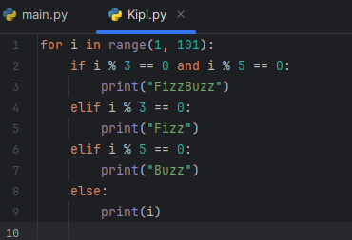

**Output:**

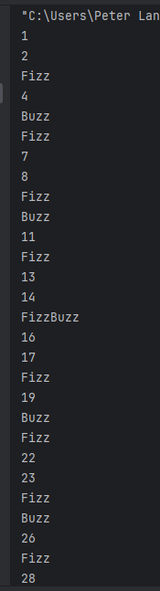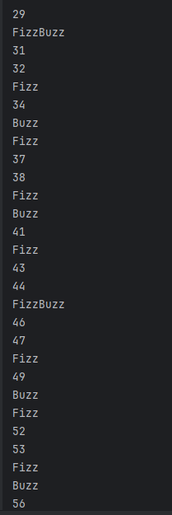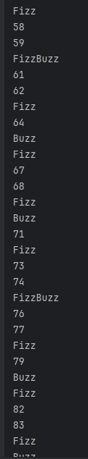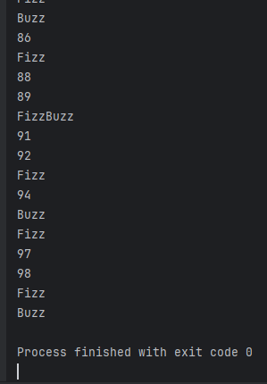

**Question 2: Fibonacci Sequence**

Write a program to generate the Fibonacci sequence up to 100.

Program:

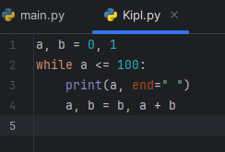

Output:

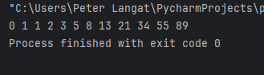

**Question 3: Power of Two**

Write a program that takes an integer as input and returns true if the input is a power of two.

Examples:

8=> returns true

6=> returns false

Program:

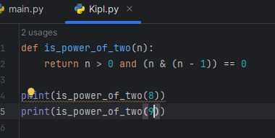

Output:

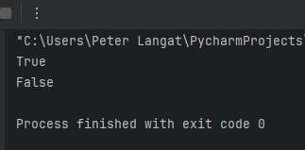

**Question 4: Capitalize Words**

Write a program that accepts a string as input, capitalizes the first letter of each word in the

string, and then returns the result string.

Examples:

"hi"=> returns "Hi"

"i love programming"=> returns "I Love Programming"

Program:

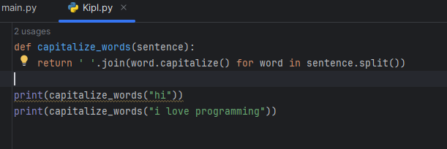

Output:

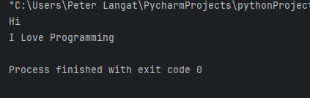

**Question 5: Reverse Integer**

Write a program that takes an integer as input and returns an integer with reversed digit

ordering.

Examples:

For input 500, the program should return 5.

For input -56, the program should return -65.

For input -90, the program should return -9.

For input 91, the program should return19

Program:

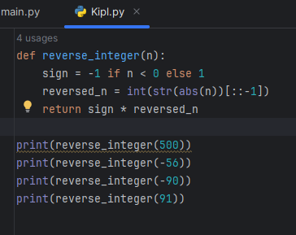

Output:

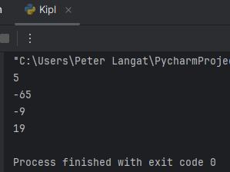

**Question 6: Count Vowels**

Write a program that counts the number of vowels in a sentence.

eg " Hello World " => returns 2

Program:

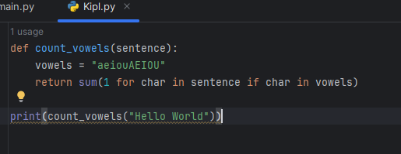

Output:

