Deep Learning Model for Detecting COVID‑19 on Chest X-Ray Using Convolutional Neural Networks

In this project we are using Convolution Neural Networks (CNN) deep learning algorithm to detect COVID-19 disease from chest x-ray. To implement this project we have trained CNN with more than 500 COVID and NORMAL chest X-Ray images. We have used below dataset to trained CNN model

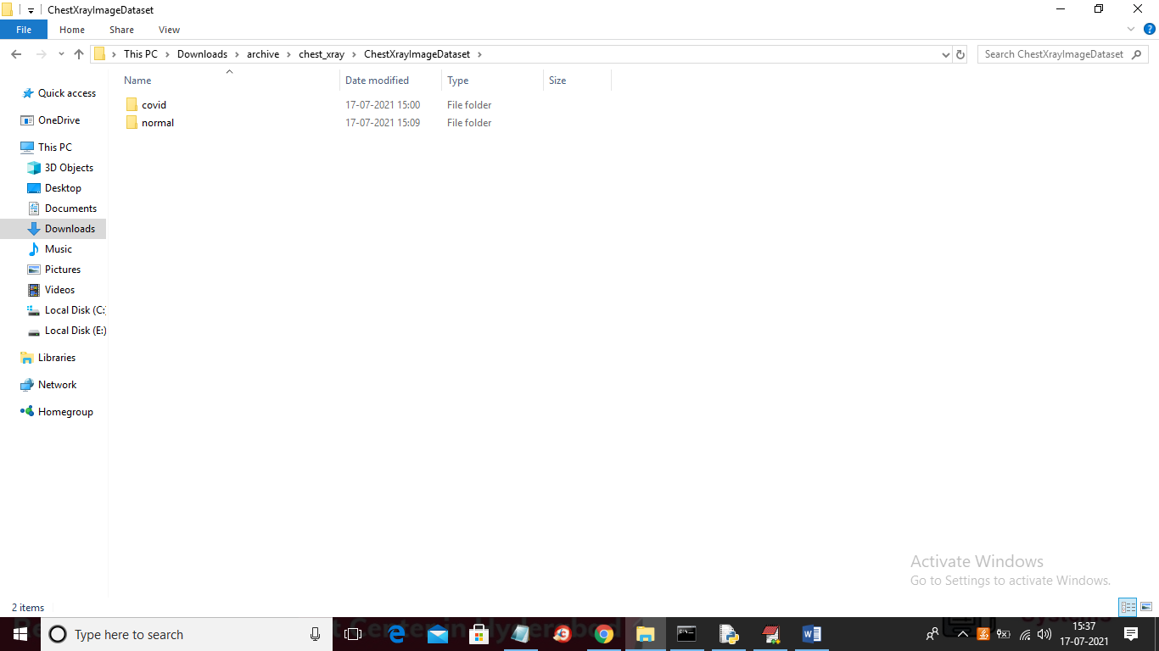

In above screen we have two folders where one folder contains COVID X-Ray images and other folder contains normal images and just go inside any folder to see images like below screen

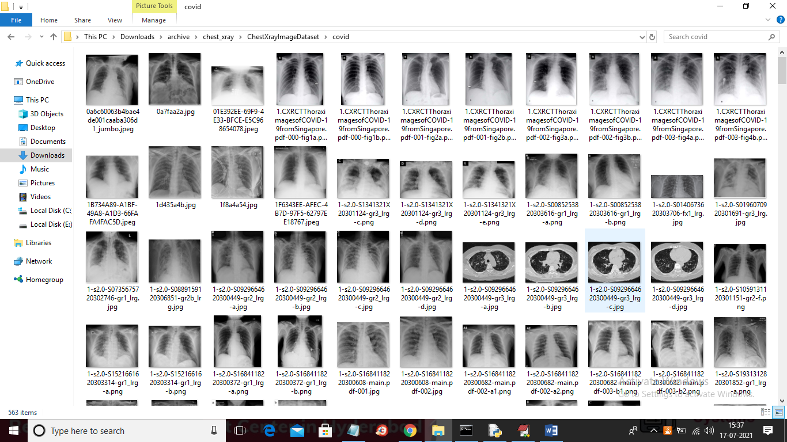

To implement this project we have designed following modules

1. Upload Covid-19 Chest X-ray Dataset: using this module we will upload chest X-Ray dataset images to application
2. Preprocess Dataset: This module will read all images and then resize all images to CNN compatible size and then normalize all images with 0 and 1 by diving all images pixels with 256. As we know all images will have pixel colour values between 0-255 so dividing pixel with 256 will give value between 0 and 1. This normalize values helps us in building CNN model with better accuracy. After preprocessing dataset will be ready for training with CNN
3. Build CNN Covid-19 Detection Model: This module will take dataset processed images and then start training with CNN and to train CNN we took 10 EPOCH.
4. Upload Test Data & Predict Disease: using this module we will upload test chest X-Ray image and then CNN will predict whether X-Ray is NORMAL or contains COVID-19 disease
5. Accuracy Comparison Graph: using this module we will plot CNN accuracy and loss values graph

Below screen shots showing CNN code with comments which explain how CNN is created to train on Chest X-Ray images

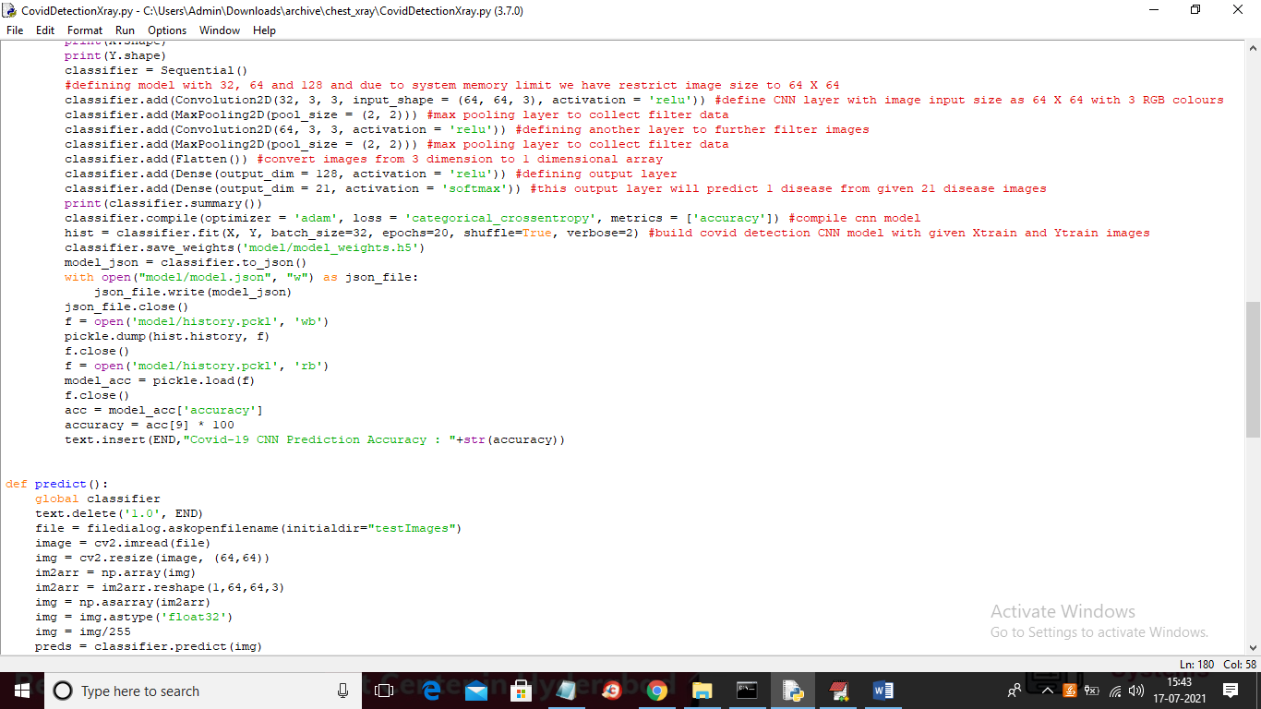

In above screen read red colour comments to know about CNN training and implementation.

SCREEN SHOTS

To run code double click on ‘run.bat’ file to get below screen

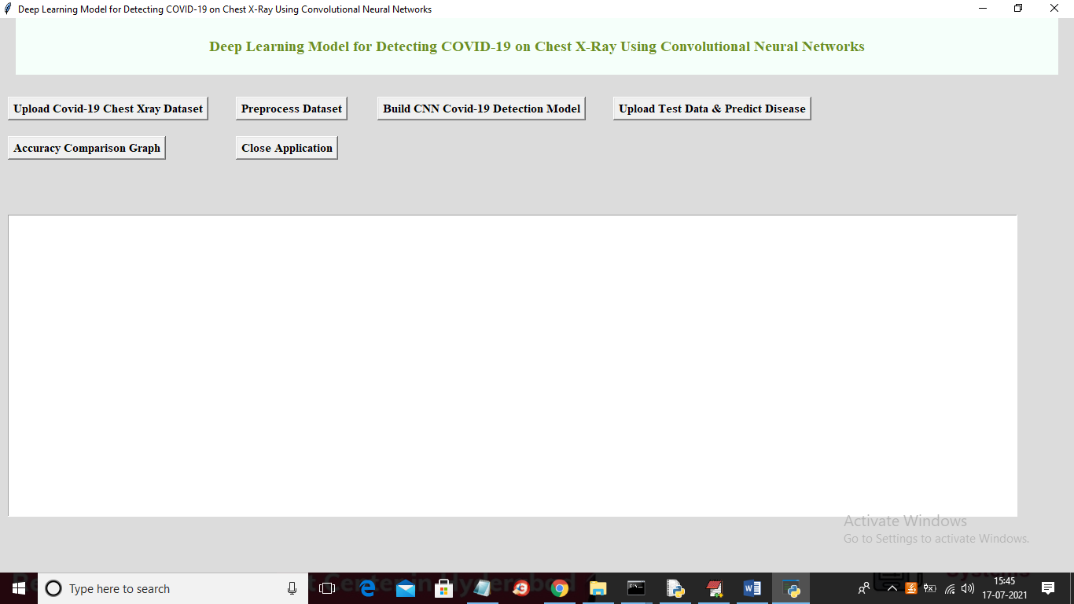

In above screen click on ‘Upload Covid-19 Chest Xray Dataset’ button to upload dataset

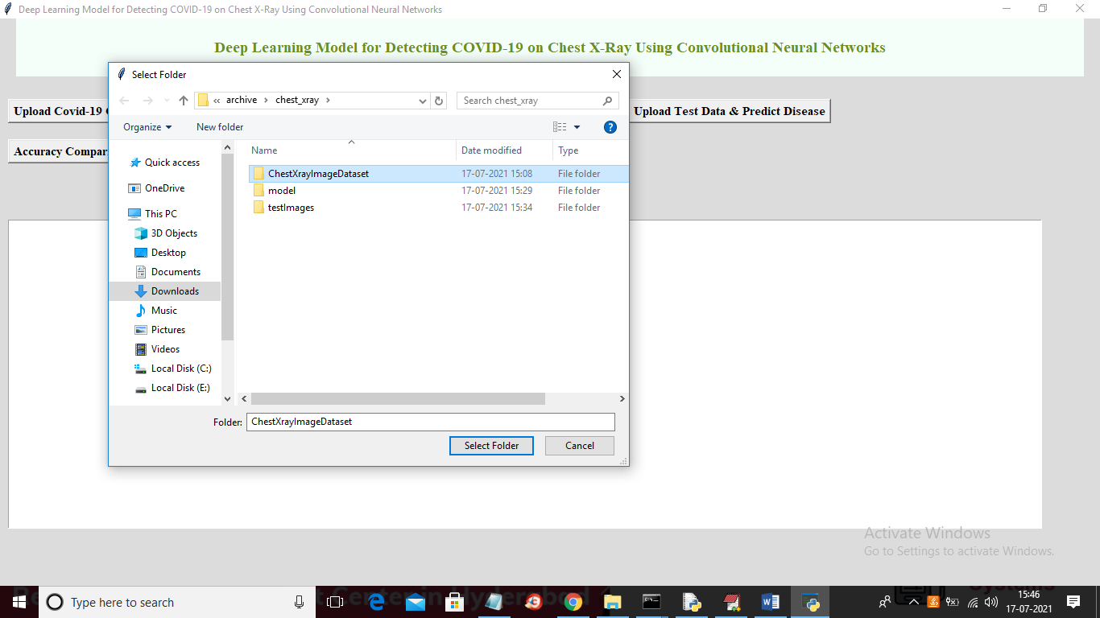

In above screen selecting and uploading entire ‘ChestXrayImageDataset’ folder and then click on ‘Select Folder’ button to load dataset and to get below screen

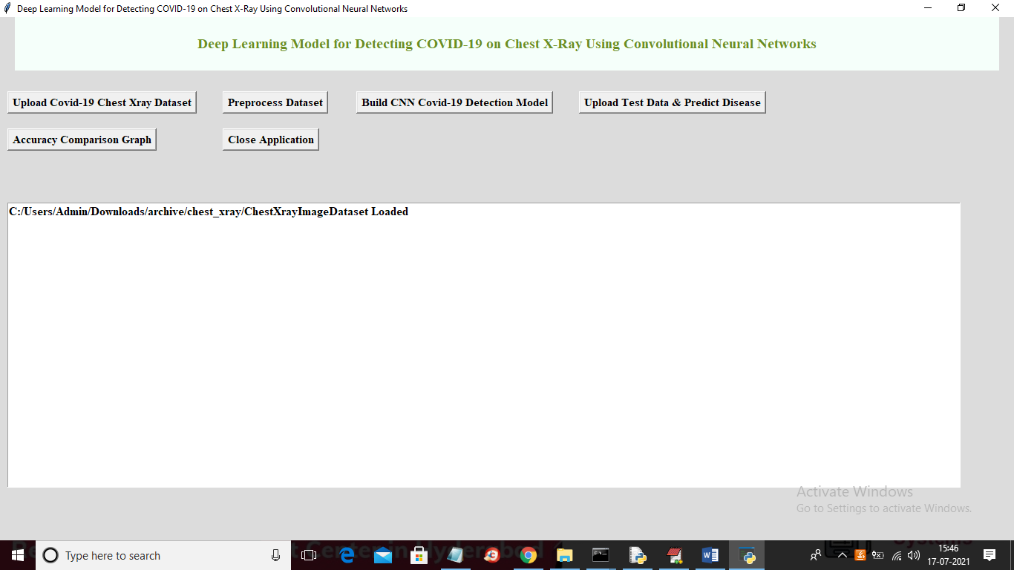

In above screen dataset loaded and now click on ‘Preprocess Dataset’ button to read and process images

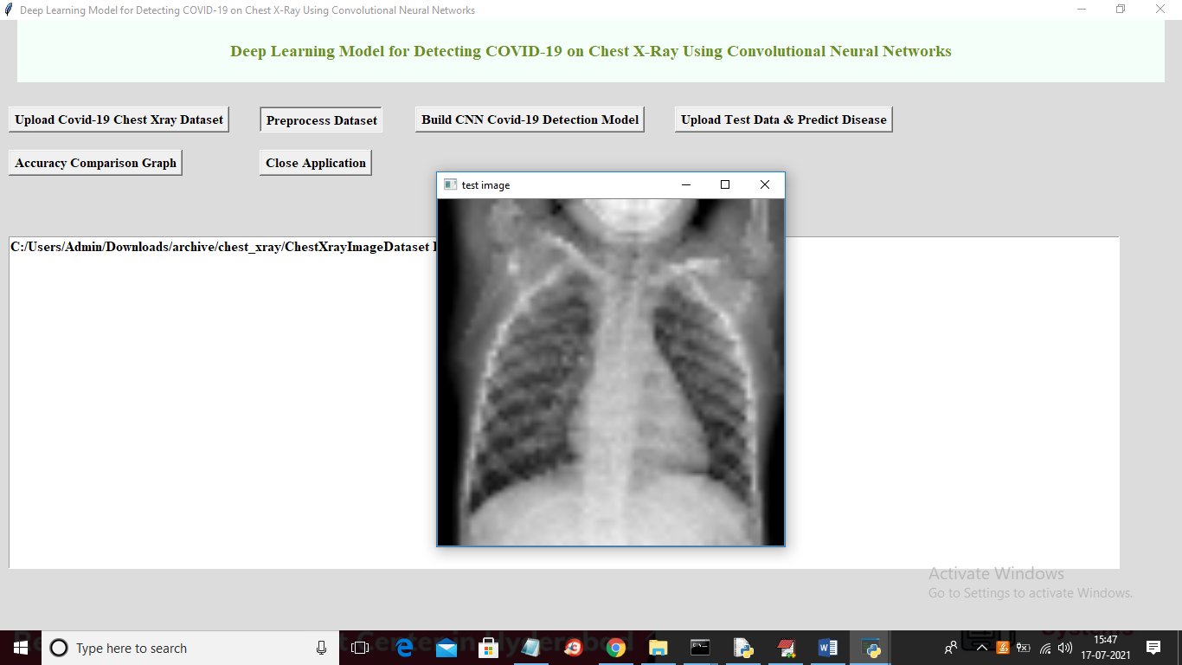

In above screen after preprocessing I am displaying one image to check whether image are loaded properly or not and now close above image to get below screen

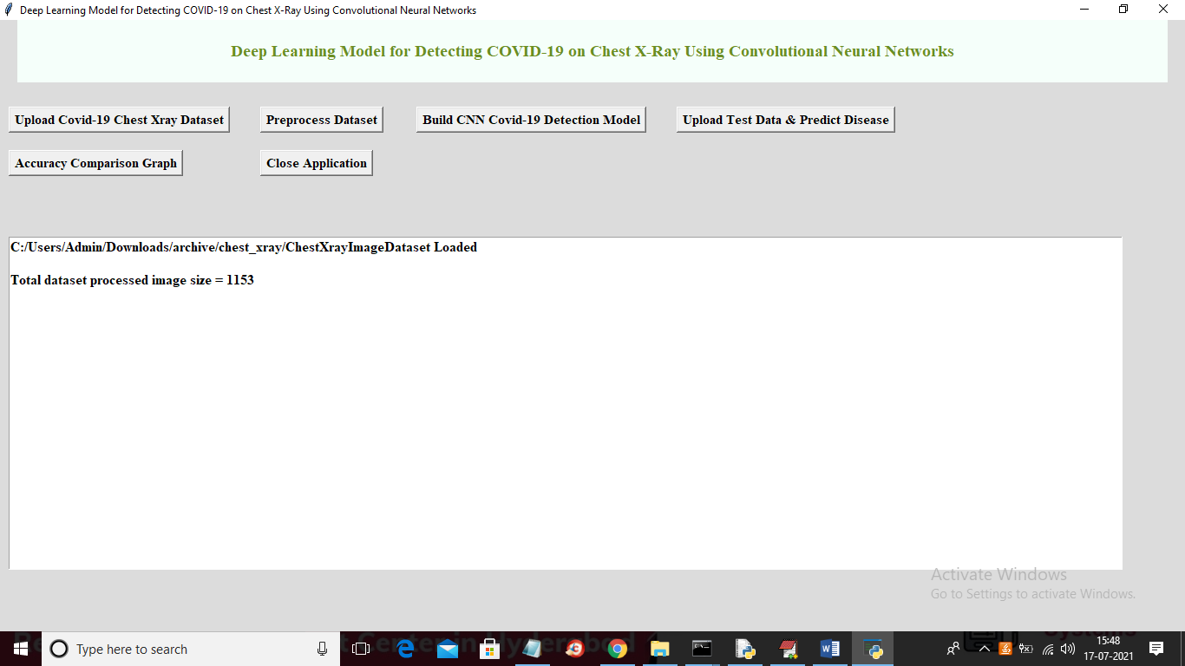

In above screen application found total 1153 images and all images are processed and loaded for training and now dataset is ready for training and now click on ‘Build CNN Covid-19 Detection Model’ button to start training CNN with above dataset and to get below screen

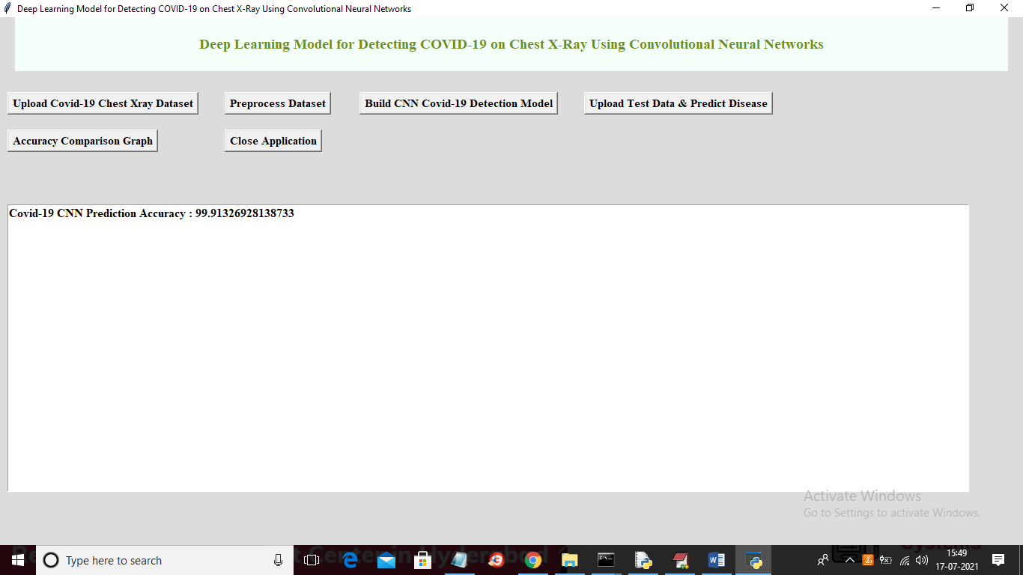

In above screen CNN model is trained and we got its accuracy as 99.91% and now CNN model is ready and now click on ‘Upload Test Data & Predict Disease’ button to upload test image and then predict disease

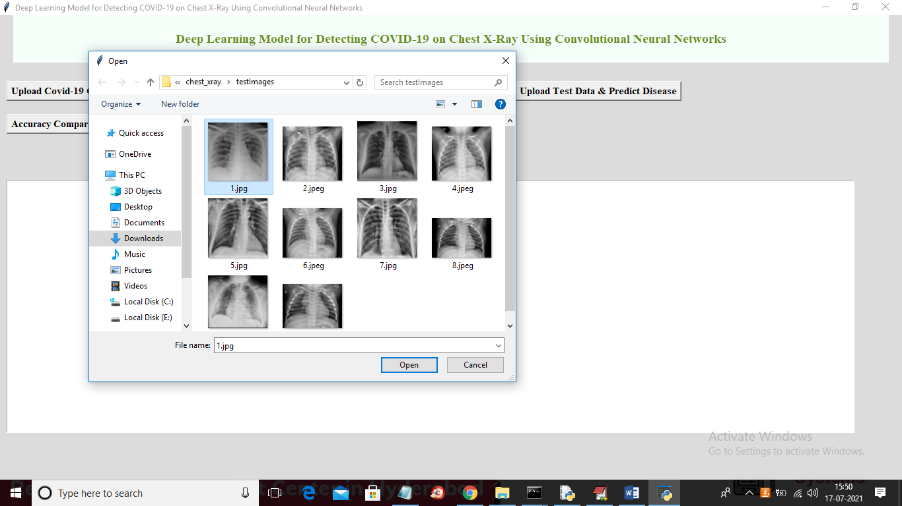

In above screen selecting and uploading ‘1.jpg’ image and then click on ‘Open’ button to get below prediction result

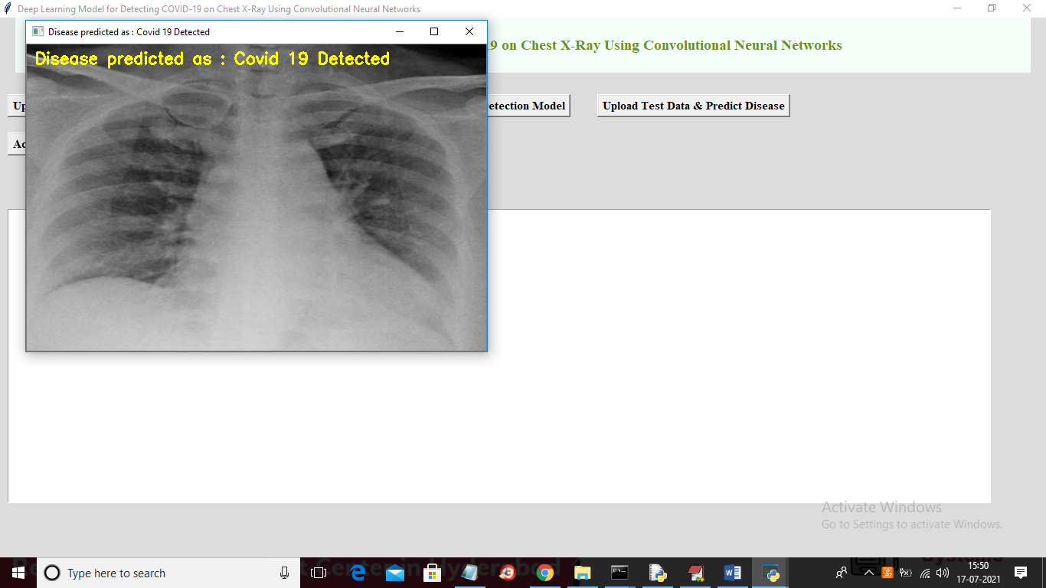

In above screen image in yellow colour text we can see uploaded chest X-Ray predicted as Covid-19 disease and now test with other images

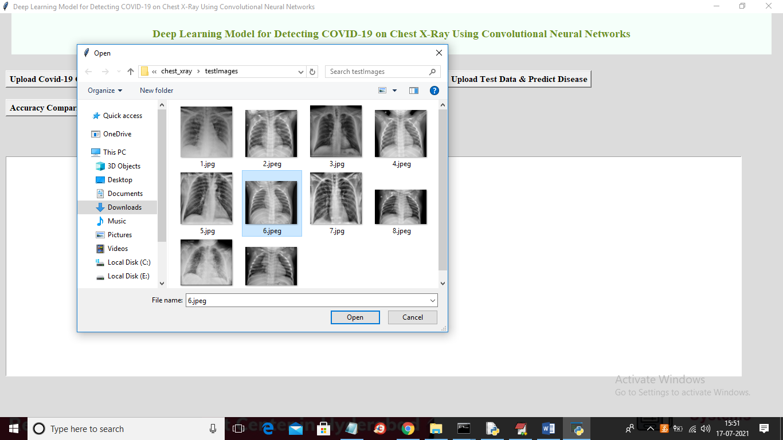

In above screen uploading ‘6.jpeg’ image and now click ‘Open’ button to get below result

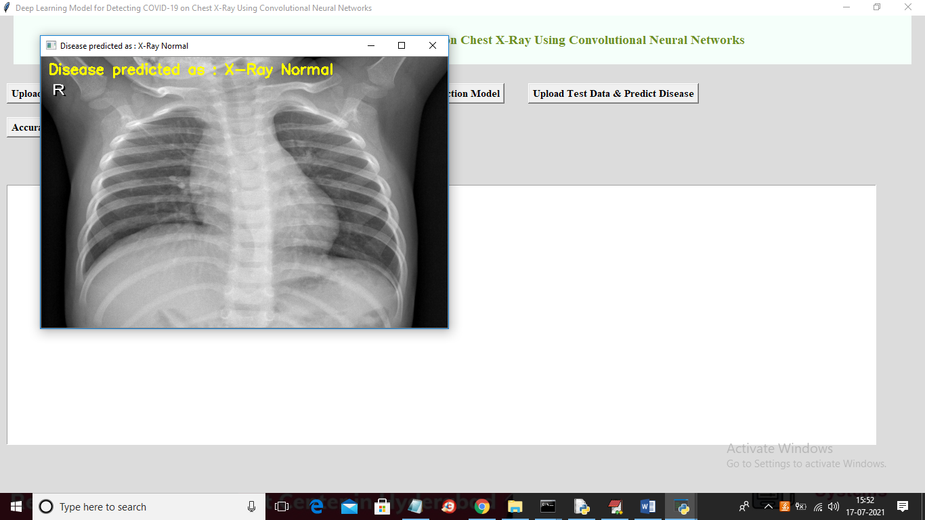

In above image X-Ray is predicted as Normal. Similarly you can upload other images and test them and now click on ‘Accuracy Comparison Graph’ to get below result

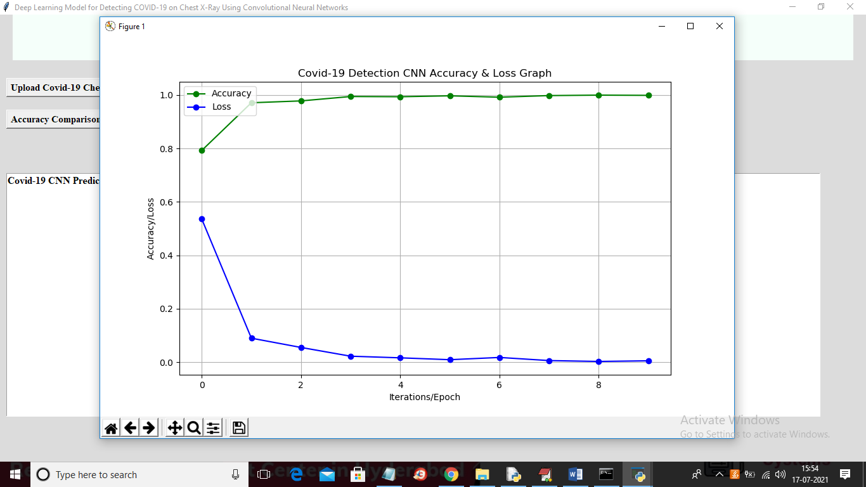

In above graph x-axis represents Epoch and y-axis represents accuracy and loss value. Blue line represents CNN LOSS and green line represents CNN accuracy and in above graph we can see with increasing EPOCH accuracy also get increased and LOSS get decreased. For any reliable CNN model accuracy must be high and LOSS must be low