

**Statistical Learning 16/17**

**Project Explanation**

**Group Members**

Pablo Bordons Estrada

Sergio Gámez Ruiz de Olano

Pierre Mercatoris

Mohammadmehdi Fayazbakhsh

November 2016

**Summary:**

The goal of this project is to recognise hand postures from grayscale photographs. There are over 4800 images with 6 different types of hand postures (see fig. 1), from 10 different persons. The variables of each image will either be pixels or area of the image with its grayscale intensity. The data will be downloaded from S. Marcel collection of images ([Data reference](http://www.idiap.ch/resource/gestures/))

The idea came to us as the analysis of images implies very high dimensionality of data and will require dimension reduction. As none of us has been working with the analysis of images and we all wish to understand better how to extract information from other kinds of data, this dataset/analysis seemed best suited to this project and our curiosity.

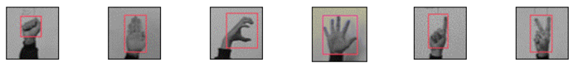

**Figure 1:** Six different hand postures contained in the grayscale images dataset.

**Data reference:**

http://www.idiap.ch/resource/gestures/