Project Title
Optimal Binary Search Tree for Efficient Search Optimization
Project Report submitted for the partial fulfilment of grade for the course

Data Structures and Algorithms -3 (25CS2103E)
in

A.Y. 2026-2027

Submitted by
T. Jashwanth (2520030386)
P. Naveen (2520030518)
E. Ashwith (2520030475)

Team Number: 21
Section: 4

Under the guidance of

Mrs. J. Yamini Devi

Assistant Professor, Department of CSE
Hyderabad-500090, Telangana, India.

K L (Deemed to be) University
DEPARTMENT OF COMPUTER SCIENCE ENGINEERING



DECLARATION

The Mini Project Report entitled “Optimal Binary Search Tree for Efficient Search Optimization” is a record of Bonafide work of T. Jashwanth – 2520030386, P. Naveen – 2520030518, E. Ashwith – 2520030475, submitted in partial fulfillment for the award of B. Tech in Computer Science and Engineering to the K L University. The results embodied in this report have not been copied from any other departments/University/Institute.

T. Jashwanth – 2520030386
P. Naveen – 2520030518
E. Ashwith – 2520030475

K L (Deemed to be) University
DEPARTMENT OF COMPUTER SCIENCE ENGINEERING
CERTIFICATE

This is to certify that the mini project based report entitled “Optimal Binary Search Tree for Efficient Search Optimization” is a bonafide work done and submitted by T. Jashwanth – 2520030386, P. Naveen – 2520030518, E. Ashwith – 2520030475 in partial fulfillment of the requirements for the award of the degree of BACHELOR OF TECHNOLOGY in Department of Computer Science Engineering, K L (Deemed to be University), during the academic year 2026-2027.

Signature of the Supervisor

Signature of the HOD Signature of the External Examiner

ACKNOWLEDGEMENT

The success in this project would not have been possible but for the timely help and guidance rendered by many people. Our wish to express my sincere thanks to all those who has assisted us in one way or the other for the completion of my project.

Our greatest appreciation to my guide, Mrs. J. Yamini Devi, Assistant Professor, Department of Computer Science and Engineering, which cannot be expressed in words for her tremendous support, encouragement and guidance for this project.

We express our gratitude to Dr. P. Venkateshwar Rao, Head of the Department for Computer Science Engineering for providing us with adequate facilities, ways and means by which we are able to complete this project-based Lab.

We thank all the members of teaching and non-teaching staff members, and also who have assisted me directly or indirectly for successful completion of this project. Finally, I sincerely thank my parents, friends and classmates for their kind help and cooperation during my work.

T. Jashwanth – 2520030386
P. Naveen – 2520030518
E. Ashwith – 2520030475

TABLE OF CONTENTS

S.No. | Contents | Page no.
1. | Abstract | 6
 |  | 7
2. | Introduction | 8
3. | Literature survey | 10
4. | Problem Statement and Objectives | 11
5. | Hardware and Software requirements | 12
6. | Implementation | 15
7. | Results & Discussion | 17
8. | Conclusion & Future Scope | 18
9. | References

1.ABSTRACT
The Optimal Binary Search Tree (OBST) project aims to develop an application that constructs an efficient Binary Search Tree using a given set of keys and their search frequencies. The primary objective is to minimize the average search cost by arranging the keys in an optimal order. Unlike a standard Binary Search Tree, an Optimal Binary Search Tree considers how frequently each key is accessed, ensuring that frequently searched keys are placed closer to the root, thereby reducing the overall search time.
The application accepts a list of sorted keys along with their corresponding search frequencies as input. It then applies the Dynamic Programming technique to determine the optimal tree structure that yields the minimum expected search cost. After computation, the system displays the resulting Optimal Binary Search Tree and calculates the expected search cost, allowing users to understand the efficiency gained through optimization.
This project demonstrates the practical application of interval dynamic programming in solving optimization problems and highlights the importance of algorithm design in improving search performance. It provides an educational platform for students to understand dynamic programming concepts, binary search trees, and cost optimization techniques. The system is suitable for academic learning and can serve as a foundation for advanced search optimization applications in databases, compilers, and information retrieval systems.
Team Name: Team 21
Team Logo (if any): Not applicable
Team Members:
1. T. Jashwanth, 2520030386
2. P. Naveen, 2520030518
3. E. Ashwith, 2520030475
- INTRODUCTION

Searching is one of the most frequent operations in computer systems, and the Binary Search Tree (BST) is a basic data structure that supports it. A standard BST is shaped by the order in which keys are inserted, or by balancing rules such as those in AVL and Red-Black trees. Neither approach looks at how often each key is actually searched. For example, if “Apple” is searched 1000 times and “Zebra” only once, a balanced BST may still place “Zebra” near the root, so the most common searches become slower than they need to be.
The Optimal Binary Search Tree (OBST) addresses this problem. Given a sorted set of keys and the search frequency of each key, it arranges the keys so that frequently searched keys sit closer to the root. The goal is not the shortest tree but the cheapest tree, measured by the weighted path length: the sum of frequency × (depth + 1) over all keys. Since a tree of n keys can be shaped in an exponential number of ways, brute force is impractical. This is a classic optimization problem with optimal substructure and overlapping subproblems, and it is solved with Interval Dynamic Programming in O(n³) time.
The motivation for this project is both academic and practical. Academically, it is a clear example of how a dynamic programming recurrence is designed, filled in a cost table and traced back through a root table. Practically, the same idea underlies database indexing, compiler symbol tables and dictionary look-ups in search engines, where access patterns are skewed.
This project implements the OBST algorithm in C++. It reads sorted keys and their frequencies, builds the cost and root tables with interval DP, reconstructs and displays the optimal tree, and reports the minimum expected search cost. The rest of this report covers the literature survey, the problem statement and objectives, the hardware and software requirements, the implementation, the results and discussion, and the conclusion with future scope.
- LITERATURE SURVEY

1. Knuth, D. E. (1971) – Optimal Binary Search Trees. Knuth gave the dynamic programming algorithm for constructing a binary search tree with minimum expected search cost and proved that an optimal tree has optimal subtrees (optimal substructure). He also showed that the optimal roots are monotone, which reduces the running time from O(n³) to O(n²). Our recurrence for the cost table and the root table is based on this work.
2. Cormen, Leiserson, Rivest and Stein – Introduction to Algorithms (CLRS). CLRS presents OBST as a standard dynamic programming example, with the recurrence, the pseudo-code and the tables for cost, weight and root. We followed this formulation for the cost table C[i][j], and used prefix sums so that the frequency sum of any interval is found in constant time.
3. Gilbert, E. N. and Moore, E. F. (1959) – Variable-Length Binary Encodings. This early work studied alphabetic binary trees, in which the order of the leaves must follow the order of the keys. It is a precursor of the OBST problem and the historical basis for optimizing ordered search structures.
4. Hu, T. C. and Tucker, A. C. (1971) – Optimal Computer Search Trees and Variable-Length Alphabetical Codes. Hu and Tucker gave an O(n log n) algorithm for optimal alphabetic trees, where weights are attached to the leaves only. It solves a closely related problem faster than the general OBST dynamic program, and shows the trade-off between problem variants and algorithm cost.
5. Mehlhorn, K. (1975) – Nearly Optimal Binary Search Trees. Mehlhorn proposed fast heuristics that build trees whose cost is close to the optimum in O(n) time. These are useful when n is very large and the exact O(n³) or O(n²) algorithm is too slow, and they show the accuracy-versus-speed choice that a real system faces.
6. AVL and Red-Black Trees. These self-balancing trees guarantee O(log n) height for any sequence of operations. We compare against them because balancing the height is not always the cheapest choice when keys are accessed with very different frequencies, which is the case that the OBST handles.
7. Sleator, D. D. and Tarjan, R. E. (1985) – Self-Adjusting Binary Search Trees (Splay Trees). Splay trees move each accessed node to the root, so they adapt to the access pattern without knowing frequencies in advance. They are the modern dynamic alternative, whereas our OBST is a static tree built once from known frequencies and gives the minimum possible expected cost for them.
8. GeeksforGeeks and Wikipedia tutorials on Optimal Binary Search Tree. These online resources describe the naive recursive solution with exponential time, the memoized solution and the tabulated bottom-up solution in O(n³) time. We used them to cross-check our understanding of the recurrence and to confirm the sample results.
Summary: the existing work shows that exact OBST construction is solved by dynamic programming, that faster variants exist for special cases, and that balanced or self-adjusting trees are alternatives. This project implements the basic O(n³) interval DP version and displays the resulting tree and its cost, so that the idea is easy to follow for learners.
- Problem Statement and Objectives

Problem Statement:
Given n distinct sorted keys K = {k₁, k₂, …, kₙ} with search frequencies F = {f₁, f₂, …, fₙ}, construct a binary search tree that minimizes the expected search cost, Total Cost = Σ fᵢ × (depth(kᵢ) + 1).
Problem Description:
Standard BSTs ignore how often a key is searched, so frequently used keys can end up deep in the tree. We need the arrangement of keys that gives the lowest weighted path length, without trying all exponentially many tree shapes.
Objectives:
Purpose of the project: The project was started to show how knowledge of search frequencies can be used to build a search tree that is cheaper than an insertion-order or height-balanced tree. The following objectives were framed to achieve this.
1. Input Handling: Accept sorted keys and their corresponding integer frequencies.
2. DP Implementation: Apply interval dynamic programming to compute the minimal cost for every sub-interval of keys.
3. Root Table Construction: Store the optimal root index for every interval so that the tree can be reconstructed.
4. Tree Visualization: Display the resulting optimal binary search tree structure.
5. Cost Computation: Output the minimum expected search cost.
6. Performance Analysis: Compare the efficiency of the DP approach, O(n³), against brute-force (exponential) approaches.
- HARDWARE AND SOFTWARE REQUIREMENTS

Hardware Requirements:
• Processor: Intel Core i3 / AMD Ryzen 3 or higher
• RAM: Minimum 4 GB (8 GB recommended)
• Storage: 100 MB of free disk space
Software Requirements:
• Operating System: Windows 10/11, Linux (Ubuntu 20.04+) or macOS
• Language: C++ (using the Standard Template Library, STL)
• IDE / Compiler: VS Code / Code::Blocks / GCC
• Libraries: iostream, vector and iomanip (for formatted console output)
- IMPLEMENTATION

The application is written in C++ and is organized into four modules. The algorithm follows the flow chart given below: the input is read, the cost and root tables are filled by interval length using prefix sums, and the optimal tree is then built from the root table and displayed.
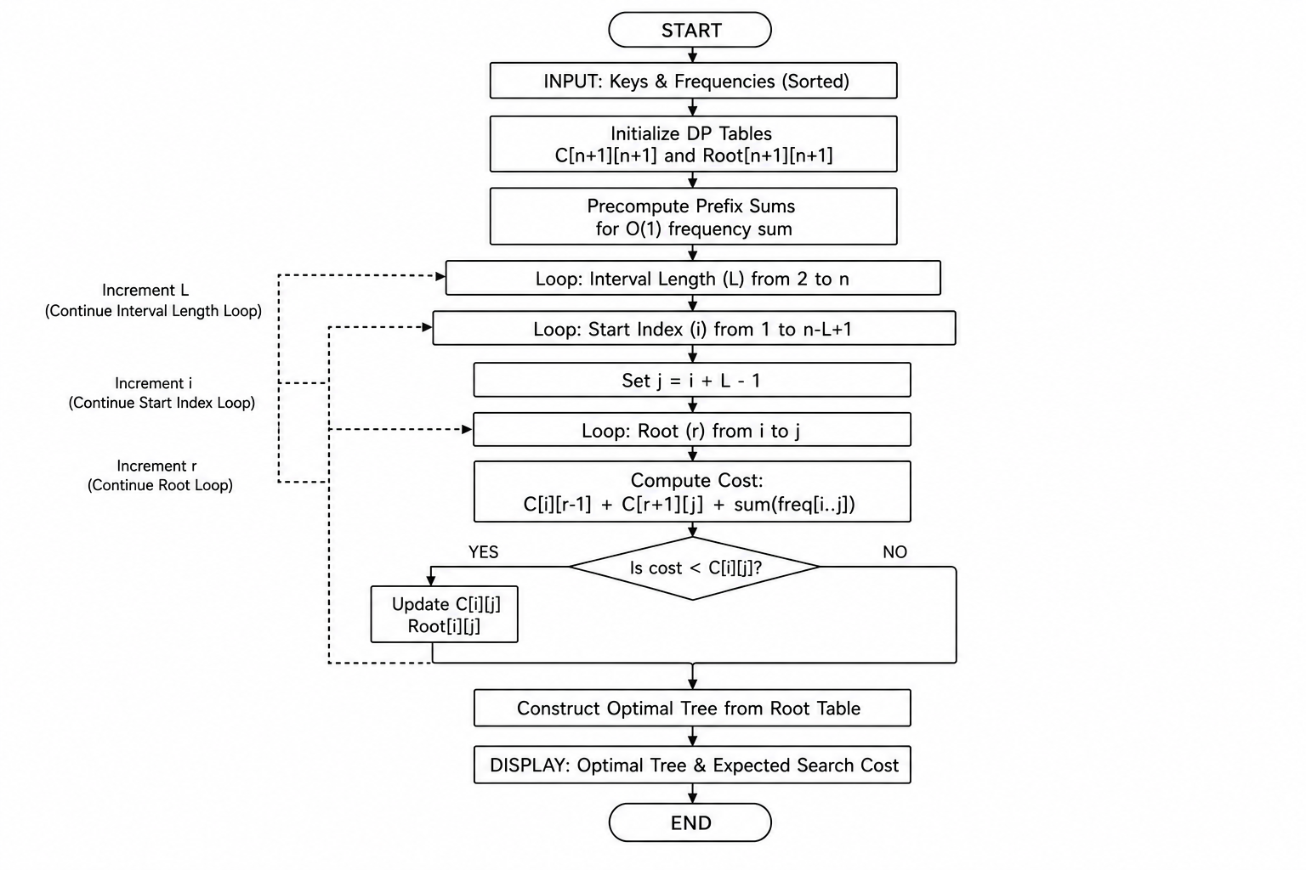
Figure 6.1: Flow chart of the Optimal Binary Search Tree algorithm
Module 1: Input Handling
Reads the number of keys, the sorted keys and their frequencies, and checks that the keys are distinct and in sorted order.
#include <iostream>
#include <vector>
#include <iomanip>
#include <climits>
using namespace std;
// ---------- Module 1: Input handling ----------
bool readInput(int &n, vector<int> &keys, vector<int> &freq) {
cout << "Enter number of keys: ";
if (!(cin >> n) || n <= 0) return false;
keys.assign(n + 1, 0);
freq.assign(n + 1, 0);
cout << "Enter " << n << " sorted keys: ";
for (int i = 1; i <= n; i++) cin >> keys[i];
cout << "Enter " << n << " search frequencies: ";
for (int i = 1; i <= n; i++) cin >> freq[i];
for (int i = 2; i <= n; i++)
if (keys[i] <= keys[i - 1]) {
cout << "Keys must be distinct and sorted!\n";
return false;
}
return true;
}
Module 2: Interval Dynamic Programming (Cost and Root Tables)
Computes prefix sums, then for every interval [i, j] tries each key as the root and stores the minimum cost in C[i][j] and the best root in R[i][j]. Time O(n³), space O(n²).
// ---------- Module 2: Interval DP (cost table + root table) ----------
int buildOBST(int n, const vector<int> &freq,
vector<vector<int>> &C, vector<vector<int>> &R) {
vector<int> pre(n + 1, 0); // prefix sums of frequencies
for (int i = 1; i <= n; i++) pre[i] = pre[i - 1] + freq[i];
C.assign(n + 2, vector<int>(n + 2, 0));
R.assign(n + 2, vector<int>(n + 2, 0));
for (int i = 1; i <= n; i++) { C[i][i] = freq[i]; R[i][i] = i; }
for (int len = 2; len <= n; len++) { // interval length
for (int i = 1; i + len - 1 <= n; i++) {
int j = i + len - 1;
int w = pre[j] - pre[i - 1]; // sum of freq[i..j]
C[i][j] = INT_MAX;
for (int r = i; r <= j; r++) { // try every key as root
int left = (r > i) ? C[i][r - 1] : 0;
int right = (r < j) ? C[r + 1][j] : 0;
int cost = left + right + w;
if (cost < C[i][j]) { C[i][j] = cost; R[i][j] = r; }
}
}
}
return C[1][n];
}
Module 3: Tree Reconstruction and Display
Uses the root table to rebuild the tree recursively, prints it level by level with indentation, computes node depths, and prints the cost and root tables.
// ---------- Module 3: Tree reconstruction and display ----------
void printTree(int i, int j, const vector<vector<int>> &R,
const vector<int> &keys, const string &prefix,
const string &label) {
if (i > j) return;
int r = R[i][j];
cout << prefix << label << "[" << keys[r] << "]\n";
printTree(i, r - 1, R, keys, prefix + " ", "L--- ");
printTree(r + 1, j, R, keys, prefix + " ", "R--- ");
}
void computeDepths(int i, int j, int d, const vector<vector<int>> &R,
vector<int> &depth) {
if (i > j) return;
int r = R[i][j];
depth[r] = d;
computeDepths(i, r - 1, d + 1, R, depth);
computeDepths(r + 1, j, d + 1, R, depth);
}
void printTable(const char *name, int n, const vector<vector<int>> &T) {
cout << "\n" << name << ":\n ";
for (int j = 1; j <= n; j++) cout << setw(6) << j;
cout << "\n";
for (int i = 1; i <= n; i++) {
cout << setw(4) << i << " ";
for (int j = 1; j <= n; j++)
if (j < i) cout << setw(6) << "-";
else cout << setw(6) << T[i][j];
cout << "\n";
}
}
Module 4: Main Driver and Cost Verification
Calls the modules in order, prints the tables and the tree, and recomputes the cost as Σ frequency × (depth + 1) to verify the value from the DP table.
// ---------- Module 4: Main driver and cost verification ----------
int main() {
int n;
vector<int> keys, freq;
if (!readInput(n, keys, freq)) return 1;
vector<vector<int>> C, R;
int best = buildOBST(n, freq, C, R);
printTable("Cost table C[i][j]", n, C);
printTable("Root table R[i][j]", n, R);
cout << "\nOptimal Binary Search Tree (root at top):\n";
printTree(1, n, R, keys, "", "");
vector<int> depth(n + 1, 0);
computeDepths(1, n, 0, R, depth);
int check = 0;
cout << "\nExpected search cost = ";
for (int i = 1; i <= n; i++) {
check += freq[i] * (depth[i] + 1);
cout << "(" << freq[i] << "x" << depth[i] + 1 << ")" << (i < n ? " + " : "");
}
cout << " = " << check << "\n";
cout << "Minimum cost from DP table = " << best << "\n";
cout << "Overall root = " << keys[R[1][n]] << "\n";
return 0;
}
- RESULTS & DISCUSSION

Test Case 1
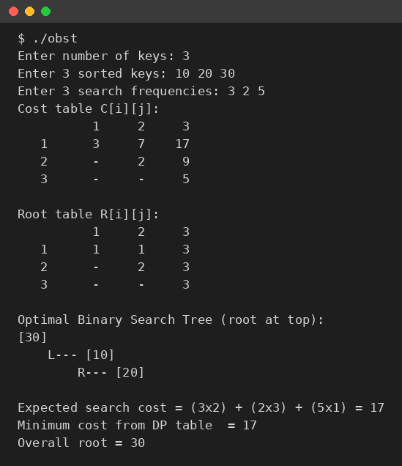
Figure 7.1: Output for keys {10, 20, 30} with frequencies {3, 2, 5}
For keys {10, 20, 30} and frequencies {3, 2, 5}, the program fills the cost table and root table and finds C[1][3] = 17 with the root 30. The resulting tree is 30 → 10 → 20, with cost 5×1 + 3×2 + 2×3 = 17.
Comparison of tree shapes for Test Case 1
Tree shape (root) | Expected cost | Calculation
Skewed tree, root 10 (worst case) | 22 | 3×1 + 2×2 + 5×3
Height-balanced tree, root 20 | 18 | 2×1 + 3×2 + 5×2
Optimal tree, root 30 (OBST) | 17 | 5×1 + 3×2 + 2×3

The OBST costs 17 against 22 for the worst-case tree, a reduction of about 22.7%, and it is also better than the height-balanced tree rooted at 20, which costs 18. This shows that balancing alone is not optimal when frequencies differ.
Test Case 2
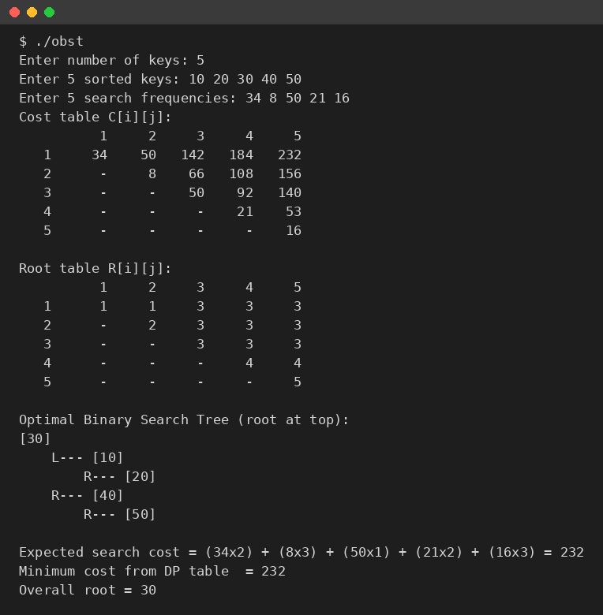
Figure 7.2: Output for keys {10, 20, 30, 40, 50} with frequencies {34, 8, 50, 21, 16}
For five keys with frequencies {34, 8, 50, 21, 16}, the program selects key 30 (frequency 50) as the root and finds a minimum cost of 232. The highest-frequency keys, 30 and 10, are placed at depths 0 and 1.
Discussion
The cost computed from the DP table matched the cost recomputed from the tree depths in both tests, and the results for both test cases were also confirmed with an independent brute-force search over all tree shapes. The tree always places keys with high frequency near the root.
On performance, the DP fills about n²/2 table entries and tries up to n roots for each, so the running time is O(n³) and the space is O(n²). Brute force examines every possible tree shape, whose number is the Catalan number C(n) and grows exponentially, so it becomes unusable beyond a few dozen keys. Knuth's optimization would bring the DP down to O(n²).
- CONCLUSION & FUTURE SCOPE

Conclusion
The project met its objectives. We built an application that accepts sorted keys with their frequencies, applies interval dynamic programming to compute the minimal cost of every sub-interval, stores the optimal roots, reconstructs and displays the optimal tree, and reports the minimum expected search cost. The O(n³) DP avoids the exponential cost of brute force, and the tree clearly shows high-frequency keys elevated towards the root. The project also demonstrates optimal substructure, overlapping subproblems and interval DP, and the same idea applies to database indexing, compiler symbol tables and search engine dictionaries.
Future Scope
Near term:
• Unsuccessful searches: add dummy keys (failure probabilities) to account for searches that miss, using the full Knuth algorithm.
• Graphical user interface: move beyond console output and draw the BST dynamically, for example with Java Swing or Python Tkinter.
Medium term:
• Knuth's optimization: use the monotonicity of roots to reach O(n²) time and handle datasets of more than 10,000 keys.
• Dynamic OBST: support insertions and deletions, as the current version is static.
Long term:
• Database integration: plug this logic into a database query optimizer for real-time index selection based on query logs.
- REFERENCES

[1] D. E. Knuth, “Optimal Binary Search Trees,” Acta Informatica, vol. 1, no. 1, pp. 14–25, 1971.
[2] T. H. Cormen, C. E. Leiserson, R. L. Rivest and C. Stein, Introduction to Algorithms, 3rd ed., MIT Press, 2009, Section 15.5: Optimal Binary Search Trees.
[3] E. N. Gilbert and E. F. Moore, “Variable-Length Binary Encodings,” Bell System Technical Journal, vol. 38, no. 4, pp. 933–967, 1959.
[4] T. C. Hu and A. C. Tucker, “Optimal Computer Search Trees and Variable-Length Alphabetical Codes,” SIAM Journal on Applied Mathematics, vol. 21, no. 4, pp. 514–532, 1971. https://en.wikipedia.org/wiki/Hu%E2%80%93Tucker_coding
[5] K. Mehlhorn, “Nearly Optimal Binary Search Trees,” Acta Informatica, vol. 5, pp. 287–295, 1975.
[6] D. D. Sleator and R. E. Tarjan, “Self-Adjusting Binary Search Trees,” Journal of the ACM, vol. 32, no. 3, pp. 652–686, 1985. https://en.wikipedia.org/wiki/Splay_tree
[7] AVL tree. https://en.wikipedia.org/wiki/AVL_tree
[8] Red–black tree. https://en.wikipedia.org/wiki/Red%E2%80%93black_tree
[9] Optimal binary search tree, Wikipedia. https://en.wikipedia.org/wiki/Optimal_binary_search_tree
[10] Optimal Binary Search Tree, GeeksforGeeks. https://www.geeksforgeeks.org/optimal-binary-search-tree-dp-24/

