Tracking-Algorithm Ground Truth & Comparison Report
Comparison of 5 trackers (ByteTrack, BoT-SORT, OC-SORT, DeepOCSORT, McByte++) across 3 counting-logic versions (v1 foot-point, v2 pose/neck, v3 head-detector), scored against manually reviewed ground truth for the two dataset clips.

1. Methodology
Ground truth was built by visually reviewing both clips frame-by-frame against data/results/tracking_algo/bytetrack/v1/clip{1,2}.mp4 (the same raw footage every tracker ran on; this render simply has the A/B zone polygons burned in for reference). Candidate moments to check were found by unioning all 5 trackers' own event frames and clustering nearby ones — used only to bound review scope, never trusted as truth. Each cluster was independently judged by sustained body motion through the doorway (growing + approaching camera = OUT, shrinking + receding = IN), ignoring track IDs (they churn under occlusion) and each tracker's own flashed direction tag (that's exactly what's being verified). Full per-cluster detail: scripts/tracking_algo/ground_truth.csv.

2. Ground Truth
Clip | Genuine IN | Genuine OUT | Total
clip1 | 8 | 21 | 29
clip2 | 2 | 6 | 8
Confidence note: clip1's opening ~8 seconds (frames 64-224) is the least certain window — a dense, fully-occluded cluster of identically-uniformed people; the true OUT count there is a best estimate with a plausible range of 3-5. All other windows are medium-high to high confidence.

3. Key Finding: Debounce-Dwell Artifacts
The dominant remaining source of overcounting is boundary-dwell jitter: a person standing still exactly on the A/B line (scanning a badge, adjusting a mask, hanging a jacket on a wall hook) has their crossing point jitter back and forth across the line and re-fires a “crossing” with no real movement. ZoneCounter's DEBOUNCE_FRAMES=15 (0.6s) absorbs most of this, but it still shows up worst for trackers that hold an ID alive longest through the dwell (McByte++'s Re-ID), since they get more chances to re-trigger it.

4. Visualizations
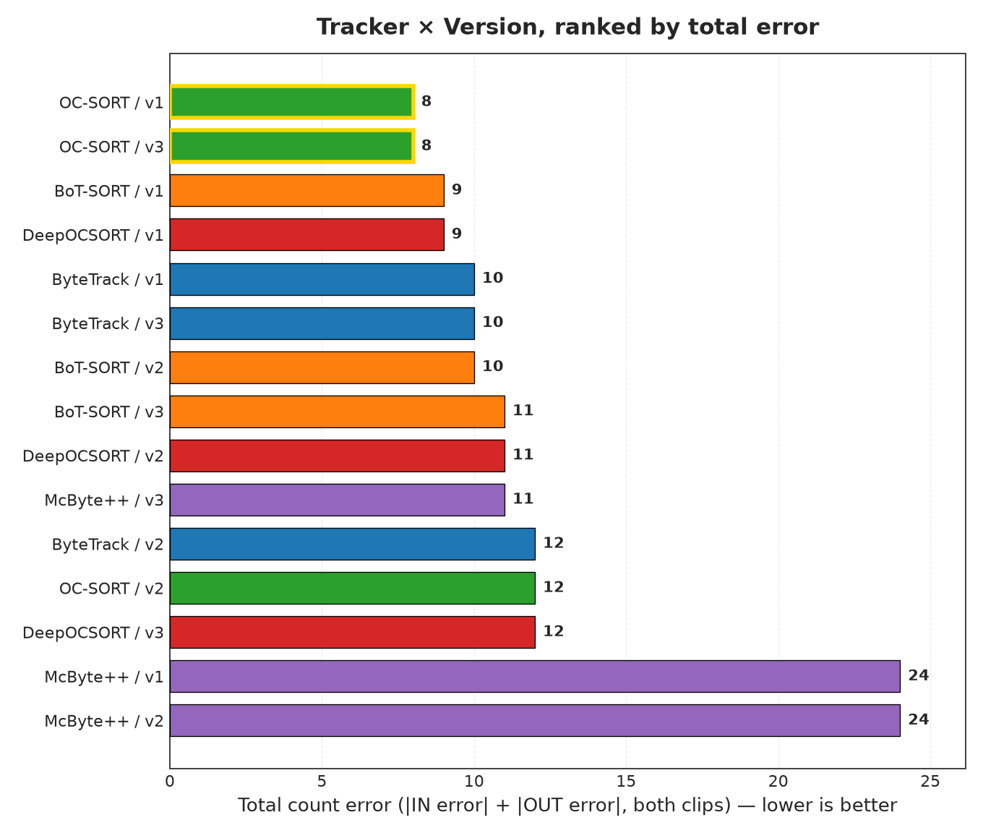
Figure 1. Every tracker×version pair ranked by total count error (both clips combined), shortest bar = lowest error = best. Gold-edged bars mark the best pair(s); equal-length bars with equal printed numbers are exact ties.
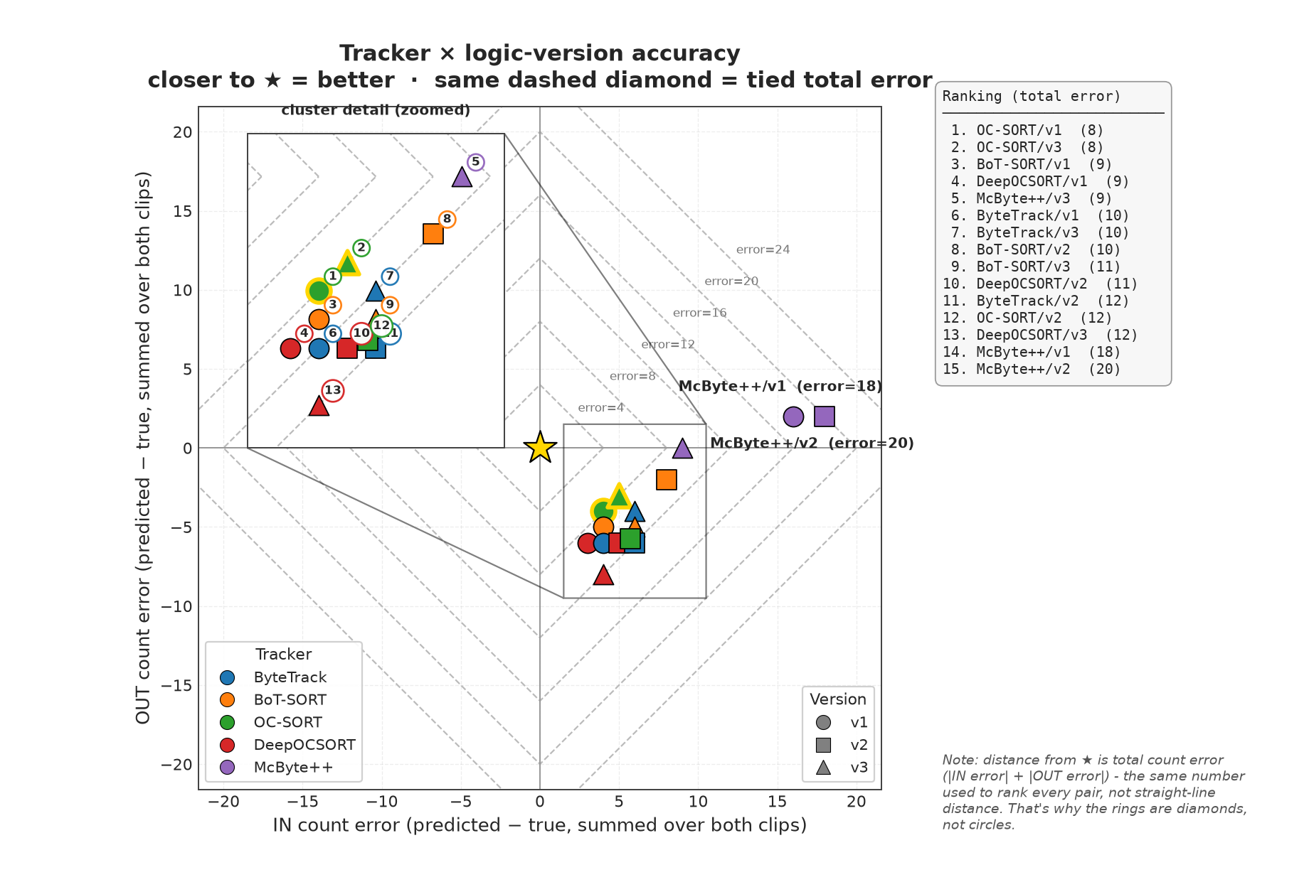
Figure 2. Signed IN vs. OUT count error per pair (color = tracker, shape = version); the gold star is ground truth. Distance from the star is drawn as dashed diamonds, not circles, because the ranking metric is total count error (|IN error| + |OUT error|) — points on the same diamond are exact ties regardless of which axis their error sits on. The 13 competitive pairs are zoomed into the inset (numbered by rank, cross-referenced to the list on the right); McByte++ v1/v2 are the two labeled outliers. Nearly every pair overcounts IN (boundary-dwell jitter, Section 3) but undercounts OUT (lost tracks in clip1's dense, occluded opening cluster) — McByte++ is the exception, its stronger Re-ID keeps IDs alive through the dwell so it also overcounts OUT slightly instead of losing them.
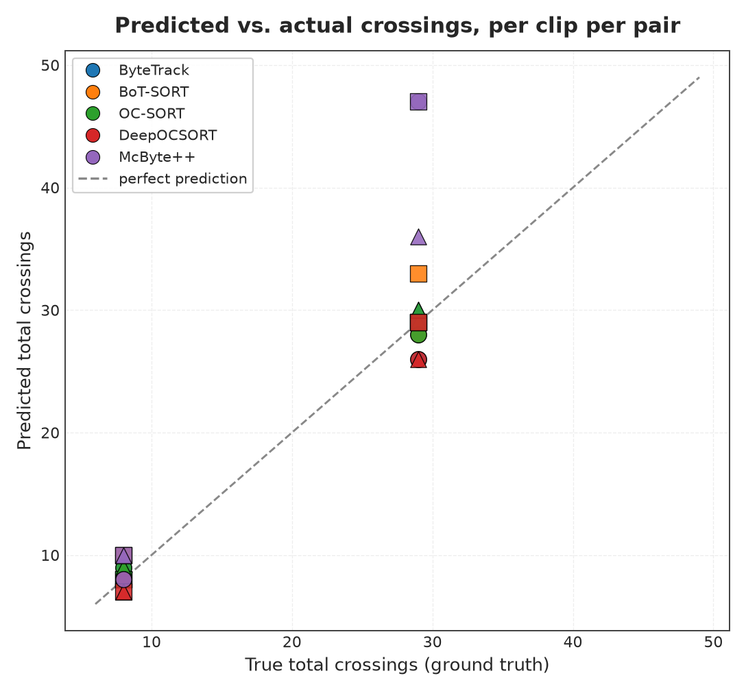
Figure 3. Predicted vs. true total crossings per clip per pair, against the y=x “perfect prediction” line. Points above the line overcount; McByte++ overcounts most on the busy clip.
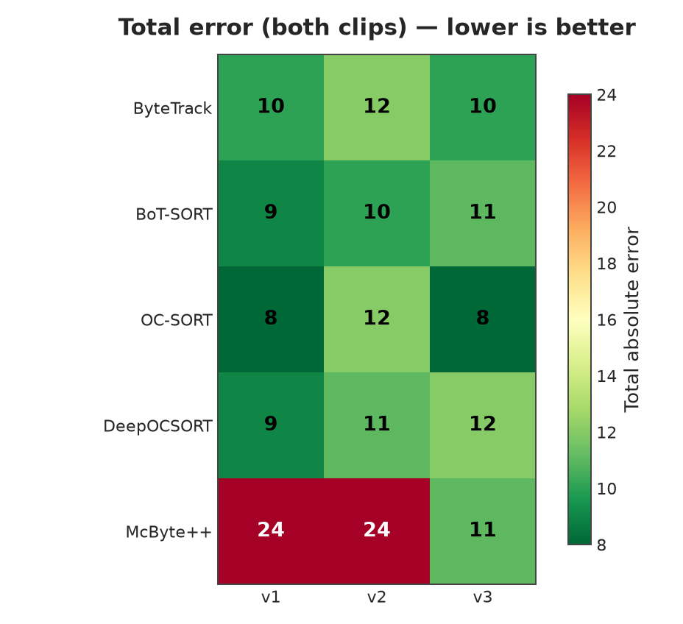
Figure 4. Total absolute error (both clips combined) for every tracker×version combination. Greener = closer to ground truth.
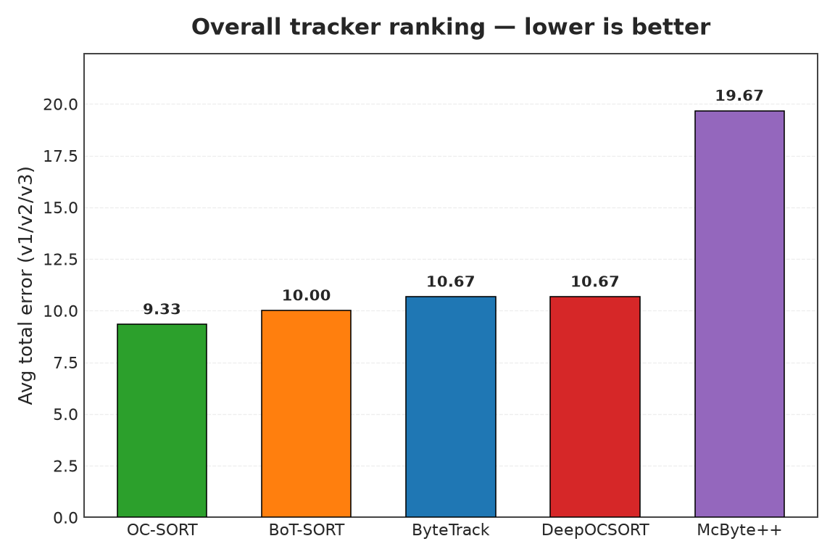
Figure 5. Overall tracker ranking: average total error across v1/v2/v3.

5. Rankings

5.1 Overall tracker ranking (avg error across v1/v2/v3)
Rank | Tracker | Avg error
1 | OC-SORT | 9.33
2 | BoT-SORT | 10.00
3 | ByteTrack | 10.67
4 | DeepOCSORT | 10.67
5 | McByte++ | 19.67

5.2 Overall logic-version ranking (avg error across trackers)
Rank | Version | Avg error
1 | v3 | 10.40
2 | v1 | 12.00
3 | v2 | 13.80

5.3 Best pair (tracker + logic version)
Rank | Tracker | Version | Total error
1 | OC-SORT | v1 | 8
2 | OC-SORT | v3 | 8
3 | BoT-SORT | v1 | 9
4 | DeepOCSORT | v1 | 9
5 | ByteTrack | v1 | 10
6 | ByteTrack | v3 | 10
7 | BoT-SORT | v2 | 10
8 | BoT-SORT | v3 | 11
9 | DeepOCSORT | v2 | 11
10 | McByte++ | v3 | 11
11 | ByteTrack | v2 | 12
12 | OC-SORT | v2 | 12
13 | DeepOCSORT | v3 | 12
14 | McByte++ | v1 | 24
15 | McByte++ | v2 | 24

6. Conclusion
Overall best tracker: OC-SORT (avg error 9.33). Overall best logic version: v3 (avg error 10.40). Best pair: OC-SORT + v1 (error 8). McByte++ ranks last despite being the most sophisticated tracker here (Re-ID, mask-aware) — its stronger ID retention keeps a dwelling person's identity alive longer, giving the shared counting logic's boundary-jitter weakness (Section 3) more chances to re-trigger; its tracking quality isn't necessarily worse, it's just better at exposing that bug. The gap between the top four trackers is small relative to clip-to-clip noise — don't over-read fine differences among them.

