Tracking-Algorithm Ground Truth & Comparison Report
Comparison of 5 trackers (ByteTrack, BoT-SORT, OC-SORT, DeepOCSORT, McByte++) across 3 counting-logic versions (v1 foot-point, v2 pose/neck, v3 head-detector), scored against manually reviewed ground truth for the two dataset clips.

1. Methodology
Ground truth was built by visually reviewing both clips frame-by-frame against data/results/tracking_algo/bytetrack/v1/clip{1,2}.mp4 (the same raw footage every tracker ran on; this render simply has the A/B zone polygons burned in for reference). Candidate moments to check were found by unioning all 5 trackers' own event frames and clustering nearby ones — used only to bound review scope, never trusted as truth. Each cluster was independently judged by sustained body motion through the doorway (growing + approaching camera = OUT, shrinking + receding = IN), ignoring track IDs (they churn under occlusion) and each tracker's own flashed direction tag (that's exactly what's being verified). Full per-cluster detail: scripts/tracking_algo/ground_truth.csv.

2. Ground Truth
Clip | Genuine IN | Genuine OUT | Total
clip1 | 8 | 21 | 29
clip2 | 2 | 6 | 8
Confidence note: clip1's opening ~8 seconds (frames 64-224) is the least certain window — a dense, fully-occluded cluster of identically-uniformed people; the true OUT count there is a best estimate with a plausible range of 3-5. All other windows are medium-high to high confidence.

3. Key Finding: Debounce-Dwell Artifacts
ZoneCounter's DEBOUNCE_FRAMES=4 (0.16s) is short enough that a person standing still exactly on the A/B boundary line (scanning a badge, adjusting a mask, hanging a jacket on a wall hook) has their foot-point jitter across the line and re-fires a “crossing” repeatedly with no real movement. This is the dominant reason every tracker's raw count runs higher than the true count — worst for trackers that hold an ID alive longest through the dwell (McByte++'s Re-ID), since they get more chances to re-trigger the same bug.

4. Visualizations
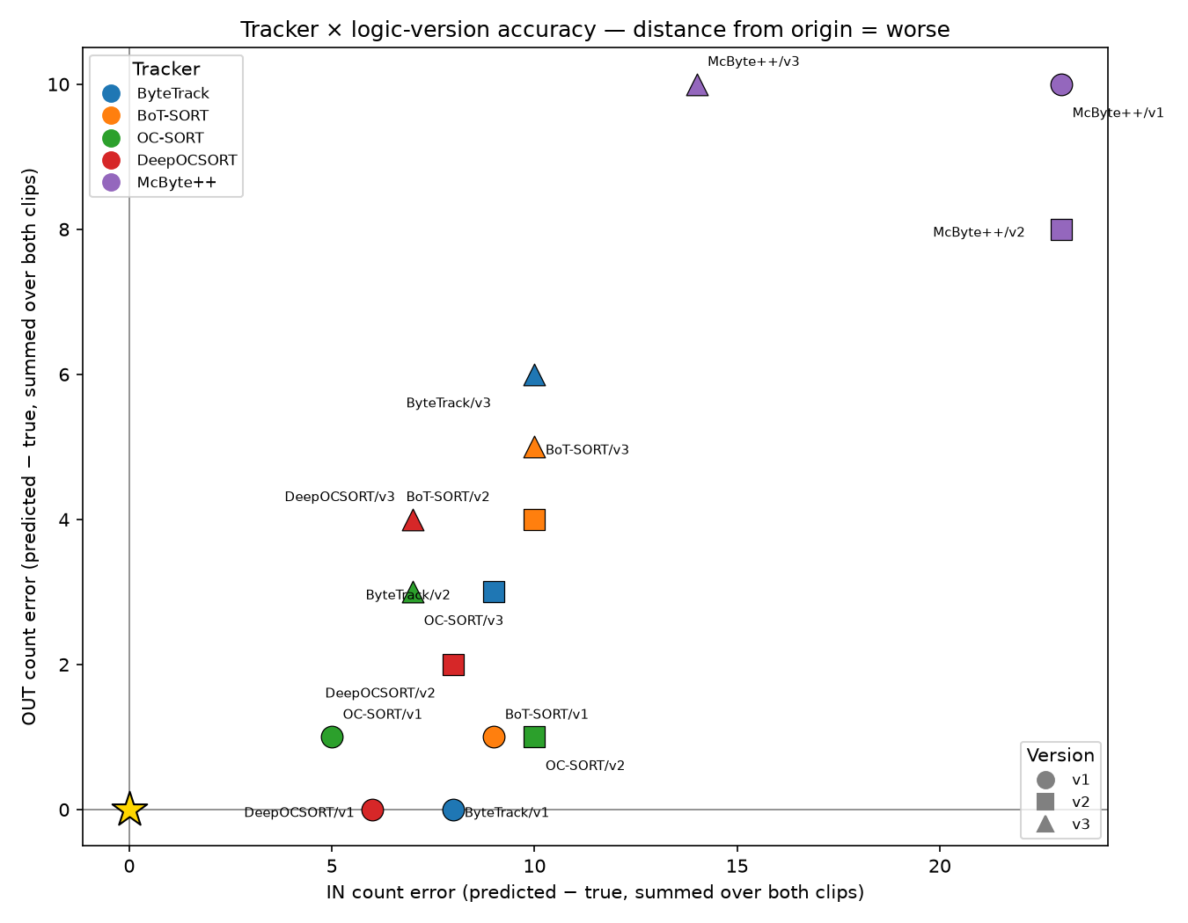
Figure 1. Signed IN/OUT count error per tracker×version pair, summed over both clips. The gold star is the ground truth itself — closer to it is more accurate.
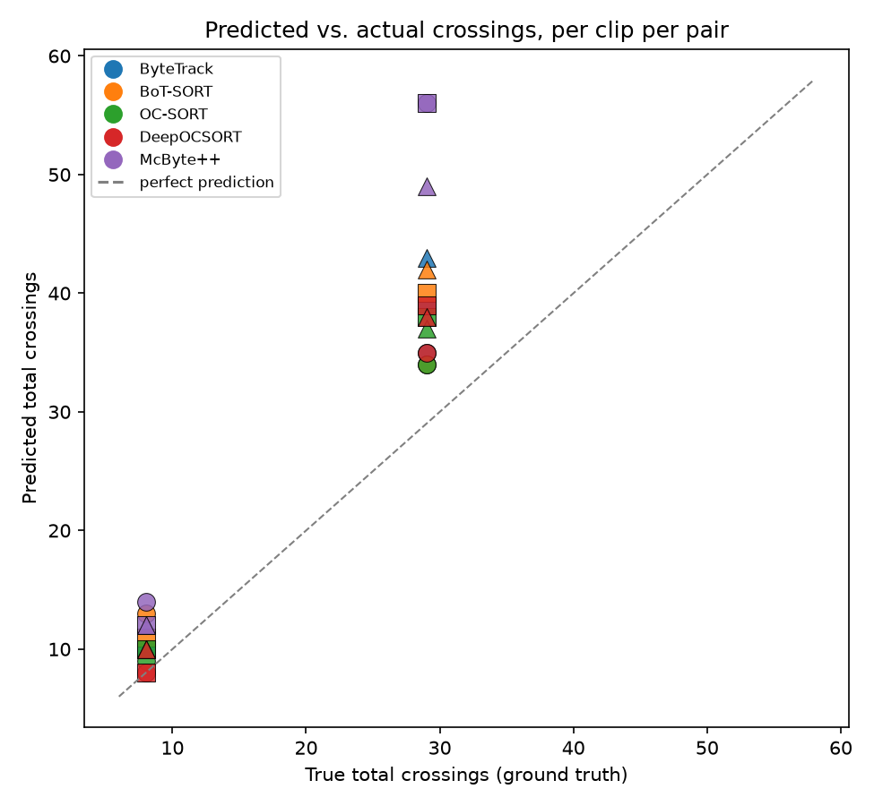
Figure 2. Predicted vs. true total crossings per clip per pair, against the y=x “perfect prediction” line. Points above the line overcount; McByte++ overcounts most on the busy clip.
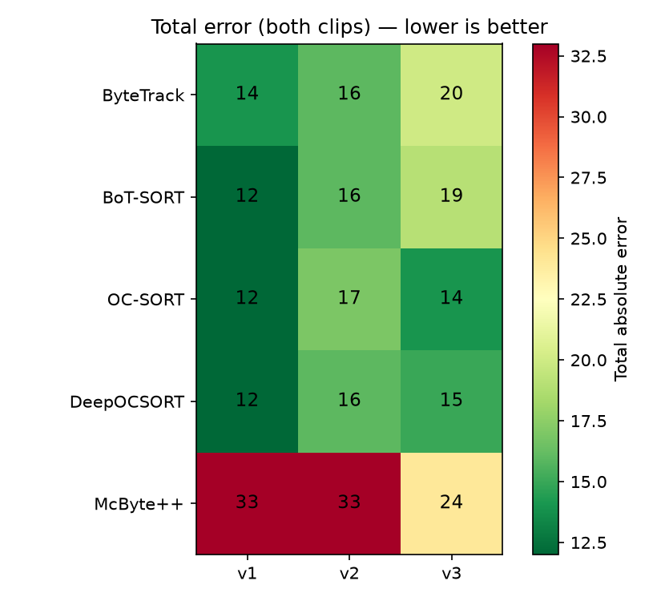
Figure 3. Total absolute error (both clips combined) for every tracker×version combination. Greener = closer to ground truth.
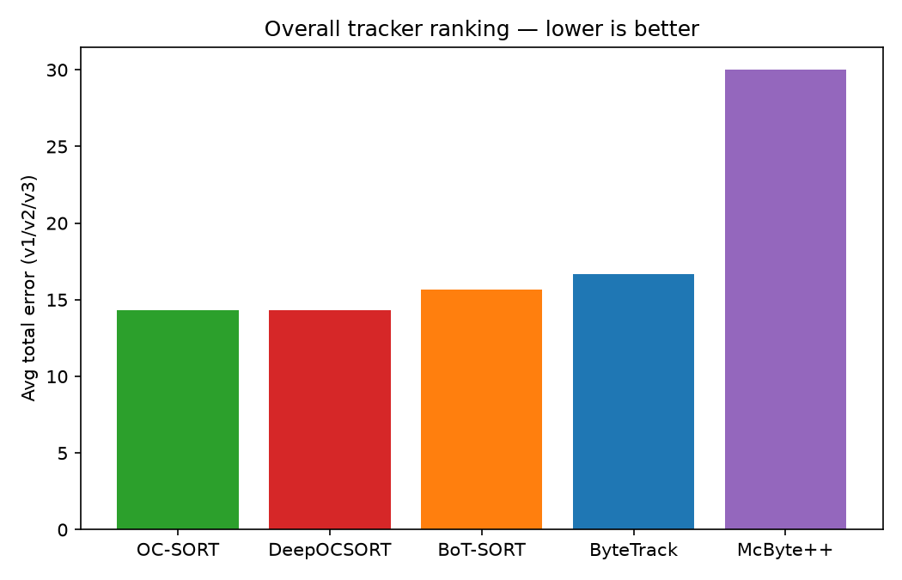
Figure 4. Overall tracker ranking: average total error across v1/v2/v3.

5. Rankings

5.1 Overall tracker ranking (avg error across v1/v2/v3)
Rank | Tracker | Avg error
1 | OC-SORT | 14.33
2 | DeepOCSORT | 14.33
3 | BoT-SORT | 15.67
4 | ByteTrack | 16.67
5 | McByte++ | 30.00

5.2 Overall logic-version ranking (avg error across trackers)
Rank | Version | Avg error
1 | v1 | 16.60
2 | v3 | 18.40
3 | v2 | 19.60

5.3 Best pair (tracker + logic version)
Rank | Tracker | Version | Total error
1 | BoT-SORT | v1 | 12
2 | OC-SORT | v1 | 12
3 | DeepOCSORT | v1 | 12
4 | ByteTrack | v1 | 14
5 | OC-SORT | v3 | 14
6 | DeepOCSORT | v3 | 15
7 | ByteTrack | v2 | 16
8 | BoT-SORT | v2 | 16
9 | DeepOCSORT | v2 | 16
10 | OC-SORT | v2 | 17
11 | BoT-SORT | v3 | 19
12 | ByteTrack | v3 | 20
13 | McByte++ | v3 | 24
14 | McByte++ | v1 | 33
15 | McByte++ | v2 | 33

6. Conclusion
Overall best tracker: OC-SORT. Best pair: BoT-SORT + v1 (error 12). v1 (simple foot-point) wins across the board because it sits furthest from where dwelling people linger at the doorway; v2/v3's neck/head points sit closer to that congestion and jitter across the boundary more. McByte++ ranks last not because its tracking is worse — it's the most sophisticated tracker here — but because its stronger ID retention exposes the shared counting logic's debounce weakness harder than trackers that lose the ID to occlusion first. Next step: raise DEBOUNCE_FRAMES from 4 to ~12-15 and re-score to see how much of this gap closes.

7. Debounce Experiment (DEBOUNCE_FRAMES 4 → 15)
Section 3 identified boundary-dwell jitter (DEBOUNCE_FRAMES=4, 0.16s) as the dominant source of overcounting. This section re-runs the full comparison with DEBOUNCE_FRAMES=15 (0.6s) — long enough to absorb a stationary dwell — against the same ground truth, with results kept in a separate data/results/tracking_algo_debounce15/ tree so the debounce=4 baseline above is untouched.
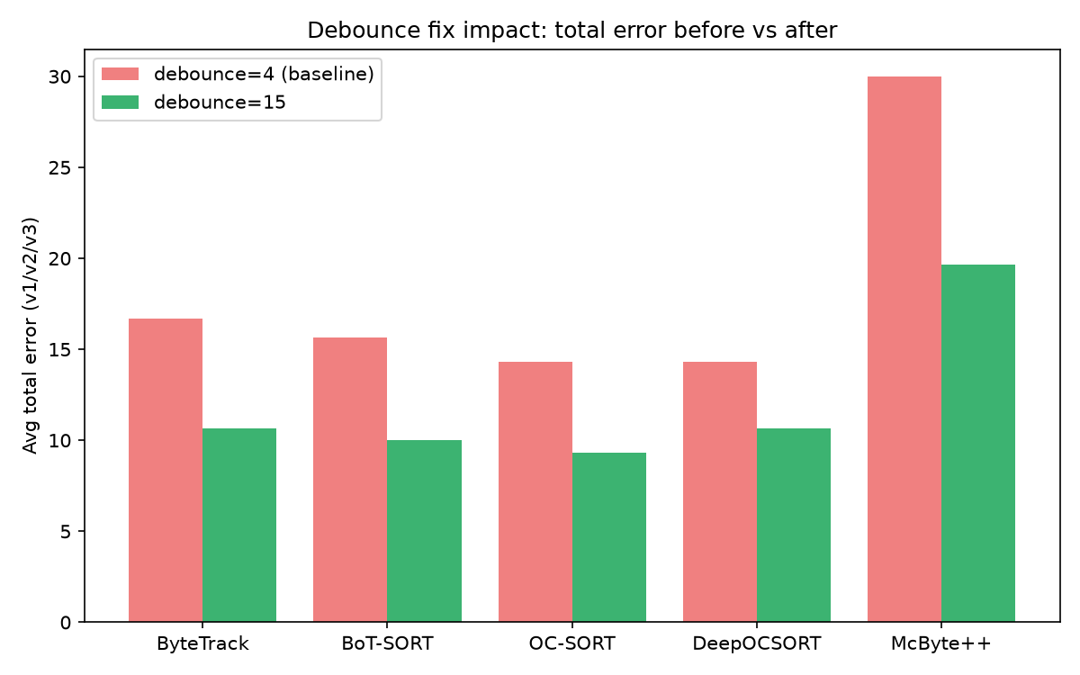
Figure 5. Total error per tracker (avg across v1/v2/v3), debounce=4 vs debounce=15.
Tracker | Avg error (debounce=4) | Avg error (debounce=15) | Change
ByteTrack | 16.67 | 10.67 | -6.00
BoT-SORT | 15.67 | 10.00 | -5.67
OC-SORT | 14.33 | 9.33 | -5.00
DeepOCSORT | 14.33 | 10.67 | -3.67
McByte++ | 30.00 | 19.67 | -10.33

7.1 Per-pair error, before vs after
Tracker | Version | Error (debounce=4) | Error (debounce=15) | Change
OC-SORT | v1 | 12 | 8 | -4
OC-SORT | v3 | 14 | 8 | -6
BoT-SORT | v1 | 12 | 9 | -3
DeepOCSORT | v1 | 12 | 9 | -3
ByteTrack | v1 | 14 | 10 | -4
BoT-SORT | v2 | 16 | 10 | -6
ByteTrack | v3 | 20 | 10 | -10
DeepOCSORT | v2 | 16 | 11 | -5
BoT-SORT | v3 | 19 | 11 | -8
McByte++ | v3 | 24 | 11 | -13
DeepOCSORT | v3 | 15 | 12 | -3
ByteTrack | v2 | 16 | 12 | -4
OC-SORT | v2 | 17 | 12 | -5
McByte++ | v1 | 33 | 24 | -9
McByte++ | v2 | 33 | 24 | -9
At debounce=15, the best pair is OC-SORT + v1 (error 8), vs BoT-SORT + v1 (error 12) at debounce=4.

