SKUBA gesture detection — Phase 3 baseline classifier
Generated 2026-08-31
Verdict: Phase 3 exit criterion NOT met.
Two tree baselines were trained independently as candidates for the single classifier slot (section 3). On accuracy they tie — macro-F1 0.64 on the real-generalisation classes. Most classes work, but `rock` and `mini_heart` are at 0.00 F1 — every test frame of each is classified as a different class. Those two failures are data/feature problems, not model-choice problems, and define the Phase 4 work.

1. Architecture — where this sits
The pipeline has exactly ONE classifier slot: 152-d fused feature vector in -> (class, confidence) out -> temporal smoothing -> final label or idle. Phase 3 trains candidate models for that slot; it does not stack or ensemble them. LightGBM and RandomForest are two candidates. Phase 4 adds an MLP and picks one to lock (ARCHITECTURE.md 'Classifier interface').
LightGBM = gradient-boosted shallow trees (each corrects the last). RandomForest = many independent deep trees, averaged. Both on the raw 152-d vector, class_weight='balanced', features clipped to +-10.

2. Train / test data
Train: 62,627 rows — cleaned external features (HaGRID, COCO) + augmentation, for 8 classes; the other 6 (sit, squat, laying, i_love_you, heart, glico_pose) are augmented copies of s01 frames (no external source). See docs/phase2b_external_data.md.
Test: 1,581 rows, never augmented — every original s01/s02 frame (1,367) + 214 held-out HaGRID `thumb` frames. s01/s02 are NOT in training (except as augmented copies for the 6 aug-only classes).

3. LightGBM vs RandomForest — the head-to-head
Both trained on the same 62,627-row train.npz, class_weight='balanced', raw 152-d features clipped to +-10. This is the Phase 3 comparison; Phase 4 adds an MLP and locks one.
metric | LightGBM | RandomForest
macro-F1 (all classes) | 0.745 | 0.748
macro-F1 (real-eval only) | 0.637 | 0.639
sit @ s02 recall (only clean cross-person number) | 0.43 | 0.77
fit time | 118.0 s | 56.0 s
model file size | 36.2 MB | 396.3 MB
Per-class F1 (bold = the two differ by > 0.05):
class | LGBM F1 | RF F1
idle | 0.59 | 0.65 | *
raise_right_hand | 0.82 | 0.81
raise_left_hand | 0.91 | 0.90
sit | 0.95 | 0.98
squat | 1.00 | 1.00
laying | 1.00 | 1.00
ok | 0.77 | 0.77
i_love_you | 0.68 | 0.69
rock | 0.00 | 0.00
two_finger | 0.83 | 0.81
thumb | 0.98 | 0.97
heart | 0.81 | 0.81
mini_heart | 0.00 | 0.00
t_pose | 0.84 | 0.84
glico_pose | 1.00 | 1.00
Read: accuracy is a wash. RandomForest is chosen as the working default for two reasons — its `sit`@s02 cross-person recall is much higher (0.77 vs 0.43; that is the only honest generalisation number we have) and its confidences are calibrated (LightGBM outputs ~1.0 on almost everything, which breaks the idle/unknown threshold in Phase 5). LightGBM's one real advantage is size (36 MB vs 396 MB) — revisit if the deploy target is tight on disk. Final lock is a Phase 4 decision, after the MLP and the feature fixes.

4. Per-class results (RandomForest)
class | eval type | n | prec | rec | F1 | conf
idle | cross_domain | 60 | 0.48 | 1.00 | 0.65 | 0.72
raise_right_hand | cross_domain | 96 | 0.98 | 0.69 | 0.81 | 0.71
raise_left_hand | cross_domain | 45 | 0.91 | 0.89 | 0.90 | 0.67
sit | aug_only_leak | 375 | 1.00 | 0.96 | 0.98 | 0.90
squat | aug_only_leak | 108 | 1.00 | 1.00 | 1.00 | 1.00
laying | aug_only_leak | 77 | 1.00 | 1.00 | 1.00 | 0.99
ok | cross_domain | 45 | 0.97 | 0.64 | 0.77 | 0.80
i_love_you | aug_only_leak | 141 | 0.53 | 1.00 | 0.69 | 1.00
rock | cross_domain | 102 | 0.00 | 0.00 | 0.00 | 0.80
two_finger | cross_domain | 87 | 0.89 | 0.74 | 0.81 | 0.91
thumb | held_out_external | 214 | 0.99 | 0.96 | 0.97 | 0.89
heart | aug_only_leak | 84 | 0.68 | 1.00 | 0.81 | 0.98
mini_heart | cross_domain | 45 | 0.00 | 0.00 | 0.00 | 0.87
t_pose | cross_domain | 36 | 1.00 | 0.72 | 0.84 | 0.82
glico_pose | aug_only_leak | 66 | 1.00 | 1.00 | 1.00 | 1.00
What each eval type means:
- cross_domain: external train, s01/s02 test — a real generalisation number
- held_out_external: cross-subject within HaGRID (same webcam domain)
- aug_only_leak: train = augmented s01 frames — NOT a generalisation number

5. sit — the one clean cross-person number
`sit` is trained on augmented s01 frames only, so its s02 test frames (a different person, different session, different room) are a genuine cross-person check:
subject | recall | meaning
s01 (315 frames) | 1.00 | same person as training basis — leaked, ignore
s02 (60 frames) | 0.77 | clean cross-person — the honest sit number

6. The two failures
rock -> i_love_you (all 102 frames); mini_heart -> heart (40/45).
- s01-attractor effect: `i_love_you` and `heart` are trained ONLY on augmented s01 frames, so the model over-fits that one person's hand and body. Any other s01 test frame that is geometrically nearby — s01's `rock`, s01's `mini_heart` — gets pulled in.
- Hand-landmark domain gap: on s01's `rock` the normalised thumb-to-pinky fingertip distance is ~1.3; on HaGRID's `rock` (what the model trained on) it is ~0.5. Palm-width normalisation does not close this — MediaPipe Hands on a tight wrist-crop of a distant robot-camera hand produces a differently proportioned skeleton than on a large frontal webcam hand.
- mini_heart body position: HaGRID `hand_heart` is a chest-level finger-heart; s01's `mini_heart` is hands-together overhead, which matches s01's `heart` (also overhead).
Below: MediaPipe hand landmarks for s01 `rock` (row 1, the misclassified test frames), s01 `i_love_you` (row 2, the aug-only training basis), and HaGRID `rock` (row 3, the actual training data). Rows 1 and 2 are the same person in the same session and are nearly identical in landmark space. Row 3 shows the HaGRID wrist-crop often misses the hand entirely (crop is sized by shoulder width, which is unreliable when the hips are out of frame) — so the model's `rock` knowledge is thin to begin with.
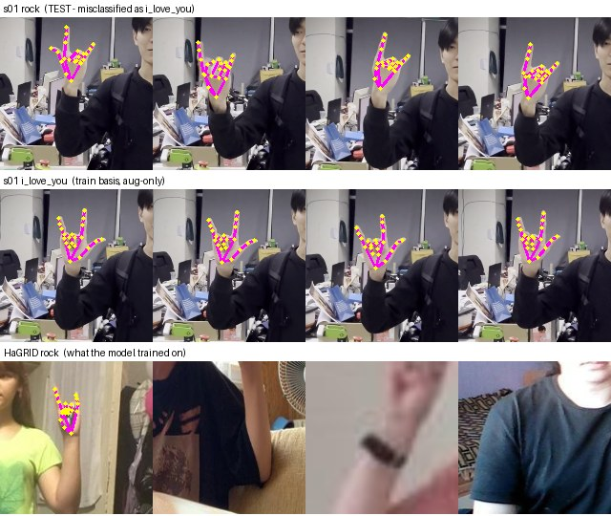

7. Top confusions
true | predicted as | count
rock | i_love_you | 99
mini_heart | heart | 40
two_finger | i_love_you | 23
raise_right_hand | idle | 22
sit | idle | 12
ok | idle | 11
t_pose | idle | 10
thumb | idle | 6
ok | i_love_you | 5
rock | two_finger | 3

8. Phase 4 plan
- 1. Close the hand-landmark domain gap — add hand-scale + hand-rotation jitter to features/augment.py, or canonicalise hand orientation in normalize_hand, or switch to joint-angle features (scale-free, would sidestep it entirely). IMPLEMENTATION_PLAN Phase 4 already calls for the raw-coords vs derived-features comparison.
- 2. Stop `i_love_you` / `heart` poisoning neighbours — raise their per-class confidence threshold, down-weight them, or find real data (none exists for the ASL ILY handshape; HaGRID's heart is the wrong pose).
- 3. mini_heart — drop the HaGRID chest-level data and treat as aug-only, or add an overhead-position augmentation.
- 4. idle over-triggers (precision 0.48) — tune the idle threshold on a validation slice; the `call`->idle hard-negatives may be too aggressive.
- 5. Re-run the LightGBM vs RF vs MLP comparison once the features are fixed, then lock one config (Phase 4 deliverable).

