SKUBA gesture detection — Phase 2 dataset
Generated 2026-08-31
We have only 2 recorded subjects (s01: all classes; s02: laying + sit). That is too few for a leak-free subject-wise split. Decision (RoboCup@Home context, licences not a blocker): TRAIN the classifier on public datasets and keep every original s01/s02 frame as a held-out TEST set. This report is what to tell the team: which datasets, what the images look like, and how the training set was built.

1. What was downloaded
Source | Dataset | Image style | Licence | Our classes
HaGRID v1 | cj-mills/hagrid-sample-30k-384p (HF mirror of hukenovs/hagrid) | webcam / phone images, upper body, hand bbox <=16% of frame | custom BY-SA-style, no NC clause (RoboCup use fine) | ok, two_finger (peace), rock, thumb (like); call -> idle hard-negative
HaGRID no_gesture | cj-mills/hagrid-classification-512p-no-gesture-150k | same, hand visible but no gesture | as above | idle
HaGRID v2 | testdummyvt/hagRIDv2_512px (val split) | same, 34 classes | disputed commercial status; RoboCup use fine | mini_heart (hand_heart / hand_heart2)
COCO 2017 | person_keypoints_train2017 + images.cocodataset.org | in-the-wild photos, full scenes, many sports/action shots | annotations CC BY 4.0 | t_pose, raise_right_hand, raise_left_hand; + idle negatives
Nothing was downloaded in bulk. pipeline/extract_external.py streams the HuggingFace parquet shards one at a time (~50-500 MB, deleted right after), runs our MediaPipe Pose + Hands pipeline on each image, and keeps ONLY the 152-d normalised feature vector (~0.6 KB/frame). COCO downloads only the ~250 MB keypoint-annotation JSON plus the few hundred images that pass a pose filter. No source images are retained.

2. What the training images look like
6 examples per class below: top row = the source image, bottom row = the MediaPipe skeleton + wrist-anchored hand crop that we actually turn into features. This is exactly what the model sees.

ok — HaGRID
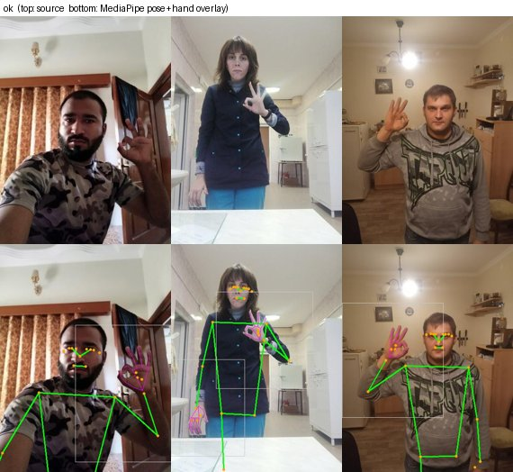

rock — HaGRID
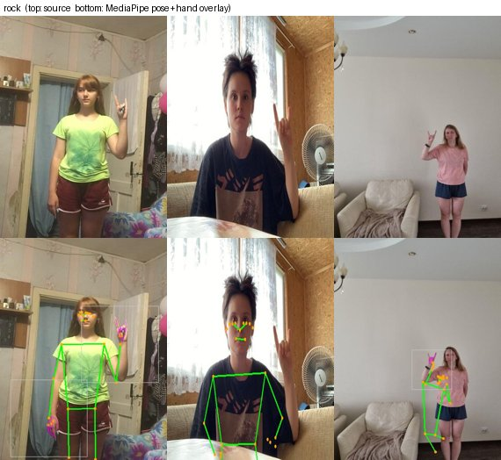

thumb — HaGRID
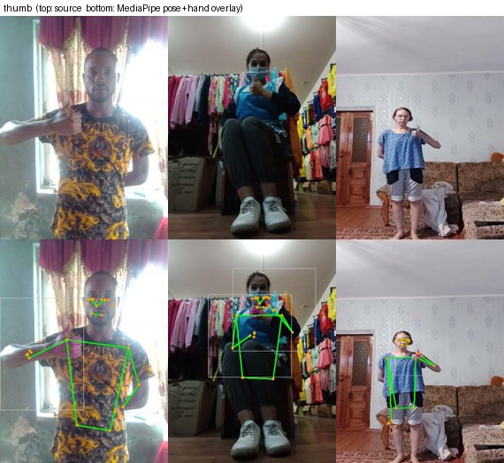

two_finger — HaGRID
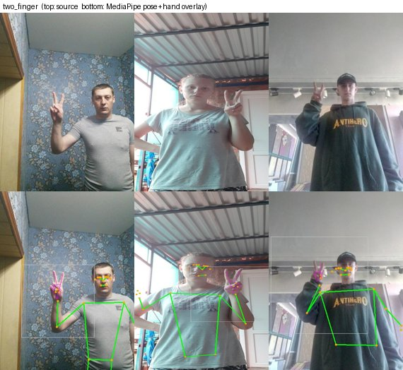

ily_negative_call — HaGRID (-> idle negative)
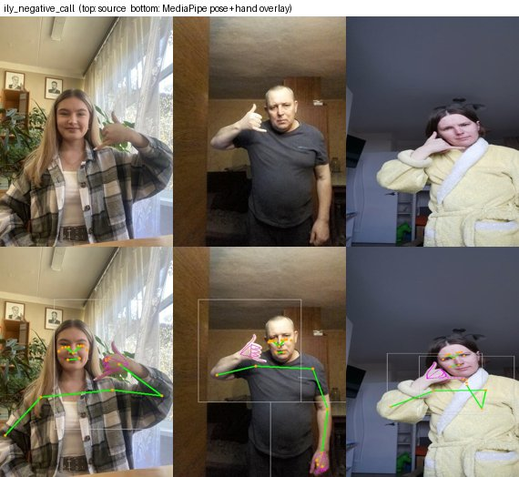

idle_hagrid — HaGRID no_gesture -> idle
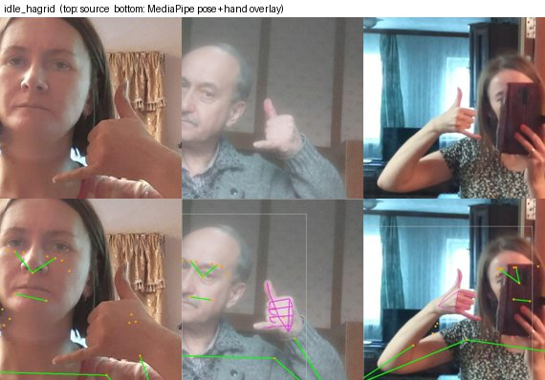

t_pose — COCO
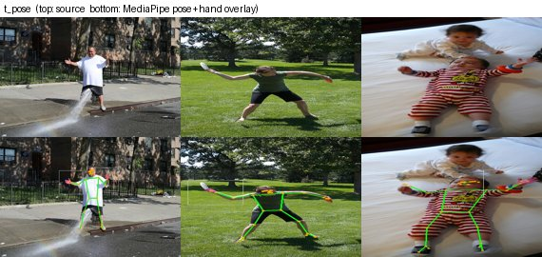

raise_right_hand — COCO
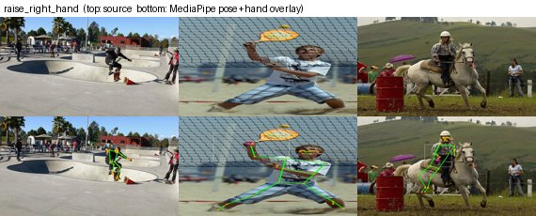

raise_left_hand — COCO
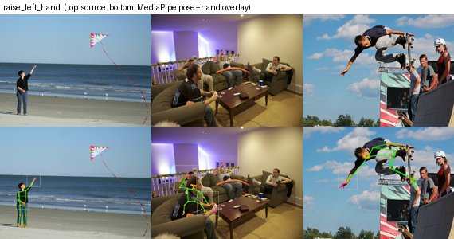

idle_coco — COCO -> idle
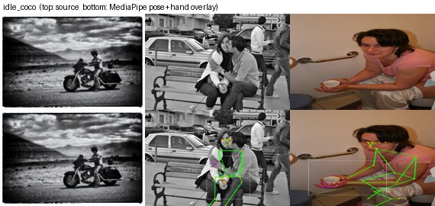
mini_heart (HaGRIDv2 hand_heart) samples could not be pulled — the HuggingFace preview API is down for that repo. Grab them on Colab if the team needs them. Note the class also failed in Phase 3: HaGRID's hand-heart is a CHEST-level finger-heart, s01's mini_heart is hands-together OVERHEAD — different pose.
Note the COCO honesty problem visible above: COCO has ACTIONS, not gestures. 'arm raised' catches pitchers, tennis players, riders; 't_pose' catches a baby lying with arms spread. MediaPipe re-verification (section 4) drops ~55% of the COCO rows, but the survivors are still sports-flavoured. This is why t_pose / raise_hand test lower and why Phase 6 field data matters.

3. From image to feature
- person -> MediaPipe Pose -> 33 body landmarks.
- each wrist -> square crop sized by shoulder width -> MediaPipe Hands -> 21 landmarks/hand (or absent -> presence flag = 0).
- normalise: body centred on the shoulder-hip midpoint / scaled by shoulder-hip distance; each hand centred on its wrist / scaled by palm width (features/normalize.py).
- concatenate -> 152-d vector: body[0:66], left hand[66:108] + flag[108], right hand[109:151] + flag[151] (features/schema.py).

4. Cleaning the external features
pipeline/build_dataset.py::_clean_external drops: (a) rows with any |feature| > 12 — normalisation blows up when the hips are out of a webcam frame; (b) hand-shape classes (ok/rock/thumb/two_finger/mini_heart) with no hand detected; (c) COCO pose rows whose MediaPipe keypoints don't actually show the pose (COCO's own annotation frequently points at a different person in a multi-person photo).
source file | raw rows | kept | %
_coco_idle.npz | 1500 | 1492 | 99
raise_left_hand.npz | 1109 | 467 | 42
raise_right_hand.npz | 1424 | 584 | 41
t_pose.npz | 186 | 102 | 54
_ily_negative.npz | 1662 | 1506 | 90
ok.npz | 1654 | 1508 | 91
rock.npz | 1625 | 1434 | 88
thumb.npz | 1611 | 1431 | 88
two_finger.npz | 2500 | 2108 | 84
idle.npz | 3000 | 2990 | 99
mini_heart.npz | 1800 | 1784 | 99

5. Building train / test
train.npz = 62,627 rows: cleaned external features + augmentation (mirror+relabel, limb-length jitter, rotation, keypoint dropout, coord noise — features/augment.py). Per-class cap ~7,000; scarce classes boosted to ~2,200.
test.npz = 1,581 rows, NEVER augmented: 1,367 original s01/s02 frames + 214 held-out HaGRID `thumb` (s01 has no thumb). s01/s02 never appear in training except as augmented copies for the 6 aug-only classes.
class | eval type | train source | train rows | test rows
idle | cross_domain | external: coco_pose/hagrid/hagrid_nogesture | 7000 | 60
raise_right_hand | cross_domain | external: coco_pose | 2920 | 96
raise_left_hand | cross_domain | external: coco_pose | 2802 | 45
sit | aug_only_leak | aug(s01) only x7 | 2205 | 375
squat | aug_only_leak | aug(s01) only x21 | 2268 | 108
laying | aug_only_leak | aug(s02) only x29 | 2233 | 77
ok | cross_domain | external: hagrid | 7000 | 45
i_love_you | aug_only_leak | aug(s01) only x16 | 2256 | 141
rock | cross_domain | external: hagrid | 7000 | 102
two_finger | cross_domain | external: hagrid | 7000 | 87
thumb | held_out_external | external: hagrid | 6085 | 214
heart | aug_only_leak | aug(s01) only x27 | 2268 | 84
mini_heart | cross_domain | external: hagrid_v2_heart | 7000 | 45
t_pose | cross_domain | external: coco_pose | 2346 | 36
glico_pose | aug_only_leak | aug(s01) only x34 | 2244 | 66

6. What each class's test number will mean
- cross_domain (idle, ok, two_finger, rock, thumb, mini_heart, raise_L/R_hand, t_pose): external train, our test — a REAL cross-subject + cross-domain generalisation number.
- held_out_external (thumb): cross-subject within HaGRID, same webcam domain.
- aug_only_leak (sit, squat, laying, i_love_you, heart, glico_pose): no external data. Train = augmented s01 frames. For `sit`, s02's frames are still a clean cross-person check (aug pool is s01-only); for `laying` there is no s01 so it is a full leak. These are NOT generalisation numbers — Phase 6 field testing is the gate.

7. Known gaps
- sit / laying / squat / i_love_you / heart / glico_pose — no external data found (NTU needs registration, Le2i's link is dead, ASL ILY sign is in no static-image dataset).
- Hand-landmark domain gap: s01's fingertip spread is ~2x HaGRID's even after palm-width normalisation (Phase 3 report). This broke `rock`.
- COCO poses are action photos, not held gestures.
- mini_heart body position (chest vs overhead).

