SKUBA gesture detection — Phase 4: classifier comparison
Generated 2026-09-01
3 candidate classifiers trained on the same 12-class pipeline (train 52,738 / val 2,357 / test 1,254), scored by classifier/evaluate.py. Leading model on the real-generalisation metric: LGBM.

1. Headline metrics — every candidate
metric | LGBM | RF | LOGREG
macro-F1 (12) | 0.888 | 0.823 | 0.667
macro-F1 (real-eval) | 0.866 | 0.788 | 0.610
accuracy | 0.923 | 0.868 | 0.785
balanced acc | 0.878 | 0.815 | 0.677
ECE (lower better) | 0.036 | 0.146 | 0.083
conf | correct | 0.952 | 0.769 | 0.884
conf | wrong | 0.796 | 0.437 | 0.520
size (MB) | 31 | 389 | <1
fit (s) | 104 | 43 | 31
'real-eval' = macro-F1 over the classes with a genuine cross-domain / cross-subject test (excludes the aug-only-leak classes squat, glico_pose). 'conf | correct' vs 'conf | wrong' is the mean max-probability when the prediction is right vs wrong — the gap is what the Phase 5 idle/unknown threshold needs; a model that is accurate but piles all its confidence at ~1.0 needs post-hoc calibration first.
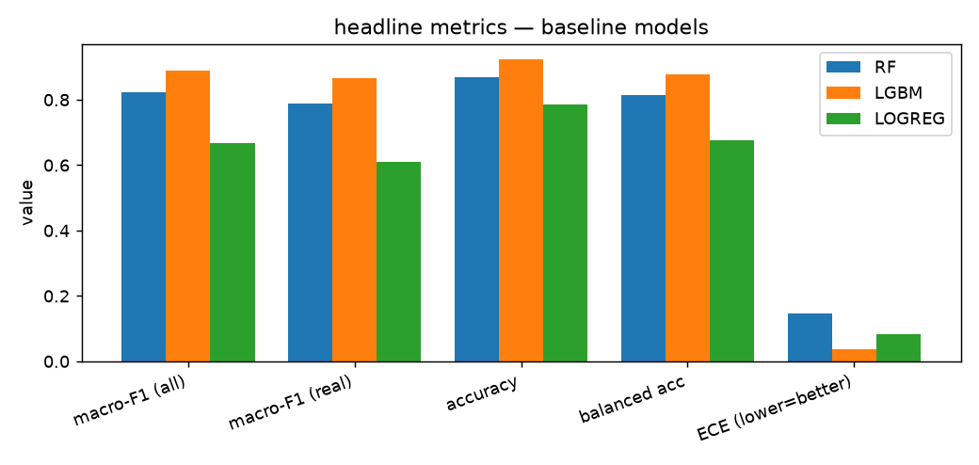

2. Per-class F1
class | LGBM | RF | LOGREG
idle | 0.66 | 0.62 | 0.00
raise_right_hand | 0.81 | 0.79 | 0.74
raise_left_hand | 0.83 | 0.79 | 0.72
sit | 0.96 | 0.89 | 0.80
squat | 1.00 | 1.00 | 0.92
laying | 0.94 | 0.41 | 0.33
ok | 0.78 | 0.78 | 0.78
two_finger | 0.98 | 0.96 | 0.97
thumb | 0.98 | 0.98 | 0.89
mini_heart | 0.89 | 0.83 | 0.00
t_pose | 0.82 | 0.82 | 0.87
glico_pose | 1.00 | 1.00 | 0.99
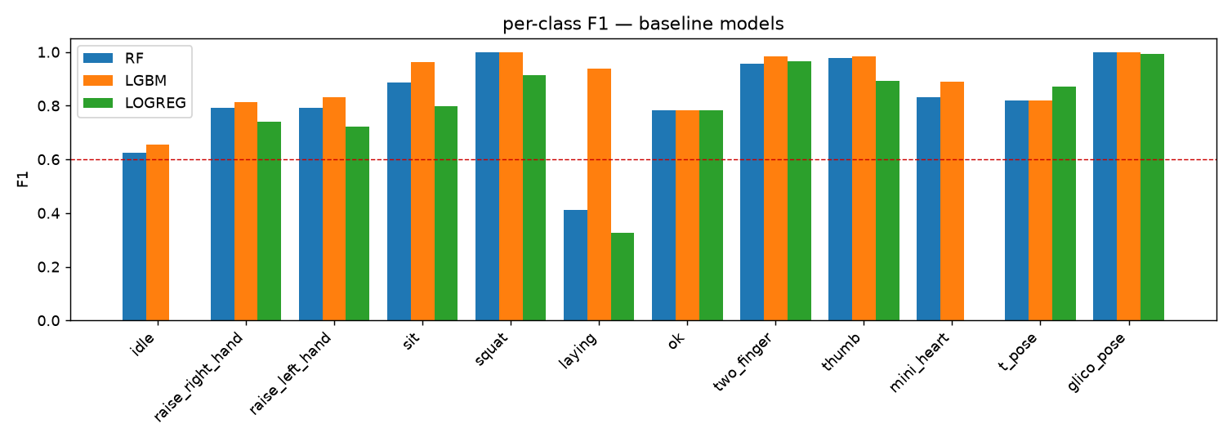

3. Cross-person (sit — the only multi-subject class)
model | sit @ s01 | sit @ s02 (never trained)
LGBM | 0.971 | 1.0
RF | 0.94 | 0.9
LOGREG | 0.946 | 0.633
s02 recall is the single most trustworthy number — a person who never appears in training.

4. The leading model in detail — LGBM
class | eval type | n | prec | rec | F1 | conf
idle | cross_domain | 60 | 0.492 | 0.983 | 0.656 | 0.976
raise_right_hand | cross_domain | 96 | 0.971 | 0.698 | 0.812 | 0.956
raise_left_hand | cross_domain | 45 | 0.784 | 0.889 | 0.833 | 0.977
sit | cross_domain | 375 | 0.951 | 0.976 | 0.963 | 0.896
squat | aug_only_leak | 108 | 1.0 | 1.0 | 1.0 | 1.0
laying | cross_domain | 77 | 1.0 | 0.883 | 0.938 | 0.874
ok | cross_domain | 45 | 1.0 | 0.644 | 0.784 | 0.969
two_finger | cross_domain | 87 | 0.967 | 1.0 | 0.983 | 1.0
thumb | held_out_external | 214 | 1.0 | 0.967 | 0.983 | 0.981
mini_heart | cross_domain | 45 | 1.0 | 0.8 | 0.889 | 0.743
t_pose | cross_domain | 36 | 1.0 | 0.694 | 0.82 | 0.922
glico_pose | aug_only_leak | 66 | 1.0 | 1.0 | 1.0 | 1.0
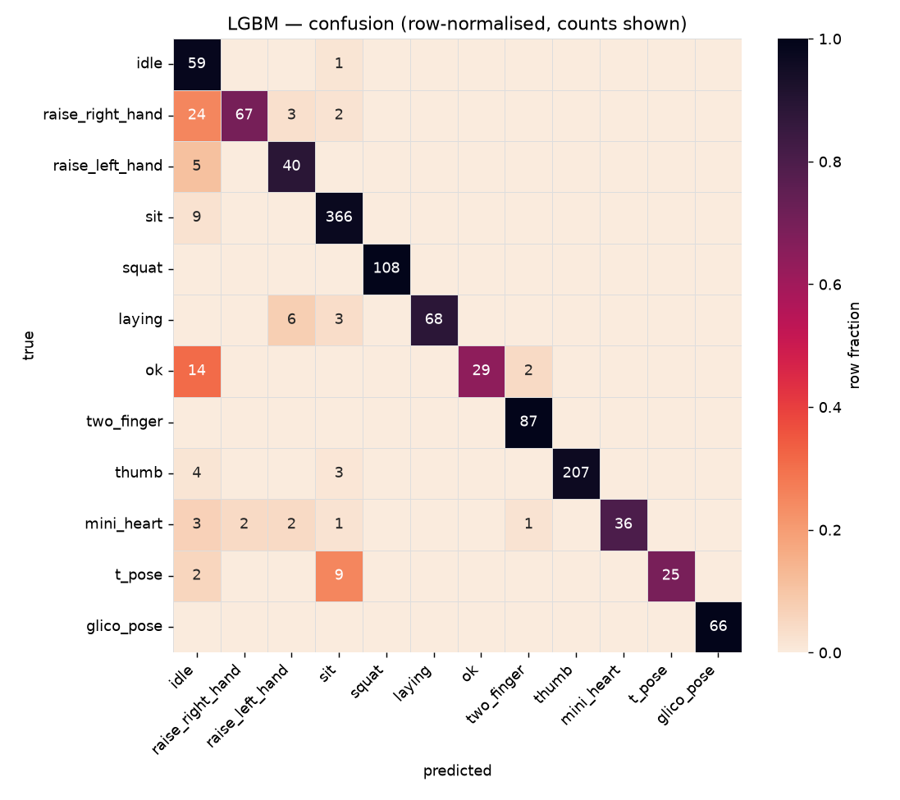
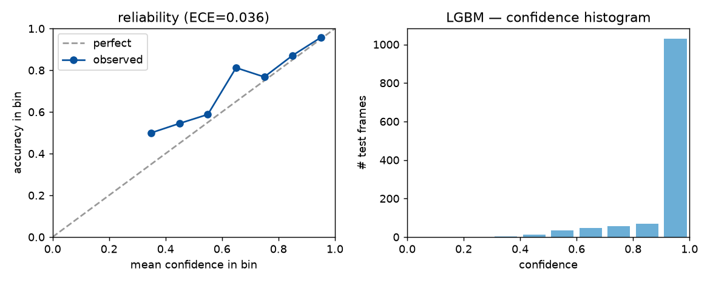

5. Verdict + what's next
LGBM is the working pick. Remaining Phase 4 work: (a) if LGBM's confidence is piled at ~1.0, apply Platt / isotonic / temperature calibration and re-score; (b) shrink any tree model that is the pick and over-sized; (c) Track D — tune AugParams strength against the val split; (d) Track E — per-class confidence thresholds on the val split for the idle/unknown fallback. Then lock and write docs/phase4_baseline.md.

