SKUBA gesture detection — Phase 1 backbone test
Generated 2026-08-30
Verdict: MediaPipe Pose + MediaPipe Hands.
MediaPipe wins on the constraint that actually matters for this project — GPU memory. It runs entirely on CPU (0 MB VRAM), while the shared GPU on the deploy laptop has to be left free for the other robot modules. It also gave the most stable keypoints on the hard poses and had no second-person confusion. YOLO and RTMPose are faster on GPU but every one of those milliseconds is bought with VRAM the robot cannot spare, and both mis-locked onto a bystander in the test clips.

Scorecard
Backbone | VRAM MB | CPU ms/f | GPU ms/f | Detect (avg) | Keypoint quality | Use it?
MediaPipe Pose | 0 (CPU) | 38 | 37 (CPU) | 98% | Stable on squat/sit. No flyaway keypoints; single-person model so it never jumps to the bystander. Occluded legs are inferred, occasionally implausible on the worst floor frames. | YES - default
YOLO11n-pose | 70 | 119 | 24 | 100% | Head/face keypoints repeatedly shoot to the frame corners at high confidence; skeleton jumps to the background bystander in several frames. | no
YOLO11s-pose | 130 | 198 | 21 | 100% | Torso cleaner than 11n but the corner-flyaway head keypoints and bystander pickup remain. | no
RTMPose-t (rtmlib) | 359 | 167 | 37 | 100% | Skeleton usually clean; the bundled YOLOX-tiny detector picks the bystander in a minority of frames. | no
RTMPose-m (rtmlib) | 611 | 356 | 83 | 100% | Best skeleton of the lot — clean through the whole deep crouch, no flyaways. Costs: 356 ms/frame on CPU, and the YOLOX-m detector can still grab a bystander. | no
VRAM: MediaPipe 0 (CPU). CPU/GPU ms are per frame on squat_01, this machine. 'Detect' = frames with a person found, averaged over the three posture clips.

1. Test setup
Host: Windows-10-10.0.26200-SP0, Python 3.11.15. GPU: NVIDIA GeForce RTX 3050 Laptop GPU (4096.0 MB). Latency is measured on this machine and is only a proxy for the Acer/Ubuntu deploy laptop; treat the ranking and the VRAM figures as the durable result.
Hard-case clips (from data/clips/, subject at ~2–4 m): posture — laying_01, squat_01, sit_02; hands — rock_01, ok_01, i_love_you_01, two_finger_01. For each backbone we record per-frame latency (mean / p90 / FPS), the detection rate, peak VRAM, and an 8-frame annotated montage for visual keypoint-quality review.
Note: the MediaPipe Python wheel is CPU-only on both Windows and Linux — there is no GPU delegate through pip — so its 'GPU' row is identical to CPU.

2. Body-pose latency & VRAM — CPU
Backbone | Ran on | squat ms/f | p90 ms | FPS | laying ms/f | sit ms/f | VRAM MB
MediaPipe Pose | cpu | 37.9 | 45.6 | 26.4 | 41.1 | 43.7 | 0
YOLO11n-pose | cpu | 118.8 | 132.0 | 8.4 | 136.8 | 128.5 | 0
YOLO11s-pose | cpu | 197.9 | 223.1 | 5.1 | 199.2 | 177.5 | 0
RTMPose-t (rtmlib) | cpu | 166.5 | 199.7 | 6.0 | 154.0 | 156.9 | 0
RTMPose-m (rtmlib) | cpu | 355.5 | 405.7 | 2.8 | 365.4 | 361.9 | 0

3. Body-pose latency & VRAM — GPU requested
Backbone | Ran on | squat ms/f | p90 ms | FPS | laying ms/f | sit ms/f | VRAM MB
MediaPipe Pose | cpu | 37.1 | 44.5 | 27.0 | 45.5 | 37.2 | 0
YOLO11n-pose | cuda | 23.6 | 29.6 | 42.3 | 28.5 | 25.0 | 70
YOLO11s-pose | cuda | 21.2 | 25.9 | 47.1 | 46.3 | 24.8 | 130
RTMPose-t (rtmlib) | cuda | 36.8 | 47.1 | 27.2 | 60.4 | 31.4 | 359
RTMPose-m (rtmlib) | cuda | 83.5 | 99.3 | 12.0 | 65.2 | 79.5 | 611

4. Detection rate (person found / total frames)
CPU pass:
Backbone | laying | squat | sit
MediaPipe Pose | 37/40 | 40/40 | 40/40
YOLO11n-pose | 40/40 | 40/40 | 40/40
YOLO11s-pose | 40/40 | 40/40 | 40/40
RTMPose-t (rtmlib) | 40/40 | 40/40 | 40/40
RTMPose-m (rtmlib) | 40/40 | 40/40 | 40/40

5. Keypoint quality — visual review
8 frames per clip, evenly spaced. Green = skeleton, orange = keypoints. Look for: keypoints flying to the frame edge, the skeleton jumping to a second person, limbs snapping to implausible angles. Keypoints are the same on CPU and GPU (identical models) — only latency changes. Full annotated clips: results/phase1/annotated/.

MediaPipe Pose — squat
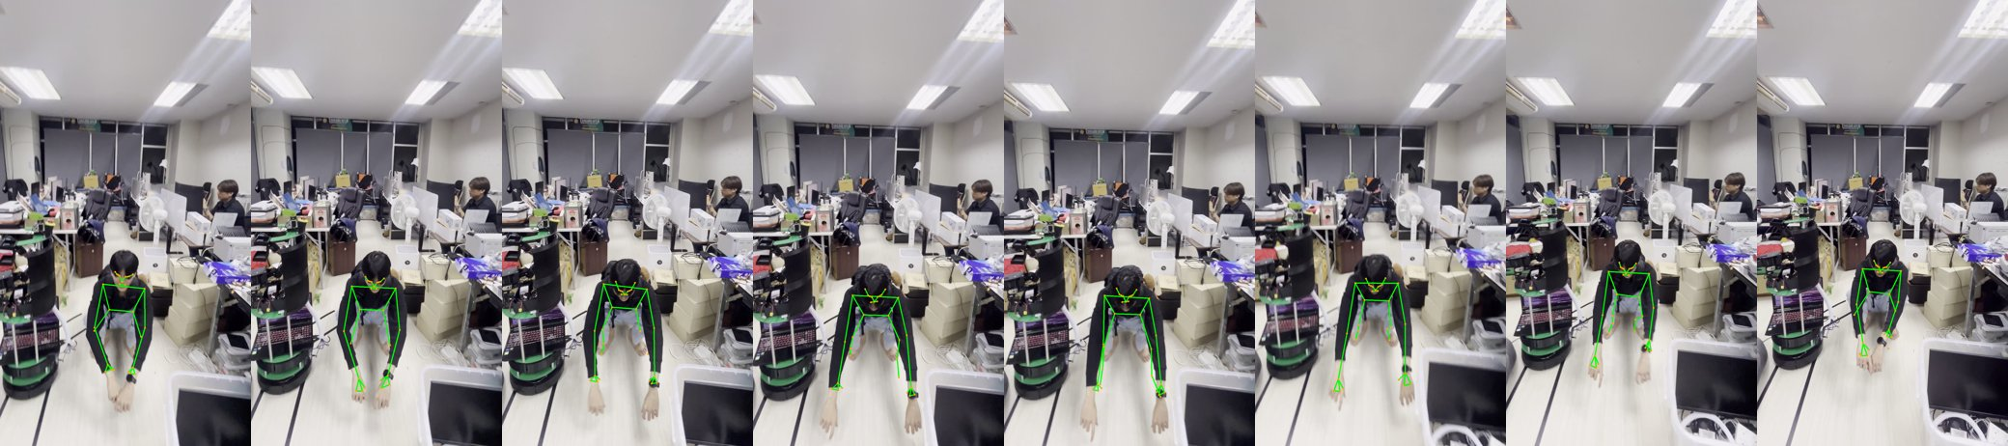

MediaPipe Pose — laying
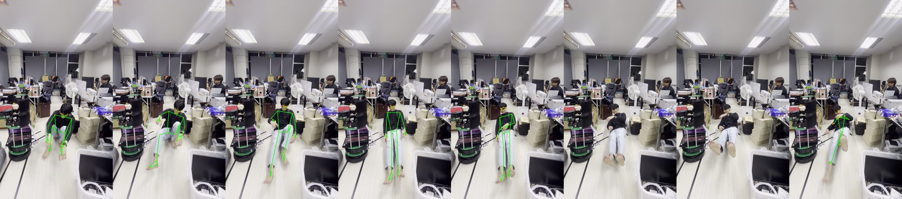

MediaPipe Pose — sit
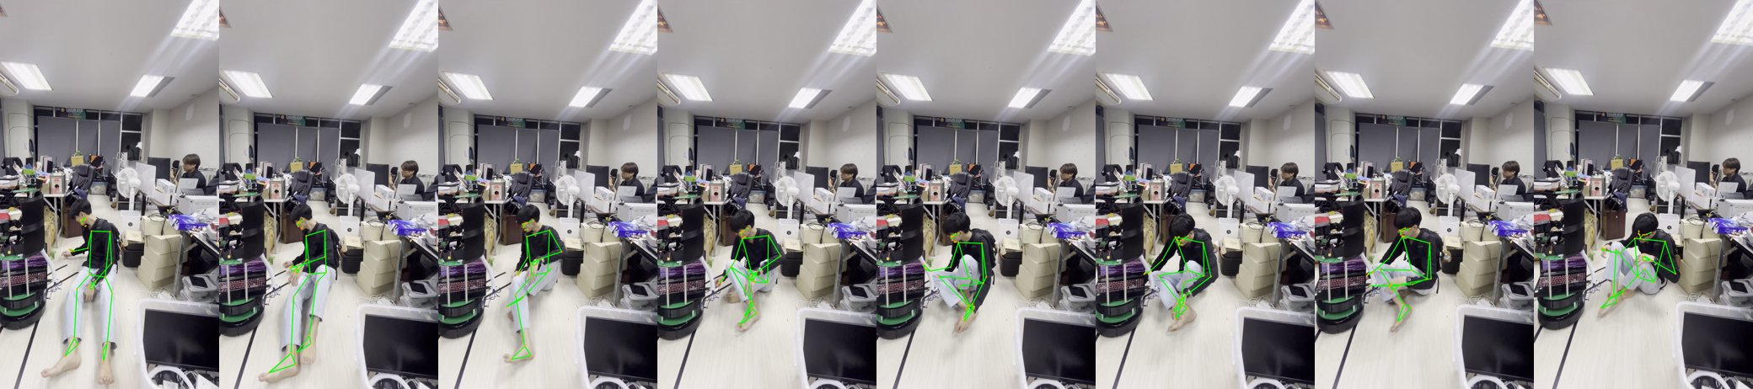

YOLO11n-pose — squat
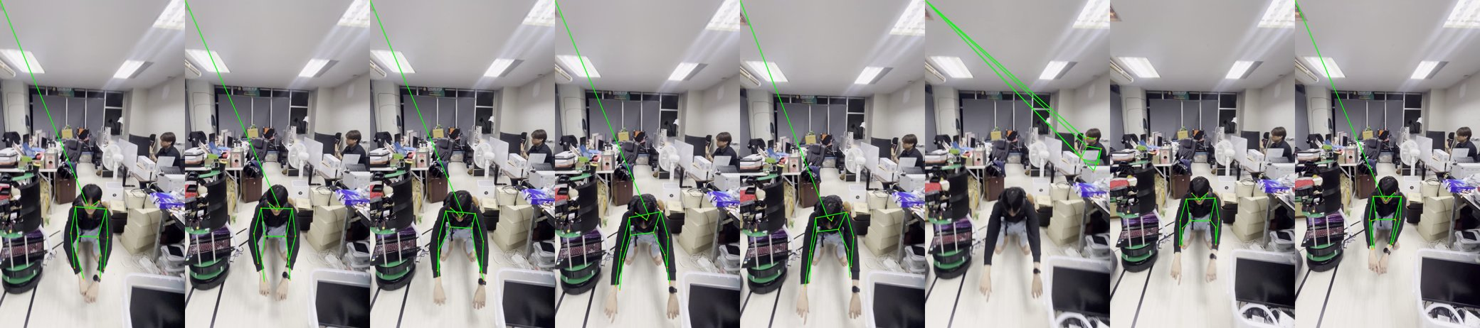

YOLO11n-pose — laying
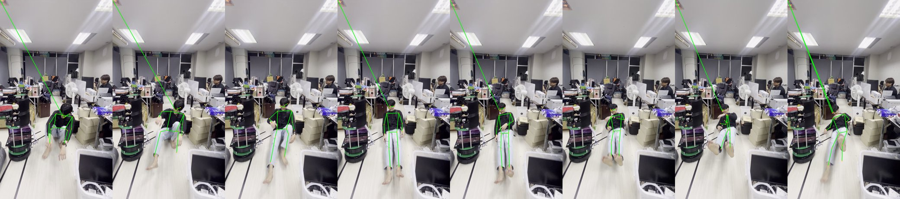

YOLO11n-pose — sit
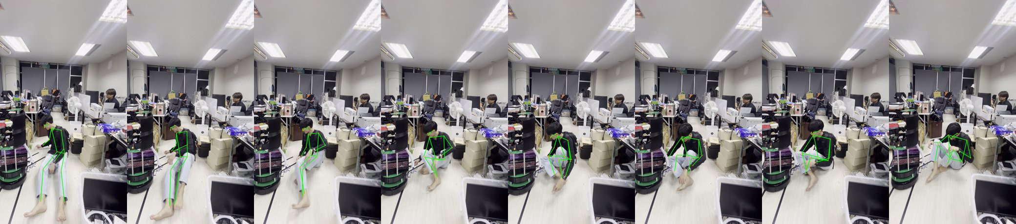

YOLO11s-pose — squat
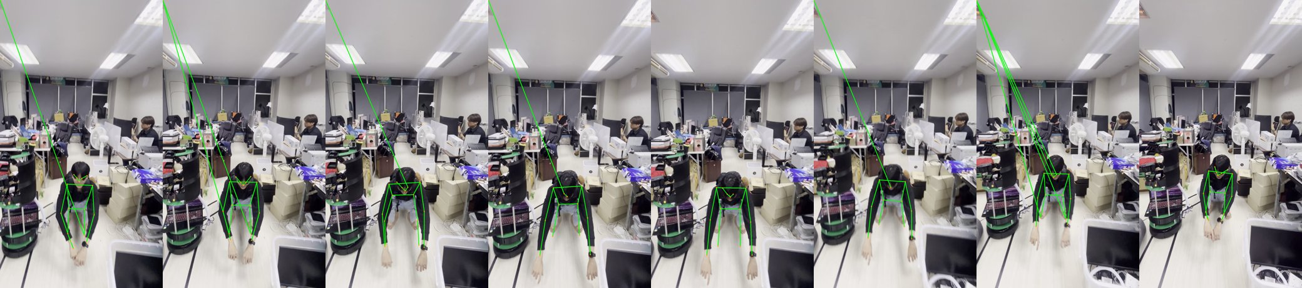

YOLO11s-pose — laying
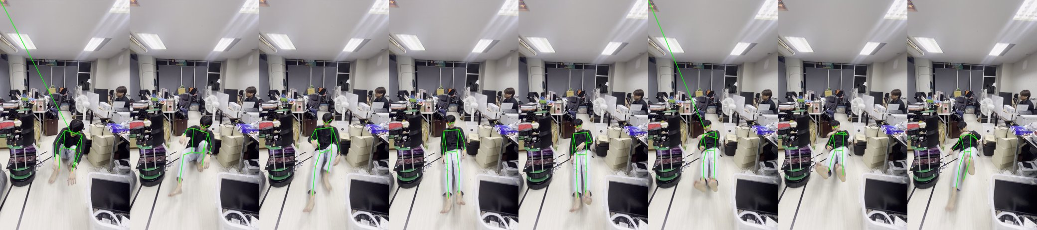

YOLO11s-pose — sit
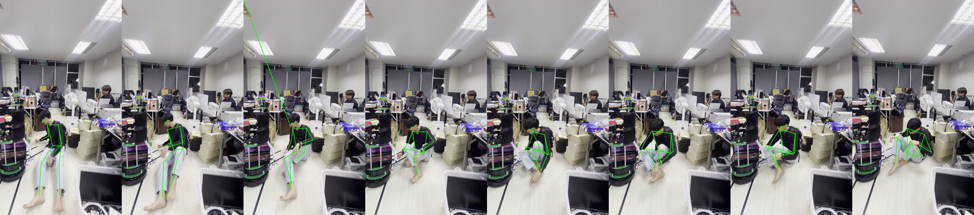

RTMPose-t (rtmlib) — squat
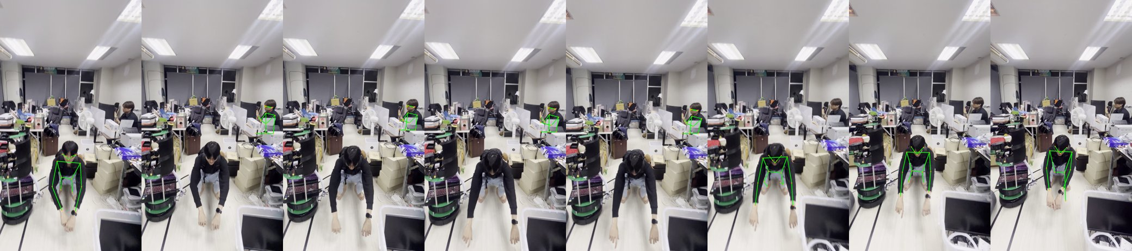

RTMPose-t (rtmlib) — laying
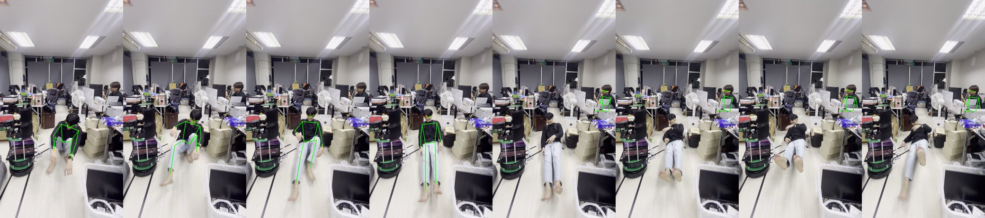

RTMPose-t (rtmlib) — sit
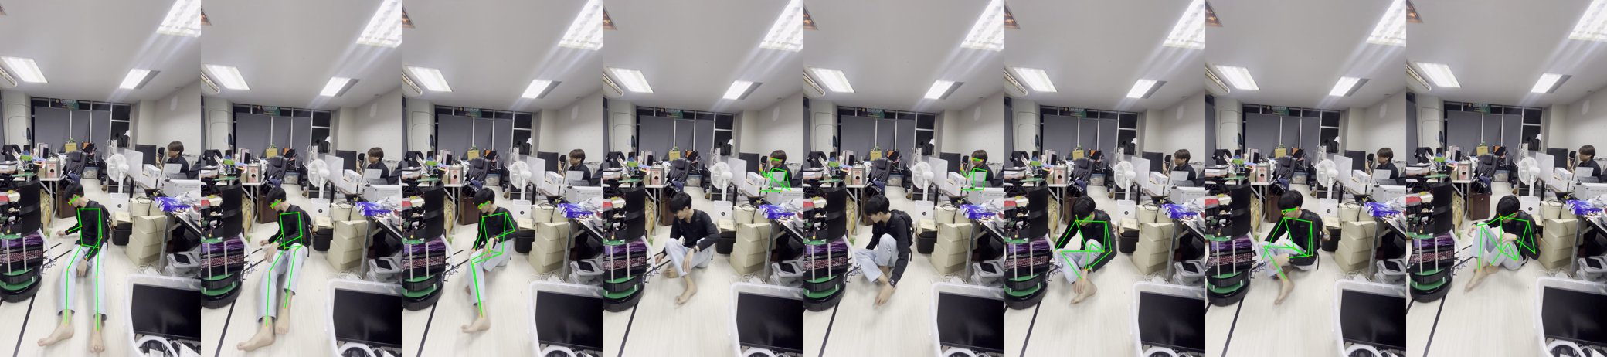

RTMPose-m (rtmlib) — squat
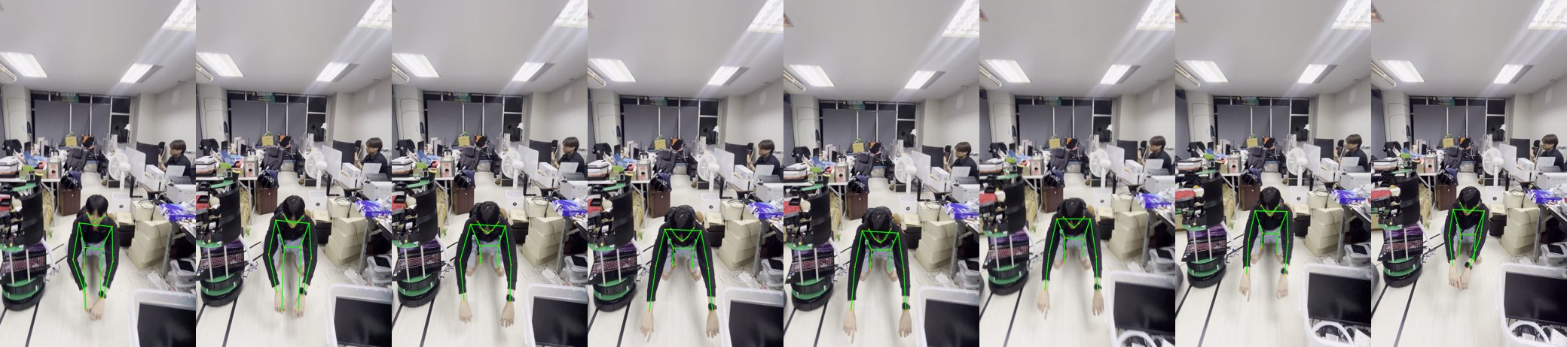

RTMPose-m (rtmlib) — laying
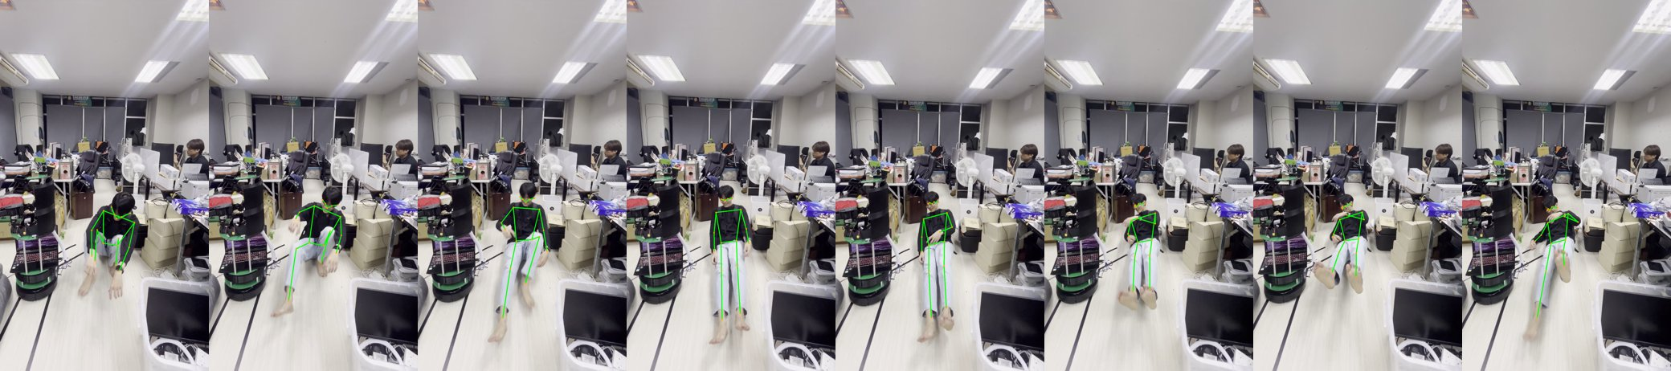

RTMPose-m (rtmlib) — sit
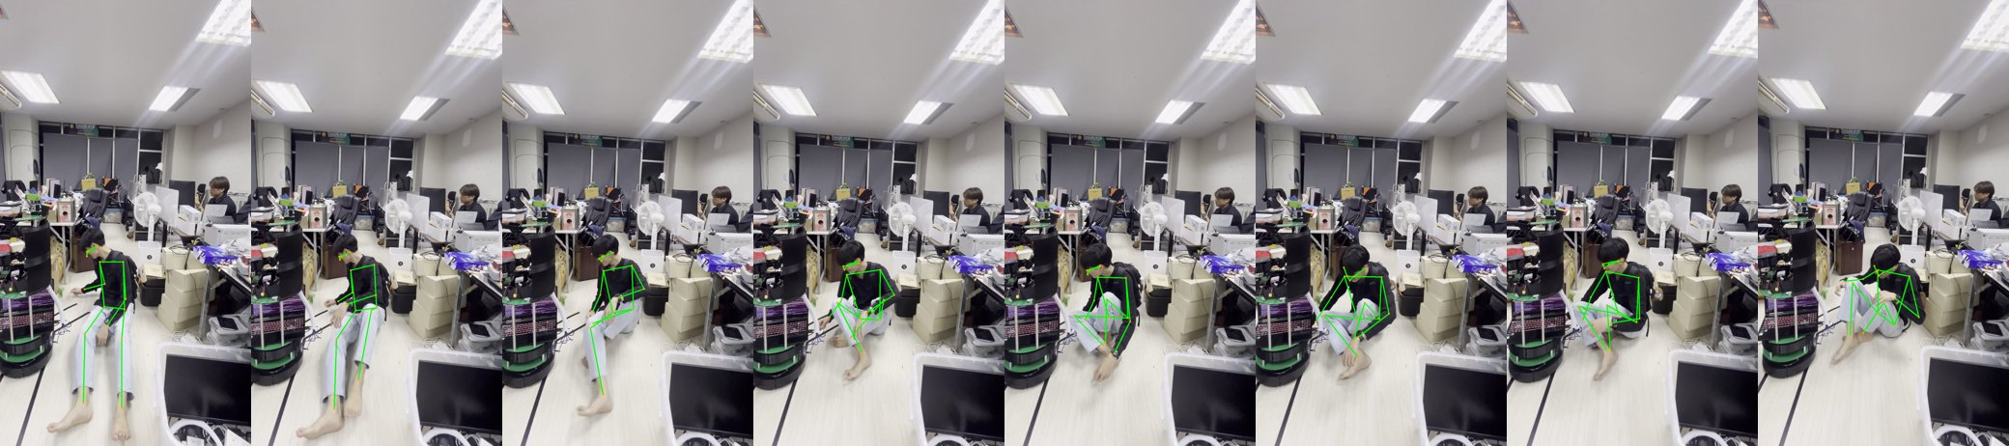

5b. Why not just run the fast one on the GPU?
The dev GPU has 4096.0 MB; the deploy laptop is similar and its VRAM is shared with the other perception / navigation modules. Every model that touches the GPU takes a fixed slice away from them for the whole session. The GPU-latency win (below) does not change that MediaPipe's 0-MB footprint is the right default; revisit only if a measured accuracy gap forces it.

6. Hands — MediaPipe Hands on wrist-anchored crops
Gesture clip | detected / crops | ms/crop
rock | 102/102 | 56.6 ms
ok | 35/45 | 39.8 ms
i_love_you | 141/141 | 39.0 ms
two_finger | 87/87 | 39.2 ms
Misses are concentrated at the moments the hand enters/leaves frame (motion blur), not on the held gesture — which is exactly what the presence-flag + temporal-smoothing design absorbs.

7. Combined pipeline (the real workload)
MediaPipe Pose + 2 wrist-crop hand detections per frame: 116 ms/frame ≈ 8.6 FPS (CPU pass) / 120 ms ≈ 8.3 FPS (GPU pass — unchanged, MediaPipe does not use the GPU). The two hand crops are the bottleneck (~2/3 of the time).

8. Recommendation
- Lock MediaPipe Pose + MediaPipe Hands.
- Rationale in priority order: (1) 0 VRAM — the deploy GPU is shared; (2) most stable keypoints on squat/sit, no bystander lock-on; (3) on CPU it is 3–9× faster than every alternative; (4) hand landmarks stable on the overlapping-finger shapes (rock, ILY).
- The GPU alternative, stated plainly: YOLO11n-pose on CUDA is the fastest option at ~24 ms (42 FPS) but costs ~70 MB VRAM, a torch+CUDA runtime (~5 GB on disk), the flyaway-keypoint / bystander bugs, and a re-write of the person-selection logic. RTMPose-m has the nicest skeleton but needs ~600 MB VRAM and a separate detector. None of that is worth it while the robot's GPU budget is the binding constraint.

Open items before Phase 1 is fully signed off
- Record a clean 'laying' clip from the robot's camera height and re-run — the current laying_01 is mostly transition and occlusion.
- Confirm the combined ~9 FPS on the actual Acer/Ubuntu laptop and agree a real-time budget. If short: MediaPipe Tasks GPU delegate, smaller hand crops, or static_image_mode=False for hands.

