**NAME : P PREM SAI**

**USN : 1BM19CS109**

**BDA-LAB 2**

1) Using MongoDB

1. Create a database for Students and Create a Student Collection (_id,Name, USN, Semester, Dept_Name, CGPA, Hobbies(Set)).
2. Insert required documents to the collection.
3. First Filter on “Dept_Name:CSE” and then group it on “Semester” and

compute the Average CPGA for that semester and flter those documents where the “Avg_CPGA” is greater than 7.5.

1. Command used to export MongoDB JSON documents from “Student” Collection into the “Students” database into a CSV fle “Output.txt”.

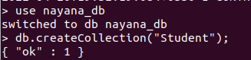

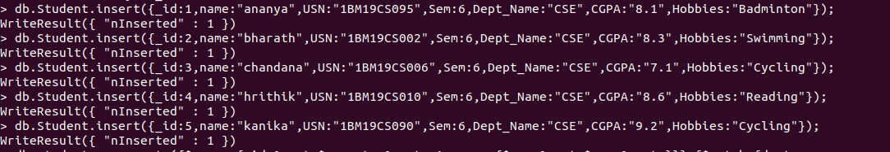

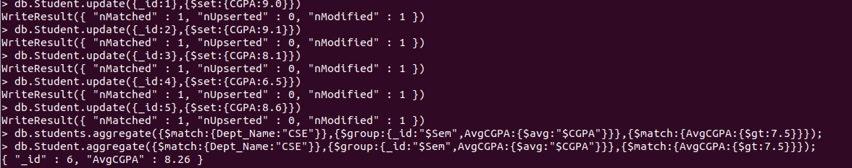



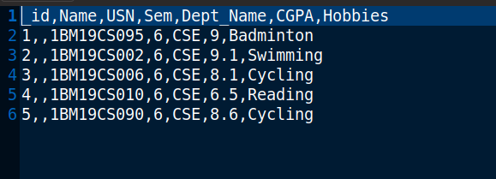

2)Create a mongodb collection Bank. Demonstrate the following by choosing felds of your choice.

1. Insert three documents
2. Use Arrays(Use Pull and Pop operation)
3. Use Index
4. Use Cursors
5. Updation

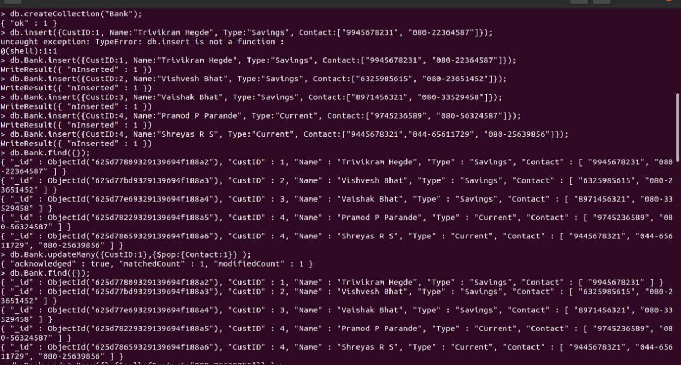

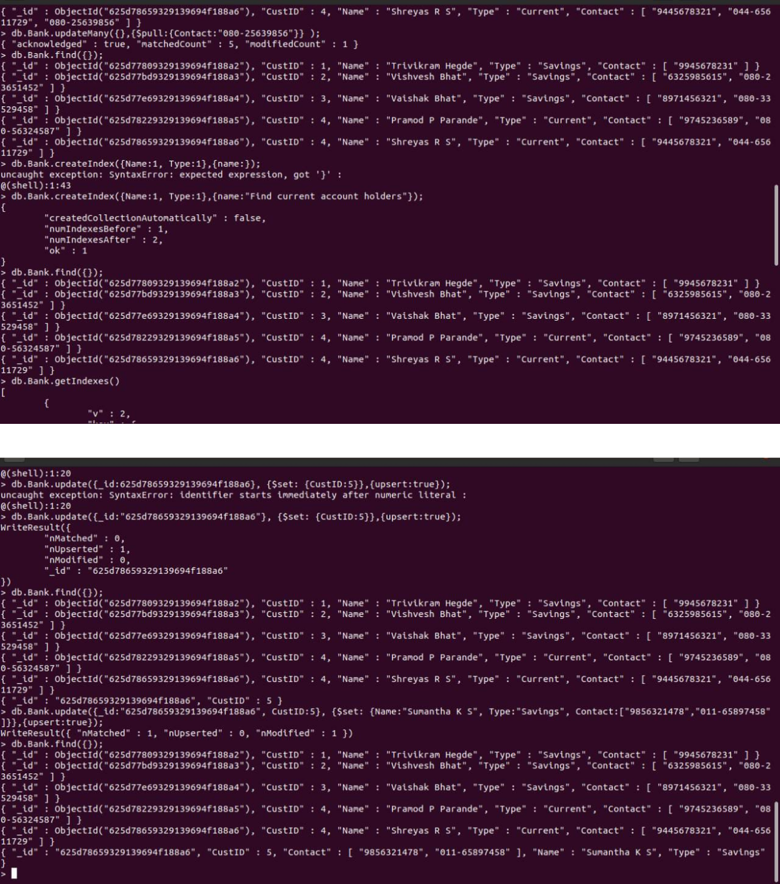

1) Using MongoDB,

1. Create a database for Faculty and Create a Faculty Collection(Faculty_id, Name, Designation ,Department, Age, Salary, Specialization(Set)).
2. Insert required documents to the collection.
3. First Filter on “Dept_Name:MECH” and then group it on “Designation” and

compute the Average Salary for that Designation and flter those documents where the “Avg_Sal” is greater than 650000. iv) Demonstrate usage of import and export commands

Write MongoDB queries for the following:

1)To display only the product name from all the documents of the product collection.

2)To display only the Product ID, ExpiryDate as well as the quantity from the document of the product collection where the _id column is 1.

3)To fnd those documents where the price is not set to 15000.

4)To fnd those documents from the Product collection where the quantity is set to 9 and the product name is set to ‘monitor’.

5)To fnd documents from the Product collection where the Product name ends in ‘d’.

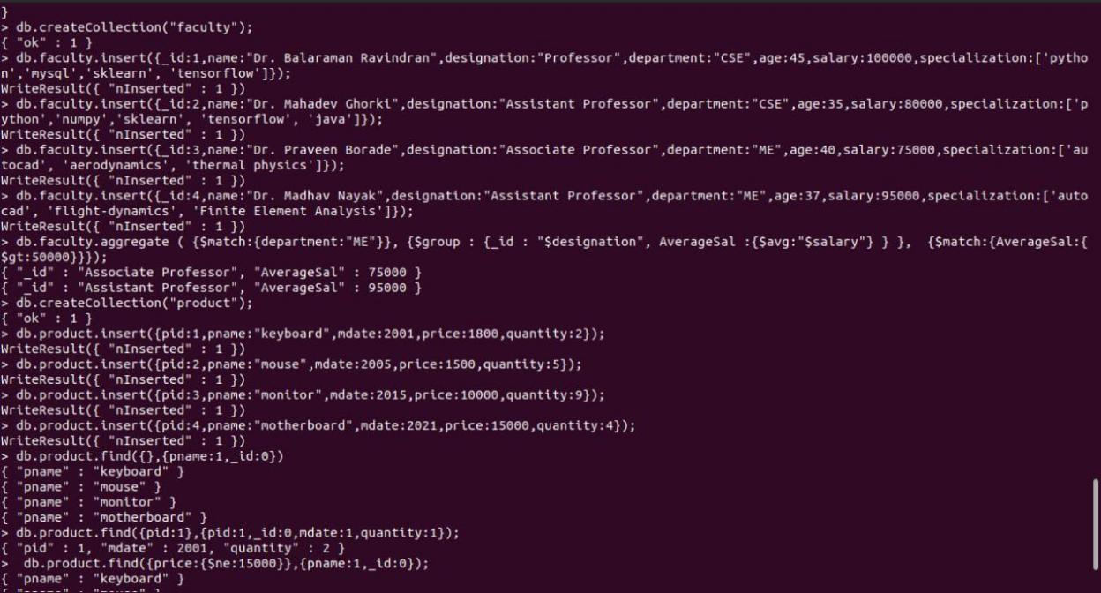

|  |  |
| --- | --- |
| 3)Create a mongodb collection Hospital. Demonstrate the following by choosing felds of | |
| choice. | |
| 1. | Insert three documents |
| 2. | Use Arrays(Use Pull and Pop operation) |
| 3. | Use Index |
| 4. | Use Cursors |
| 5. | Updation |

