1. mkdir

2. ls

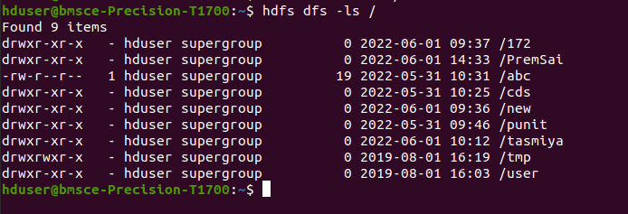

3. put

4. copyFromLocal

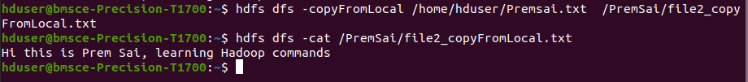
5. get

6. copyToLocal

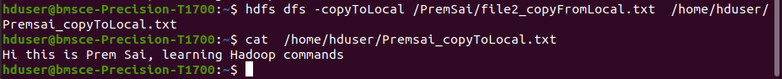
7. cat

8. mv

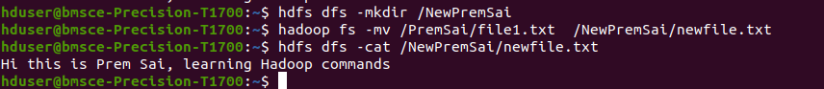
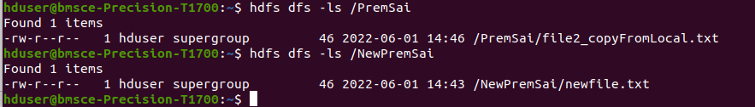

9. cp

