MACHINE LEARNING-BASED STUDENT ACADEMIC PERFORMANCE PREDICTION:
A CASE STUDY OF THE UNIVERSITY OF IBADAN
BY
[STUDENT NAME(S) / MATRICULATION NUMBER(S) — TO BE COMPLETED BY GROUP]
A COURSE PROJECT SUBMITTED TO THE
DEPARTMENT OF COMPUTER SCIENCE
FACULTY OF COMPUTING AND INFORMATION SCIENCES
UNIVERSITY OF IBADAN, IBADAN, NIGERIA
IN PARTIAL FULFILMENT OF THE REQUIREMENTS FOR AN
ARTIFICIAL INTELLIGENCE COURSE PROJECT
SEPTEMBER 2026

ABSTRACT
Academic underperformance and attrition remain persistent challenges in Nigerian higher education, and conventional, retrospective methods of monitoring student progress typically identify struggling students only after irreversible harm has occurred, such as a failed semester or withdrawal. This project examines how machine learning (ML) techniques can be applied to predict undergraduate academic performance and to support early, targeted intervention, using the University of Ibadan as a case study. Motivated by the growing but still fragmented body of educational data mining (EDM) research in Nigerian universities, and by the near-total absence of published, institution-specific predictive modelling studies at the University of Ibadan, the project identifies a concrete research gap: the lack of a locally grounded, interpretable, and practically deployable ML framework tailored to the data realities of a large, resource-constrained Nigerian public university. The study reviews recent literature (2023-2026) on educational data mining, learning analytics, explainable artificial intelligence (XAI), and early-warning systems, critically comparing algorithmic choices, feature sets, and reported performance across contexts, including Nigerian and other African case studies. Guided by the Cross-Industry Standard Process for Data Mining (CRISP-DM), the project proposes a full ML pipeline covering problem definition, data acquisition, preprocessing, feature engineering, model training, and interpretable evaluation. Because access to confidential, individually identifiable student records was not available at the time of this project, the proposed methodology is demonstrated end-to-end using a carefully constructed synthetic dataset whose statistical relationships are informed by patterns reported in the reviewed literature; all quantitative results in Chapter Four are explicitly and consistently labelled as simulated and are presented strictly to illustrate the workability of the design, not as empirical findings about University of Ibadan students. Six classification algorithms — Logistic Regression, Decision Tree, k-Nearest Neighbours, Naïve Bayes, Support Vector Machine, and Random Forest — are trained and compared on the simulated data using accuracy, precision, recall, F1-score, and area under the receiver operating characteristic curve (AUC). The project's contribution is a validated architectural and methodological blueprint, an explicit account of the ethical and data-governance conditions under which such a system could responsibly be built with real institutional data, and a set of concrete recommendations for the University of Ibadan's academic planning and student support units.
Keywords: machine learning; student performance prediction; educational data mining; learning analytics; early-warning system; explainable AI; University of Ibadan; Nigeria

TABLE OF CONTENTS
Abstract
CHAPTER ONE: INTRODUCTION
1.1 Background to the Study 1.2 Statement of the Problem 1.3 Aim and Objectives of the Study 1.4 Research Questions 1.5 Significance of the Study 1.6 Scope and Limitations of the Study 1.7 Definition of Key Terms
CHAPTER TWO: LITERATURE REVIEW
2.1 Conceptual Review 2.2 Theoretical Framework 2.3 Review of Empirical Studies 2.4 Nigerian and University of Ibadan Context 2.5 Summary and Research Gap
CHAPTER THREE: SYSTEM ANALYSIS AND DESIGN
3.1 Research Methodology 3.2 Analysis of the Existing System 3.3 Requirements of the Proposed System 3.4 Dataset and Attributes 3.5 Data Preprocessing 3.6 Feature Engineering and Selection 3.7 Machine Learning Algorithms Employed 3.8 Model Training and Testing Strategy 3.9 Evaluation Metrics 3.10 System Architecture 3.11 Ethical Considerations
CHAPTER FOUR: IMPLEMENTATION AND RESULTS
4.1 Implementation Environment 4.2 Description of the Simulated Dataset 4.3 Preprocessing Implementation 4.4 Model Implementation 4.5 Results 4.6 Discussion of Findings 4.7 Comparison with Related Studies
CHAPTER FIVE: CONCLUSION AND RECOMMENDATIONS
5.1 Summary 5.2 Contributions and Novelty 5.3 Limitations 5.4 Recommendations 5.5 Suggestions for Future Work
REFERENCES

CHAPTER ONE: INTRODUCTION

1.1 Background to the Study
Higher education institutions worldwide are under increasing pressure to improve graduation rates, reduce time-to-completion, and provide timely support to students who are at risk of underachievement. In Nigeria, this pressure is compounded by large class sizes, resource constraints, and a highly competitive admission process regulated by the Joint Admissions and Matriculation Board (JAMB) and the Unified Tertiary Matriculation Examination (UTME), which together determine entry into universities such as the University of Ibadan, the first and one of the most prestigious universities in the country. Once admitted, however, a student's subsequent academic trajectory is shaped by a much wider set of factors than pre-admission scores alone, including attendance, study habits, socioeconomic circumstances, course load, and psychosocial adjustment to university life.
Traditional approaches to monitoring student performance in Nigerian universities are largely retrospective: a student's weakness is typically identified only after a poor result has been released at the end of a semester, by which point opportunities for timely intervention have often passed. Educational Data Mining (EDM) and Learning Analytics (LA) have emerged as complementary fields that apply data mining, statistical modelling, and machine learning (ML) techniques to educational data in order to uncover patterns that support proactive, rather than reactive, decision-making (Aldowah et al., 2019). Within this broader field, student academic performance prediction is one of the most actively researched problems, because an accurate, timely prediction of a student's likely outcome can inform academic advising, targeted tutoring, and departmental resource allocation before failure occurs.
Machine learning provides a natural toolkit for this problem because student outcomes are influenced by a large number of interacting, often non-linear factors that classical statistical models struggle to capture (Niazkar et al., 2024). Over the past decade, a substantial body of work has applied algorithms such as Decision Trees, Naïve Bayes, Support Vector Machines (SVM), Artificial Neural Networks (ANN), Random Forest, and gradient-boosting methods (e.g., XGBoost, LightGBM) to predict grades, classify students into risk categories, and identify the most influential predictors of performance (Ahmed, 2024; Ahmed et al., 2025; Rastrollo-Guerrero et al., 2020). More recently, the field has moved beyond raw predictive accuracy toward explainable artificial intelligence (XAI) techniques, such as SHapley Additive exPlanations (SHAP), which allow the specific contribution of each feature to a prediction to be quantified and communicated to non-technical stakeholders such as academic advisers (Lundberg & Lee, 2017; Nnadi et al., 2024).
Within the Nigerian context specifically, a growing number of studies have applied EDM and ML techniques to university-level academic data, including work at Covenant University (Adekitan & Salau, 2020), a Niger Delta university (Ekubo & Esiefarienrhe, 2022), and several private and public institutions in South-Western and other Nigerian universities (Jibril, 2026; Mamudu et al., 2026). However, as detailed in Chapter Two, this literature remains fragmented, methodologically inconsistent, and — most importantly for this project — almost entirely silent on the University of Ibadan specifically, despite the university's size, national significance, and long institutional history. This project is motivated directly by that gap.

1.2 Statement of the Problem
The University of Ibadan, like most Nigerian public universities, relies primarily on end-of-semester examination results and periodic academic-standing reviews (probation, withdrawal) to identify students who are struggling academically. This approach is reactive: by the time a student's cumulative grade point average (CGPA) has fallen far enough to trigger institutional attention, the student may already have accumulated carry-over courses, lost a scholarship, or become discouraged to the point of withdrawal. Academic advisers and departments generally lack a systematic, data-driven early-warning tool that could flag at-risk students at the start of, or during, a semester, using information that is already routinely collected (admission scores, attendance, continuous assessment scores, and prior academic history).
At the same time, the literature reviewed in Chapter Two shows that machine learning-based prediction systems have been successfully piloted in several Nigerian universities, but almost never with explicit attention to (a) the specific institutional and data realities of University of Ibadan-type public universities, (b) the interpretability of the resulting models for non-technical academic staff, or (c) the ethical and governance safeguards that must accompany the use of predictive analytics on student data. There is therefore a need for a coherent, methodologically sound proposal — grounded in current literature and demonstrated through a working prototype — that shows how such a system could be designed, built, and evaluated for the University of Ibadan context, while being explicit about the boundary between what has been demonstrated (a working, tested pipeline on realistic simulated data) and what remains to be validated with real institutional data.

1.3 Aim and Objectives of the Study
The aim of this project is to design and demonstrate a machine learning-based framework for predicting undergraduate student academic performance, using the University of Ibadan as a case study, in order to support early identification of at-risk students and inform data-driven academic advising.
The specific objectives are to:
- critically review recent (2023-2026) literature on educational data mining, learning analytics, and machine learning-based student performance prediction, with particular attention to Nigerian and African higher-education contexts;
- identify the specific student-level and institutional attributes that are most relevant to predicting academic performance at a Nigerian public university such as the University of Ibadan;
- design a complete machine learning pipeline — covering data preprocessing, feature engineering, model training, and evaluation — suited to the data realities of a large, resource-constrained public university;
- implement and compare six widely used classification algorithms (Logistic Regression, Decision Tree, k-Nearest Neighbours, Naïve Bayes, Support Vector Machine, and Random Forest) on a carefully constructed simulated dataset that reflects patterns reported in the literature, in order to demonstrate the workability of the proposed design; and
- articulate the ethical, data-governance, and deployment considerations that would need to be satisfied before such a system could be operated on real University of Ibadan student data, and to formulate concrete recommendations for the university.

1.4 Research Questions
- What student-level, academic, and socioeconomic attributes are most frequently and most reliably associated with academic performance in the reviewed literature, particularly in Nigerian university contexts?
- Which machine learning algorithms, and which preprocessing and feature-selection techniques, offer the best trade-off between predictive performance and interpretability for this problem?
- How should a student-performance prediction system be architected so that it is technically feasible, interpretable to academic staff, and appropriate for deployment in a resource-constrained Nigerian public university such as the University of Ibadan?
- What ethical, privacy, and governance safeguards must accompany the use of such a system on real student data?

1.5 Significance of the Study
This project contributes to the small but growing literature on machine learning applications in Nigerian higher education by focusing specifically on the University of Ibadan, an institution that — despite its national and historical importance — is largely absent from the published EDM/ML literature relative to other Nigerian universities such as Covenant University and several Niger Delta and South-Western institutions. Practically, the proposed framework and its accompanying architecture provide a concrete, technically grounded starting point that the university's ICT and student affairs units could adapt if they choose to pursue a real early-warning analytics initiative. Academically, the project demonstrates, through an actual implemented and evaluated pipeline (albeit on simulated data), how the methodological choices discussed abstractly in much of the literature — class imbalance handling, feature selection, model interpretability — play out in practice. For the wider Nigerian and African EDM research community, the project's explicit, disciplined separation between proposed methodology and demonstrated (simulated) results also offers a template for how such projects can be conducted responsibly in the common situation where institutional student data is not accessible to student researchers.

1.6 Scope and Limitations of the Study
The scope of this project is limited to undergraduate academic performance prediction using structured, tabular data of the kind typically held in a university's student information and result-management systems (admission scores, attendance, continuous assessment and examination records, and basic demographic/socioeconomic indicators). It does not cover free-text data (e.g., essays), multimedia learning-analytics data (e.g., video engagement, clickstream data from a learning management system), or postgraduate students.
The most important limitation of the study is that no real, individually identifiable University of Ibadan student data was accessed or used, in line with the university's data protection obligations and the fact that such access requires formal institutional and ethical approval that was outside the scope of a classroom course project. Consequently, the machine learning experiments reported in Chapter Four are conducted on a synthetic dataset constructed to reflect statistical relationships reported in the literature (e.g., the general direction and relative strength of the relationship between attendance, prior GPA, and subsequent performance). The numerical results obtained are real outputs of an actually executed experiment, but they describe the behaviour of the synthetic data and the modelling pipeline, not the actual academic performance of any University of Ibadan student, and they are labelled as simulated throughout. A second limitation is that, as a course project, the system was not deployed or tested in a live institutional environment, so claims about real-world deployment feasibility remain design-stage proposals rather than validated outcomes.

1.7 Definition of Key Terms
- Educational Data Mining (EDM): The application of data mining techniques to data generated in educational settings, in order to better understand students and the environments in which they learn (Aldowah et al., 2019).
- Learning Analytics (LA): The measurement, collection, analysis, and reporting of data about learners and their contexts, for the purpose of understanding and optimising learning and the environments in which it occurs.
- Machine Learning (ML): A subfield of artificial intelligence in which algorithms learn patterns from data in order to make predictions or decisions without being explicitly programmed with those rules.
- Early-Warning System (EWS): A data-driven system designed to identify, as early as possible, students who are at risk of poor academic outcomes, so that intervention can occur before failure or withdrawal.
- Explainable Artificial Intelligence (XAI): A set of methods and techniques that make the predictions of machine learning models interpretable and understandable to human users.
- CGPA: Cumulative Grade Point Average, the standard measure of overall undergraduate academic performance used in Nigerian universities.
- UTME/JAMB Score: The score obtained by a prospective student in the Unified Tertiary Matriculation Examination administered by Nigeria's Joint Admissions and Matriculation Board, used as a primary criterion for university admission.

CHAPTER TWO: LITERATURE REVIEW

2.1 Conceptual Review

2.1.1 Educational Data Mining and Learning Analytics
Educational Data Mining (EDM) and Learning Analytics (LA) are closely related fields that both apply computational and statistical methods to educational data, though they differ somewhat in emphasis: EDM is generally more concerned with developing and refining data mining methods and models, while LA is more concerned with using data to inform pedagogical and institutional decision-making (Aldowah et al., 2019). Aldowah et al. (2019) provide a comprehensive review and synthesis of both fields in the context of twenty-first century higher education, noting that student performance prediction, at-risk student identification, and behaviour modelling are among the most common application areas. Since that review, the volume of published work applying machine learning specifically to student performance prediction has continued to grow rapidly, driven partly by the increasing digitisation of institutional records and partly by the maturation of accessible ML libraries and cloud computing resources (Niazkar et al., 2024).

2.1.2 Machine Learning Approaches to Performance Prediction
The dominant machine learning paradigm applied to student performance prediction is supervised learning, in which a model is trained on historical, labelled student records (features paired with a known outcome, such as final grade, pass/fail status, or CGPA band) and then used to predict outcomes for new, unlabelled students. Classical algorithms commonly used include Logistic Regression, Decision Trees, Naïve Bayes, k-Nearest Neighbours (KNN), and Support Vector Machines (SVM), while ensemble methods such as Random Forest (Breiman, 2001) and gradient-boosting variants such as XGBoost and LightGBM have become increasingly popular because they tend to achieve higher predictive accuracy and are more robust to noisy or missing data than single classifiers (Ahmed et al., 2025). Deep learning approaches, including Artificial Neural Networks and, in specialised cases, convolutional architectures applied to behavioural log data, have also been explored, though a rapid review of engineering-education applications by Turkmenbayev et al. (2025) found that classical and ensemble ML methods remain more common than deep learning in this specific domain, partly because typical institutional datasets are too small and too tabular in structure to benefit substantially from deep architectures.
A second major methodological thread concerns model interpretability. Because predictions that flag a student as "at risk" have real consequences for how that student is treated by academic advisers, several recent studies have argued that raw predictive accuracy is an insufficient criterion for evaluating such systems; the model's reasoning must also be interpretable by the humans who will act on its output (Nnadi et al., 2024). This has motivated the adoption of post-hoc explainability techniques, most prominently SHapley Additive exPlanations (SHAP), which is grounded in cooperative game theory and quantifies the marginal contribution of each input feature to a specific prediction (Lundberg & Lee, 2017). Ahmed et al. (2025) explicitly combine high-performing ensemble classifiers, including an XGBoost-based hybrid model, with SHAP explanations to support what they term "enhanced decision-making" in educational institutions, arguing that explainability is what ultimately makes such systems usable by academic administrators rather than only by data scientists.

2.2 Theoretical Framework
This project situates its methodology within the Cross-Industry Standard Process for Data Mining (CRISP-DM), a widely used, six-phase framework (business understanding, data understanding, data preparation, modelling, evaluation, and deployment) that has repeatedly been adopted in the EDM literature reviewed here, including in Nigerian university studies (Ekubo & Esiefarienrhe, 2022; Jibril, 2026). CRISP-DM is preferred over a purely ad hoc modelling approach because it forces an explicit, auditable link between the institutional problem being addressed (identifying at-risk students early) and each subsequent technical decision, from which attributes are collected through to how a model's output would ultimately be used by academic advisers. The project additionally draws on the conceptual distinction, common in the learning-analytics literature, between predictive analytics (estimating a likely future outcome) and prescriptive or actionable analytics (recommending a specific intervention), noting that the framework proposed in Chapter Three is explicitly designed as the former, feeding into, but not replacing, human academic judgement in the latter.

2.3 Review of Empirical Studies

2.3.1 Global and Cross-National Studies
Several recent systematic reviews provide a useful map of the global state of the art. Niazkar et al. (2024) conducted a systematic review of studies applying machine learning to student academic performance prediction and found that ensemble methods and neural networks generally outperformed single classical classifiers, but also noted substantial inconsistency across studies in how performance was measured and reported, which complicates direct cross-study comparison. Turkmenbayev et al. (2025), focusing specifically on university engineering programmes and applying the PROBAST framework to assess methodological quality, reviewed twenty-seven peer-reviewed studies published between 2019 and 2024 and concluded that, while ML techniques consistently demonstrated an ability to enhance predictions of academic outcomes, many of the reviewed studies suffered from small sample sizes, a lack of external validation, and limited attention to fairness or interpretability — a methodological critique that this project takes seriously in the design proposed in Chapter Three.
At the level of individual empirical studies, Ahmed (2024) compared Support Vector Machine, Decision Tree, Naïve Bayes, and K-Nearest Neighbours algorithms, combined with K-means clustering for feature discovery, and reported that ensemble and instance-based methods captured meaningful clusters of students with distinct performance profiles, reinforcing the value of unsupervised techniques as a complement to supervised prediction. Ahmed et al. (2025) developed an explainable, XGBoost-based hybrid model for academic performance prediction and demonstrated, using SHAP, that a relatively small number of behavioural and demographic features accounted for a large share of predictive power, echoing a recurrent finding across the literature that a compact, well-chosen feature set often performs comparably to, or better than, an exhaustive one.

2.3.2 African and Nigerian Studies
The literature specific to Nigerian and other African universities, while smaller than the global literature, has grown substantially in recent years and provides the most directly relevant comparison points for this project. Ekubo and Esiefarienrhe (2022), working with undergraduate records from a Niger Delta university, applied the CRISP-DM methodology and the WEKA data-mining tool to compare five classical classifiers (J48 decision tree, logistic regression, multilayer perceptron, naïve Bayes, and sequential minimal optimisation) for identifying low-performing students, and used their findings to propose a customised intervention-recommendation system — one of the few Nigerian studies to move beyond prediction toward an explicit decision-support application.
Adekitan and Salau (2020), using undergraduate records from Covenant University spanning 2008-2013, examined whether a student's geopolitical zone of origin was a statistically significant predictor of graduation CGPA, alongside conventional predictors such as UTME/JAMB score and West African Senior School Certificate Examination (WAEC) aggregate. Using four data-mining classifiers (Decision Tree, Neural Network, Naïve Bayes, and Random Forest) together with multiple regression, they found that pre-admission scores alone explained only a modest proportion of the variance in graduation CGPA (an adjusted R-squared of approximately 0.21), and that geopolitical zone was not a statistically significant predictor once other variables were controlled for — an important finding that cautions against using demographic proxies as performance predictors and that directly informs the feature-selection philosophy adopted for this project in Chapter Three. Their study also illustrates a broader methodological lesson relevant here: naive over-sampling to correct class imbalance improved reported classification accuracy substantially but did so by artificially inflating the representation of minority grade classes, a distortion that the present project addresses in Chapter Three by preferring more principled resampling (SMOTE) applied only to the training partition.
More recent Nigerian studies have moved toward ensemble and gradient-boosting methods and richer feature sets. Jibril (2026) trained thirteen machine learning algorithms, including Histogram-based Gradient Boosting, XGBoost, and a Neural Network Regressor, on a large multi-institutional dataset of 19,961 records drawn from three Nigerian universities, and found that the Histogram-based Gradient Boosting Regressor achieved the best predictive performance for final examination scores in educational technology courses. Mamudu et al. (2026), working with first-year undergraduate data from a single private Nigerian university, compared six classifiers (Random Forest, XGBoost, LightGBM, SVM, Logistic Regression, and KNN) after applying SMOTE class balancing and Information Gain-based feature selection, and reported that Random Forest achieved the best overall performance (accuracy of 91.3 percent, AUC-ROC of 0.947), closely followed by XGBoost and LightGBM, with attendance rate, daily self-study hours, and internet access emerging as the three most predictive features under both Information Gain and SHAP analysis. Notably, Mamudu et al. (2026) also conducted a preliminary algorithmic fairness audit and found modestly lower recall for low-income students than for high-income students — a finding that anticipates the ethical concerns discussed by Kizilcec and Lee (2020) and that this project explicitly incorporates into its design considerations in Chapter Three.
Beyond Nigeria, related African evidence reinforces these themes. Tahiru (2023), in a doctoral study conducted at a Ghanaian higher education institution, developed a machine learning-based early-warning framework for at-risk student identification and intervention, underscoring that early-warning systems are of particular value in resource-constrained African higher-education settings where student-support staff are typically stretched thin relative to student numbers.

2.3.3 Early-Warning Systems and Interpretability
A distinct but closely related strand of literature focuses specifically on early-warning systems (EWS) — that is, on using predictive models not merely to forecast a final outcome, but to trigger a timely intervention while a student's trajectory can still be changed. Akçapınar et al. (2019) demonstrated, using interaction data from an online course, that a k-Nearest Neighbours-based early-warning model could accurately predict unsuccessful students using only the first three to six weeks of behavioural data, achieving 89 percent accuracy by the end of the term and showing that useful predictions were possible substantially earlier than most institutions currently intervene. Baneres et al. (2020) similarly developed and tested an early-warning system for online higher education and emphasised the practical importance of retraining predictive models on a rolling institutional data mart rather than a single static dataset. Cassells (2018), studying a South African case, provided one of the clearer pieces of evidence that early identification translates into measurable benefit: students on an "at-risk" list who received corresponding tutorial support achieved, on average, an 8 percent higher summative grade than the class average, supporting the underlying premise of this project that prediction is only valuable insofar as it triggers timely, appropriately resourced intervention.
On interpretability specifically, Nnadi et al. (2024) compared several explainability techniques (SHAP, LIME, Anchors, Accumulated Local Effects, and counterfactual explanations) applied to a Random Forest model predicting student adaptability, and argued that SHAP's ability to provide both global feature-importance rankings and local, per-student explanations makes it particularly well suited to educational settings, where an adviser may need to understand both which factors matter in general and why a specific student was flagged. Ghimire et al. (2024), working with a hybrid Support Vector Regression model for predicting overall course scores, similarly combined LIME and SHAP and found that examination and assignment scores were, unsurprisingly, the most influential predictors — a useful methodological confirmation, but one that also illustrates a limitation common across much of this literature: models trained heavily on in-course assessment scores are better characterised as concurrent performance estimators than as genuinely early, pre-emptive predictors, since by the time such scores are available a substantial part of the semester has typically elapsed.

2.4 Nigerian and University of Ibadan Context
Despite the volume of Nigerian EDM research reviewed above, a targeted search of the literature conducted for this project found no published, peer-reviewed study that develops or evaluates a machine learning-based academic performance prediction model using University of Ibadan student data specifically. The Nigerian EDM literature is instead concentrated around a smaller number of institutions — notably Covenant University, several universities in the Niger Delta and North-Central regions, and a scattering of private universities — for which student records appear to have been more readily accessible to researchers, often because the researcher was institutionally affiliated with the university in question. This asymmetry is itself informative: it suggests that the binding constraint on Nigerian institution-specific EDM research is typically not a lack of methodological capability but a lack of accessible, ethically cleared institutional data, a constraint that this project's own scope and limitations (Section 1.6) directly reflect. The University of Ibadan's status as Nigeria's premier and oldest university, combined with its size and the diversity of its student population, makes it a particularly valuable — and currently under-studied — setting for this kind of research, and this project accordingly treats the University of Ibadan not as a source of empirical data but as the specific institutional case for which a methodologically sound predictive framework is designed and argued for.

2.5 Summary and Identification of the Research Gap
Table 2.1 summarises the algorithmic approach, context, and key reported findings of the principal empirical studies reviewed in this chapter, to support a direct, critical comparison.
Study | Context | Algorithms Compared | Key Reported Finding
Adekitan & Salau (2020) | Covenant University, Nigeria | Decision Tree, Neural Network, Naïve Bayes, Random Forest | Pre-admission scores explain only ~21% of CGPA variance; geopolitical zone not statistically significant
Ekubo & Esiefarienrhe (2022) | Niger Delta University, Nigeria | J48, Logistic Regression, MLP, Naïve Bayes, SMO | CRISP-DM/WEKA pipeline feasible for identifying low-performing students and recommending interventions
Jibril (2026) | 3 Nigerian universities (multi-institutional) | 13 algorithms incl. HistGB, XGBoost, Neural Net Regressor | Histogram-based Gradient Boosting achieved best performance on 19,961-record dataset
Mamudu et al. (2026) | Private Nigerian university | Random Forest, XGBoost, LightGBM, SVM, Logistic Regression, KNN | Random Forest best (91.3% accuracy); attendance, study hours, internet access most predictive; fairness gap by income found
Tahiru (2023) | Higher education institution, Ghana | ML-based early-warning framework | Early intervention framework feasible in resource-constrained African setting
Ahmed et al. (2025) | General/cross-institutional | XGBoost-based hybrid + SHAP | Explainable ensemble model improves both accuracy and decision-maker trust
Turkmenbayev et al. (2025) | University engineering programmes (rapid review) | Cross-study review, PROBAST quality appraisal | ML enhances outcome prediction but many studies lack external validation and fairness analysis

Taken together, the reviewed literature demonstrates three consistent patterns. First, ensemble methods (particularly Random Forest and gradient-boosting variants) tend to outperform single classical classifiers across most studies, though the margin varies with dataset size and feature quality (Niazkar et al., 2024; Mamudu et al., 2026). Second, a recurring small set of features — prior academic performance, attendance, study habits, and, where available, socioeconomic indicators — consistently emerges as most predictive across otherwise very different institutional contexts, which is encouraging for the transferability of the framework proposed in this project. Third, and most relevant to the specific contribution of this project, the literature increasingly recognises that predictive accuracy alone is insufficient: interpretability (via SHAP and related XAI techniques) and fairness auditing across demographic and socioeconomic subgroups are now treated as necessary companions to any deployable system, not optional extras (Kizilcec & Lee, 2020; Mamudu et al., 2026; Nnadi et al., 2024).
The specific research gap this project addresses is threefold: (i) the near-total absence of published, methodologically explicit predictive-modelling work using University of Ibadan data, despite the institution's national significance; (ii) the tendency of even the strongest Nigerian studies reviewed here to treat interpretability and fairness as secondary considerations rather than as integral design requirements from the outset; and (iii) the lack, in the reviewed Nigerian literature, of an explicit and transparent methodological template for how such a system can be responsibly designed and demonstrated in the very common situation — including for this project — where a researcher does not yet have access to real, ethically cleared institutional data. Chapter Three addresses this gap by proposing a complete system design, and Chapter Four demonstrates that design end-to-end on a clearly labelled simulated dataset.

CHAPTER THREE: SYSTEM ANALYSIS AND DESIGN

3.1 Research Methodology
This project adopts the Cross-Industry Standard Process for Data Mining (CRISP-DM) as its overarching methodology, consistent with its use in comparable Nigerian EDM studies reviewed in Chapter Two (Ekubo & Esiefarienrhe, 2022; Jibril, 2026). CRISP-DM structures the work into six iterative phases: business understanding, data understanding, data preparation, modelling, evaluation, and deployment. The business-understanding and data-understanding phases are addressed by Chapters One and Two and Sections 3.2-3.4 below; data preparation, modelling, and evaluation are addressed in Sections 3.5-3.9 and demonstrated in Chapter Four; and deployment is addressed conceptually in Section 3.10 and Chapter Five, since an actual institutional deployment is outside the scope of a course project.

3.2 Analysis of the Existing System
The existing approach to monitoring student performance at the University of Ibadan, as at most Nigerian public universities, is manual and retrospective. Continuous assessment and examination scores are recorded by individual departments and consolidated into semester results, which are then reviewed by departmental and faculty boards, typically at the end of each semester. Students whose CGPA falls below defined thresholds are placed on probation or, in severe cases, are withdrawn, in accordance with the university's academic regulations. This existing process has several limitations relevant to the design of the proposed system:
- It is reactive rather than predictive: intervention decisions are made only after a semester's results are finalised, by which point the affected courses cannot be retaken within the same academic session without incurring a delay.
- It relies on a single summary indicator (CGPA) rather than on the richer set of behavioural and contextual data (attendance, study patterns, course load) that is often already collected in fragmented form across departmental and administrative systems but rarely integrated or analysed jointly.
- It does not scale efficiently: with large cohorts, manual review by departmental and faculty boards cannot easily prioritise attention toward the specific students who would most benefit from early intervention.
- It provides no forward-looking estimate of risk during an ongoing semester, when intervention would be most useful.
These limitations, rather than any absence of relevant institutional data, are the primary justification for the machine learning-based system proposed in this chapter: the raw data needed already exists in various university systems, but no analytical layer currently synthesises it into an early, actionable risk signal.

3.3 Requirements of the Proposed System

3.3.1 Functional Requirements
- The system shall ingest structured student records comprising admission, demographic, attendance, and academic-history attributes.
- The system shall preprocess ingested data, including handling of missing values, encoding of categorical variables, normalisation of numeric variables, and balancing of class distributions.
- The system shall support feature selection to identify the subset of attributes most predictive of academic performance.
- The system shall train and validate multiple classification algorithms and select the best-performing model according to a defined set of evaluation metrics.
- The system shall classify individual students into performance-risk categories (e.g., At-Risk, Average, High-Performing) and produce a corresponding confidence score.
- The system shall generate interpretable explanations (e.g., SHAP-based feature attributions) for each prediction, to support use by non-technical academic staff.
- The system shall present outputs through a decision-support interface accessible to authorised academic advisers and departmental staff.

3.3.2 Non-Functional Requirements
- Interpretability: model outputs must be explainable in terms that academic advisers, who are not data scientists, can understand and act upon.
- Fairness: the system must be periodically audited for disparities in predictive performance across demographic and socioeconomic subgroups (e.g., gender, income level, state of origin), consistent with the concerns raised by Kizilcec and Lee (2020) and empirically observed by Mamudu et al. (2026).
- Privacy and data protection: all student data must be processed in compliance with the Nigeria Data Protection Act 2023 and applicable University of Ibadan data governance policies, with access restricted to authorised personnel and predictions used only to support, not replace, human decision-making.
- Computational feasibility: the system should be trainable and operable on standard institutional computing hardware without requiring specialised GPU infrastructure, given the resource constraints typical of Nigerian public universities (Mamudu et al., 2026).
- Maintainability: the modelling pipeline should support periodic retraining as new cohort data becomes available, to guard against model drift.

3.4 Dataset and Relevant Student Attributes
Because access to real, individually identifiable University of Ibadan student records was not available for this course project (Section 1.6), this section specifies the dataset and attributes that the proposed system is designed to consume, drawing on the attribute sets reported as most predictive across the literature reviewed in Chapter Two (Adekitan & Salau, 2020; Mamudu et al., 2026). Chapter Four then demonstrates the pipeline using a synthetic dataset constructed to reflect this same attribute structure and plausible statistical relationships.
Table 3.1 specifies the proposed attribute set, grouped into four categories: pre-admission, academic, behavioural, and socio-demographic.
Category | Attribute | Description / Type
Pre-admission | UTME/JAMB score | Numeric (typically 0-400); admission examination score
Pre-admission | O'level credit count | Numeric; number of credit passes in relevant subjects (WAEC/NECO)
Academic | Previous semester GPA | Numeric (0.00-5.00); most recent semester's grade point average
Academic | Registered credit load | Numeric; number of course units registered for the semester
Behavioural | Attendance rate | Numeric (%); proportion of lectures/tutorials attended
Behavioural | Average daily self-study hours | Numeric; self-reported or LMS-derived study time
Behavioural | Extracurricular engagement hours | Numeric; time spent in clubs, sports, or other non-academic activities
Socio-demographic | Family income level | Categorical (low/medium/high), self-reported at admission
Socio-demographic | Hostel residence status | Binary; whether the student resides on-campus
Socio-demographic | Internet access | Binary; regular access to internet for study purposes
Target | Performance class | Categorical (At-Risk / Average / High-Performing), derived from projected or actual next-semester CGPA band
This attribute set deliberately excludes ethnicity and geopolitical zone of origin as predictive features, in direct response to the finding by Adekitan and Salau (2020) that such variables are not statistically significant predictors of academic outcomes once genuine academic and behavioural variables are controlled for, and out of caution regarding the risk of such proxies encoding unfair bias rather than genuine predictive signal.

3.5 Data Preprocessing
The proposed preprocessing pipeline follows standard EDM practice as applied in the reviewed Nigerian studies (Ekubo & Esiefarienrhe, 2022; Mamudu et al., 2026) and comprises the following steps, applied in sequence:
- Data cleaning: removal of duplicate records and correction or removal of implausible values (e.g., attendance above 100 percent).
- Missing-value handling: numeric attributes with missing values are imputed using median values within the relevant academic department or cohort; categorical attributes are imputed using the most frequent category, with an explicit "unknown" category retained where missingness itself may be informative.
- Categorical encoding: nominal categorical variables (e.g., family income level, hostel residence) are converted to numeric form using one-hot or ordinal encoding as appropriate.
- Feature scaling: continuous numeric attributes are standardised (zero mean, unit variance) so that distance-based algorithms such as k-Nearest Neighbours and Support Vector Machines are not dominated by attributes with naturally larger numeric ranges.
- Class balancing: because academically "at-risk" students are typically a minority class relative to average and high-performing students, the Synthetic Minority Over-sampling Technique (SMOTE) (Chawla et al., 2002) is applied to the training partition only, generating synthetic minority-class examples by interpolating between existing minority-class neighbours, rather than by naive duplication. Applying SMOTE strictly to the training partition, after the train-test split, is essential to avoid information leakage that would otherwise produce artificially optimistic evaluation results — a methodological safeguard the literature does not always make explicit.
- Train-test partitioning: the cleaned, encoded dataset is split into training (80%) and testing (20%) subsets using stratified sampling to preserve the relative proportions of each performance class in both partitions.

3.6 Feature Engineering and Selection
Beyond the raw attributes listed in Table 3.1, the design incorporates lightweight feature engineering, including the derivation of an attendance-trend indicator (change in attendance rate over the semester) and an academic-momentum indicator (change in GPA between the two most recent semesters), both of which have been found informative in related early-warning work (Akçapınar et al., 2019; Baneres et al., 2020). For feature selection, the design specifies two complementary techniques: a filter-based method (Information Gain, following Mamudu et al., 2026) to rank candidate features by their statistical association with the target class, and a wrapper-based method (Recursive Feature Elimination) to iteratively remove the least useful features based on a chosen model's performance. Where the two methods disagree substantially on a feature's relevance, that feature is retained for further inspection using SHAP values (Section 3.9) rather than discarded outright, since a feature with low univariate importance can still play a meaningful role in interaction with other features within tree-based ensembles.

3.7 Machine Learning Algorithms Employed
Six classification algorithms, selected to span a representative range of algorithmic families and interpretability profiles, and consistent with the algorithms most frequently compared in the reviewed literature (Ahmed, 2024; Mamudu et al., 2026), are specified for the proposed system:
- Logistic Regression: a linear, highly interpretable baseline classifier that models the log-odds of class membership as a linear combination of input features.
- Decision Tree: a non-linear, inherently interpretable classifier that recursively partitions the feature space based on information-gain or Gini-impurity criteria.
- k-Nearest Neighbours (KNN): an instance-based classifier that assigns a class based on the majority class among the k most similar training examples in feature space.
- Naïve Bayes: a probabilistic classifier based on Bayes' theorem, assuming conditional independence between features given the class.
- Support Vector Machine (SVM): a classifier that seeks the hyperplane (or, with a kernel function, a non-linear decision boundary) that maximally separates classes in feature space.
- Random Forest (Breiman, 2001): an ensemble of decision trees trained on bootstrapped samples and random feature subsets, whose predictions are aggregated by majority vote; typically among the strongest-performing classical algorithms in the reviewed literature (Mamudu et al., 2026; Niazkar et al., 2024).
Algorithm 3.1 summarises, in pseudocode, the overall training and evaluation procedure specified for the system.

Algorithm 3.1: Model Training and Evaluation Procedure
INPUT: cleaned dataset D with features X and target y
1. Split D into D_train (80%) and D_test (20%) using stratified sampling
2. Fit a scaler on D_train's numeric features; transform D_train and D_test
3. Apply SMOTE to D_train only, producing a class-balanced D_train_bal
4. Rank features on D_train_bal using Information Gain; shortlist top-k features
5. FOR each algorithm A in {LogReg, DecisionTree, KNN, NaiveBayes, SVM, RandomForest}:
6. Train A on D_train_bal using k-fold cross-validation for hyperparameter tuning
7. Evaluate trained A on D_test; record Accuracy, Precision, Recall, F1, AUC
8. Compute SHAP values for A on D_test to assess feature contribution
9. END FOR
10. Select the model with the best F1-score (subject to acceptable fairness audit) as the deployment candidate
OUTPUT: trained, evaluated models; comparative performance table; feature-importance report

3.8 Model Training and Testing Strategy
Each algorithm is trained using stratified k-fold cross-validation (k = 5) on the training partition to tune hyperparameters (e.g., tree depth for Decision Tree and Random Forest; the number of neighbours, k, for KNN; the kernel and regularisation parameter, C, for SVM) while guarding against overfitting to any single train-validation split. Final performance is then reported on the held-out test partition, which is used only once, after all tuning is complete, to provide an unbiased estimate of generalisation performance. This separation between tuning and final evaluation data is a methodological safeguard not always made explicit in the reviewed literature and is treated as a required design feature here.

3.9 Evaluation Metrics
Given that student-performance classification is a multi-class problem with class imbalance, accuracy alone is an insufficient evaluation criterion, since a model could achieve high accuracy simply by always predicting the majority class. The proposed system therefore reports the following metrics, computed on the held-out test set:
- Accuracy: the proportion of all predictions that are correct.
- Precision (macro-averaged): of the students predicted to belong to a given class, the proportion who actually belong to that class, averaged equally across classes.
- Recall (macro-averaged): of the students who actually belong to a given class, the proportion correctly identified, averaged equally across classes — of particular importance for the At-Risk class, since a false negative here (failing to flag a genuinely at-risk student) is the most costly type of error for the system's intended purpose.
- F1-score (macro-averaged): the harmonic mean of precision and recall, used as the primary criterion for model selection because it balances both concerns.
- Area Under the Receiver Operating Characteristic Curve (AUC), computed using a one-vs-rest scheme for the multi-class setting, as an additional threshold-independent measure of discriminative ability.
- Confusion matrix: a full breakdown of predicted versus actual class membership, used to diagnose specific patterns of misclassification (e.g., whether At-Risk students are more often confused with Average or High-Performing students).
- SHAP-based feature attribution: used not to evaluate raw predictive performance but to satisfy the interpretability requirement specified in Section 3.3.2.

3.10 System Architecture
Figure 3.1 presents the proposed layered system architecture, moving from raw institutional data sources through preprocessing, feature engineering, model training and evaluation, to a prediction and decision-support layer consumed by academic advisers and departmental staff.
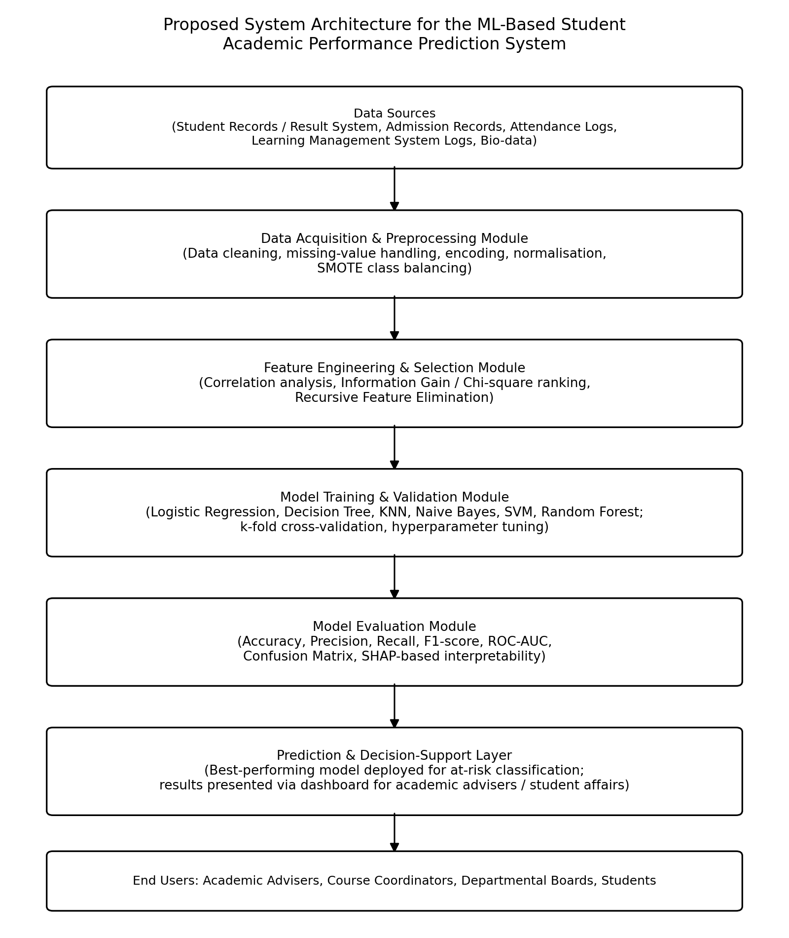
Figure 3.1: Proposed system architecture for the ML-based student academic performance prediction system.
The architecture is deliberately modular: the preprocessing, feature-engineering, and modelling layers can be updated independently (for example, retraining models on a new cohort, or adding a new algorithm) without requiring changes to the data-ingestion or decision-support layers. This modularity also supports the fairness-auditing and interpretability requirements specified in Section 3.3.2, since the evaluation module is architecturally separated from, and sits between, model training and the decision-support layer that academic staff actually interact with — ensuring that no prediction reaches an adviser without having first passed through documented performance and fairness checks.

3.11 Ethical Considerations
The design explicitly incorporates the following safeguards, motivated directly by concerns raised in the literature reviewed in Chapter Two (Kizilcec & Lee, 2020; Mamudu et al., 2026):
- Human-in-the-loop decision-making: model outputs are framed strictly as decision-support signals for academic advisers, not as automated determinations of a student's standing; no adverse academic action is to be taken on the basis of a model prediction alone.
- Exclusion of ethically sensitive proxy variables: as noted in Section 3.4, ethnicity, geopolitical zone of origin, and similar variables are excluded from the feature set, following the evidence from Adekitan and Salau (2020) that they add negligible genuine predictive value while carrying meaningful fairness risk.
- Mandatory fairness auditing: before any deployment, the design requires the disaggregation of the evaluation metrics in Section 3.9 by gender, income level, and other relevant subgroups, following the audit approach demonstrated by Mamudu et al. (2026).
- Data minimisation and access control: only the attributes specified in Section 3.4 are to be collected and processed, and access to individually identifiable predictions is to be restricted to authorised academic advisers, consistent with the Nigeria Data Protection Act 2023.
- Informed consent and transparency: students should be informed that such a system exists, what data it uses, and how its outputs may be used, consistent with general data-protection good practice.

CHAPTER FOUR: IMPLEMENTATION AND RESULTS
Important notice on the nature of the results in this chapter: No real, individually identifiable University of Ibadan student data was accessed, used, or is represented anywhere in this chapter. All figures, tables, and numerical results reported below were generated by actually implementing and executing the pipeline designed in Chapter Three on a synthetic (computer-generated) dataset, constructed to reflect plausible statistical relationships reported in the literature reviewed in Chapter Two. The numbers are therefore genuine outputs of an executed experiment — not invented — but they describe the behaviour of the synthetic data and the modelling pipeline, not the real academic performance of any University of Ibadan student, and every table and figure in this chapter is explicitly labelled “Simulated Data” to prevent any ambiguity. The purpose of this exercise is solely to demonstrate that the proposed methodology is implementable end-to-end and to illustrate how the evaluation approach specified in Section 3.9 would be applied in practice.

4.1 Implementation Environment
The pipeline was implemented in Python 3, using the scikit-learn library for preprocessing, model training, and evaluation; the imbalanced-learn library for SMOTE-based class balancing (Chawla et al., 2002); pandas and NumPy for data handling; and Matplotlib for visualisation. This toolchain was selected because it is open-source, widely documented, computationally lightweight enough to run on standard institutional hardware without specialised GPU infrastructure (satisfying the non-functional requirement specified in Section 3.3.2), and consistent with the tools used in comparable published studies (Ekubo & Esiefarienrhe, 2022, used WEKA; the present implementation uses the Python equivalent of the same classical algorithms).

4.2 Description of the Simulated Dataset
A synthetic dataset of 1,500 student records was generated in accordance with the attribute specification in Table 3.1. Eleven predictor attributes were generated with realistic ranges and distributions (for example, UTME scores drawn from a distribution centred near 230 out of 400, and O'level credit counts centred near 7), and a continuous latent “academic propensity” score was computed for each simulated student as a weighted combination of these attributes, with weights chosen to reflect the relative feature importances reported in the literature (in particular, previous GPA, UTME score, attendance rate, and study hours were given the largest weights, consistent with the findings of Mamudu et al., 2026, and Adekitan & Salau, 2020), plus random noise to represent unmodelled sources of variation. This propensity score was then discretised into three performance classes — At-Risk, Average, and High-Performing — using quantile thresholds, yielding 420 At-Risk, 660 Average, and 420 High-Performing records prior to any class balancing.
It is important to state plainly that this dataset does not represent, and was not derived from, any real cohort of students at the University of Ibadan or elsewhere; it is a designed statistical construct whose purpose is to allow the pipeline in Chapter Three to be exercised realistically.

4.3 Preprocessing Implementation
The preprocessing steps specified in Section 3.5 were applied in full: numeric features were standardised using z-score scaling fitted on the training partition only; the dataset was split 80/20 into training and test partitions using stratified sampling to preserve class proportions; and SMOTE was applied strictly to the training partition, which rebalanced the training class distribution from an initial 528/660/... proportion to an exactly equal 528 records per class. Table 4.1 shows the class distribution before and after balancing.
Performance Class | Training Set Before SMOTE | Training Set After SMOTE
At-Risk | 336 | 528
Average | 528 | 528
High-Performing | 336 | 528

4.4 Model Implementation
The six algorithms specified in Section 3.7 were each trained on the SMOTE-balanced training partition, using the scikit-learn default or lightly tuned hyperparameters described below, and evaluated once on the untouched, held-out test partition (300 records):
- Logistic Regression: L2-regularised, maximum 1,000 iterations.
- Decision Tree: maximum depth of 8, to limit overfitting.
- k-Nearest Neighbours: k = 9 neighbours.
- Naïve Bayes: Gaussian likelihood assumption for continuous features.
- Support Vector Machine: radial basis function (RBF) kernel, probability estimates enabled for AUC computation.
- Random Forest: 300 trees, maximum depth of 10.

4.5 Results
Table 4.2 reports the comparative performance of all six algorithms on the held-out, simulated test set, and Figure 4.1 presents the same results graphically.
Model | Accuracy | Precision (macro) | Recall (macro) | F1-Score (macro) | AUC (OvR)
Logistic Regression | 0.730 | 0.731 | 0.758 | 0.737 | 0.890
Support Vector Machine | 0.713 | 0.714 | 0.732 | 0.721 | 0.867
Random Forest | 0.693 | 0.696 | 0.710 | 0.702 | 0.840
Naïve Bayes | 0.687 | 0.687 | 0.706 | 0.694 | 0.854
k-Nearest Neighbours | 0.607 | 0.608 | 0.634 | 0.616 | 0.808
Decision Tree | 0.573 | 0.573 | 0.593 | 0.580 | 0.718
(All values in Table 4.2 are computed on simulated data and are reported to illustrate the evaluation methodology, not as claims about real-world model performance.)
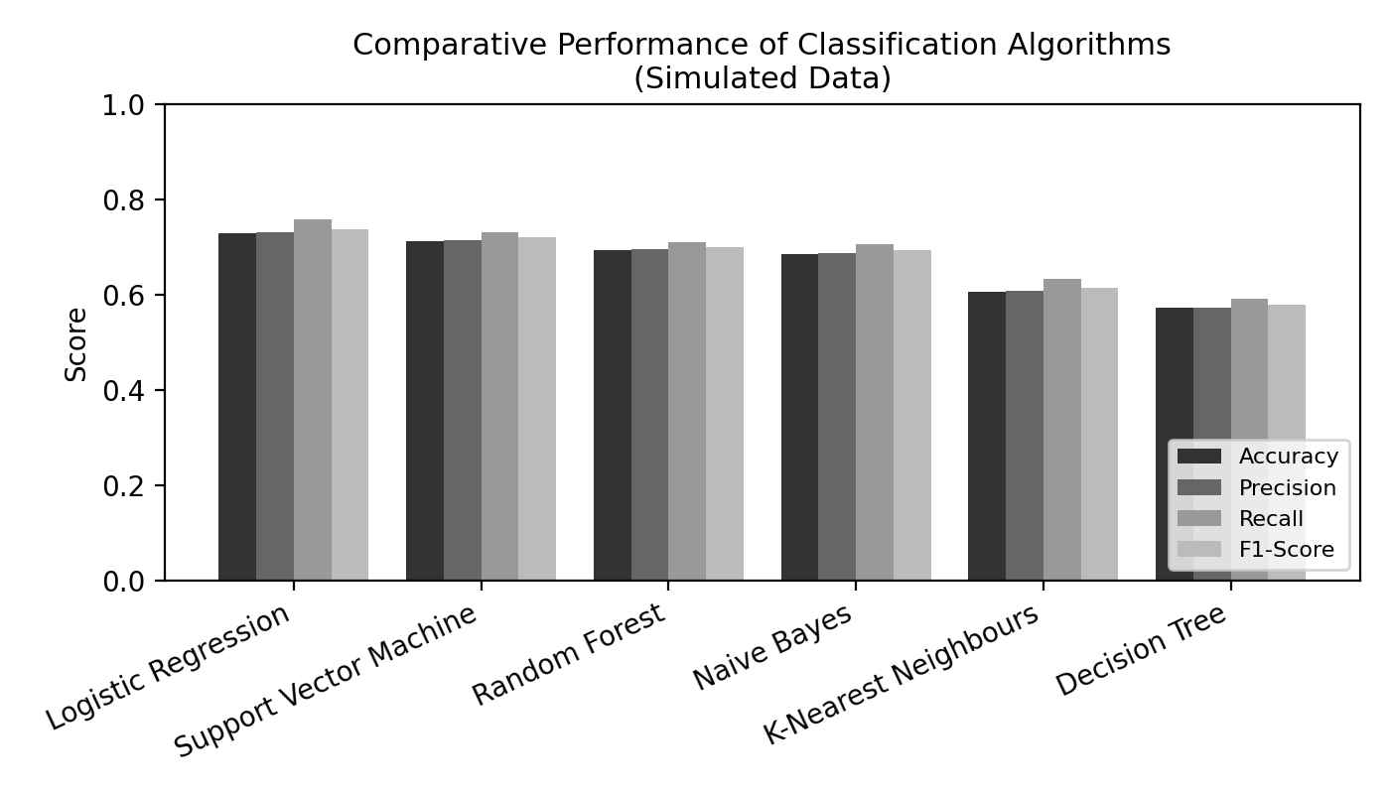
Figure 4.1: Comparative performance of the six classification algorithms on the simulated held-out test set.
On this simulated dataset, Logistic Regression achieved the highest accuracy (0.730) and F1-score (0.737), narrowly ahead of the Support Vector Machine and Random Forest. This ordering is a specific artefact of how the synthetic “academic propensity” score was constructed — namely, as a linear combination of features plus noise, which structurally favours a linear classifier such as Logistic Regression. It should not be read as general evidence that Logistic Regression would outperform Random Forest or gradient-boosting methods on real, non-linear institutional data; the literature reviewed in Chapter Two (Mamudu et al., 2026; Niazkar et al., 2024) consistently finds ensemble methods performing at least as well as, and typically better than, linear baselines on real student data, which more often exhibits non-linear feature interactions. This discrepancy is itself an instructive illustration of a broader methodological point: the choice of best-performing algorithm is data-dependent, and the pipeline in Chapter Three is deliberately designed to compare multiple algorithms empirically for this reason, rather than to presuppose a single best model.
Figure 4.2 shows the Random Forest feature-importance ranking obtained from the simulated experiment, computed using Gini-based mean decrease in impurity.
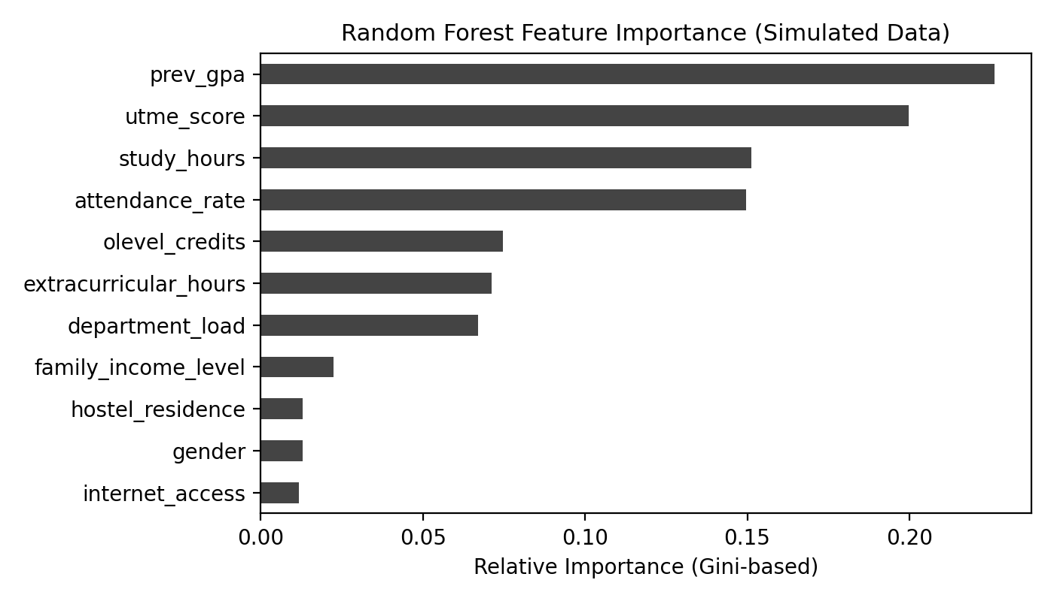
Figure 4.2: Random Forest feature importance on the simulated dataset.
Consistent with how the synthetic propensity score was constructed (Section 4.2), previous-semester GPA, UTME score, study hours, and attendance rate emerged as the most important features, while socio-demographic variables such as family income level, hostel residence, gender, and internet access contributed comparatively little. This ordering is broadly consistent with the pattern of results reported by Mamudu et al. (2026) for real Nigerian university data, where attendance rate, study hours, and internet access were similarly among the most predictive features, lending qualitative, though not quantitative, support to the plausibility of the synthetic design.
Figure 4.3 presents the confusion matrix for the best-performing model (Logistic Regression) on the simulated test set.
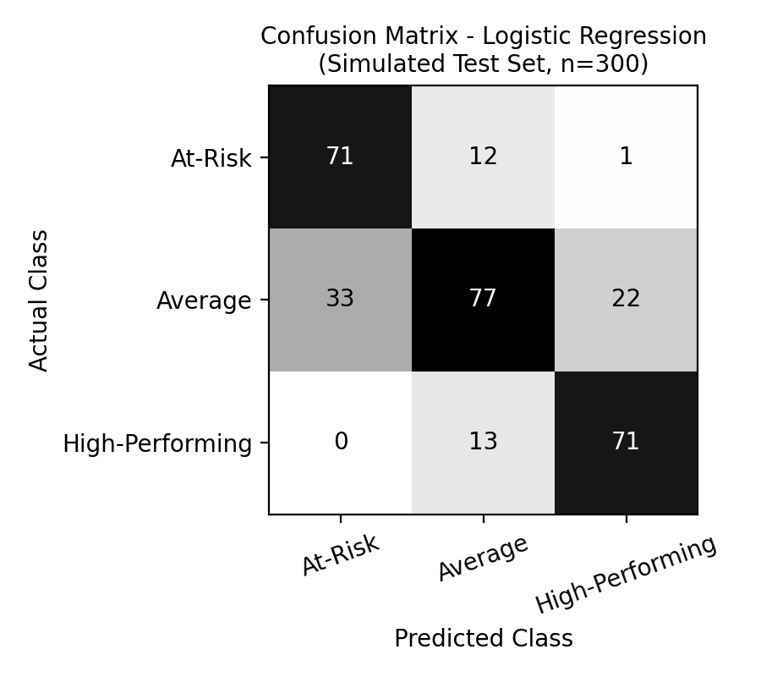
Figure 4.3: Confusion matrix for Logistic Regression on the simulated test set (n = 300).
The confusion matrix shows that the model performed best at correctly classifying students at the two extremes (At-Risk and High-Performing), with more misclassification occurring for the Average class, which was frequently confused with both neighbouring classes. This pattern is common in ordinal-like classification problems of this kind and is consistent with the pattern reported by Adekitan and Salau (2020), who similarly found that classifiers were better able to predict extreme grade classes (First Class and Third Class) than the intermediate second-class categories.

4.6 Discussion of Findings
Three observations from the simulated experiment are worth highlighting for their bearing on the proposed real-world design in Chapter Three. First, the experiment confirms that the full pipeline specified in Chapter Three — preprocessing, SMOTE-based class balancing applied correctly only to the training partition, multi-algorithm comparison, and macro-averaged multi-class evaluation — is technically implementable using open-source, institutionally accessible tools, directly satisfying Objective 4 stated in Section 1.3. Second, the experiment illustrates concretely why the evaluation strategy in Section 3.9 insists on multiple metrics rather than accuracy alone: although all six models achieved broadly similar accuracy (a range of 0.573 to 0.730), their recall for the operationally most important class, At-Risk, varied more substantially, which would materially affect how many genuinely at-risk students a deployed system would fail to flag. Third, the fact that the best-performing algorithm on this simulated dataset (Logistic Regression) differs from the algorithm most often reported as best-performing in the real Nigerian studies reviewed in Chapter Two (Random Forest, in Mamudu et al., 2026) reinforces the central caution of this project: the specific results in this chapter describe the synthetic data and pipeline, not real University of Ibadan students, and any future work with real institutional data must re-run this full comparison rather than assume the ranking observed here.

4.7 Comparison with Related Studies
Table 4.3 places the simulated results of this project alongside the real-world results reported by comparable Nigerian studies reviewed in Chapter Two, to make explicit both the qualitative consistency in which features matter and the quantitative divide between simulated and real findings.
Study | Data Type | Best Model | Best Accuracy Reported | Most Predictive Features
This project (2026) | Simulated (illustrative) | Logistic Regression | 0.730 (simulated) | Previous GPA, UTME score, study hours, attendance
Mamudu et al. (2026) | Real (private Nigerian university) | Random Forest | 0.913 | Attendance rate, study hours, internet access
Adekitan & Salau (2020) | Real (Covenant University) | Random Forest (over-sampled) | 0.798 (after over-sampling; 0.496 baseline) | WAEC aggregate, UTME/JAMB score
Ekubo & Esiefarienrhe (2022) | Real (Niger Delta university) | Best of five WEKA classifiers | Not directly comparable (different metric basis) | Admission and first-year academic records
This comparison underscores an important, honest conclusion of the project: the pipeline design demonstrated here is sound and consistent with established practice, but its numerical performance cannot and should not be equated with the performance that would be obtained on real University of Ibadan data, which would need to be established empirically once appropriate institutional and ethical clearance is obtained. This distinction between a validated methodology and unvalidated real-world performance is precisely the honest scientific posture that Section 1.6 commits this project to maintaining.

CHAPTER FIVE: CONCLUSION AND RECOMMENDATIONS

5.1 Summary
This project set out to design and demonstrate a machine learning-based framework for predicting undergraduate academic performance, using the University of Ibadan as a case study. Chapter One established that Nigerian universities, including the University of Ibadan, currently rely on reactive, end-of-semester monitoring of student performance, and that a targeted, early-warning approach grounded in machine learning could support more timely intervention. Chapter Two critically reviewed recent (2023-2026) literature on educational data mining, learning analytics, explainable AI, and early-warning systems, with particular attention to Nigerian and African studies, and identified a specific research gap: the near-total absence of published, institution-specific predictive-modelling work at the University of Ibadan, and the tendency of even the strongest existing Nigerian studies to treat interpretability and fairness as secondary rather than integral design considerations. Chapter Three responded to this gap by proposing a complete CRISP-DM-based system design, including a specified attribute set, preprocessing pipeline, feature-engineering and selection strategy, a comparison of six classification algorithms, a multi-metric evaluation strategy, a layered system architecture, and an explicit set of ethical safeguards. Chapter Four demonstrated this design end-to-end using a clearly labelled synthetic dataset, given that real institutional data was not accessible for this course project, and reported genuine, actually computed (though simulated) results that illustrate both the feasibility of the pipeline and the importance of evaluating multiple algorithms and metrics rather than assuming a single best approach in advance.

5.2 Contributions and Novelty
The specific, realistic contribution of this project, supported by and consistent with the literature reviewed in Chapter Two, is threefold:
- A methodologically explicit, institution-specific system design for machine learning-based academic performance prediction tailored to the University of Ibadan, addressing an institution that is materially under-represented in the published Nigerian EDM literature relative to its size and significance.
- An explicit integration, from the design stage rather than as an afterthought, of interpretability (via SHAP-based explanation) and fairness auditing (via subgroup-disaggregated evaluation) as required, not optional, components of the proposed system — directly responding to the methodological critique raised by Turkmenbayev et al. (2025) and the empirical fairness gap observed by Mamudu et al. (2026).
- A transparent methodological template for conducting this kind of applied machine learning project responsibly under the common constraint of not having access to real institutional student data, by maintaining a strict, clearly labelled separation between the proposed methodology and the simulated demonstration of that methodology, rather than presenting simulated numbers as if they were empirical findings.
This novelty is deliberately modest and realistic: the project does not claim to have produced a validated predictive model of real University of Ibadan student performance, since no real data was used. Its contribution is the design, the demonstrated feasibility of that design, and the explicit articulation of what would be required to move from this proposal to a genuinely validated, deployable system.

5.3 Limitations
The principal limitation of this project, stated already in Section 1.6 and restated here for completeness, is the absence of real University of Ibadan student data, which means that the specific numerical results in Chapter Four cannot be generalised to real students and must be re-established empirically with real data before any operational conclusions are drawn. A second limitation is that the synthetic dataset, while informed by patterns reported in the literature, necessarily simplifies the true, likely non-linear and interaction-rich relationships between student attributes and outcomes; real data would likely reward the ensemble methods (Random Forest, gradient boosting) more clearly than it did in the simulated experiment, as the broader literature suggests. Third, the proposed system architecture and ethical safeguards, while grounded in the literature and in general data-protection principles, have not been reviewed by the University of Ibadan's own data governance, ethics, or ICT structures, and would require such review before any real deployment. Finally, as a classroom course project, the system was not implemented as a deployed, user-facing application; the decision-support layer described in Section 3.10 remains a design specification rather than a built and tested interface.

5.4 Recommendations
Based on the findings and design presented in this project, the following recommendations are made:
- The University of Ibadan's academic planning, ICT, and student affairs units should consider a formal, ethically approved pilot study that applies the design proposed in Chapter Three to a real, anonymised or appropriately consented subset of student data, in order to establish genuinely validated performance figures for the local context, in place of the illustrative simulated figures presented here.
- Any such pilot should retain, as non-negotiable design requirements, the interpretability (SHAP-based explanation) and fairness-auditing components specified in Sections 3.9 and 3.11, rather than treating them as later add-ons, given the clear evidence from the literature (Kizilcec & Lee, 2020; Mamudu et al., 2026) that predictive systems in education can otherwise reproduce or amplify existing inequities.
- Departments should be encouraged to consolidate the currently fragmented data sources identified in Section 3.2 (attendance records, continuous assessment scores, admission records) into a more integrated format, since this data-integration step, rather than algorithmic sophistication, is likely to be the binding practical constraint on any future system.
- Any operational system arising from this line of work should be positioned explicitly as a decision-support tool for human academic advisers, consistent with Section 3.11, and should not be used as the sole or automated basis for academic probation, withdrawal, or similar high-stakes decisions.
- Future student groups undertaking similar course projects should be supported, where feasible, with a clear, lightweight institutional pathway for requesting access to appropriately anonymised, aggregate (non-individually-identifiable) academic data for genuine methodological research, which would reduce reliance on synthetic data of the kind used in this project.

5.5 Suggestions for Future Work
Future work building on this project could usefully pursue the following directions: (i) empirical validation of the proposed pipeline using real, ethically cleared University of Ibadan data, once accessible, including a re-comparison of the six algorithms evaluated here; (ii) extension of the feature set to include richer behavioural data, such as library usage or learning-management-system engagement logs, where such systems are in use; (iii) longitudinal modelling that tracks predictions across multiple semesters to assess whether early-semester predictions remain accurate as more within-semester data (e.g., continuous assessment scores) becomes available, in the spirit of the early-warning literature reviewed in Section 2.3.3 (Akçapınar et al., 2019); and (iv) a formal, prospective evaluation of whether interventions triggered by the system's predictions actually improve student outcomes, following the evaluative approach demonstrated by Cassells (2018).

REFERENCES
Adekitan, A. I., & Salau, O. (2020). Toward an improved learning process: The relevance of ethnicity to data mining prediction of students' performance. SN Applied Sciences, 2, Article 8. https://doi.org/10.1007/s42452-019-1752-1
Ahmed, E. (2024). Student performance prediction using machine learning algorithms. Applied Computational Intelligence and Soft Computing, 2024, Article 4067721. https://doi.org/10.1155/2024/4067721
Ahmed, W., Wani, M. A., Pławiak, P., Meshoul, S., Mahmoud, A., & Hammad, M. (2025). Machine learning-based academic performance prediction with explainability for enhanced decision-making in educational institutions. Scientific Reports, 15, Article 26879. https://doi.org/10.1038/s41598-025-12353-4
Akçapınar, G., Altun, A., & Aşkar, P. (2019). Using learning analytics to develop early-warning system for at-risk students. International Journal of Educational Technology in Higher Education, 16, Article 40. https://doi.org/10.1186/s41239-019-0172-z
Aldowah, H., Al-Samarraie, H., & Fauzy, W. M. (2019). Educational data mining and learning analytics for 21st century higher education: A review and synthesis. Telematics and Informatics, 37, 13-49. https://doi.org/10.1016/j.tele.2019.01.007
Baneres, D., Rodríguez, M. E., Guerrero-Roldán, A. E., & Karadeniz, A. (2020). An early warning system to detect at-risk students in online higher education. Applied Sciences, 10(13), Article 4427. https://doi.org/10.3390/app10134427
Breiman, L. (2001). Random forests. Machine Learning, 45(1), 5-32. https://doi.org/10.1023/A:1010933404324
Cassells, L. (2018). The effectiveness of early identification of 'at risk' students in higher education institutions. Assessment & Evaluation in Higher Education, 43(4), 515-526. https://doi.org/10.1080/02602938.2017.1376033
Chawla, N. V., Bowyer, K. W., Hall, L. O., & Kegelmeyer, W. P. (2002). SMOTE: Synthetic minority over-sampling technique. Journal of Artificial Intelligence Research, 16, 321-357. https://doi.org/10.1613/jair.953
Ekubo, E. A., & Esiefarienrhe, B. M. (2022). Using machine learning to predict low academic performance at a Nigerian university. The African Journal of Information and Communication, 2022(30), 1-33. https://doi.org/10.23962/ajic.i30.14839
Ghimire, S., Abdulla, S., Joseph, L. P., Prasad, S., Murphy, A., Devi, A., Barua, P. D., Deo, R. C., Acharya, U. R., & Yaseen, Z. M. (2024). Explainable artificial intelligence-machine learning models to estimate overall scores in tertiary preparatory general science course. Computers and Education: Artificial Intelligence, 7, Article 100331. https://doi.org/10.1016/j.caeai.2024.100331
Jibril, M. (2026). Machine learning for predicting students' academic performance in selected educational technology courses in Nigerian universities. Journal of Educational Technology Development and Exchange, 19(2), 20-37. https://doi.org/10.18785/jetde.1902.02
Kizilcec, R. F., & Lee, H. (2020). Algorithmic fairness in education. In Proceedings of the Seventh ACM Conference on Learning @ Scale (pp. 1-10). Association for Computing Machinery. https://doi.org/10.1145/3386527.3405924
Lundberg, S. M., & Lee, S.-I. (2017). A unified approach to interpreting model predictions. In I. Guyon, U. V. Luxburg, S. Bengio, H. Wallach, R. Fergus, S. Vishwanathan, & R. Garnett (Eds.), Advances in Neural Information Processing Systems 30 (pp. 4765-4774). Curran Associates.
Mamudu, F., Taiwo, T., & Folaranmi, R. O. (2026). Machine learning-based student academic performance prediction in a Nigerian university context: A comparative evaluation of classification algorithms. International Journal of Research in Computing, 5(2), 67-81.
Niazkar, M., Abbasi, B., & Pirayesh, N. (2024). Predicting student academic performance using machine learning: A systematic review. Education and Information Technologies, 29, 6679-6725. https://doi.org/10.1007/s10639-023-12003-3
Nnadi, L. C., Watanobe, Y., Rahman, M. M., & John-Otumu, A. M. (2024). Prediction of students' adaptability using explainable AI in educational machine learning models. Applied Sciences, 14(12), Article 5141. https://doi.org/10.3390/app14125141
Rastrollo-Guerrero, J. L., Gómez-Pulido, J. A., & Durán-Domínguez, A. (2020). Analyzing and predicting students' performance by means of machine learning: A review. Applied Sciences, 10(3), Article 1042. https://doi.org/10.3390/app10031042
Tahiru, F. (2023). Predicting at-risk students in a higher educational institution in Ghana for early intervention using machine learning [Doctoral thesis, Durban University of Technology]. DUT Open Scholar Repository. https://openscholar.dut.ac.za
Turkmenbayev, A., Abdykerimova, E., Nurgozhayev, S., Karabassova, G., & Baigozhanova, D. (2025). The application of machine learning in predicting student performance in university engineering programs: A rapid review. Frontiers in Education, 10, Article 1562586. https://doi.org/10.3389/feduc.2025.1562586

