Name: Roja P

Associate Id: 761069

Mail: [roja.p@cognizant.com](mailto:roja.p@cognizant.com)

GitHub Link: <https://github.com/P-Roja/MileStone3>

1. Displaying company details using sector id

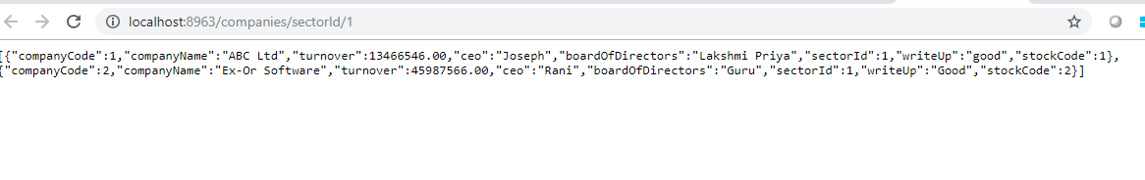

1. Displaying IPO details using company code



1. Displaying company details using letter



1. Displaying Stock Price Details using Company Code

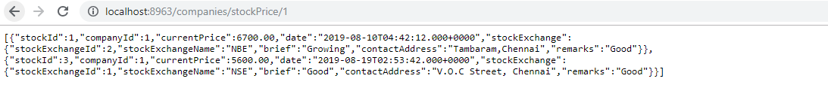

1. Displaying stock price details from one date to another date

