**Milestone1**

Name : P Roja

Employee Id : 761069

Mail : [roja.p3@cognizant.com](mailto:roja.p3@cognizant.com)

Location : Siruseri, Chennai

**Schema Diagram**

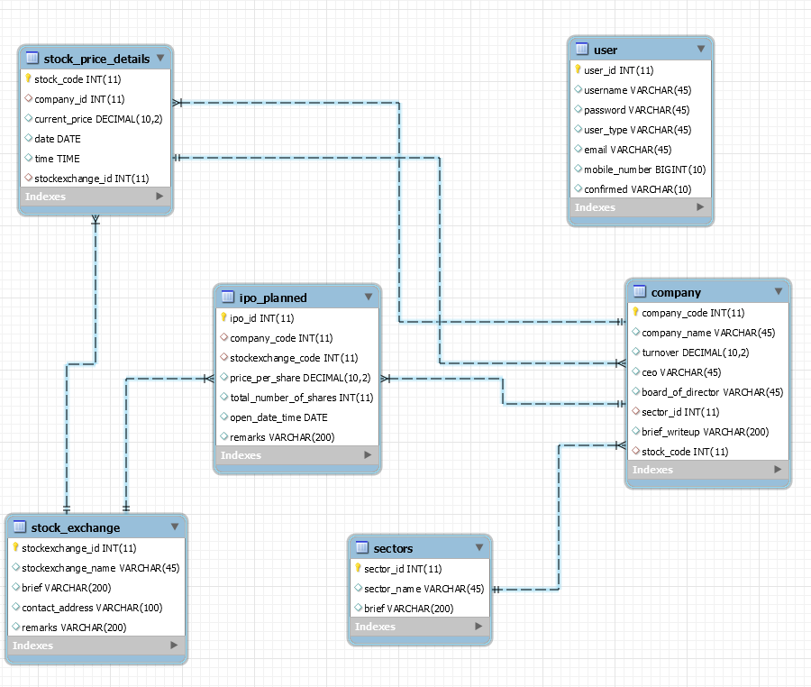

**HTML Screens**

1. **User Registration :**

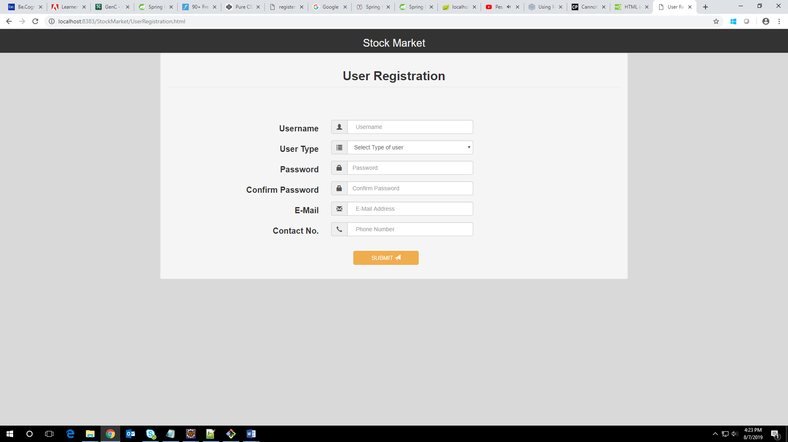

1. **Login**

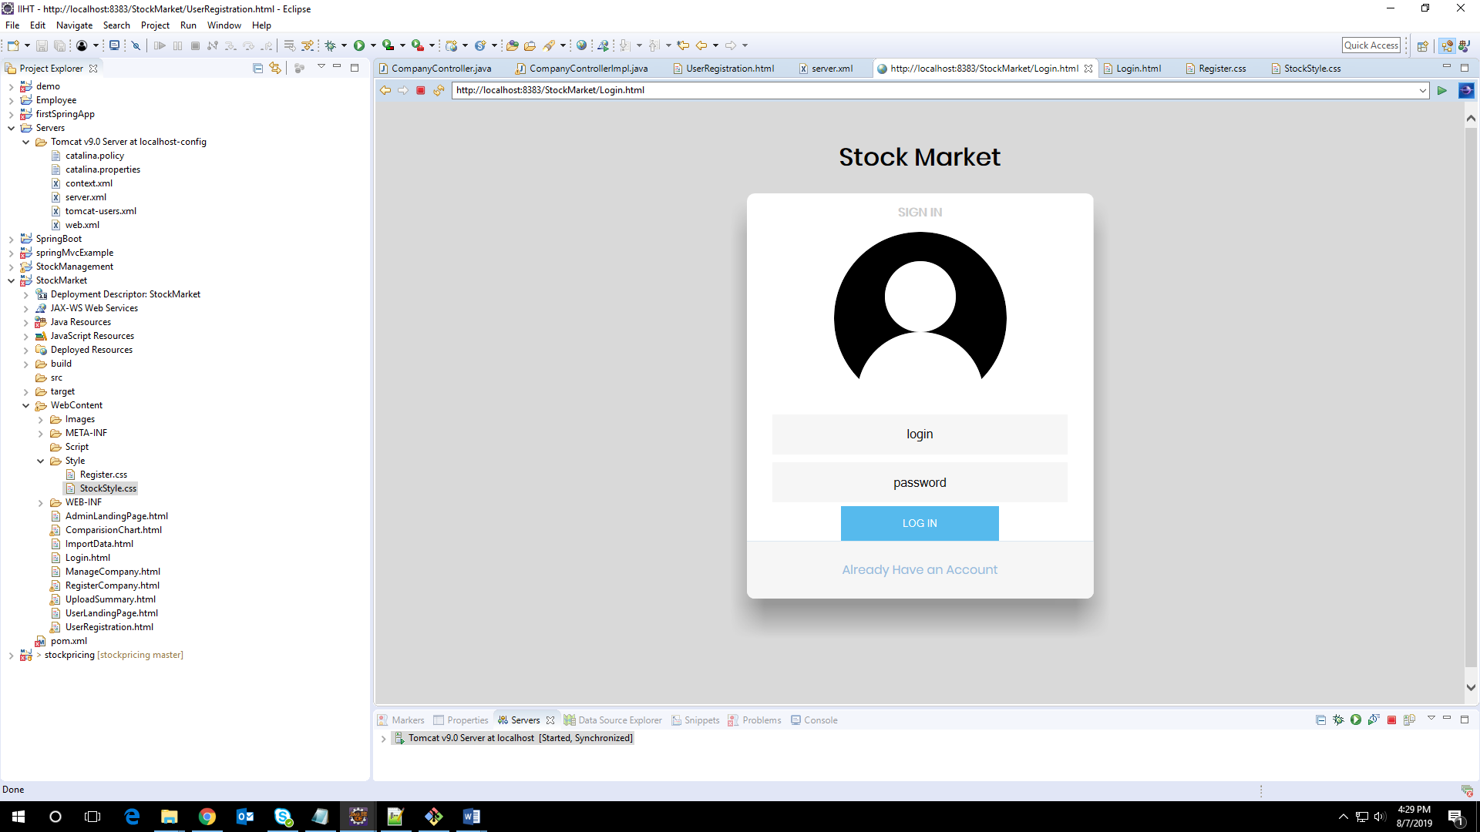

1. **Admin Landing Page**

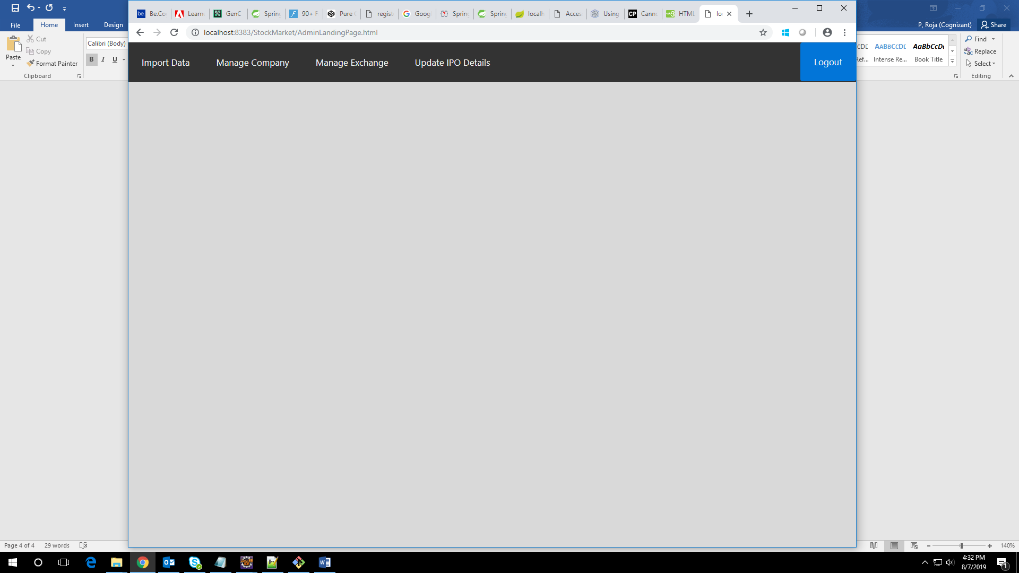

1. **Import Data**

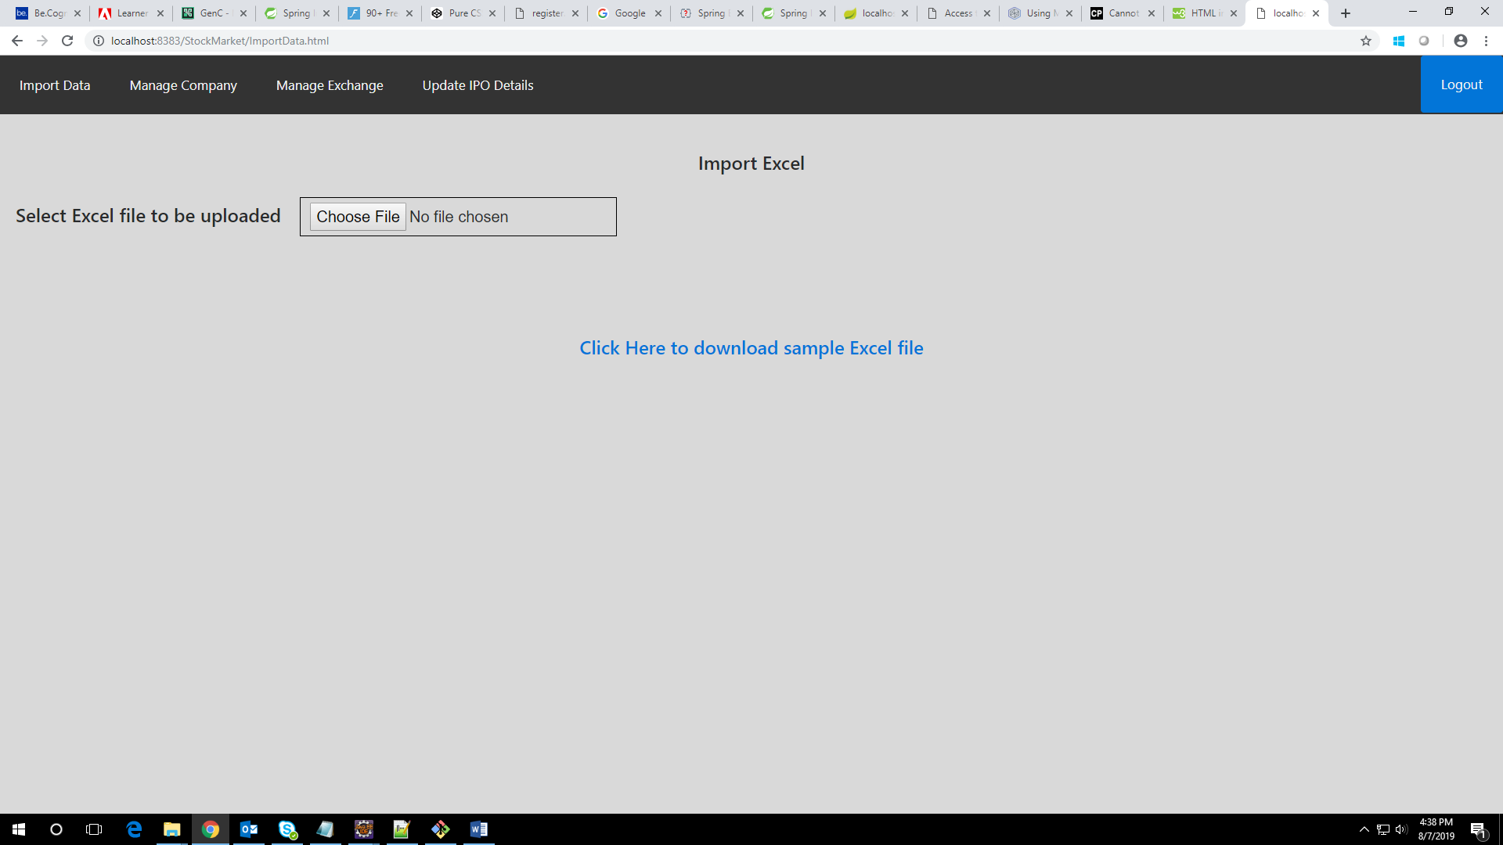

1. **Upload Summary**

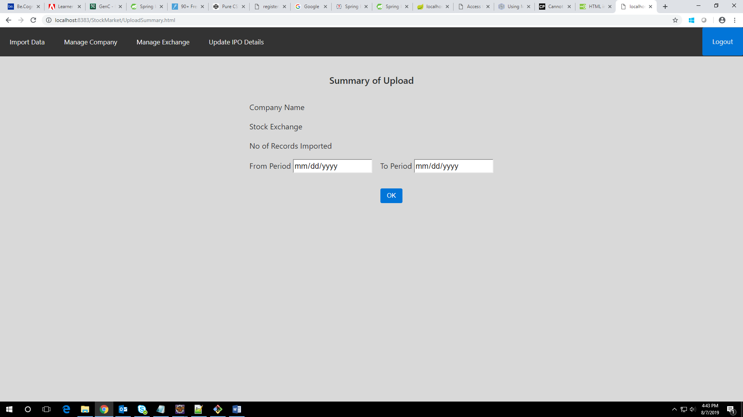

1. **Manage Companies**

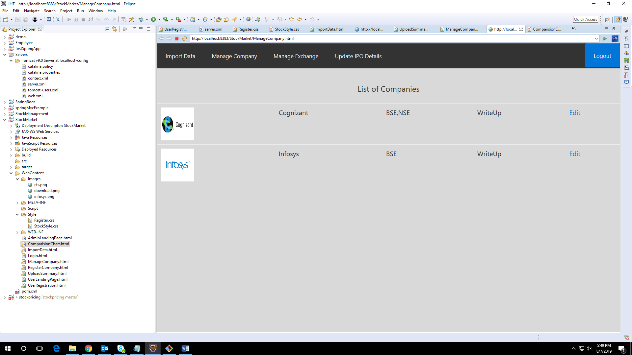

1. **Create New Company**

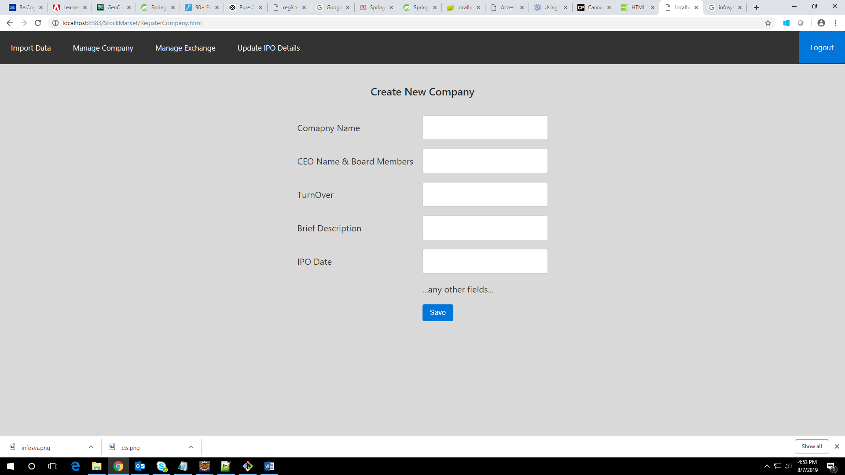

1. **User Landing Page**

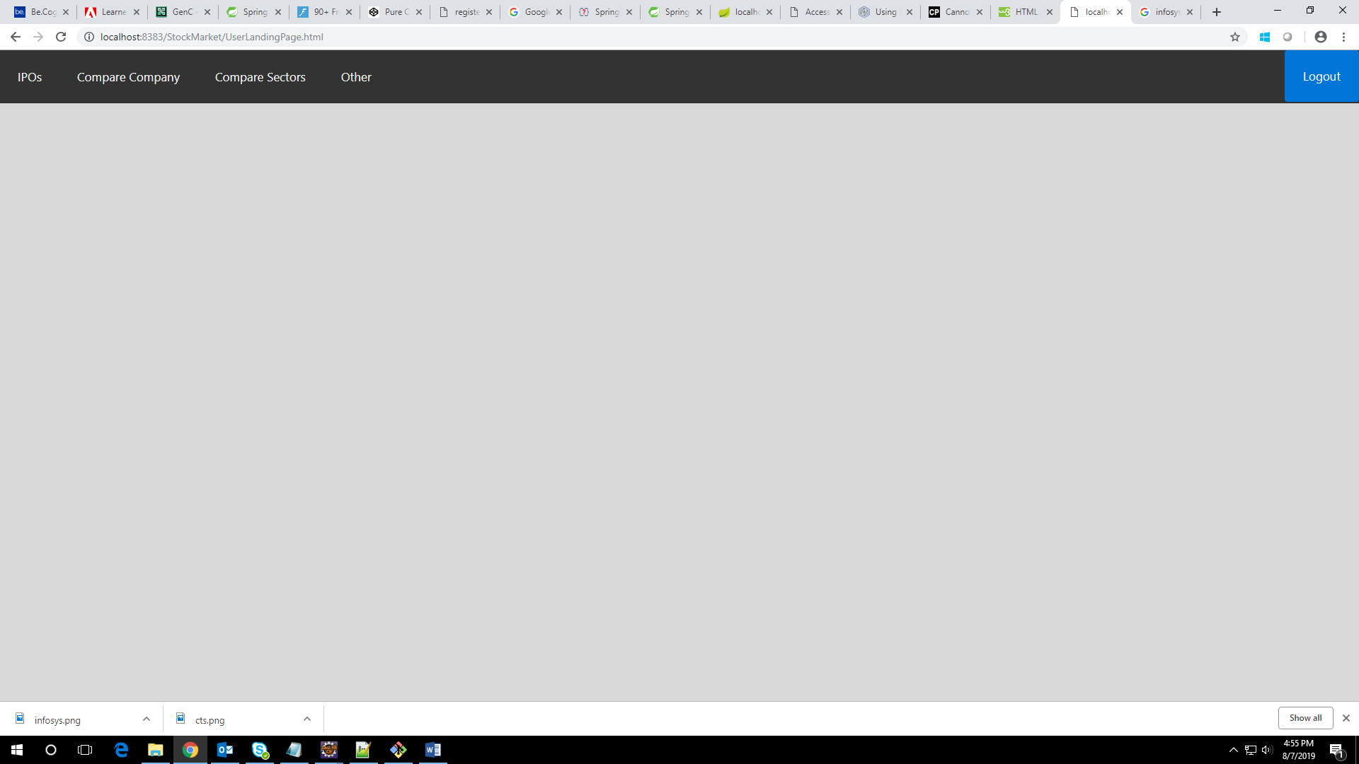

1. **Comparision Charts**

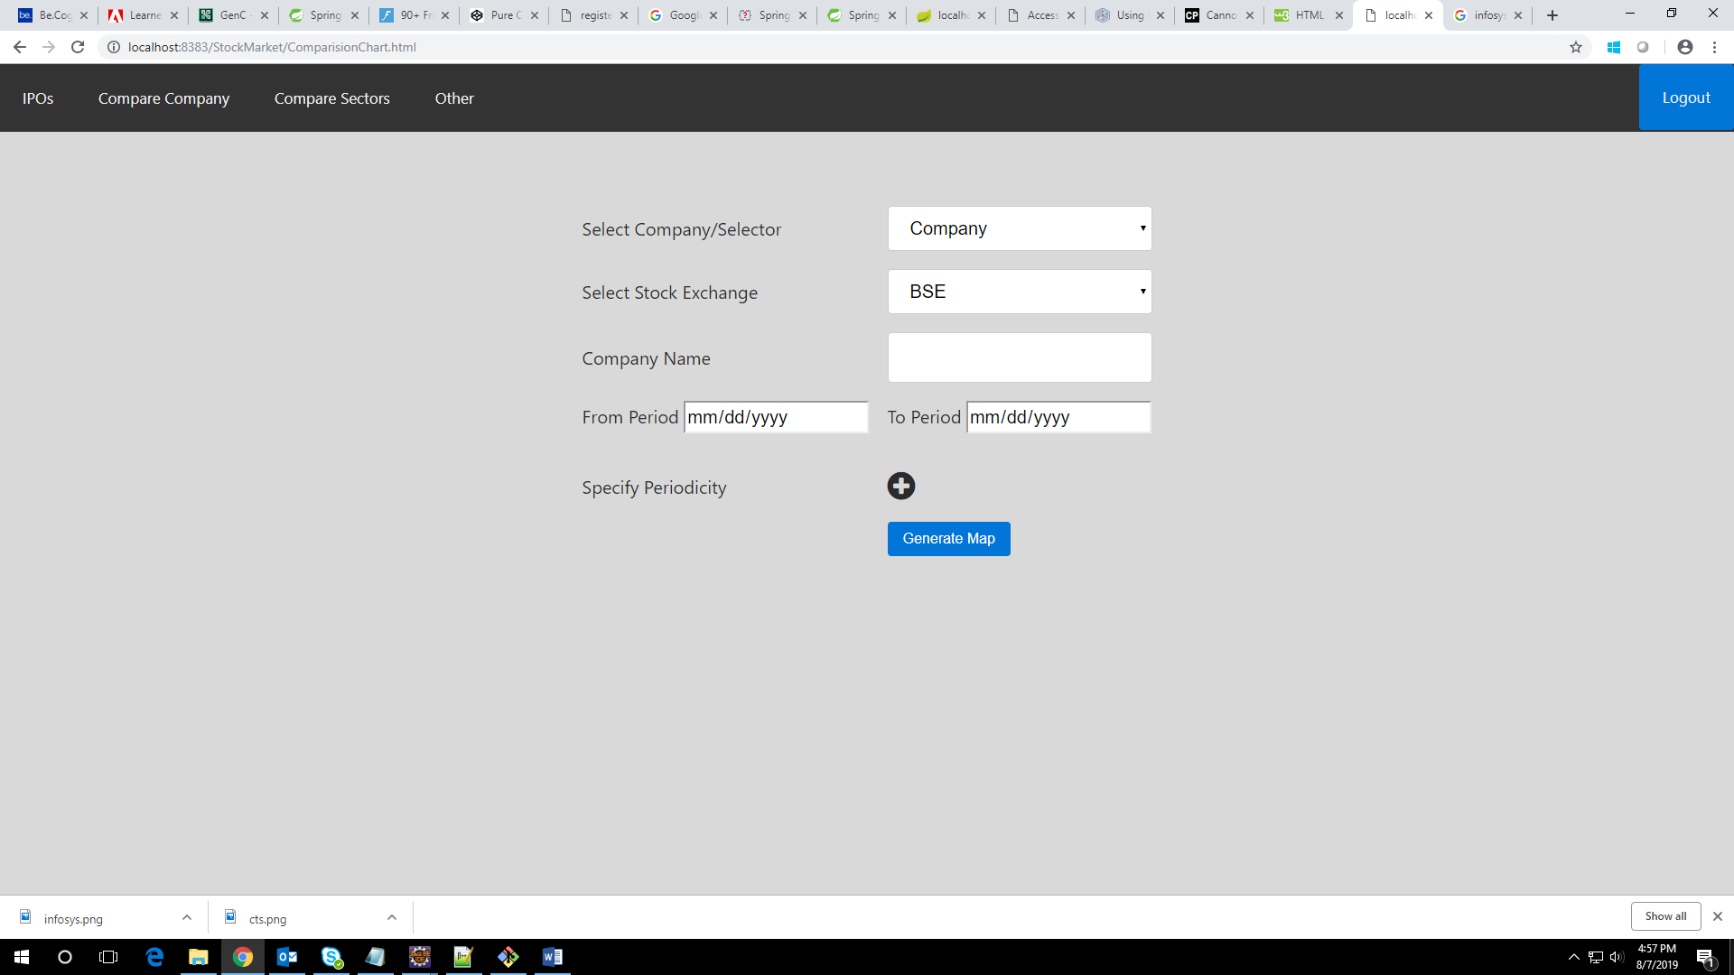

**GitHub Link:**  <https://github.com/P-Roja/StockMarket>

**Output:**

