***V2VCouriers***

**Team Members:** Preksha Reddy Sanjana Podduturi

Purnima R S

## Mentor:

Rajkumar subramanian



# Chapter [1] Introduction

### Purpose:

This Software Requirements Specification (SRS) document will provide a detailed description of the steps, phases and design necessary for the v2vCouriers.This SRS document will allow for a complete understanding, of what is to be expected of the v2vCouriers to be constructed. A clear understanding of the v2vCouriers and its’ functionality will allow for the correct software system to be developed for the users of the software, and will be used for the development of the future stages of the project.This SRS document will provide the foundation for the project. From this SRS document, the v2vCouriers can be designed, constructed, and finally implemented and tested.

### Overview of Document:

Chapter [1] describes the purpose and scope of this SRS document, and its contribution on the overall software engineering project.

Chapter [2] describes the meaning, scope and aim of the courier system project. It also includes about the vision and objective of this system.

Chapter [3] discusses about the plan for approaching the project and some discussions about the structure of the team. Chapter

[4] discusses about the core components related with Software Requirements Specification (SRS). Here, the present or the existing system is compared with the proposed system.

The requirements are specified in general.

Chapter [5] describes about different UML diagrams related with the analysis phase, such as “use-case diagrams”, “sequence diagrams”, “Class Diagram” , “Architecture diagram “ and so on are illustrated.Sample pages of login page , sign up, home page

, courier filling form , admin and courier pages are also shown . chapter [6] discuss about the tables and modules.

Chapter [7] discuss about overall the project and conclusion as well.

# Chapter [2] Introduction of v2vCouriers

### Introduction:

In modern age, as time increase, needs & requirements of the person are also increased. They want more facility & try to do their task quickly & within time .Within the country, the things can be imported through post service. However, it consumes the time& sometimes problem of damage or missing occur. The courier service is one of the solutions of these problems. It is used to send some things to any person within time.

### Meaning of courier services:

“Courier agency means a commercial concern engaged in the door-to-door transportation of time sensitive documents, goods or articles, utilizing the services of person, either directly or indirectly, to carry or accompany such goods, documents or articles.”

### Scope:

This project provides the facility to all users to send and receive the courier. They can get the information of the status of the courier. This project is for only Domestic Courier Management. **Aim of project:** To design and implement a Courier Management System capable of enhancing customer

deliveries by features such as speed, security, tracking etc. from specific towns or cities, to regional and national services

### Objective:

When we have already entered the 21stcentury, we may not afford to listen words like Sorry, Misrouting, Confusion, Late deliveries, loss of Packets, No-response, No feedback etc. We have tried to make all these miss happening & feel pleasure to couriers. The main object of this project is given below:

1. The main object of this project is that it facilitate user to communicate in a faster manner in comparison of manual system. Through this system, the status of the courier can be known easily whereas in manual system it is difficult.
2. To propose all in one system that include both tracking & Courier System.
3. To develop a software solution for courier service system that provide best service, error free and last longer.

# Chapter [3] Project Planning

### The software process:

A process is a collection of activities, actions, and tasks that are performed when some work product is to be created. In addition, a software process is a set of activities that leads to the production of a software product. These activities may involve the development of software from scratch in a standard programming language like Java. Although there are many software processes, some fundamental activities are common to all software processes:

* Specification - what the system should do and its development Constraints
* Development - production of the software system.
* Validation - checking that the software is what the customer wants.
* Evolution - changing the software in response to changing Demands.

### Team Structure:

The principles of teams: Two major aspects of team activity are: 1 .The communication between the people in the team.

2 .Deciding who does what work.

Our system has Democratic Decentralized (DD) team structure, as there is no permanent team leader. Problem of the system is solved by discussion among the team members and decisions on problems and approach are made by group consensus.

**WHY ANGULAR?**

AngularJS is one of the most versatile and popular frameworks available today.

All the functions and commands of this framework use code templates written in HTML script.

Moreover, the AngularJS framework has many powerful features. These features allow decoupling any application logic from DOM (Document Object Model) manipulation. It also provides a host of amazing and useful features. This is why

[AngularJS development](https://www.goodfirms.co/directory/languages/top-software-development-companies/angularjs) is often the preferred option for businesses.

**Here is a list of features that AngularJS offers**

1. **Model View Controller (MVC) Framework.**
2. **User interface with HTML**
3. **POJO Model**
4. **Active community on Google**
5. **Routing**
6. **Two-way binding**

**Why Angular is the Best Framework:**

AngularJS is a very powerful JavaScript framework designed and maintained by Google. It is built specifically to overcome the various limitations of existing technologies in one seamlessly integrated package. Here are the top reasons why Angular JS is preferably the better framework than others.

AngularJS is a modern JavaScript Framework which is used to build highly interactive Single Page Applications. It was

developed by Google to simplify front-end development.It assembles rich and natural web applications and furthermore gives web developers the choice to develop client- side applications.

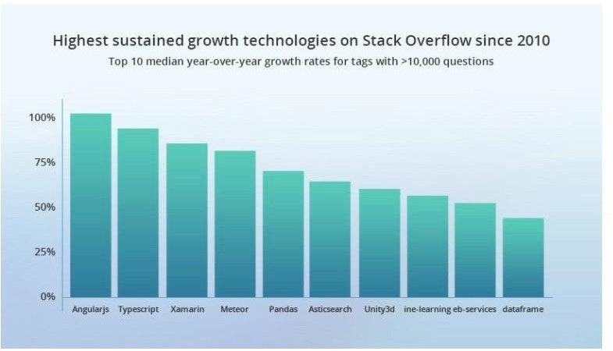

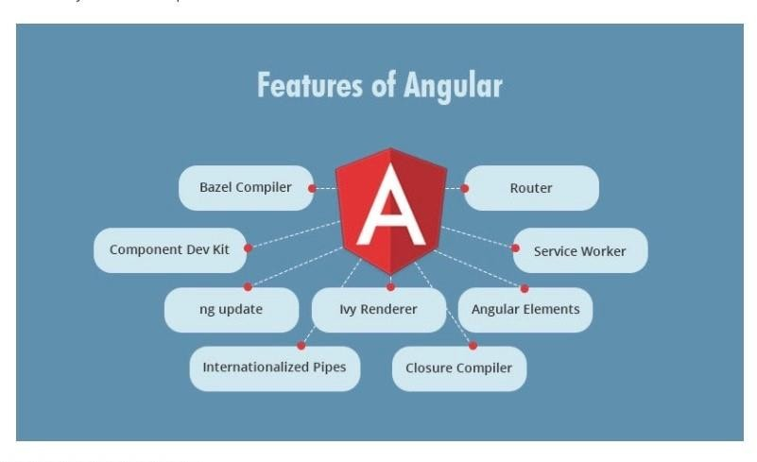

**Why Spring?**

Spring makes programming java quicker, easier, and safer for everybody.Spring’s focuses on speed , simplicity , and productivity has made it the worlds popular java framework.

1.Spring is flexible 2.Spring is productive 3.Spring is fast 4.Spring is secure 5.Spring is Supportive

# Spring Framework Features

Spring is a powerful, lightweight framework used for application development. In broader terms, you can say that the Spring framework is a well-defined tool that supports several

web applications using [Java](http://https/data-flair.training/blogs/java-tutorial/) as a programming language.

# Most Important Features of the Spring Framework:

## i. Lightweight ii. Aspect-Oriented Programming (AOP) iii. Transaction Management iv. Container

1. **Dependency Injection vi. Integration with other frameworks**

**Benefits of the Spring Framework:**

The following is the list of a few great benefits of using the Spring Framework:

•

|  |  |  |  |  |  |
| --- | --- | --- | --- | --- | --- |
| Spring is a powerful framework, which address many  common problems in Java EE. It includes support for | | | |  | |
| managing business objects and exposing their services to | | | | | |
| presentation tier component. |  | | | | |
| It facilitates good programming practice such as | | |  | | |
| programming using interfaces instead of classes. Spring | | | | |  |
| enables developers to develop enterprise applications | | | | | |
| using POJO and POJI model progra | | ming. | | | |
|  | | | | | |
|  | | | | |  |

•

m

* + It is modular, allowing you to use only those parts that you need. It allows us to just choose any part of it in isolation.
  + It supports both XML- and annotation-based configuration.
  + Spring provides a lightweight container that can be activated without using web server or application server software.
  + It gives good support for IoC and Dependency Injection results in loose coupling.
  + The Spring Framework supports JDBC framework that improves productivity and reduces the error.
  + It provides abstraction on ORM software to develop the ORM persistence logic.
  + The Spring Web MVC framework provides powerful and a flexible Web framework as an alternative to Struts

# Chapter [4] Software Requirements

**Specification**

**How existing system work:**

Description of the event-flow of present system is pointed out below:

1. Client go to the website and fill the form to post a courier. The Details included in the form are

* Full name of sender
* Sender mobile no
* Sender full address
* Full name of Receiver •Receiver mobile no.
* Receiver full address.

1. Now Customer will hand over his or her good to the courier boy when he arrives on the pickup date as mentioned in the form.
2. If everything is okay way bill is printed out. It contains all the information to identify the delivery.
3. Then the data for a particular courier maintained in a proper file. A person summarizes all the data of the courier in a register, this work require a high-level of attention since it has to be taken care that no wring entry goes into the register.

### Limitations of existing system:

1. There have no tracking system to know the current location for courier.
2. Manual data entry.
3. Data may lost or damage.
4. Any unauthorized person can access confidential data.
5. Any information cannot be easily searched.
6. Redundancy of data.
7. More time consuming.
8. Inaccuracy in transactions.
9. Slow processing.
10. All connection between Courier Company and client is mobile based.

### Proposed System & It’s Advantages:

After a detailed study of the existing system, it is evident that is does not fulfill the objective of the organization. To make the objective possible for the organization, it is required to have a computerized information system with the help of which all tasks can be processed more accurately and quickly. To achieve this, it is necessary to design and develop a new system. Proposed system is being designed in such a way that many users can have a view with the system simultaneously. It makes effective and perfect utilization of manpower and resources.

By new system client get a tracking number by which client can track his courier. Also, get update information by E-mail or SMS.

New system has following advantage:

Ø Online tracking system: User can track the courier and identified the location.

Ø Be update: User can get all the updates via website e.g., whether packet is delivered, pending or returned to the user etc. Ø Easy in maintaining information: Admin can be easily update information about a specific courier using the tracking id. Ø Routing Information: A Sender can see the all routing information and estimated date of delivery.

Ø User satisfaction: The system is such that is stands up to the user expectations like easy and faster retrieval of information. Ø Safety: The system will be accessible by only the authorized users. As information, being the most crucial for the organization, then the safety of information is importation.

Ø Highly accurate: resources being used by the system will be compatible with the latest technologies available in the market, as proposed system uses highly technically compatible resources, there will be very less wear and tear.

Ø Less time consuming: Work carried out by the staff at various stages will be less time consuming.

### Requirements Specifica1ons:

Development Tools: Front End:Angular Back End:Spring Boot Server End:MySQL

# Chapter [5] System Analysis

System Analysis gives the information about how the software is implemented useing the UML diagrams.

**Use-Case diagram**

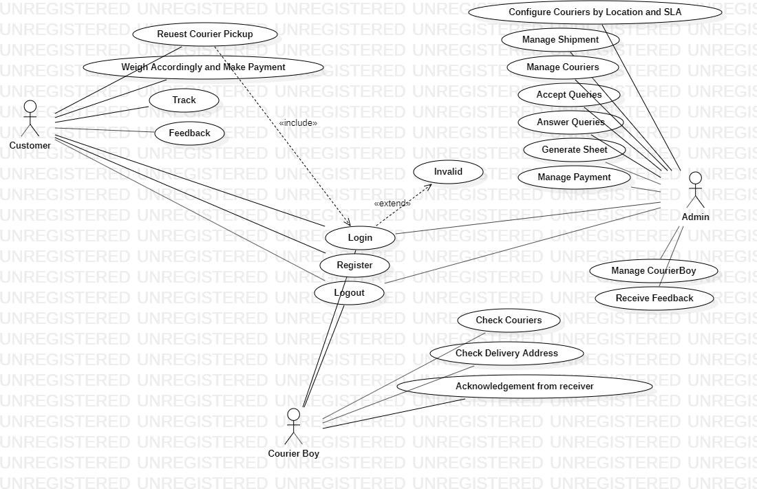

**Class diagram**

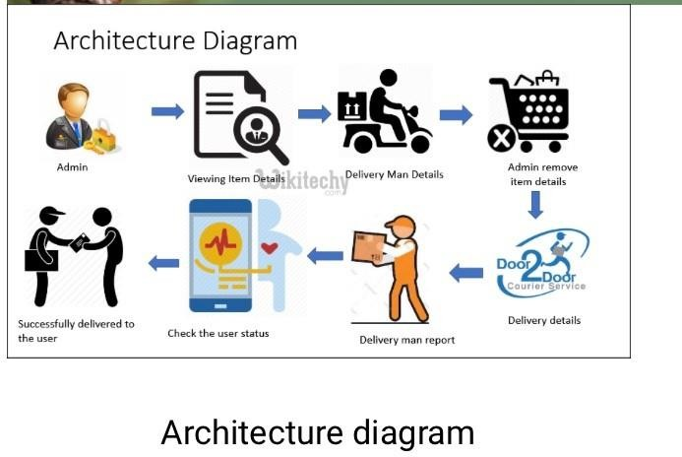

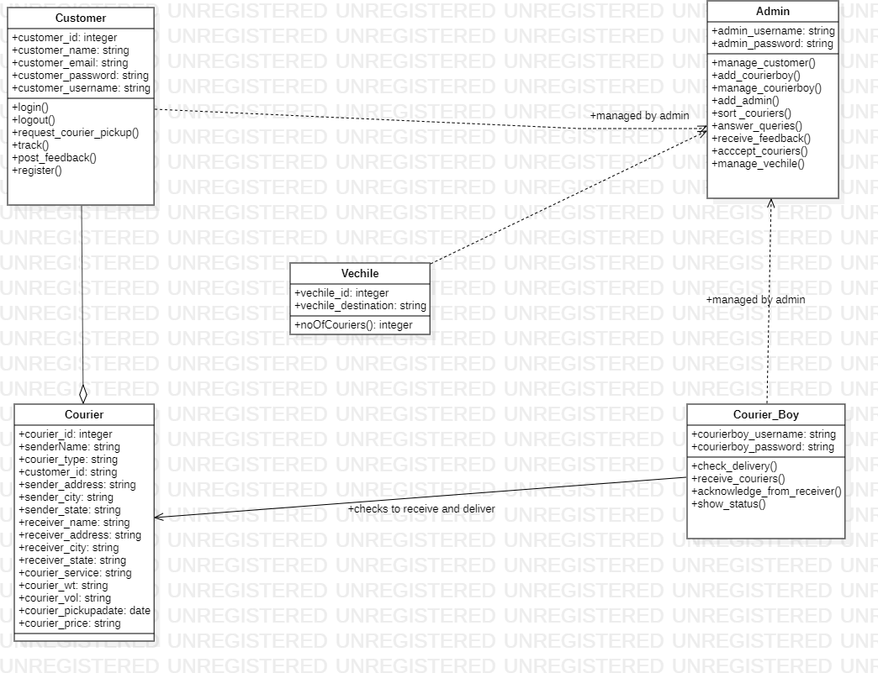

**ER diagram**

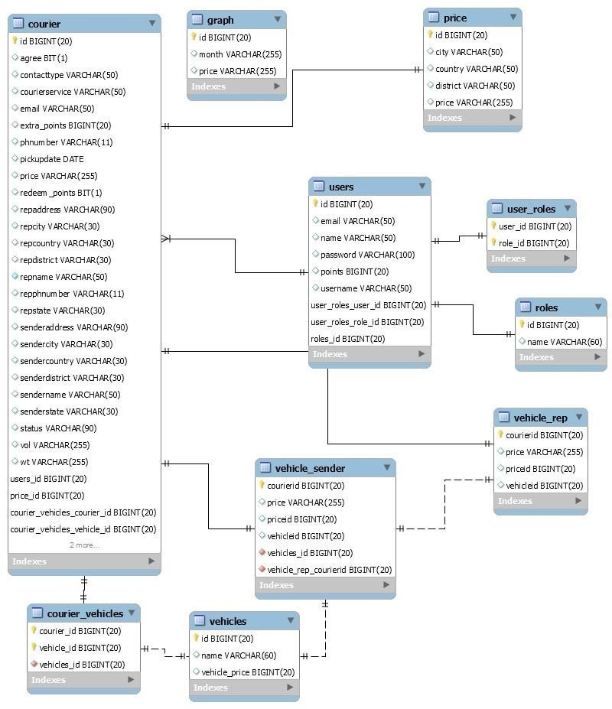

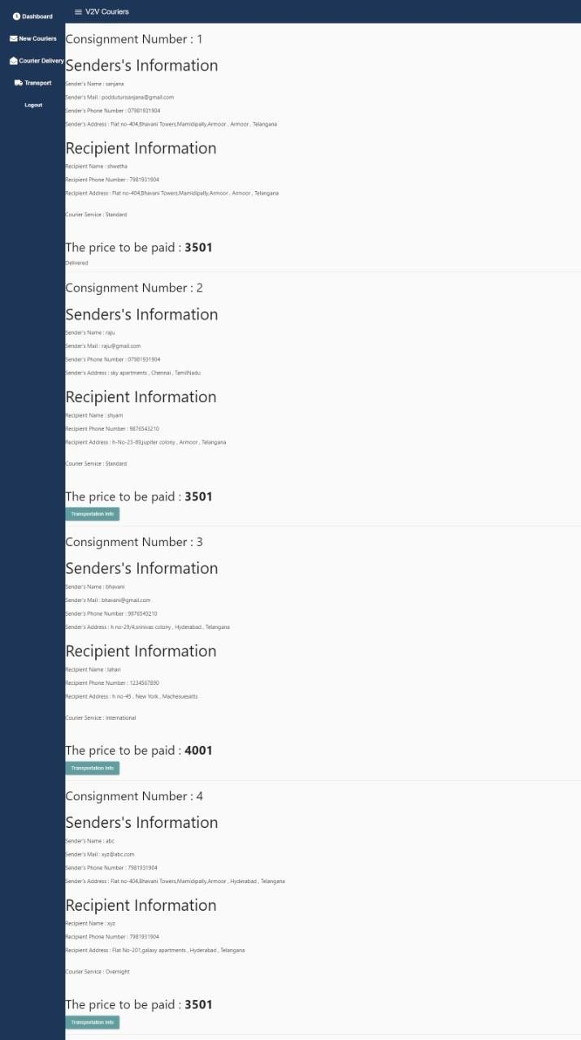

**SEQUENCE DIAGRAM**

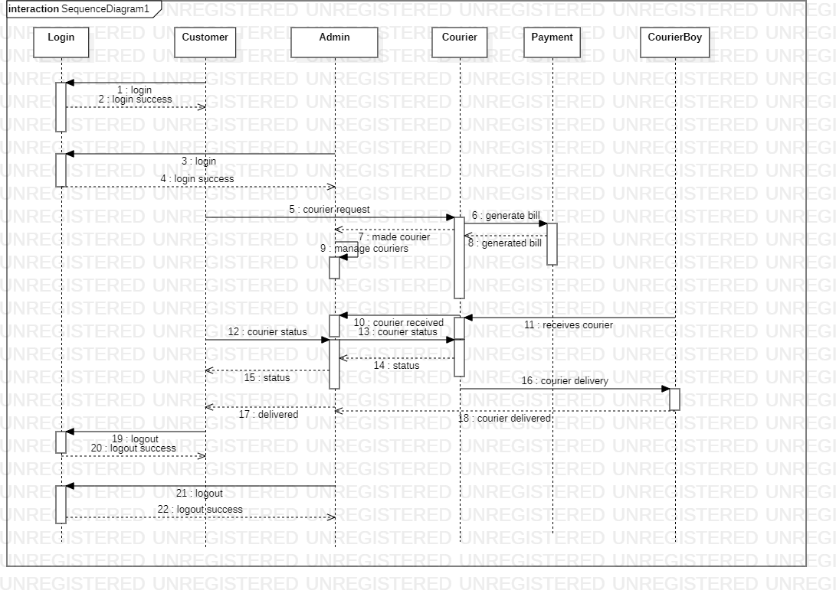

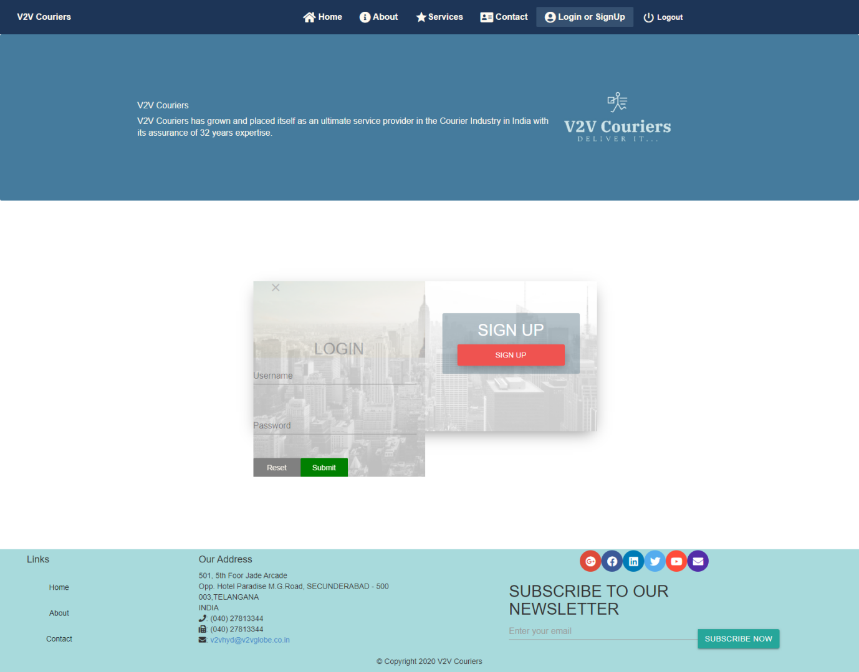

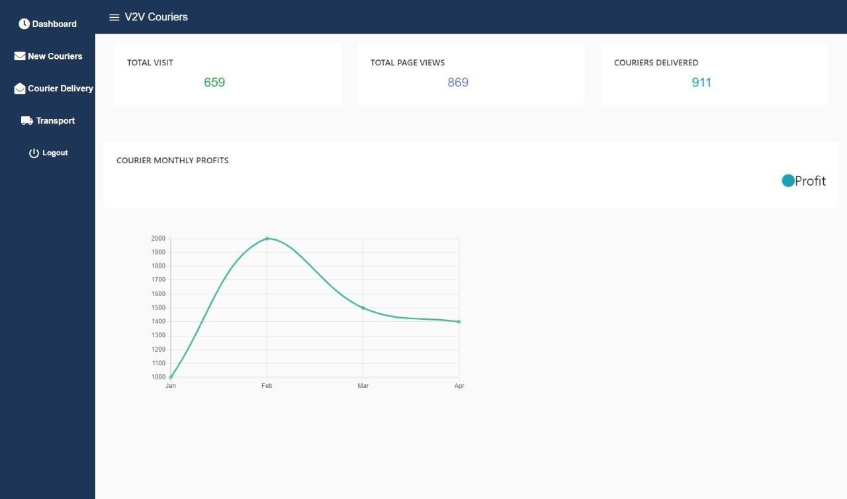

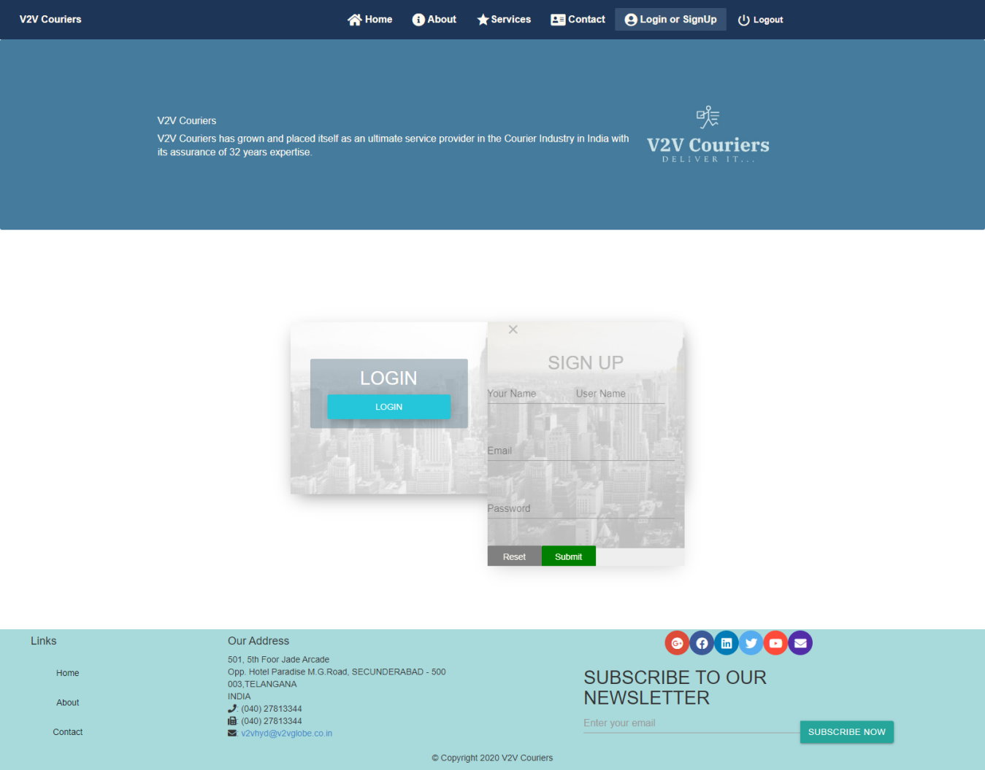

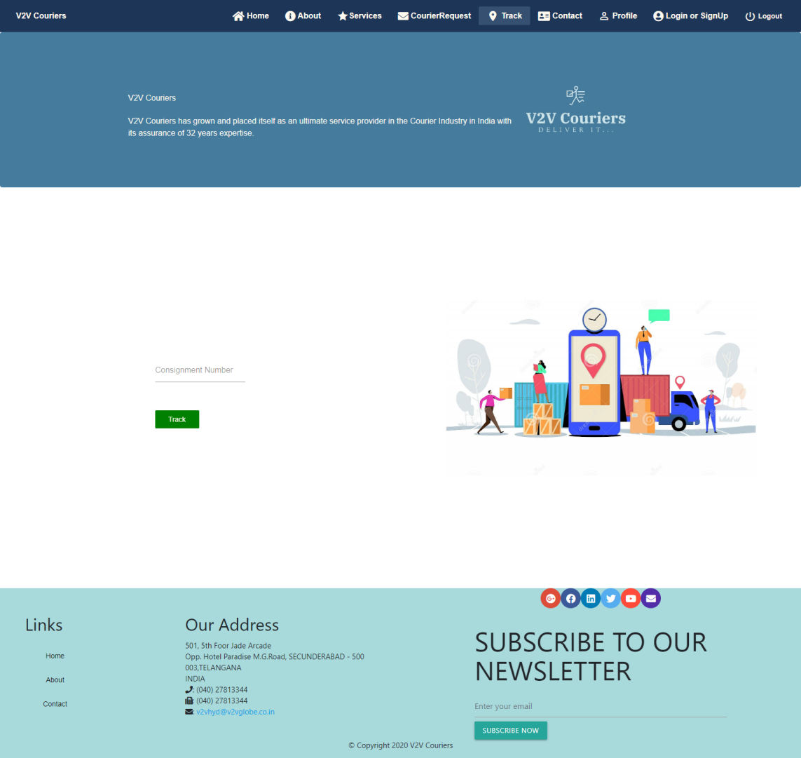

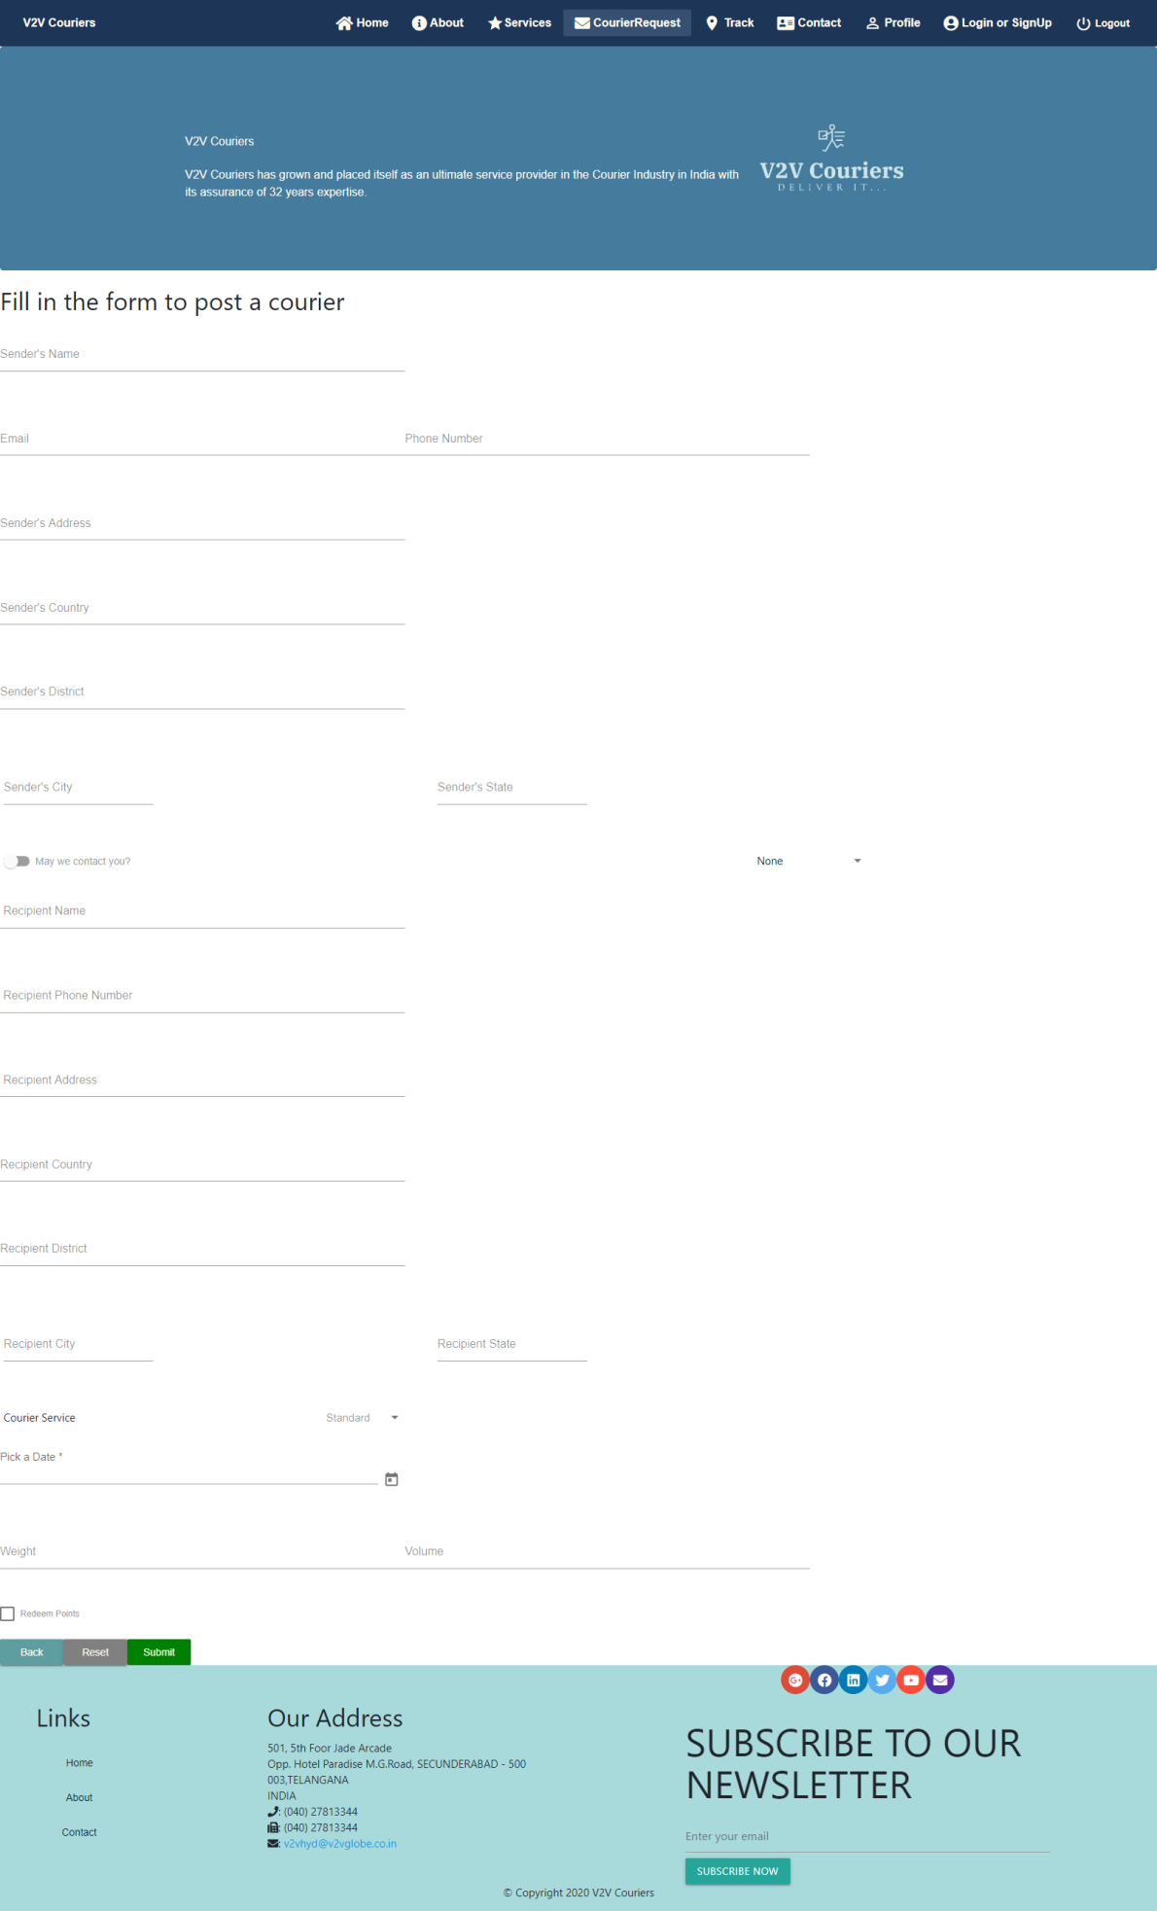

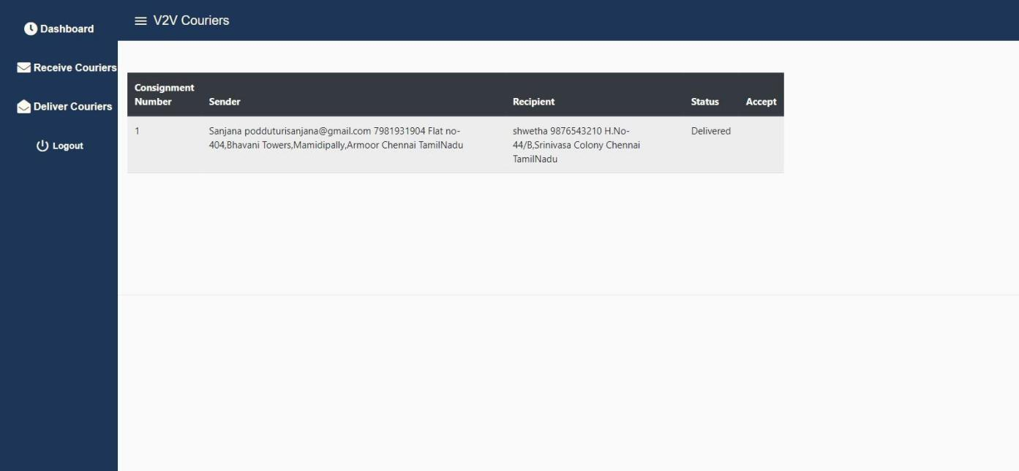

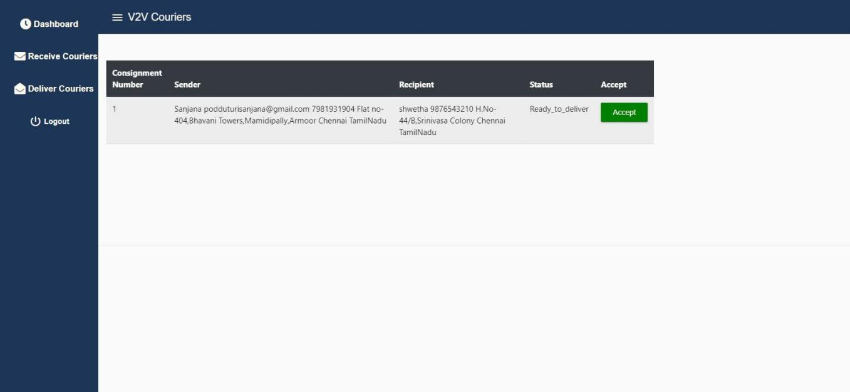

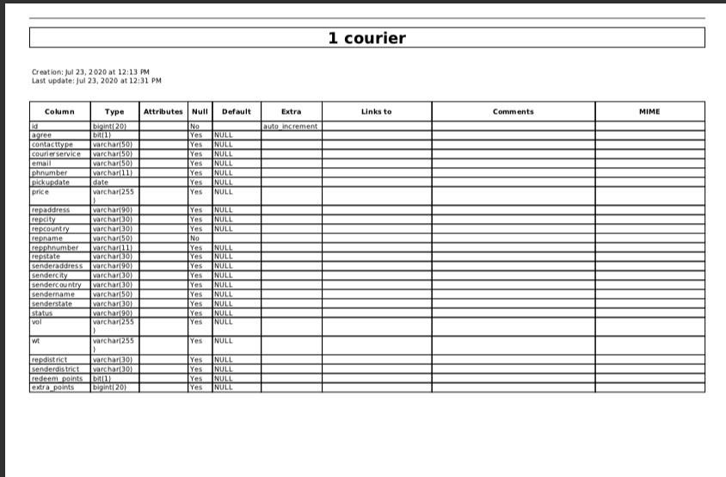**Chapter [6]**

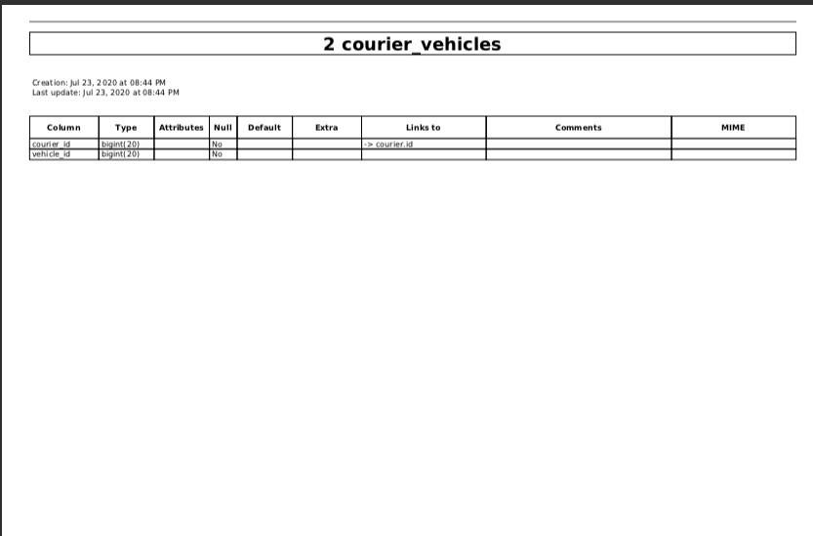

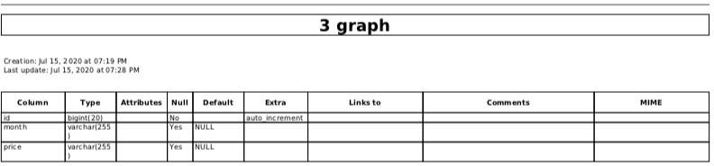

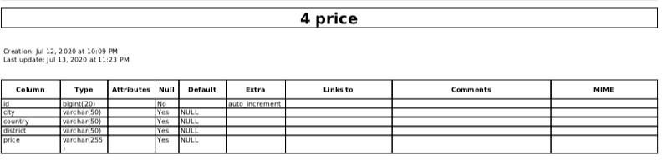

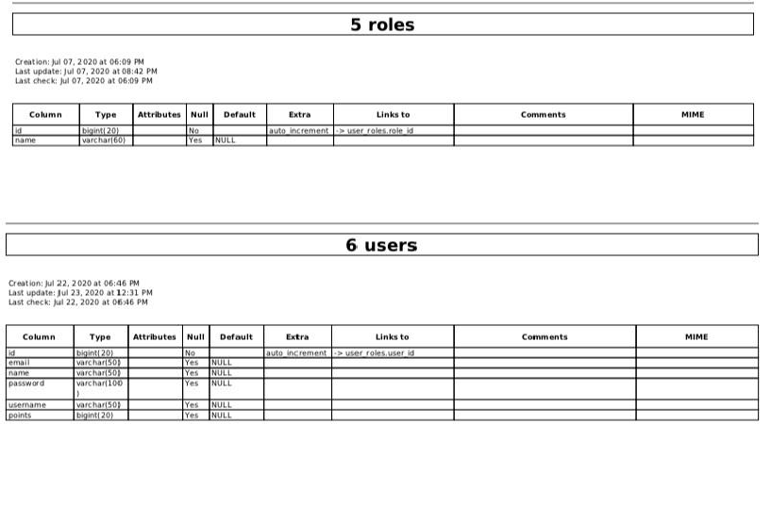

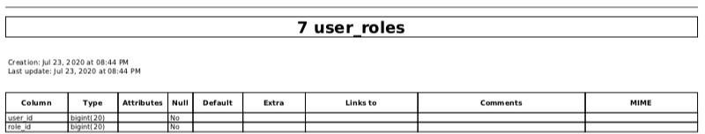

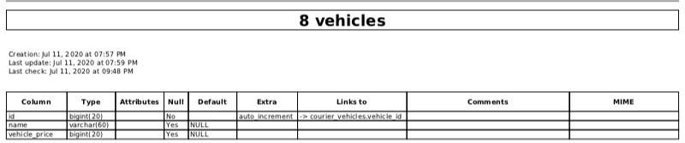

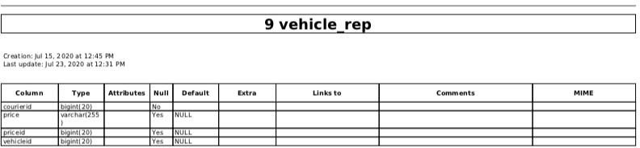

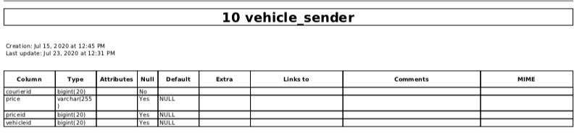

**MODULES:**

**Courier Registration and Monitoring Module:**

This module is used by the User to register the courier and pay the required amount. Users can send

their couriers across the internet and no need to visit anywhere.Users can be able to monitor the current status of the courier. **Courier Management Module :**

This module is used by the Admin to manage the courier distribution.This module decides the optimum transportation costs based on the requested courier service.

**Transportation Module :**

This Module is used by the Admin to manage transportation vehicles and their routes based on the addresses of the couriers and courier services.

### Dashboard Module :

The objective of this module is to provide a dashboard to the admin which shows the arrival of the couriers and the couriers to be departed(with their destination,status).Admin can checkout to

ensure that all couriers are dispatched on time as planned by the Courier Management module. **User Courier Tracking Module :**

This module enables users to track the courier location and status using the courier consignment id.

### Courier Location Data Capture Module :

This module captures the entry and exit of all the couriers to the warehouses,transportation vehicles

and final destination.This information is used by the other modules to track the courier location and transportation id.

### SSO Module :

This module provides Single Sign On for all internal applications.

### Admin Module:

This module is used to manage the application configurations,applications users and their permissions.

### CourierBoy Module:

This module is used by the courierboy which shows report of couriers to recieve and deliver based on the destination and courier service.

**Chapter[7]**

**Discussion and Conclusion**

### Discussion:

The software is verified and validated for different critical inputs and it produces accurate result. The software can be modified according to user requirements. The database files used in this software are designed carefully to overcome the problems of storing and retrieval of information generally related to traditional file processing system.

### Work we have done:

**R**egistration ,login page , saving courier details and picking appropriate vehicles for each courier fully integrated and courier price calculation part and PayPal is also ingrates completely

**Upper edge:**We will give coins to the user when he registers and when he posts the courier.These coins will be used for reducing the price of the courier.

### Conclusion:

At present the software system satisfies most of the functions of a very general Courier system management system. Unauthorized access to the data is nearly eliminated by providing password authentication system.

This project has made us require a professional outlook towards problem statement and solving it to the best and maximum

**References:**

<https://angular.io/>

<https://material.angular.io/>

<https://spring.io/guides/gs/spring-boot/>

<https://www.npmjs.com/>

<https://mkyong.com/spring-boot>

[https://grokonez.com/frontend/angular/how-to-integrate-angular-6-springboot-2-0-restapi](https://grokonez.com/frontend/angular/how-to-integrate-angular-6-springboot-2-0-restapi-springtoolsuite" \l ":~:text=Integrate SpringBoot RestAPI & Angular 6,-Angular call SpringBoot&text=Angular6-Client and SpringBoot server,SpringBoot server at port 8080 .&text=%E2%80%93 Build and run the SpringBoot project at port 8080 .)