**VISVESVARAYA TECHNOLOGICAL UNIVERSITY**

**BELAGAVI – 590 018**



A REPORT ON MINI-PROJECT WORK

**GARBAGE MONITORING AND CONTROLLING WITH SMART SEGREGATION OF DRY AND WET WASTE**

***Submitted in the partial fulfilment of the requirements for the award of the degree of***

**BACHELOR OF ENGINEERING**

*in*

**ELECTRONICS & COMMUNICATION**

|  |  |
| --- | --- |
| **Mini-Project Associates** | |
| **S SUHAS** | **4BD20EC060** |
| **SHREYAS P** | **4BD20EC066** |
| **VYSHNAVI H K** | **4BD20EC090** |
| **CHITRA A** | **4BD21EC408** |

**Dr. K M PRAKASH**

**M. Tech (DECA), Ph.D., MISTE, MIETE, MIE**

**Mini-Project Guide**

|  |  |
| --- | --- |
| **Dr. G S Sunitha** | **Dr. H B Aravind** |
| **M. Tech (DEAC), Ph.D., MISTE, FIETE, FIE** | **B.E., M.E., Ph.D., FIE, MISTE, FIEE** |
| **Program coordinator** | **Principal** |



**Bapuji Educational Association®**

**Bapuji Institute of Engineering and Technology**

**Davangere-577 004**

**Department of Electronics & Communication Engineering**

**2022-2023**

**BAPUJI INSTITUTE OF ENGINEERING AND TECHNOLOGY**

**DAVANGERE, KARNATAKA – 577004**

**DEPARTMENT OF ELECTRONICS & COMMUNICATION   
ENGINEERING**

**Certificate**

Certified that the Mini-Project work entitled “**Garbage Monitoring and Controlling with Smart Segregation of Dry and Wet Waste**” carried out by Mr. S SUHAS USN 4BD20EC060, Mr. SHREYAS P USN 4BD20EC066, Ms. VYSHNAVI H K USN 4BD20EC090, Ms. CHITRA A USN 4BD21EC408 bonafide students of this institution in partial fulfillment for the award of degree of **Bachelor of Engineering in Electronics & Communication** by **Visvesvaraya Technological University**, Belgaum during the academic year **2022-23**. It is certified that all corrections / suggestions indicated for internal assessment have been incorporated in the report deposited in the departmental library. The project report has been approved as it satisfies the academic requirements in respect of Project work prescribed for the said degree.

______________

**Dr. K M Prakash**

**M. Tech (DEAC), Ph.D., MISTE, MIETE, MIE**

**Mini-Project Guide**

|  |  |  |  |
| --- | --- | --- | --- |
| **Dr. G S Sunitha** |  |  | **Dr. H B Aravind** |
| **M. Tech (DEAC), Ph.D., MISTE, FIETE, FIE** | | **B.E., M.E., Ph.D., FIE, MISTE, FIEE** | |
| **Program Coordinator** | | **Principal** | |

**External Viva–Voce**

|  |  |  |
| --- | --- | --- |
| **Name of the Examiners** | | **Signature with Date** |
|  |  |  |
|  |  |  |

**VISION OF THE INSTITUTE**

To be a center of excellence recognized nationally and internationally, in distinctive areas of engineering education and research, based on a culture of innovation and excellence.

**MISSION OF THE INSTITUTE**

BIET contributes to the growth and development of its students by imparting a broad-based engineering education and empowering them to be successful in their chosen field by inculcating in them positive approach, leadership qualities and ethical values.

**VISION OF THE DEPARTMENT**

To be in the forefront in providing quality technical education and research in Electronics & Communication Engineering to produce skilled professionals to cater to the challenges of the society.

**MISSION OF THE DEPARTMENT**

1. To facilitate the students with profound technical knowledge through effective teaching learning process for a successful career.
2. To impart quality education to strengthen students to meet the industry standards and face confidently the challenges in the program.
3. To develop the essence of innovation and research among students and faculty by providing infrastructure and a conducive environment.
4. To inculcate the student community with ethical values, communication skills, leadership qualities, entrepreneurial skills and lifelong learning to meet the societal needs.

**MINI-PROJECT WORK (18ECMP68)**

**Course Learning Objectives:**

This course will enable us to:

•Understand and analyse the engineering problem.

•Acquire technical knowledge and collect the information.

•Enhance communication, technical presentation and report preparation skills.

•Provide an opportunity to exercise the creative and innovation ideas in group.

# Acknowledgements

We would like to acknowledge the help and encouragement given by various people during the course of this project.

We would like to express our sincere gratitude to our guide Dr. K. M. Prakash, Associate Professor, Department of Electronics and Communication Engineering, Bapuji Institute of Engineering and Technology, Davangere, for his guidance, continuous support and motivation in completing the Mini-project successfully.

We would like to thank mini-project coordinators Dr. Leela G H, Associate Professor and Mrs. Sucharitha S D, Assistant Professor for the kind co-ordination during the course of the work.

We would like to express our sincere gratitude to Dr. G S Sunitha, Professor and Head, Department of Electronics & Communication Engineering, BIET, Davanagere, for her kind support, guidance and encouragement throughout the course of this work.

We are thankful to our beloved principal Dr. H B Aravind for providing excellent academic climate.

We would like to thank all the teaching and non-teaching staff of Dept. of E&CE for their kind co-operation during the course of the work. The support provided by the college and departmental library is greatly acknowledged.

Finally, we are thankful to our parents and friends, who helped us in one way or the other throughout our project work.

Mini-Project Associates

S Suhas

Shreyas P

Vyshnavi H K

Chitra A

# Abstract

The amount of waste has been increasing due to the increase in human population and urbanization. In cities, the overflowed bin creates an unhygienic environment. Thus degrades the environment, to overcome this situation “Garbage Monitoring and Segregation of Dry and Wet Waste” is developed to reduce the work for the rag pickers. The wastes are segregated by the human beings which leads to health problems to the workers. The proposed system separates the waste into two categories namely dry and wet waste. Each of the wastes are detected by the respective sensors and gets segregated inside the bins.

# Table of contents

Acknowledgements i

Abstract ii

Table of contents iii

List of Figures iv

Chapter 1 INTRODUCTION 1

Chapter 2 OBJECTIVES 2

Chapter 3 METHODOLOGY 3

3.1 Block Diagram 3

Chapter 4 HARDWARE REQUIREMENTS 4

4.1 Arduino UNO 4

4.2 IR Proximity Sensor 5

4.3 Moisture Sensor 5

4.4 Ultrasonic Sensor 6

4.5 Servo Motor 6

4.6 16X2 LCD Display 7

4.7 Buzzer 7

4.8 10K Potentiometer 8

4.9 4 x AA Battery Holder Case 8

4.10 Wiring diagram and Description 9

Chapter 5 SOFTWARE REQUIREMENTS 10

5.1 Arduino IDE 10

5.2 Libraries used 10

5.3 Flowchart 11

Chapter 6 RESULT AND DISCUSSION 12

6.1 Final Output 12

APPLICATIONS 13

ADVANTAGES 14

LIMITATIONS 14

CONCLUSION 15

FUTURE SCOPE 15

REFERENCES 16

APPENDIX A 17

APPENDIX B 21

COURSE OUTCOMES 25

# List of Figures

Figure 3.1.1: Block Diagram. 3

Figure 4.1.1: Arduino UNO 4

Figure 4.2.1: IR Proximity Sensor 5

Figure 4.3.1 Moisture Sensor 5

Figure 4.4.1 Ultrasonic Sensor 6

Figure 4.5.1: Servo Motor 6

Figure 4.6.1: 16X2 LCD Display 7

Figure 4.7.1: Buzzer 7

Figure 4.8.1: 10K Potentiometer 8

Figure 4.9.1: 4 X AA Battery Holder Case 8

Figure 4.10.1: Wiring diagram. 9

Figure 5.1.1: Arduino IDE 10

Figure 5.3.1: Flow Chart 11

Figure 6.1.1: Dry Waste Segregation. 12

Figure 6.1.2: Wet Waste Segregation. 12

# INTRODUCTION

The management of waste is a crucial aspect of ensuring the sustainability of our planet. In many cities and towns around the world, waste management practices are still largely manual, leading to inefficiencies and environmental hazards. The need for a more efficient and sustainable waste management system has become more pressing, especially as the amount of waste generated continues to increase.

This developed System utilizes sensors to identify different types of waste and separate them into their respective categories. This system has numerous benefits, including reducing the amount of waste that ends up in landfills, increasing the amount of waste that can be recycled, reducing the need for manual labor, and improving the overall efficiency of waste management processes.

The project has the potential to significantly improve waste management practices, reduce waste contamination and promote sustainable waste disposal methods. It will also contribute to the development of smart city infrastructure which leverages technology to optimize resource usage and reduce environmental impact. Additionally, garbage monitoring and controlling with smart segregation of dry and wet waste systems can help to minimize the environmental impact of waste disposal, by ensuring that recyclable materials are properly sorted and recycled, and that non-recyclable waste is disposed of in the most appropriate manner.

Moreover, it encourages people to be more conscious of their waste and to dispose it properly, which can help to create a more sustainable future for all.

# 

# OBJECTIVES

* To understand about various sensors and its functionality.
* To develop waste monitoring and segregation system using Arduino.
* To fabricate a less complex automatic waste monitoring and segregation system.

# 

# METHODOLOGY

## Block Diagram

**Arduino uno**

**IR SENSOR**

**Power supply**

**Buzzer**

**LCD**

**Servo Motor**

**Slot 1**

**Slot 2**

**Moisture Sensor**

**Ultrasonic Sensor**

Figure 3.1.1: Block Diagram.

The system consists of power supply, Arduino UNO, moisture sensor, IR sensor, ultrasonic sensor, servo motor, 16X2 LCD display and buzzer. Garbage monitoring and segregation of dry and wet waste System is driven by the Microcontroller Arduino UNO. All the components that are connected to Arduino UNO are programmed using the Arduino IDE. The program is written in Embedded C language and it reads the input/output pins of the components. Firstly, the waste is being dumped in the bin and the IR sensor senses the presence of waste. In the presence of waste moisture sensor checks whether the waste is dry or wet. Based on the output given by moisture sensor the waste is dumped in respective slots by servo motor. Ultrasonic sensors are present in each slot which measures the level of bin. In case the bin is full ultrasonic sensor detects it and LCD displays the bin is full and the buzzer buzzes.

# HARDWARE REQUIREMENTS

## Arduino UNO

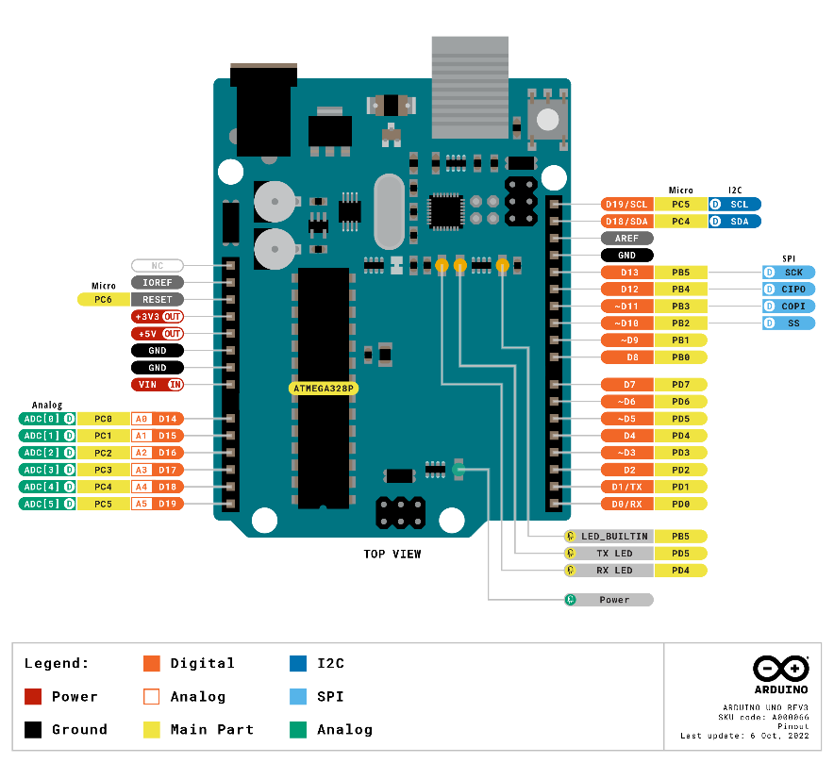

Figure 4.1.1: Arduino UNO

* The Arduino boards are equipped with 14 digital pins for input or output and 6 analog pins for input that are used to interface different circuits.
* The customization of microcontrollers is done by utilizing Embedded C and C++ programming codes.
* Current Arduino boards are programmed by means of Universal Serial Bus (USB).
* It is the main controlling unit.

## IR Proximity Sensor

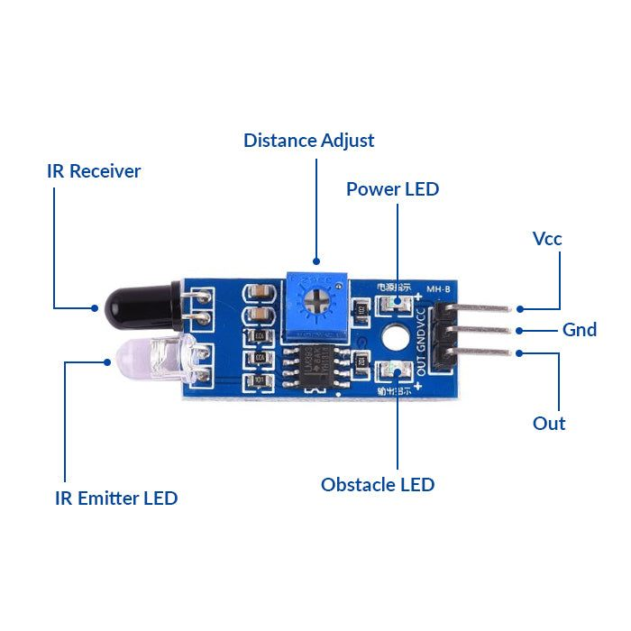

Figure 4.2.1: IR Proximity Sensor

* The presence of objects is detected without any physical contact with the help of IR proximity sensor.
* It detects objects by “emitting electromagnetic field or electromagnetic radiation and observes the changes in the field or return signal.”
* It is used to detect the presence of the waste.

## Moisture Sensor

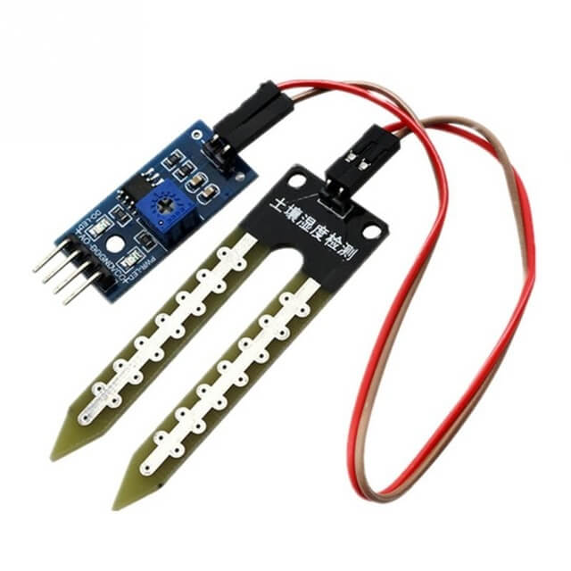

Figure 1.3.1: Moisture Sensor

* It is used to identify if the garbage is wet or dry.
* The content of moisture in the waste is tested and accordingly it is dropped in the appropriate dustbin.
* It measures the volumetric content of water inside the waste and gives us the moisture level as output.
* The module has both digital and analog outputs and a potentiometer to adjust the threshold level.

## Ultrasonic Sensor

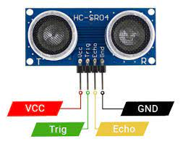

Figure 4.4.1: Ultrasonic Sensor

* It is used to keep check on the garbage level of the bin.
* The acoustic Ultrasonic sensor is divided into three categories:

Receivers

Transceivers

Transmitters

* The transmitters radiate the ultrasound by converting electrical signals into ultrasound.
* It is then reflected by the obstacle and received by the receiver that converts the ultrasound into electrical signal.
* The reflected signals are used to interpret the position of the garbage in the bin.

## Servo Motor

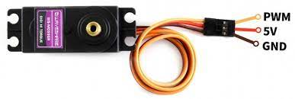

Figure 4.5.1: Servo Motor

* It is used to deflect the waste to the respective bins. A servomotor is defined by “a rotary actuator or linear actuator that takes into account exact control of angular or linear position, velocity and acceleration.”
* MG995 Metal Gear Servo Motor is a high-speed standard servo motor that can rotate approximately 180 degrees (60 in each direction).

## 16X2 LCD Display

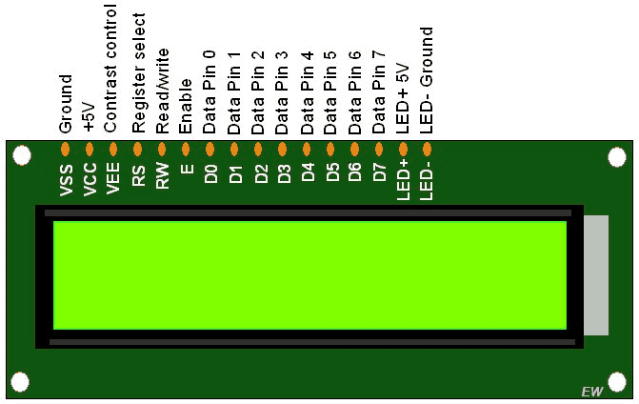

Figure 4.6.1: 16X2 LCD Display

* An LCD (Liquid Crystal Display) very basic module and is very commonly used in various devices and circuits.
* A 16x2 LCD means it can display 16 characters per line and there are 2 such lines. In this LCD each character is displayed in 5x7 pixel matrix.
* The 16 x 2 intelligent alphanumeric dot matrix display is capable of displaying 224 different characters and symbols. This LCD has two registers, namely, Command and Data.
* Used to show the level of waste in bin and indicates when bin is full.

## Buzzer

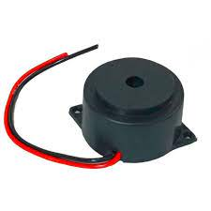

Figure 4.7.1: Buzzer

* The passive buzzer is an electromagnetic speaker used to generate sound signals of different frequencies when bin is full. The active buzzer is the simplest module to produce a sound of about 2 kHz.

## 10K Potentiometer

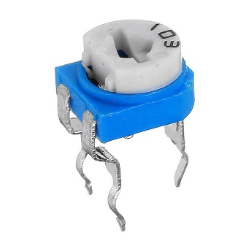

Figure 4.8.1: 10K Potentiometer

* [A potentiometer is a three-terminal resistor with a sliding or rotating contact that forms an adjustable voltage divider](https://en.wikipedia.org/wiki/Potentiometer). [It is often used to regulate the current flow either by adding or subtracting resistance from the circuit](https://www.vedantu.com/physics/potentiometer-working).
* [Potentiometers consist of a resistive element, a sliding contact (wiper) that moves along the element, making good electrical contact with one part of it, electrical terminals at each end of the element, a mechanism that moves the wiper from one end to the other, and a housing containing the element and wiper](https://en.wikipedia.org/wiki/Potentiometer)
* Used to control the contrast of 16x2 LCD display.

## 4 x AA Battery Holder Case

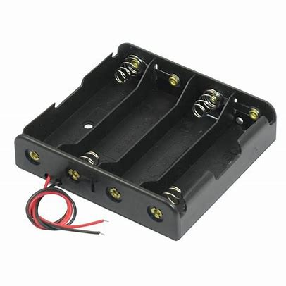

Figure 4.9.1: 4 X AA Battery Holder Case

* A 4 x AA Battery Holder case is suitable for 4 x AA batteries with spring clip design.
* We can easily put the AA battery in it.
* It powers the unit with AA batteries in it.

## Wiring diagram and Description

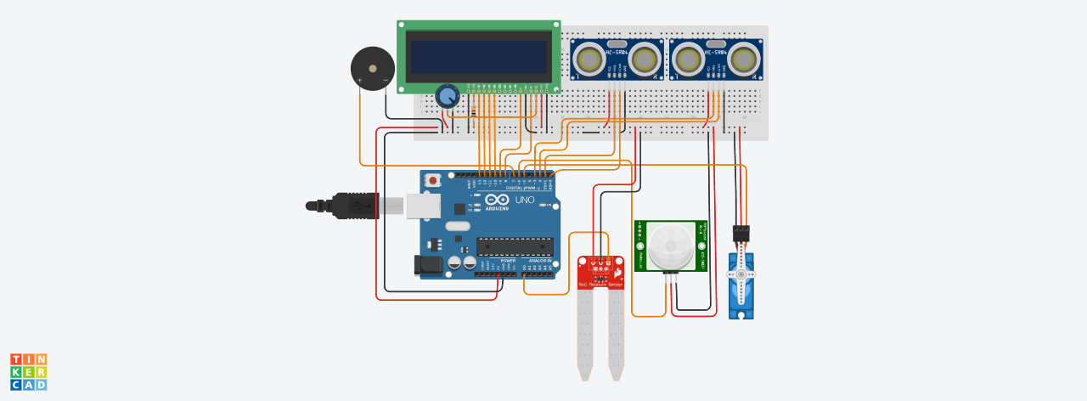

Figure 4.10.1: Wiring diagram.

A IR Proximity sensor consists of 3 pins D0, VCC and ground, the D0 pin is connected to pin 6 of Arduino Uno. The moisture sensor consists of 4 pins A0, D0, VCC and ground, the A0 is connected to analog A0 pin of Arduino Uno. Two ultrasonic sensors consist of 4 pins Tx (trigger pin), Rx (Echo pin), VCC and ground. TX (trigger pin) and RX (echo pin) of the sensor is given as input pin 0, 2 and 1, 3 of Arduino respectively. The servo motor consists of 3 pins control (PWM), VCC and ground, Control (PWM) pin is connected to PWM pin 5 of Arduino Uno. 16X2 LCD display is used to display the output from the Arduino Uno connected to pins 8(RS), 9(Enable), 10(D4), 11(D5), 12(D6), 13(D7) and contrast pin is connected to 10K Potentiometer. Buzzer is an output source, one of its terminals is connected to ground and the other terminal to digital pin 7 of Arduino Uno. When the pin 7 is high the buzzer buzzes.

# SOFTWARE REQUIREMENTS

## Arduino IDE



Figure 5.1.1 : Arduino IDE

* A cross platform application comprising functions that are coded in Embedded C and C++.
* In this system, the program is written in Embedded C for the working of the hardware components.
* The program code written on Arduino IDE was then fed to the Arduino for the working of the whole system.

## Libraries used

* **Servo.h:** Allows Arduino boards to control a variety of servo motors.  
  This library can control a great number of servos. It makes careful use of timers: the library can control 12 servos using only 1 timer.
* **LiquidCrystal.h:** Allows communication with alphanumerical liquid crystal displays (LCDs). This library allows an Arduino/Genuino board to control LiquidCrystal displays (LCDs) based on the Hitachi HD44780 (or a compatible) chipset, which is found on most text-based LCDs. The library works with in either 4- or 8-bit mode (i.e., using 4 or 8 data lines in addition to the rs, enable, and, optionally, the rw control lines).
* **Ultrasonic.h:** Minimalist library for ultrasound module to Arduino  
  Work with ultrasound module in a simple and light way. Compatible with the modules HC-SR04, Ping))) and Seeed Studio sensor. This library aims to resource efficiency and to simplify access to data.

## Flowchart

**START**

**Check for waste**

**Check for Wet**

**waste**

**Servo Motor**

**rotates clock wise**

**degree**

**30**

**Is the**

**waste**

**e**

**bin full?**

**Servo Motor**

**rotates anti clock**

**wise 30 degree**

**Waste is dumped**

**in slot 1**

**Measurement of**

**level in bin**

**Waste is dumped**

**in slot 2**

**Indicates the bin**

**is full by**

**Displaying and**

**buzzing**

**Y**

**Y**

**Y**

**Y**

**N**

**N**

**N**

**Manually empty**

**the bin**

**Dry Waste**

Figure 5.3.1 : Flow Chart

# RESULT AND DISCUSSION

## Final Output

**Dry Waste Segregation**

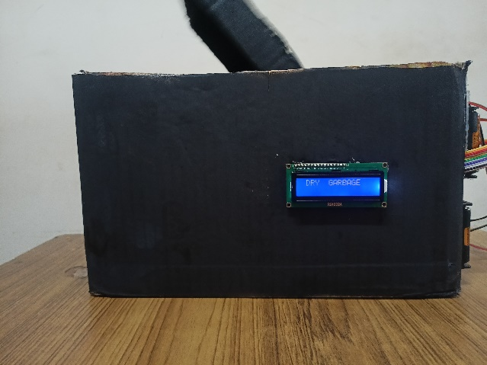

Figure 6.1.1: Dry Waste Segregation.

Dry waste segregation is the process of separating waste materials that do not decompose or decay easily from other types of waste. This type of waste includes materials such as plastics, metals, glass and paper among others. The goal of dry waste segregation is to reduce the amount of waste that ends up in landfills and promote recycling, reuse and proper disposal.

**Wet Waste Segregation**

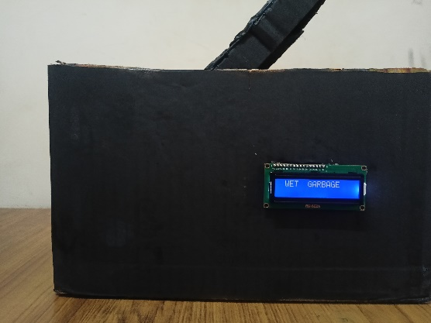

Figure 6.1.2: Wet Waste Segregation.

Wet waste segregation is the process of separating biodegradable waste materials such as food scraps, yard waste. This segregation helps in the efficient processing of wastes as wet waste can be composted or converted into biogas.

# APPLICATIONS

* **Residential:** Thissystems can be used in residential areas to help residents sort their waste into different categories.
* **Commercial:**This systems can be used in commercial areas, such as restaurants, hotels and offices to help businesses sort their waste.
* **Industrial:**This systems can be used in industrial areas, such as factories and warehouses to help businesses sort their waste.
* **Municipal:** Thissystems can be used by municipalities to help manage waste collection and disposal.

# ADVANTAGES

* **Reduces the amount of waste sent to landfills**: By segregating waste, it can be recycled or composted which reduces the amount of waste that ends up in landfills.
* **Reduces the amount of pollution from waste**: When waste is not properly managed, it can pollute the air, water, and soil. By segregating waste and recycling or composting it the amount of pollution from waste can be reduced.
* **Improves public health**: By reducing the amount of waste that ends up in landfills, the risk of disease from contaminated waste can be reduced.
* **Creates jobs**: The implementation of this systems can create jobs in the waste management industry.

# LIMITATIONS

* **Sensor accuracy**: The accuracy of the sensors used to detect the type of waste can be affected by factors such as the moisture content of the waste, the size of the waste and the ambient temperature. This can lead to false positives or negatives, which can impact the efficiency of the system.
* **Cost**: The cost of the sensors, Arduino Uno board, and other components can be a barrier to widespread adoption of this technology.
* **Complexity**: The system can be complex to set up and maintain, which may require specialized skills.
* **Interference**: The system can be susceptible to interference from other electronic devices, which can lead to false alarms or malfunctions.
* **Waste type**: The system may not be able to segregate all types of waste, such as hazardous waste or medical waste.
* **User behaviour**: The system relies on users to correctly segregate their waste, which may not always happen.

# CONCLUSION

Implementation of this system at a local level like societies, educational institutes, etc. can reduce the burden on the local authorities. The waste segregator is one small step towards building an efficient and economic waste collection system with a minimum amount of human intervention and also no hazard to human life. Segregating all these wastes at a domestic level will also be time-saving. While implementing our system we came across many problems like the sensing range of inductive proximity sensor, the accuracy of the moisture sensor, adjusting the range of IR sensors and some more, but using some modifications we tried the make the system as reliable as possible but not completely perfect. The garbage monitoring and controlling with smart segregation of dry and wet waste system using Arduino Uno is a promising new technology that has the potential to make a significant impact on waste management in urban areas.

# FUTURE SCOPE

* **Improved sensor accuracy**: The accuracy of the sensors used to detect the type of waste is likely to improve as new technologies are developed. This will reduce the number of false positives and negatives, which will improve the efficiency of the system.
* **Reduced cost**: The cost of the sensors, Arduino Uno board, and other components is likely to decrease as the technology becomes more widespread. This will make the system more affordable for cities and other organizations.
* **Simplified setup and maintenance**: The system is likely to become easier to set up and maintain as the technology matures. This will make it more accessible to a wider range of users.
* **Reduced interference**: The system is likely to become less susceptible to interference from other electronic devices as the technology is improved. This will reduce the number of false alarms and malfunctions.
* **Expanded waste type**: The system is likely to be able to segregate a wider range of waste types as the technology develops. This will make it more useful for cities and other organizations that need to manage a variety of waste streams.
* **Improved user behaviour**: As people become more aware of the importance of waste segregation, they are more likely to correctly segregate their waste. This will improve the efficiency of the system and reduce the amount of waste that is sent to landfills.

# REFERENCES

[1] Amrutha Chandramohan, Joyal Mendonca, Nikhil Ravi Shankar ‘Automated Waste Segregator’ Texas Instruments India Educators' Conference (TIIEC), CA, vol. 1, no. 1–3, pp. 41–51, May 2014

[2] Poorani Ravindhiran, Pradeep Gopal, Joseph Gladwin S, Rajavel R ‘Automated Indoor Waste Management System Employing Wave Front Algorithm and Received Signal’ IEEE Trans. Communications, vol. 1, no. 5, pp. 26 –33, Nov 2017

[3] Smita S Pawar, Shivani Pise, Kranti Walke, Renuka Mohite ‘Smart Garbage Monitoring System Using AVR Microcontroller’ Fourth International Conference on Computing Communication Control and Automation (ICCUBEA), India, vol. 3, no. 1, pp. 83–100, Feb 2018

# APPENDIX A

**ARDUINO UNO**

|  |  |  |
| --- | --- | --- |
| **Pin**  **Category** | **Pin Name** | **Details** |
| Power | Vin, 3.3V, 5V, GND | Vin: Input voltage to Arduino when using an external power source.  SV: Regulated power supply used to power microcontroller and other components on the board.  3.3V: 3.3V supply generated by on-board voltage regulator. Maximum current draw is 50mA.  GND: ground pins**.** |
| Reset | Reset | Resets the microcontroller |
| Analog pins | A0-A5 | Used to provide analog input in the range of 0-5V |
| Input/output  pins | Digital Pins 0-13 | Can be used as input or output pins. |
| Serial | 0(Rx), 1(Tx) | Used to receive and transmit TTL serial data |
| External  Interrupts | 2,3 | To trigger an interrupt. |
| PWM | 3,5,6,9,11 | Used for SPI communication |
| SPI | 10 (SS), 11 (MOSI), 12 (MISO) and 13. (SCK) | Used for SPI communication |
| Inbuilt  LED | 13 | To turn on the inbuilt LED |
| TWI | A4 (SDA), A5 (SCA) | Used for TWI communication. |

**IR SENSOR**

|  |  |
| --- | --- |
| **Pin Name** | **Description** |
| VCC | Power Supply +5v |
| GND | Power Supply Ground |
| OUTPUT | Active High Output |

**MOISTER SENSOR**

|  |  |
| --- | --- |
| **Pin Name** | **Description** |
| VCC | The Vcc pin powers the module, typically with +5V |
| GND | Power Supply Ground |
| DO | Digital Out Pin for Digital Output. |
| AO | Analog Out Pin for Analog Output |

**ULTRASONIC SENSOR**

|  |  |  |
| --- | --- | --- |
| **Pin Number** | **Pin Name** | **Description** |
| 1 | Vcc | The Vcc pin powers the sensor, typically with +5V |
| 2 | Trigger | Trigger pin is an Input pin. This pin has to be kept high for 10us to initialize measurement by sending US wave. |
| 3 | Echo | Echo pin is an Output pin. This pin goes high for a period of time which will be equal to the time taken for the US wave to return back to the sensor. |
| 4 | Ground | This pin is connected to the Ground of the system. |

**SERVO MOTOR**

|  |  |  |
| --- | --- | --- |
| **Wire Number** | **Wire Color** | **Description** |
| 1 | Brown | Ground wire connected to the ground of system |
| 2 | Red | Powers the motor typically +5V is used |
| 3 | Orange | PWM signal is given in through this wire to drive the motor |

**16X2 LCD DISPLAY**

|  |  |  |  |  |  |
| --- | --- | --- | --- | --- | --- |
| **Sr. No** | **Pin No.** | **Pin Name** | **Pin Type** | **Pin Description** | **Pin Connection** |
| 1 | Pin 1 | Ground | Source Pin | This is a ground pin of LCD | Connected to the ground of the MCU/ Power source |
| 2 | Pin 2 | VCC | Source Pin | This is the supply voltage pin of LCD | Connected to the supply pin of Power source |
| 3 | Pin 3 | V0/VEE | Control Pin | Adjusts the contrast of the LCD. | Connected to a variable POT that can source 0-5V |
| 4 | Pin 4 | Register Select | Control Pin | Toggles between Command/Data Register | Connected to a MCU pin and gets either 0 or 1.  0 -> Command Mode  1-> Data Mode |
| 5 | Pin 5 | Read/Write | Control Pin | Toggles the LCD between Read/Write Operation | Connected to a MCU pin and gets either 0 or 1.  0 -> Write Operation  1-> Read Operation |
| 6 | Pin 6 | Enable | Control Pin | Must be held high to perform Read/Write Operation | Connected to MCU and always held high. |
| 7 | Pin 7-14 | Data Bits (0-7) | Data/Command Pin | Pins used to send Command or data to the LCD. | In 4-Wire Mode  Only 4 pins (0-3) is connected to MCU  In 8-Wire Mode  All 8 pins(0-7) are connected to MCU |
| 8 | Pin 15 | LED Positive | LED Pin | Normal LED like operation to illuminate the LCD | Connected to +5V |
| 9 | Pin 16 | LED Negative | LED Pin | Normal LED like operation to illuminate the LCD connected with GND. | Connected to ground |

# APPENDIX B

**Code of Garbage monitoring and controlling with smart segregation of dry and wet waste**

#include <Servo.h>

#include <LiquidCrystal.h>

#include <Ultrasonic.h>

LiquidCrystal lcd(8,9,10,11,12,13);//RS,EN,D4,D5,D6,D7

int moisturePin = A0; // moisture sensor pin

int irSensorPin = 6; // IR sensor pin

int servoPin = 5; // servo motor pin

int buzzpin = 7; // buzzer pin

Ultrasonic ultrasonic1(1, 2); //1 trigPin, 2 echoPin ultarsonic wet bin

Ultrasonic ultrasonic2(4, 3); //3 trigopin, 4 echopin ultarsoinc dry bin

Servo myServo;

void setup()

{

Serial.begin(9600);

myServo.attach(servoPin, 600, 2300); // (pin, min, max)

myServo.write(90);

pinMode(moisturePin, INPUT); //Moisture sensor Analog input

pinMode(irSensorPin, INPUT); // IR sensor Digital input

pinMode(buzzpin, OUTPUT); // buzzer output pin

lcd.begin(16,2); //initializing LCD

lcd.setCursor(0,0);

lcd.print("Automatic Waste");

lcd.setCursor(0,1);

lcd.print("Segregation sys");

delay(5000);

lcd.clear();

}

void loop() {

int moistureValue = analogRead(moisturePin); // read moisture sensor value

int irValue = digitalRead(irSensorPin); // read IR sensor value

if (moistureValue < 800 && irValue == LOW ) { // if the waste is wet

delay(1000); // wait for 1 seconds

lcd.setCursor(0,0);

lcd.print(" WET GARBAGE"); //lcd indicates the garbage is wet

Serial.println("WET GARBAGE");

myServo.write(150); // rotate servo to one side for wet waste

delay(5000); // wait for 5 seconds

myServo.write(90); //Servomoto initial position

lcd.clear();

}

else if (irValue == LOW) { // if the waste is dry

delay(1000); // wait for 1 seconds

lcd.setCursor(0,0);

lcd.print(" DRY GARBAGE"); //lcd indicates the garbage is dry

Serial.println("DRY GARBAGE");

myServo.write(30); // rotate servo to the other side for dry waste

delay(5000); // wait for 5 seconds

myServo.write(90); //Servomoto initial position

lcd.clear();

}

else{ // if the no waste present

delay(1000); // wait for 1 seconds

lcd.setCursor(0,0);

lcd.print(" NO GARBAGE "); //lcd indicates the no garbage

Serial.print("NO GARBAGE");

myServo.write(90); //Servomoto initial position

delay(1000);

lcd.clear();

}

// Bin level Mesurement Using ultra sonic

Serial.print("Sensor 01: ");

Serial.print(ultrasonic1.read()); //serialy prints the distance

Serial.println("cm");

int ultarsonic1 = ultrasonic1.read();

if(ultarsonic1 <= 5){// When the the distance below 5cm

delay(1000);

digitalWrite(buzzpin, HIGH); // buzzer beeps

lcd.setCursor(0,0);

lcd.print("WET BIN FULL");

Serial.print("WET BIN FULL");

delay(5000);

lcd.clear();

}

else{

digitalWrite(buzzpin, LOW);

}

Serial.print("Sensor 02: ");

Serial.print(ultrasonic2.read()); //serialy prints the distance

Serial.println("cm");

int ultarsonic2 = ultrasonic2.read();

if(ultarsonic2 <= 5){// When the the distance below 5cm

delay(1000);

digitalWrite(buzzpin, HIGH); // buzzer beeps

lcd.setCursor(0,0);

lcd.print("DRY BIN FULL");

Serial.print("DRY BIN FULL");

delay(5000);

lcd.clear();

}

else{

digitalWrite(buzzpin, LOW);

}

}

# COURSE OUTCOMES

On completion of this course, we are able to:

* Solve the identification problems.
* Analyze the available resources and their utilization.
* Present the work carried out and prepare the report.
* Work in a team to find the solution for societal and technical problems.

**CONTACT DETAILS**

|  |  |
| --- | --- |
| Name: S Suhas  USN : 4BD20EC060  Email ID : [suhassid10@gmail.com](mailto:suhassid10@gmail.com)  Mobile No: 8310556913  Address : Ballari(T),Ballari(D) |  |
| Name: Shreyas P  USN: 4BD20EC066  Email ID: [shreyasp182002@gmail.com](mailto:shreyasp182002@gmail.com)  Mobile No: 7204892099  Address: 9th cross siddaverrappa badavane, Davangere(D) |  |
| Name: Vyshnavi H K  USN: 4BD20EC090  Email ID: [vyshnavihk@gmail.com](mailto:vyshnavihk@gmail.com)  Mobile No:6361321094  Address: Mandipet Davangere(D) |  |
| Name: Chitra A  USN : 4BD21EC408  Email ID : [achithra.02@gmail.com](mailto:achithra.02@gmail.com)  Mobile No: 9380656263  Address: near durgambika temple nittuvalli Davangere(D) |  |