# SID-MANUAL

The rough Outline of the SID-algorithm

Input params:

* *Input.bg_sub: Boolean;*
* *Input.psf_filename_ballistic:*
* *Input.LFM_folder:*
* *Input.x_offset:*
* *Input.y_offset:*
* *Input.dx:*
* *Input.bg_iter:*
* *Input.rectify:*
* *Input.frames:*
* *Input.do_crop:*
* *Input.recon_opts:*
* *Input.gpu_ids:*
* *Input.filter:*
* *Input.native_focal_plane:*
* *Input.neur_rad:*
* *Input.nnmf_opts*

# rank_1_factorization

% RANK_1_FACTORIZATION Rank-1-matrix-factorization of the movie Y

%

% Y~bg_spatial*bg_temporal

%

% Input:

% Y… movie

% max_iter… maximum Number of Iterations

%

% Output:

% bg_temporal… temporal component of the rank-1-factorization

% bg_spatial… spatial component of the rank-1-factorization

# compute_std_image:

% COMPUTE_STD_IMAGE: Algorithm computes the standard deviation image of the

% difference of a movie Y and a tensor product.

%

% std(Y-y_1*y_2)

%

% Input:

% Y… movie

% y_1… y_1 is a size(Y,1) times 1 array.

% y_2… y_2 is a 1 times size(Y,2) array.

%

% Output:

% std_image… Standard deviation image

# read_sensor_movie:

% READ_SENSOR_MOVIE: Algorithm loads the frames, specified in the struct

% "frames" of the movie contained in the folder "in_folder" into the

% working memory.

%

% Input:

% x_offset,y_offset,dx… Lenslet-parameters for rectification.

% Nnum… number of pixels behind microlens.

% do_rectification… boolean that determines wether the raw movie

% frames ought to be rectified.

% struct frames:

% frames.start… First frame to be loaded.

% frames.step… algorithm only loads frames with increments

% of 'step' between them.

% frames.end… Final frame to be loaded.

% frames.mean… boolean that determines wether to load just the

% frames specified by the struct "frames" or if

% the algorithm loads all frames, and

% computes the mean of the junks of frames in

% between the frames specified by the struct

% 'frames'.

% frames.list Vector of frame indices to be loaded by

% algorithm; if this field exists frames.start,

% frames.step,frames.end is ignored.

%

% Output:

% sensor_movie… Resulting framewise linearized movie

% num_frames_total… dimensions of the movie in 'in_folder'

## Prerequisites

* MATLAB 2017 or newer
* Point Spread Function struct: see lfrecon_vsc

# Getting started

You have generated a Light Field Microscope (LFM) Video of neuronal tissue labeled with fluorescent Calcium Indicator. If the Video has not yet been converted into a series of *tif*-images, with filenames ending in the frame number, with leading zeros, of the specific image in the video, do this before you start. Transfer the *tif*-files in your desired Input folder and start generating the Input -struct. Fill in the address of the Input- folder as ***Input.LFM_folder***.

Download *LFdisplay* from <http://graphics.stanford.edu/software/LFDisplay/> and determine x_offset, y_offset and dx (SID only considers the case where dx=dy).   
Set Input.rectify true, otherwise if the images have already been rectified set it to false. In the former case also fill in the parameters as ***Input.x_offset***, ***Input.y_offset*** and ***Input.dx***.

Set the field ***Input. psf_filename_ballistic*** to the address of the file containing the point-spread-function generated according to lfrecon_vsc.

Next specify the frames that you wish to include into the SID-optimization procedure. Take into account that SID can only detect neurons, that are active in some of those frames and inactive in others. The number of frames taken into account are prohibitive for the SID algorithm and they should not exceed 3000. Before you specify the frames you should also take a look at the raw movie. A good way to do this is looking at the average signal (mean over all pixels for each frame). If there are any motion artefacts or some other patterns in the video (example: someone opened a door during the imaging), then it is best not to include those frames. If you already chose specific frames you can include them in ***Input.frames.list*** as a vector of their frame indices. Otherwise you can chose a starting frame ***Input.frames.start***, an incremental step size between frames you want to include ***Input.frames.step***, and a final frame ***Input.frames.end***.

After specifying the frames you wish to include, there is also the option of not just including those specific frames, but instead for each frame you wish to include, loading frames from that frame up to the next frame specified by ***Input.frames***, computing the average frame of these and including that image instead. You can choose to do this by setting ***Input.frames.mean*** true. It will increase the time it takes to load the video significantly but will also decrease noise contributions in your sample video.

Choose an Output-folder accessible to your MATLAB and set ***Input.output_folder*** to the folder’s address.

Set ***Input.axial*** to the ratio between the physical length of a voxel in the axial direction vs. the physical length in the lateral direction.

Set ***Input.neur_rad*** to the expected radius (in pixel) of a neuron. In cases with more scattering choose a bigger value. Normally 1/3 bigger is sufficient.

Set ***Input.native_focal_plane*** to the z-index of the native focal plane of your point spread function. This z-slice is typically the one with the highest reconstruction artefacts, or the one with the highest artefacts around it.   
  
If your workstation offers GPU-support, set ***Input.gpu_ids*** to the indices of the gpu-Devices you wish to offer to the algorithm.

Background estimation   
Next specify if you wish to do a background subtraction. If you wish to do so set ***Input.bg_sub*** to true and set the number of iterations for the estimation of the background to ***Input.bg_iter*** to 2 (More iterations are usually not necessary). The algorithm will in a first step calculate the standard deviation image of the residual video, which will be included into the estimation of neuronal centers, and also the algorithm will include the spatial background component into the SID-optimization of the spatial filters of specific neurons as the last component of ***SID_output.forward_model_ini*** resulting in a continued optimization of the background, when taking local neuronal patterns into account and also significantly improve the performance of the non-negative-matrix factorization (NNMF). It is recommended to set ***Input.bg_sub*** to true.

## De-trending/Bleaching

If effects of bleaching (exp. Decaying signal) are visible in your video, you can de-trend, which is performed by multiplying each pixel trace by a common estimate of the bleaching signal.   
Since the offset of the exp. Decay is not the same for all pixels, this method is not perfect of course.  
Set ***Input.detrend*** to true if you wish to perform this operation. It is recommended to do so. Also set ***Input.delta*** (TODO).

Microlens-pattern detection  
In order to prevent overfitting during the NNMF the algorithm calculates an estimation of the part of the images containing the round shapes located behind microlenses, since this is the only part containing the desired information. There are two parameters to help the algorithm give a good estimation, and this is essential. You can choose standard values for ***Input.crop_params***, which is 2x1 double array of values between zero and ones. Otherwise the algorithm will prompt you to choose them according to the current estimation he will provide in a figure output during the run of the algorithm. The first parameter gives a cut-off value for the estimation of which part of the image even contains active microlenses, the second parameter gives a cut-off for an estimate of the microlens pattern.

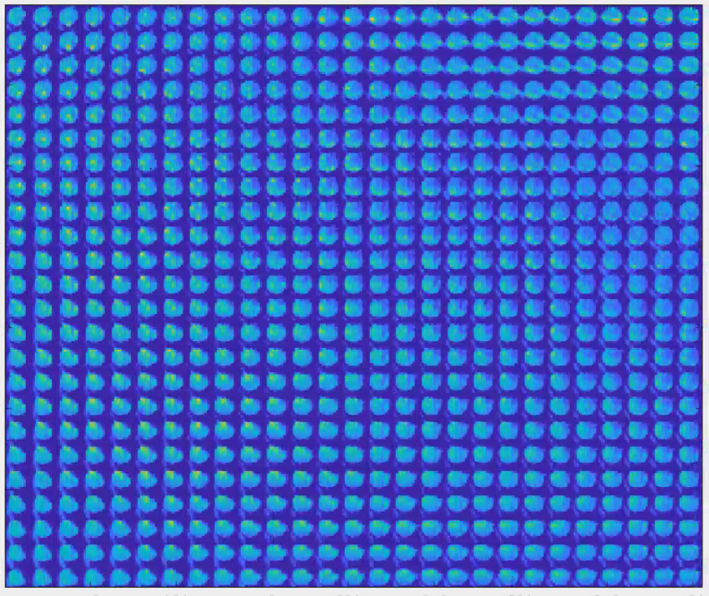

Figure : microlens pattern

If you wish to only analyze a certain rectangle inside your movie, specify a binary image set to true inside that rectangle you desire and false outside. You include this binary array as ***Input.crop_mask*** and you have to set ***Input.do_crop*** true. ***If Input.do_crop*** is true, but there is no crop_mask specified, the algorithm will choose the estimation of the part of the images that is active described in the previous paragraph.

## Low-rank-NNMF

An important part of the initial estimation of neuronal positions is the output of a low-rank-NNMF. (In the case of very large images sizes this can be a problem and you can choose to turn off this part of the algorithm by setting the rank (***Input.nnmf_opts.rank***) of the NNMF to zero, but you also have to set ***Input.optimize_kernel*** to false and not set a value for ***Input.recon_opts.ker_shape***.)  
  
First set the rank (***Input.nnmf_opts.rank***) to an appropriate value. Usually about 30 components is enough, but if the reconstruction is very costly you should turn it down. Ten components still gives good results. If you increase the number of components, you increase the chance the neighboring neurons fall in different components thereby increasing the chance to separate them from each other. Increasing the rank therefore usually decreases the density of neurons in the corresponding reconstructed spatial filters of the NNMF. Set the number of iterations the algorithm should perform (***Input.nnmf_opts.max_iter***) to 600. This is usually sufficient!

Initialization methods for the Low-rank-NNMF  
SID offers to initialization methods. First option is to set ***Input.nnmf_opts.ini_method*** to ‘rand’, which initializes the temporal components T with smoothed random traces and the spatial component S with the non-negative-least-squares solution. The second option is to set ***Input.nnmf_opts.ini_method*** to ‘pca’ which initializes the temporal and spatial components with the absolute value of the first n (rank = n) principal components of the sample video. It is recommended to use the PCA initializer since it offers the possibility to compare different runs of the NNMF with different parameters closer and leads to an inherent background subtraction by encouraging the first component to become background.

Regularizers  
The NNMF-algorithm inside SID allows a variety of Regularizers to increase the separation performance, as well as clear up the images to prevent artefacts in the subsequent reconstruction of the spatial components of the NNMF. The NNMF-algorithm tries to solve the problem

)

where is the vector of the Lagrange multipliers and is a vector of possible regularizers.  
Each component of corresponds to a specific field of ***Input.nnmf_opts***:

|  |  |  |  |
| --- | --- | --- | --- |
|  | meaning | Recommended value | Recommended |
| ***Input.nnmf_opts.lamb_ spat*** | -reg of S |  | Yes |
| ***Input.nnmf_opts.lamb_ temp*** | -reg of T |  | No |
| ***Input.nnmf_opts.lamb_corr*** | -norm of cov-matrix |  | No |
| ***Input.nnmf_opts.lamb_orth_L1*** | -norm of gram matrix of S |  | Yes |
| ***Input.nnmf_opts.lamb_orth_L2*** | -norm of gram matrix of S |  | Yes |
| ***Input.nnmf_opts.lamb_spat_TV*** | -norm of Total Variation in space |  | No |
| ***Input.nnmf_opts.lamb_temp_TV*** | -norm of Total Variation in T |  | No |

You can combine all these regularizers, but usually one is sufficient and using multiple regularizers can lead to undesired effects. It is recommended to only use ***Input.nnmf_opts.lamb_orth_L1*** or ***Input.nnmf_opts.lamb_ spat*** with a value of 1.

Choosing a good Lagrange multiplier/Cross-validation  
The Question how to choose the Lagrange multipliers can be addressed by manually evaluating the outputs of the *fast_nmf* – function (SID’s low rank NNMF func.). This involves starting with an initial guess and then run the NNMF algorithm and visually evaluating the patterns in the spatial filters. If you see nicely separated single neuron LFM-patterns (case 1), then the Lagrange multiplier was a good choice, otherwise if the pattern looks very noisy, or contains incomplete single neuron LFM-patterns (case 2), the Lagrange multiplier was too large, finally if the components are rather full (as opposed to sparse) the Lagrange multiplier was probably too small (case 3). Keep in mind that one of the components (normally the first) will always be full, since it is used as the background component.  
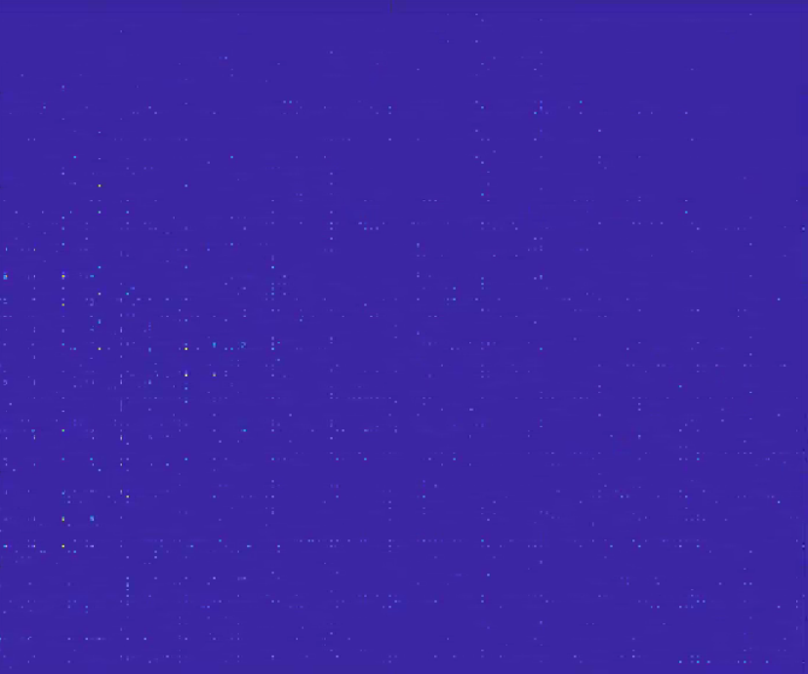

Figure : Case 1

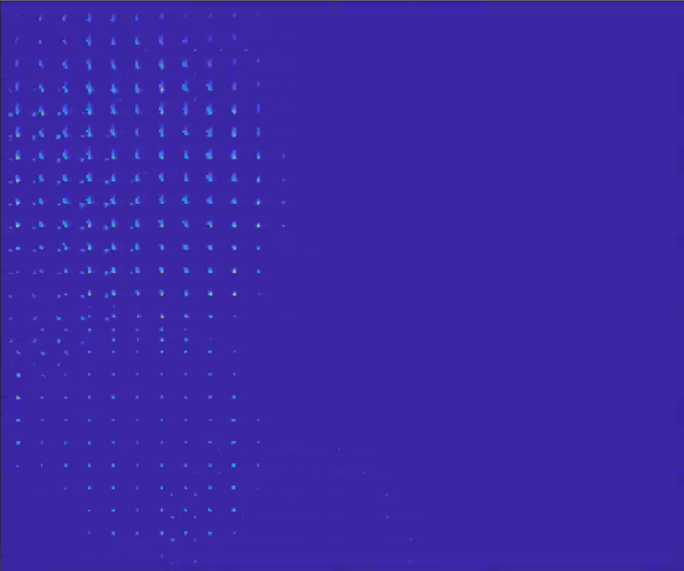

Figure : Case 2

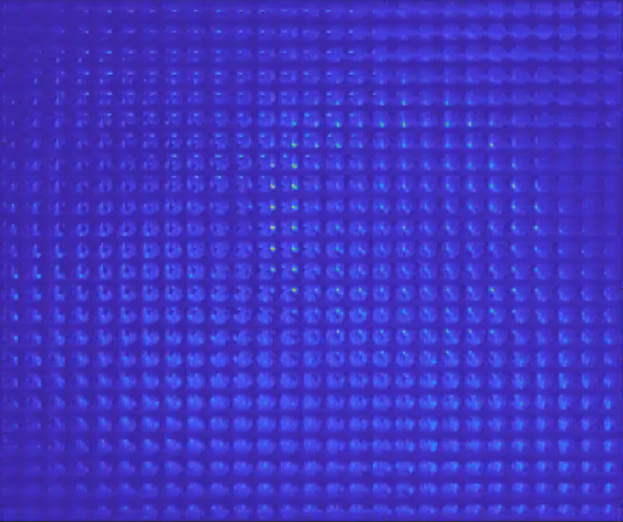

Figure : Case 3

Otherwise the fast_nmf algorithm includes the option to do cross validation for a selection of values of one of the Lagrange multipliers. What cross validation does is to partitions the data in a number of ***Input.nnmf_opts.xval.num_part*** parts and run the NNMF algorithm for a certain Lagrange multiplier for each of the parts on the video minus that part, then generates an estimate of T on that part and computes the 2-norm of the residual. These values are then averaged over all the parts and used as an estimate on how good that parameter (Lagrange multiplier) works when you try to train the NNMF to pick up spatial components that generalize well. Of course, this is only a very indirect measure and since we cannot run the NNMF algorithm so many times on the whole video, since we are prohibited by time, the cross validation algorithm only takes into account the 100x100 sub-video with the greatest variance.  
It still turns out to be very useful and it is recommended to activate this function when dealing with new data. To do so, you first have to set the field (sub-struct) ***xval*** inside ***Input.nnmf_opts***. Set ***Input.nnmf_opts.xval.num_part*** (the number of partitions) something that leaves the size in time of all of the partitions at least bigger than the usual decay time of a Ca-transient. In the case of our data something between 5 and 10 was usually good. Then set ***Input.nnmf_opts.xval.std_image = SID_output.std_image***. This is necessary to provide the algorithm with the dimensions of the video.   
Finally set ***Input.nnmf_opts.xval.multiplier*** to the Lagrange multiplier that you want to find the value for (eg. ‘lamb_orth_L1’) and set ***Input.nnmf_opts.xval.param*** to a vector of the parameters (Lagrange multiplier values) that you want to check. If you don’t set the last two fields, the standard multiplier is ‘lamb_orth_L1’ and the standard Parameter values are ***opts.xval.param = lambda*exp(-2*[0:4])*** .

## The Reconstruction (Two strategies)

Psf muss normalisiert sein damit