JOB PORTAL MANAGEMENT SYSTEM

School of Computing

Bachelor of Technology in
Computer Science & Engineering By
PRASANNA TEJASWI.D (VTU26314)
10211CS224
Full Stack Application Development Slot : E2


DEPARTMENT OF COMPUTER SCIENCE AND ENGINEERING SCHOOL OF COMPUTING

VEL TECH RANGARAJAN Dr.SAGUNTHALA R&D INSTITUTE OF SCIENCE AND TECHNOLOGY
(Deemed to be University Estd u/s 3 of UGC Act, 1956)
CHENNAI 600 062, TAMILNADU, INDIA
April, 2026

BONAFIDE CERTIFICATE
It is certified that the work contained in the Full Stack Application Development
report titled ”Job Portal Management System” by PRASANNA TEJASWI.D (VTU26314) has been carried out in Winter semester of Academic year 2025-2026(WS2526).

Signature of Faculty Dr.Hemamalini.S Assistant Professor
Computer Science & Engineering
School of Computing Vel Tech Rangarajan Dr.Sagunthala R&D Institute of Science and Technology
April, 2026

Signature Of Course Coordinator
Dr.Sumithra Professor & Head
Computer Science & Engineering
School of Computing Vel Tech Rangarajan Dr.Sagunthala R&D Institute of Science and Technology
April, 2026

DECLARATION
I declare that this written submission represents my ideas in my own words and where others’ ideas or words have been included, we have adequately cited and ref- erenced the original sources. I also declare that i have adhered to all principles of academic honesty and integrity and have not misrepresented or fabricated or falsified any idea/data/fact/source in our submission. I understand that any violation of the above will be cause for disciplinary action by the Institute and can also evoke pe- nal action from the sources which have thus not been properly cited or from whom proper permission has not been taken when needed.

(Prasanna Tejaswi.D) Register No: 23UECS0986 Date: 6th May 2026

ABSTRACT

The Job Portal Management System is a full-stack web application de- veloped to streamline the recruitment process by providing a centralized platform for job seekers and employers. Built using Java Spring Boot, Spring MVC, and Spring Data JPA following the MVC architectural pattern, the system enables ef- ficient job listing, application management, and candidate tracking. The frontend is implemented using HTML5, CSS3, and JavaScript to provide a responsive and user-friendly interface. The system supports two primary user roles: job seekers and employers. Job seekers can browse job opportunities, view detailed job descriptions, and apply for jobs by submitting their personal details along with resumes. Em- ployers can create, update, and manage job postings, as well as monitor and manage applicant information through an administrative dashboard.
The system integrates several essential features to enhance usability and ef- ficiency. These include secure user authentication using Spring Security with role- based access control, resume upload functionality using file handling mechanisms, and automated email notifications for confirming successful job applications. REST- ful APIs are used to facilitate seamless communication between frontend and back- end components, ensuring scalability and modularity. Bean Validation is imple- mented to maintain data integrity, and a layered architecture consisting of Controller, Service, and Repository layers ensures maintainability and separation of concerns. Keywords: Spring Boot, Spring MVC, Spring Data JPA, MVC Architecture, Job Portal System, Resume Upload, Email Notification, RESTful API, Spring Security, Role-Based Authentication, Bean Validation, MySQL Database, CRUD Operations, Application Tracking, Recruitment System.

LIST OF FIGURES

1.1 | Framework of Job Portal Management System . | . . . . . . . . . . . | 4
2.1 | Job Portal Management System – Architecture . | . . . . . . . . . . . | 7
4.1 | Job Portal Management System – Architecture . | . . . . . . . . . . . | 14
  - Job Portal Management System – Data Flow Diagram 15
  - Login Interface of Job Portal System 22
  - Job Seeker Dashboard 23
  - Data Base integrity 23

LIST OF TABLES
  - Comparative Evaluation of Recruitment Approaches 19
  - Mapping of Project to Complex Engineering Problem (CEP) – Part 1 27
  - Mapping of Project to Complex Engineering Problem (CEP) – Part 2 28
  - Mapping of Project to Complex Engineering Activities (CEA) 29

LIST OF ACRONYMS AND ABBREVIATIONS

API | Application Programming Interface
CSS | Cascading Style Sheets
CRUD | Create, Read, Update, Delete
HTML | HyperText Markup Language
HTTP | HyperText Transfer Protocol
IDE | Integrated Development Environment
JS | JavaScript
JSON | JavaScript Object Notation
JPA | Java Persistence API
JWT | JSON Web Token
MVC | Model View Controller
MySQL | My Structured Query Language
ORM | Object Relational Mapping
UI | User Interface
UX | User Experience

TABLE OF CONTENTS

Page.No

ABSTRACT iii
LIST OF FIGURES iv
LIST OF TABLES v
LIST OF ACRONYMS AND ABBREVIATIONS vi
- INTRODUCTION 1
  - Introduction . . . . . . . . . . . . . . . . . . . . . . . . . . . . . . 1
  - Aim of the Project . . . . . . . . . . . . . . . . . . . . . . . . . . . 2
  - Scope of the Project . . . . . . . . . . . . . . . . . . . . . . . . . . 3
  - Framework . . . . . . . . . . . . . . . . . . . . . . . . . . . . . . 3
- SURVEY OF SIMILAR APPLICATION IN MARKET 6
  - Industry Leaders and Alternatives . . . . . . . . . . . . . . . . . . 7
- FRAMEWORK DESCRIPTION 9
  - Frontend Implementation . . . . . . . . . . . . . . . . . . . . . . . 9
    - Environment Setup . . . . . . . . . . . . . . . . . . . . . . 9
    - Project Structure . . . . . . . . . . . . . . . . . . . . . . . 9
    - Execution Procedure 10
  - Backend Implementation 10
    - Environment Setup 10
    - Project Structure 11
    - Execution Procedure 11
    - Database Configuration 12
    - Schema Design 12
    - Tables Implemented 12
- METHODOLOGIES 13
  - Project Architecture 13
  - Data Flow Diagram 14
  - Module 1: User Management 14
  - Module 2: Job Management 15
  - Module 3: Application Management 16
  - Module 4: Additional Features 16
- RESULTS AND DISCUSSIONS 18
  - Implementation Screenshots 18
  - Job Seeker Dashboard 20
- CONCLUSION AND FUTURE ENHANCEMENTS 24
  - Conclusion 24
  - Future Enhancements 25
- ADDRESSING COMPLEX ENGINEERING PROBLEM AND SDG 26
  - Mapping of the Project to Complex Engineering Problem (CEP) 26
  - Mapping of the Project to Complex Engineering Activities (CEA) . 29
References 30

8 | SOURCE CODE | 32
 | 8.1 Source Code . . . . . . . . . . . . . . . . . . . . . . . . . . . . . . | 32
 | 8.1.1 User Entity . . . . . . . . . . . . . . . . . . . . . . . . . . | 32
 | 8.1.2 Authentication Controller . . . . . . . . . . . . . . . . . . | 33
 | 8.1.3 Job Controller . . . . . . . . . . . . . . . . . . . . . . . . | 35
 | 8.1.4 Application Controller . . . . . . . . . . . . . . . . . . . . | 36
 | 8.1.5 Password Change Feature . . . . . . . . . . . . . . . . . . | 37
 | 8.1.6 Chatbot Module (Frontend JavaScript) . . . . . . . . . . . . | 38

Chapter 1 INTRODUCTION

Introduction

The Job Portal Management System is a full-stack web application designed to provide a centralized platform that connects job seekers and employers efficiently. In traditional recruitment processes, job opportunities are often scattered across mul- tiple platforms, and applicants face difficulty in tracking applications, while employ- ers struggle with managing candidates. This project addresses these challenges by offering a unified, digital solution for job listing, application management, and re- cruitment tracking.
The system is developed using the Spring ecosystem, where Spring Core man- ages dependency injection, Spring MVC handles the web layer, Spring Boot simpli- fies application development with an embedded Tomcat server, and Spring Data JPA ensures seamless interaction with the database. The frontend is built using HTML5, CSS3, and JavaScript to provide a responsive and user-friendly interface. RESTful APIs facilitate communication between the frontend and backend, ensuring scalabil- ity and modular design.
The application supports two primary user roles: job seekers (students) and employers (administrators). Job seekers can browse available jobs, view detailed

descriptions, and apply by submitting their personal details along with resumes. Employers can post jobs, manage applications, and shortlist or reject candidates. The system also integrates advanced features such as resume upload functionality, email notification for application confirmation, and a structured dashboard for effi- cient management.

Aim of the Project

The primary aim of the Job Portal Management System is to digitize and streamline the recruitment process by providing an integrated platform for job post- ing, application submission, and candidate management. Specifically, the system aims to:
    - Provide job seekers with a simple and efficient interface to search, view, and apply for job opportunities.
    - Enable employers to manage job postings and monitor applications effectively through a centralized dashboard.
    - Ensure secure and reliable data handling through validation, authentication, and structured backend processing.
    - Automate communication by sending email confirmations to users upon suc- cessful job application.
    - Improve transparency by allowing users to track their application status in real time.

Scope of the Project

The scope of this project includes the development of a fully functional web-based job portal system covering the following modules:
- Job Management: Employers can create, update, and delete job postings with details such as title, description, skills required, salary, and location.
- User Registration Module: Job seekers can register and log in with validation mechanisms ensuring data integrity.
- Job Application Module: Users can apply for jobs by submitting personal details and uploading resumes using file handling mechanisms.
- Admin Dashboard: Employers can view all posted jobs, track applicants, and update application status (Applied, Shortlisted, Rejected).
- RESTful APIs: Backend APIs are exposed for job listing, application submis- sion, and status tracking.
- Email Notification System: Automated emails are sent to users upon success- ful job application using JavaMail.
- Security: Role-based authentication is implemented to differentiate between job seekers and employers.
The system is designed for local deployment and academic use. It does not in- clude advanced features such as payment processing or multi-company integrations in the current version.

Framework

The project is built using the following technology stack:

    - Backend: Spring Boot, Spring MVC, Spring Data JPA, Spring Security, Java- Mail API
    - Frontend: HTML5, CSS3, JavaScript (ES6)

    - Database: MySQL / H2 Database (via Hibernate ORM)

    - Build Tool: Apache Maven

    - Server: Embedded Apache Tomcat

    - IDE: Visual Studio Code / IntelliJ IDEA

    - Version Control: Git & GitHub

    - APIs: REST APIs for job management and application processing
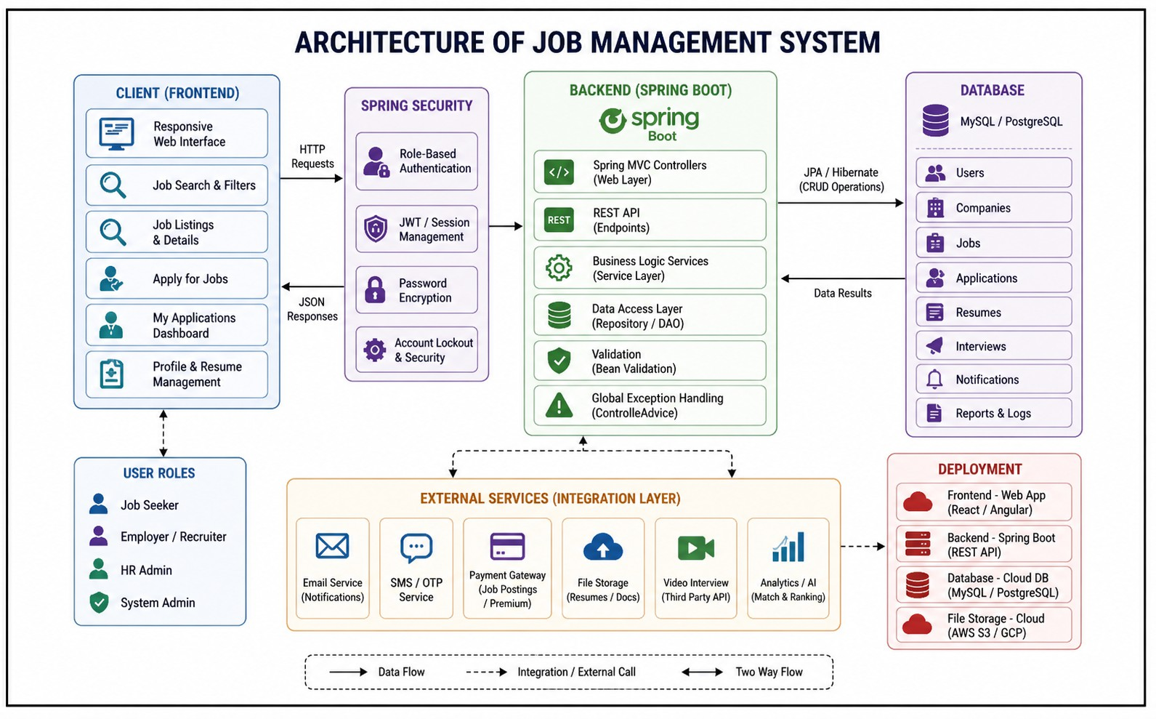

Figure 1.1: Framework of Job Portal Management System

[Figure 1.1] illustrates the layered architecture of the Job Portal Manage- ment System. The frontend (HTML, CSS, JavaScript) interacts with the Spring Boot

backend through REST APIs. The backend processes business logic, handles valida- tion, and manages application flow using Controller, Service, and Repository layers. The database stores user, job, and application data, while additional services such as email notifications are integrated to enhance system functionality. This architecture ensures scalability, maintainability, and efficient performance.

Chapter 2

SURVEY OF SIMILAR APPLICATION IN MARKET

The online job portal market has evolved significantly in recent years, tran- sitioning from simple job listing platforms to intelligent, data-driven recruitment sys- tems. Modern job portals aim to bridge the gap between job seekers and employers by providing centralized platforms that streamline the hiring process. These sys- tems focus on improving accessibility, efficiency, and transparency in recruitment workflows.
Contemporary job portals emphasize real-time job availability, dynamic fil- tering, and scalable backend architectures using RESTful APIs. These features en- able seamless interaction between frontend interfaces and backend services, ensuring efficient data handling and system scalability. Secure authentication mechanisms, including password encryption and role-based access control, are widely adopted to protect user data and maintain system integrity.
Modern frameworks such as Spring Boot and Spring MVC are extensively used for backend development due to their robustness, scalability, and ease of in- tegration. Data persistence is effectively managed using Spring Data JPA and rela- tional databases like MySQL. On the frontend, technologies such as HTML5, CSS3,

and JavaScript are used to create responsive and user-friendly interfaces.
Advanced functionalities such as resume upload, automated email notifi- cations, and application tracking systems have become standard features in modern job portals. These features enhance user experience by providing real-time updates, reducing manual effort, and improving communication between applicants and re- cruiters.

2.1 Industry Leaders and Alternatives

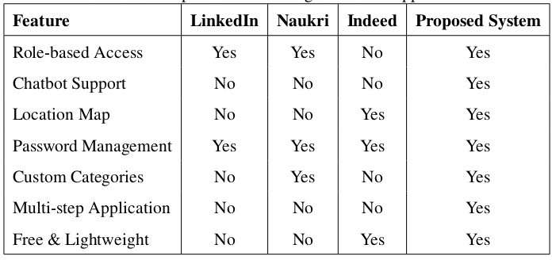

Figure 2.1: Job Portal Management System – Architecture

Table 2.1 presents a comparison of widely used job portal platforms based on their focus, advantages, and limitations. Existing platforms provide extensive reach, advanced analytics, and scalable infrastructure. However, many of them in- volve premium subscriptions, complex user interfaces, or lack customization for spe- cific use cases such as academic or local recruitment systems.
While platforms like LinkedIn and Indeed offer large-scale job discovery, they often do not provide a simplified and controlled environment suitable for aca- demic or small-scale deployments. Additionally, features such as direct resume stor-

age, customized application tracking, and simplified admin dashboards are either limited or require paid access.
The proposed Job Portal Management System addresses these limitations by offering a streamlined, cost-effective solution tailored for academic and local recruitment needs. It integrates essential features such as job listing, application submission, resume upload, email notifications, and status tracking within a single platform. The system is designed using modern development practices and scalable architectures, ensuring maintainability and efficiency.
Unlike commercial platforms, the proposed system focuses on simplicity, ease of use, and complete control over recruitment processes. This makes it suit- able for educational institutions and small organizations looking for a customized recruitment solution without dependency on third-party platforms.

Chapter 3 FRAMEWORK DESCRIPTION

Frontend Implementation

Environment Setup

The frontend of the Job Portal Management System is developed using HTML5, CSS3, and JavaScript (ES6), providing a responsive and interactive user in- terface. The frontend communicates with the backend through RESTful APIs using the Fetch API. Development was carried out using Visual Studio Code with neces- sary extensions for HTML, CSS, and JavaScript.
Static resources such as stylesheets, JavaScript files, and images are placed under the src/main/resources/static/ directory in the Spring Boot project. The application runs on an embedded Apache Tomcat server and is accessed via http://localhost:8080. The UI is designed using a modern dashboard lay- out with gradient themes and card-based components to enhance user experience.

Project Structure

The frontend follows a structured approach organized under the static/
directory:

      - HTML Pages: index.html, login.html, register.html, dashboard.html, jobs.html,

job-details.html, apply.html, admin-dashboard.html

      - CSS Files: style.css (global styling), dashboard.css (layout and cards)

      - JavaScript Files: main.js (API calls), jobs.js (job listing), apply.js (application handling)
      - Assets: Images and icons used for UI enhancement

Execution Procedure

The frontend is executed along with the Spring Boot backend. The appli- cation is started by running the main class (JobPortalApplication.java) from the IDE or using the command mvn spring-boot:run. Once the server starts, users can access the application via a web browser.
Users can register and log in, browse available jobs, view detailed job de- scriptions, and apply for jobs by submitting their details and uploading resumes. The frontend dynamically fetches job data from backend APIs and updates the UI accord- ingly. Employers can log in to access the admin dashboard where they can manage job postings and applications.

Backend Implementation

Environment Setup

The backend is developed using Java 17 and Spring Boot. Spring MVC is used for handling web requests, while Spring Data JPA manages database opera- tions. Spring Security is implemented for authentication and role-based authoriza- tion (ROLE STUDENT and ROLE EMPLOYER). Passwords are encrypted using BCrypt for secure storage.

The application connects to a relational database (MySQL or H2) using Hibernate ORM. Email functionality is implemented using JavaMailSender to send confirmation emails upon successful job application. The backend runs on an em- bedded Apache Tomcat server.

Project Structure

The backend follows a layered architecture under the package com.example.jobp

      - Entity Layer: Defines database models such as User.java, Job.java, and Application.java.
      - Repository Layer: Interfaces extending JPA repositories for performing CRUD operations and custom queries.
      - Service Layer: Contains business logic such as job management, application processing, resume handling, and email notifications.
      - Controller Layer: Handles HTTP requests and exposes REST APIs for fron- tend communication.
      - Security Configuration: Manages authentication, authorization, and session handling using Spring Security.

Execution Procedure

Before running the application, ensure the database is configured prop- erly in application.properties. If using MySQL, create a database named jobportal. Hibernate automatically creates tables based on entity classes using ddl-auto=update.
The application is started using the IDE or Maven. Once running, users can register, log in, and interact with the system. Employers can manage jobs and

applications through the admin dashboard. All REST APIs are accessible under the
/api/ endpoint.

Database Configuration

The database is configured using either MySQL or H2. Connection details such as URL, username, and password are specified in application.properties. Hibernate is used for ORM, which maps Java objects to database tables and handles schema generation.

Schema Design

The database schema follows a relational model ensuring data consistency and integrity. The system is designed with normalized tables and relationships be- tween users, jobs, and applications. Foreign key constraints are used to maintain referential integrity between tables.

Tables Implemented

The primary tables in the system include:

      - users: id, name, email, password (encrypted), role (STUDENT/EMPLOYER)

      - jobs: id, title, description, skills, salary, location, company name, posted date

      - applications: id, user id (FK), job id (FK), resume path, status (Applied/Short- listed/Rejected), applied date
Each application record is linked to both a user and a job, ensuring proper tracking of job applications. Resume files are stored in the local file system, and their paths are maintained in the database.

Chapter 4 METHODOLOGIES

Project Architecture

The Job Portal Management System is designed using a three-tier client–server architecture, which separates the application into distinct layers for better organiza- tion and maintainability. The frontend layer, built with HTML, CSS, and JavaScript, is responsible for handling user interactions and presenting data in a user-friendly interface. It communicates with the backend through HTTP requests, typically using RESTful APIs, to send and retrieve data.
The backend layer is implemented using Spring Boot, which serves as the core of the application. It handles business logic, processes incoming requests from the fron- tend, and ensures that the appropriate operations are performed. This includes tasks such as user authentication, job posting management, application tracking, and vali- dation of user inputs. By centralizing the logic in the backend, the system maintains consistency and control over how data is processed.
For data storage, the system uses a MySQL database, which is accessed through JPA (Java Persistence API) and Hibernate. These technologies simplify database interactions by mapping Java objects to database tables, reducing the need for com- plex SQL queries and improving development efficiency. They also help manage

relationships between entities such as users, jobs, and applications in a structured way.
The adiagram rchitecture is shown in Figure ??.
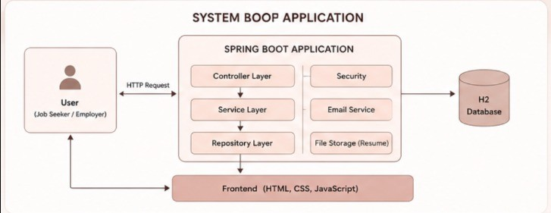

Figure 4.1: Job Portal Management System – Architecture

Data Flow Diagram

The data flow of the system begins with a user request from the browser. Job seekers and employers interact with the browser interface (1.1), which forwards re- quests to the backend logic (1.2 – PHP/MySQL in the original prototype, Spring Boot/MySQL in this implementation). The backend communicates with the MySQL database for data retrieval and updates. Role-specific subsystems (1.0 Job Seeker Subsystem and 1.4 Employer Subsystem) handle their respective operations includ- ing registration, profile management, job applications, and job postings.
The data flow diagram is shown in Figure ??.

Module 1: User Management

This module handles all user-related operations including registration, login, and profile management. Users are classified into three roles: STUDENT (Job Seeker),

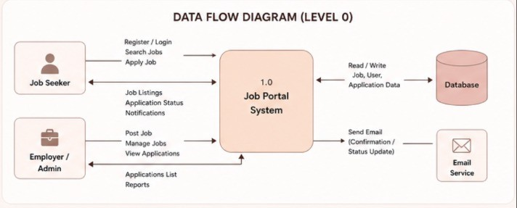

Figure 4.2: Job Portal Management System – Data Flow Diagram

EMPLOYER, and ADMIN. The registration form captures full name, email, role, password, phone, and location. Authentication is managed by Spring Security with session-based access control.
Key operations:

    - User registration with role selection.

    - Login with credential validation and role-based redirect.

    - Password change through a secured endpoint (requires current password verifi- cation).
    - User profile view and update.

Module 2: Job Management

This module allows employers to create, update, and delete job listings. Each job is associated with a category, salary range, required skills, and location. Job seekers can browse all active listings from the home page, filter by category or keyword, and view detailed job descriptions before applying.
Key operations:

    - Employer: Post, edit, and delete job listings.

    - Job Seeker: Search and browse all job listings.

    - Admin/Employer: Manage job categories.

    - Filter jobs by title, category, location, and experience level.

Module 3: Application Management

This module manages the end-to-end job application workflow. Job seekers sub- mit applications through a multi-step form capturing their background, experience, employment history, and availability. Submitted applications are stored and visible on the job seeker’s dashboard with real-time status updates (Pending, Shortlisted, Rejected).
Key operations:

    - Multi-step application form (Background, Experience, Employment, Availabil- ity).
    - Application status tracking on the dashboard.

    - Employer view of all applications for their posted jobs.

    - Admin reporting: view all users filtered by role, view employer company data.

Module 4: Additional Features

- Chatbot: An interactive chatbot is integrated into the platform to guide users through navigation, answer FAQs about the portal, and assist with common actions like finding jobs, submitting applications, or reaching the profile page. The chatbot provides a conversational UI layer on top of the core system.

- Location Map: A location map is embedded in the application to display job locations or employer office addresses geographically. This helps job seekers visually assess commute feasibility and better understand the job location context before applying.
- Password Change: A dedicated secure password change feature is provided under account settings. The user must enter their current password before setting a new one, enforcing security best practices. The backend validates the current pass- word against the stored hash before updating.

Advantages of this Project
- Centralized Platform: Provides a single platform for job seekers and employ- ers to interact, reducing dependency on multiple sources and manual communication.
- Real-time Application Tracking: Job seekers can monitor their application status (Pending/Shortlisted/Rejected) in real time from the dashboard, improving transparency in the hiring process.
- Scalable and Lightweight: Built on Spring Boot with embedded Tomcat, the system requires minimal infrastructure to deploy and can be scaled horizontally as user load increases.

Disadvantages

- The system currently lacks email notification support for application status up- dates.
- Resume file upload is not yet implemented; application details are entered man- ually.
- The chatbot operates on predefined responses and does not use a live AI/NLP engine.

Chapter 5

RESULTS AND DISCUSSIONS

Implementation Screenshots

Figure 5.1 illustrates the login interface of the Job Portal Management System, where users can securely authenticate themselves using their credentials. The sys- tem ensures secure login through encrypted password storage and role-based access control, distinguishing between job seekers and employers.
Table 5.1 presents a comparative analysis between traditional recruitment meth- ods and the proposed Job Portal system. The manual approach involves significant delays, lack of transparency, and inefficient data handling. In contrast, the Job Portal system provides a centralized platform where users can easily browse job listings, apply for jobs, and track application status in real time.
The system eliminates the need for physical document handling by enabling digital resume uploads and storage. Automated email notifications improve commu- nication by confirming successful job applications. The admin dashboard provides employers with complete control over job postings and applicant management, sig- nificantly improving recruitment efficiency.
Overall, the implemented system demonstrates improved performance, better user experience, enhanced security, and efficient data management .

Table 5.1: Comparative Evaluation of Recruitment Approaches

Feature / System | Manual / Traditional Method | Job Portal System
Job Discovery | Searching through news- papers or multiple web- sites | Centralized platform with all job listings
Application Process | Manual form filling and physical submission | Online application with single-click submission
Resume Handling | Physical documents or email attachments | Digital resume upload and storage
Application Tracking | No proper tracking mech- anism | Real-time status tracking (Applied / Shortlisted / Re- jected)
Employer Manage- ment | Manual candidate filtering and tracking | Admin dashboard with candidate management system
Communication | Phone calls or emails man- ually sent | Automated email confir- mation after job applica- tion
Data Management | Paper-based or spread- sheet records | Structured database using MySQL with JPA
Security | No proper authentication mechanism | Secure login with en- crypted passwords and role-based access
Accessibility | Limited to physical pres- ence or specific platforms | Accessible from any de- vice via web application

Job Seeker Dashboard

The dashboard provides a comprehensive overview of the job seeker’s activity, serving as a centralized space for tracking progress throughout the application pro- cess. It displays key statistics such as the total number of applications submitted, along with categorized counts including shortlisted, pending, and rejected applica- tions. These summary metrics give users a quick understanding of their current job search status and help them evaluate their progress effectively.
Below the summary section, a “Recent Applications” table presents detailed in- formation about the most recent job applications. This includes essential fields such as job titles, company names, job locations, application dates, and the current status of each application. The table is dynamically updated in real time, ensuring that users always have access to the latest information regarding their applications.
The dashboard is designed to be intuitive and user-friendly, allowing job seekers to quickly navigate through their activity without unnecessary complexity.

5.3 Admin / Database Verification
The system’s database integrity was verified using MySQL queries. The admin panel allows querying all users, filtering by role (STUDENT, EMPLOYER, AD- MIN), and viewing company data associated with employer accounts. SQL query results confirm correct data storage and retrieval for all user roles.

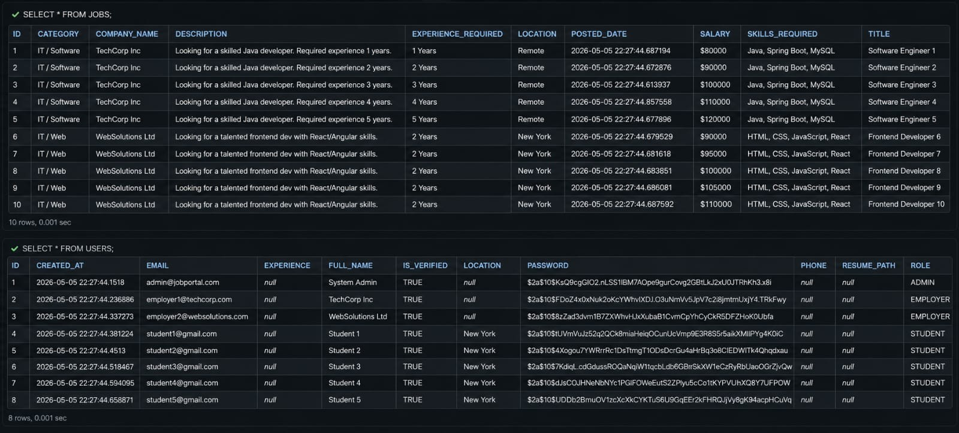

Figure 5.3: Data Base integrity

Figure 5.3 shows the database structure of the Job Portal Management System. It displays
the jobs and users tables, which store job details, user information, roles, skills, salary,
and application-related data managed through Spring Data JPA and Hibernate ORM.

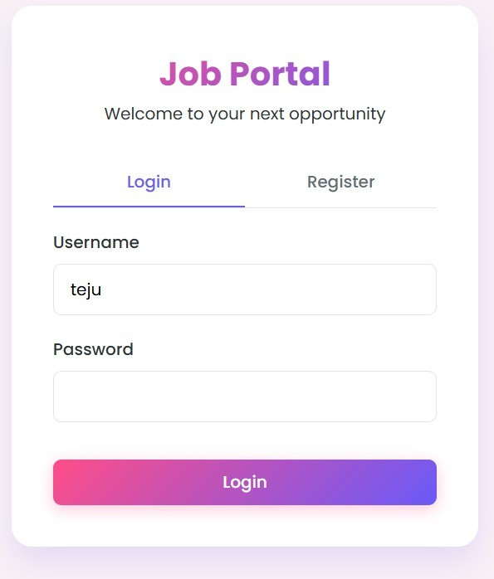

Figure 5.1: Login Interface of Job Portal System

Figure 5:1 shows the login interface of the Job Portal Management System. The page
allows users to securely log in or register using their credentials. The interface is desi
gned with a modern respon-sive layout and role-based authentication to provide secur
access for job seekers and employers.
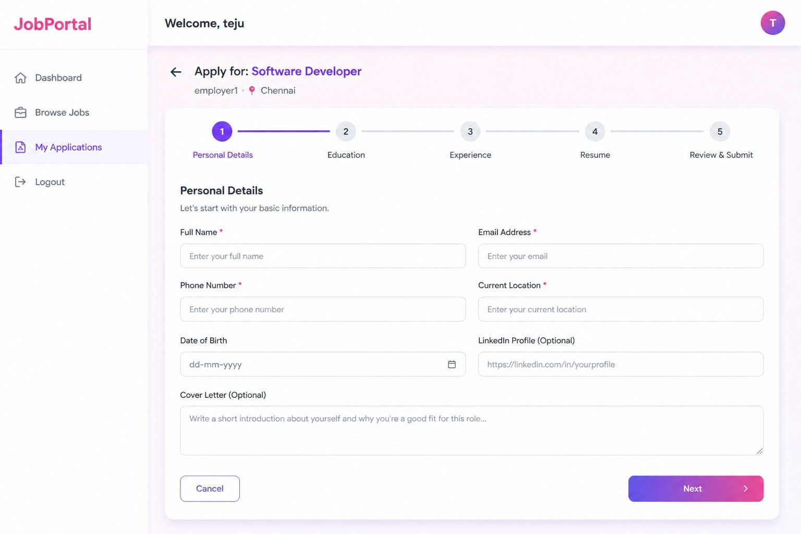

Figure 5.2: Job Seeker Dashboard

Figure 5.2 shows the job application interface of the Job Portal Management System.
The page enables users to apply for jobs by entering personal, educational, and experi-
ence details along with resume information through a multi-step application form. This
structured process ensures efficient data collection and application management.
Chapter 6 CONCLUSION AND FUTURE

ENHANCEMENTS

Conclusion

The Job Portal Management System was successfully developed as a full-stack web application using Spring Boot, HTML/CSS/JavaScript, and MySQL. The sys- tem meets its primary objective of providing a centralized, role-based recruitment platform for job seekers and employers. Key features including job listing man- agement, multi-step application submission, real-time dashboard tracking, chatbot assistance, location map visualization, and secure password management were im- plemented and verified.
The project demonstrates the practical application of core full-stack development concepts including REST API design, JPA/Hibernate ORM, session-based authen- tication, and responsive frontend design. The layered MVC architecture ensures separation of concerns and maintainability.
The system provides a solid foundation for a production-ready recruitment plat- form and can be extended with additional features to serve larger audiences.

Future Enhancements

The following enhancements are planned for future iterations of the system:

    - Email Notifications: Integrate JavaMailSender to send automated email alerts to candidates when their application status changes.
    - Resume Upload: Add file upload support for PDF resumes, stored on the server or a cloud storage service such as AWS S3.
    - AI-Powered Chatbot: Replace the rule-based chatbot with an NLP-driven as- sistant using a language model API for dynamic, context-aware responses.
    - JWT Authentication: Migrate from session-based to stateless JWT-based au- thentication for better scalability and API security.
    - Mobile Application: Develop a React Native or Flutter mobile app consuming the existing Spring Boot REST APIs.
    - Advanced Filtering: Add salary range filters, remote work toggles, and experience- level filtering for more precise job search results.
    - Analytics Dashboard: Provide employers with hiring analytics such as appli- cation funnel metrics, popular job categories, and candidate demographics.
    - Cloud Deployment: Deploy the application on AWS EC2 or Railway.app with a cloud-hosted MySQL instance for public accessibility.

Chapter 7

ADDRESSING COMPLEX ENGINEERING PROBLEM AND SDG

Mapping of the Project to Complex Engineering Problem (CEP)
The developed Online Job Portal System is mapped to the characteristics of a Complex Engineering Problem (CEP) as defined in standard engineering frame- works. A CEP typically involves multiple interacting components, diverse user re- quirements, and non-trivial decision-making processes. This project demonstrates these aspects through the integration of dynamic user roles, scalable data handling, and intelligent interaction mechanisms.
The system is designed to serve two primary stakeholders: job seekers and em- ployers, each with distinct goals, workflows, and data requirements. Managing these dual perspectives within a single platform introduces complexity in terms of system architecture, database design, and user interface customization. The application en- sures seamless coordination between these roles while maintaining data consistency and performance.

Level | Attribute | Characteristics | Targeted  WKs | Justification (as applicable)
WP1 | Depth of  Knowledge | Requires in-depth en- gineering knowledge (K3–K8) | WK3, WK4, WK5 | Involves full-stack develop- ment using Spring Boot (Java), REST API design, JPA/Hiber- nate ORM, MySQL relational  schema design.
WP2 | Range of con- flicting require- ments | Conflicting technical and non-technical is- sues | WK4, WK5 | Balances security vs usability, performance vs feature richness (chatbot/map integration), and simplicity vs role-based access  control.
WP3 | Depth of analy- sis required | No obvious solution; requires originality | WK3, WK4 | Designing a unified platform for two conflicting user roles (Job Seeker and Employer) with sep-  arate dashboards, workflows.
Table 7.1: Mapping of Project to Complex Engineering Problem (CEP) – Part 1

Level | Attribute | Characteristics | Targeted  WKs | Justification (as applicable)
WP4 | Familiarity of issues | Novel or infrequently encountered problems | WK4 | Integrating a chatbot, interactive location map, and multi-step dy- namic application form within a monolithic Spring Boot ap- plication goes beyond standard  CRUD-based web systems.
WP5 | Extent of appli- cable codes | Not fully covered by standards | WK5 | No fixed industry standards gov- ern academic job portal design; architectural and security deci- sions rely on engineering judg-  ment and industry best practices.
WP6 | Stakeholder in- volvement | Multiple stakeholders and requirements | WK5, WK6 | Addresses the distinct needs of job seekers (search, apply, track), employers (post, man- age), and administrators (report- ing, data integrity), requiring  careful requirements analysis.
WP7 | Interdependence | Requires systems- level approach | WK3, WK5 | Integrates frontend UI, Spring Boot REST backend, MySQL database, chatbot module, and location map as a cohesive sys- tem requiring synchronized op-  eration and consistent data flow.
Table 7.2: Mapping of Project to Complex Engineering Problem (CEP) – Part 2

Mapping of the Project to Complex Engineering Activities (CEA)

EA No. | Attribute | Characteristics | Justification based on the Project
EA1 | Range of Re- sources | Diverse resources and technologies | Uses Spring Boot (Java 17), HTML5/CSS3/JavaScript, MySQL, JPA/Hibernate, Maven, embedded Tomcat server, and additional modules including a chatbot interface, Google Maps API integration, and Spring Security for authentication.
EA2 | Level of Interac- tions | Optimization of complex interactions | Manages interactions between the fron- tend (fetch API calls), Spring Boot REST controllers, service layer busi- ness logic, JPA repositories, and the MySQL database
EA3 | Innovation | Creative and research- based solutions | Introduces a unified recruitment plat- form combining multi-step job appli- cation forms, real-time status tracking, AI-assisted chatbot navigation, and lo- cation map visualization in a single lightweight full-stack application with- out external SaaS dependencies.
EA4 | Consequences to Society and Envi- ronment | Significant societal im- pact | Digitizes the recruitment process for small and medium organizations, re- ducing paper usage, manual processing time, and geographic barriers to em- ployment .
EA5 | Familiarity | Extends beyond prior ex- perience | Involves REST API architecture, ORM-based database management, session security, dynamic multi-step form handling, and chatbot integration.

References

- S. K. Sharma and A. Gupta, “Design and Development of a Web-Based Job Portal System,”
International Journal of Computer Applications, vol. 182, no. 25, pp. 15–21, 2019.

- P. Kumar and R. Singh, “Secure User Authentication Using Spring Security and BCrypt in Web Applications,” in Proc. IEEE Int. Conf. on Computing, Communication and Automation (ICCCA), 2021, pp. 1–6.
- J. Fielding, “Architectural Styles and the Design of Network-Based Software Architectures,” Ph.D. dissertation, University of California, Irvine, 2000. (REST Architecture Reference)
- M. Fowler, Patterns of Enterprise Application Architecture. Boston, MA: Addison-Wesley, 2002.

- R. T. Fielding and R. N. Taylor, “Principled Design of the Modern Web Architecture,” ACM Transactions on Internet Technology, vol. 2, no. 2, pp. 115–150, 2002.
- Oracle Corporation, “JavaMail API Specification,” 2023. [Online]. Available: https:// javaee.github.io/javamail/
- C. Walls, Spring in Action, 6th Edition. Shelter Island, NY: Manning Publications, 2022. [Online]. Available: https://www.manning.com/books/spring-in-action-sixth-edition
- VMware, Spring Boot Reference Guide 3.x, 2024. [Online]. Available: https://docs. spring.io/spring-boot/docs/current/reference/htmlsingle/
- VMware, Spring Data JPA Reference Documentation, 2024. [Online]. Available: https:// docs.spring.io/spring-data/jpa/docs/current/reference/html/
- Baeldung, “Guide to Spring MVC,” 2024. [Online]. Available: https://www.baeldung. com/spring-mvc-tutorial
- Baeldung, “Spring Security Authentication Tutorial,” 2024. [Online]. Available: https:// www.baeldung.com/spring-security-login

- Mozilla Developer Network (MDN), “Fetch API,” 2024. [Online]. Available: https:// developer.mozilla.org/en-US/docs/Web/API/Fetch_API
- Oracle Corporation, “Java Platform, Standard Edition Documentation,” 2024. [Online]. Avail- able: https://docs.oracle.com/en/java/
- E. F. Codd, “A Relational Model of Data for Large Shared Data Banks,” Communications of the ACM, vol. 13, no. 6, pp. 377–387, 1970.
- H. Garcia-Molina, J. D. Ullman, and J. Widom, Database Systems: The Complete Book. Upper Saddle River, NJ: Prentice Hall, 2008.

Chapter 8 SOURCE CODE

Source Code
The following code snippets represent the core implementation of the Job Portal Management System. The backend is built using Spring Boot (Java) with JPA/Hibernate and MySQL. Key modules shown include the User entity, Authentication controller, Job controller, Application controller, and the Password Change feature.

User Entity

Listing 8.1: User.java – JPA Entity
@ Entity
@Table ( name = ” u s e r s ” ) @Data
@ No Args Constructor @ A l l A r g s C o n s t r u c t o r p u b l i c c l a s s User {

@Id
@ Generated Value ( s t r a t e g y = G e n e r a t i o n T y p e . IDENTITY ) p r i v a t e Long i d ;

@Column ( name = ” f u l l n a m e ” , n u l l a b l e = f a l s e ) p r i v a t e S t r i n g full Name ;

@Column ( n u l l a b l e = f a l s e , u n i q u e = t r u e )

p r i v a t e S t r i n g e m a i l ;

@Column ( n u l l a b l e = f a l s e ) p r i v a t e S t r i n g password ;

@Enumerated ( EnumType . STRING ) @Column ( n u l l a b l e = f a l s e )
p r i v a t e Role r o l e ; / / STUDENT , EMPLOYER, ADMIN

p r i v a t e S t r i n g phone ;
p r i v a t e S t r i n g l o c a t i o n ;
p r i v a t e S t r i n g companyName ; / / only f o r EMPLOYER r o l e
}

Authentication Controller

Listing 8.2: AuthController.java – Register and Login
@ R e s t C o n t r o l l e r
@RequestMapping ( ” / a p i / a u t h ” ) @ Cross Origin ( o r i g i n s = ” * ” )
p u b l i c c l a s s A u t h C o n t r o l l e r {

@Autowired
p r i v a t e U s e r R e p o s i t o r y u s e r R e p o s i t o r y ;

@Autowired
p r i v a t e Password Encoder password Encoder ;

/ / R e g i s t e r new user
@PostMapping ( ” / r e g i s t e r ” )
p u b l i c R e s p o n s e E n t i t y <?> r e g i s t e r ( @RequestBody User u s e r ) {
i f ( u s e r R e p o s i t o r y . e x i s t s B y E m a i l ( u s e r . g e t E m a i l ( ) ) ) {
r e t u r n R e s p o n s e E n t i t y . bad Request ( )
. body ( ” Email a l r e a d y r e g i s t e r e d . ” ) ;
}
u s e r . s e t P a s s w o r d ( password Encoder . encode ( u s e r . g e t P a s s w o r d ( ) ) ) ; u s e r R e p o s i t o r y . s a ve ( u s e r ) ;
r e t u r n R e s p o n s e E n t i t y . ok ( ” User r e g i s t e r e d s u c c e s s f u l l y . ” ) ;
}

/ / Login
@PostMapping ( ” / l o g i n ” )
p u b l i c R e s p o n s e E n t i t y <?> l o g i n ( @RequestBody Login Request r e q u e s t ,
H t t p S e s s i o n s e s s i o n ) {
User u s e r = u s e r R e p o s i t o r y . f ind By Email ( r e q u e s t . g e t E m a i l ( ) )
. o r E l s e ( n u l l ) ;

i f ( u s e r == n u l l | |
! password Encoder . matches ( r e q u e s t . g e t P a s s w o r d ( ) ,
u s e r . g e t P a s s w o r d ( ) ) ) {
r e t u r n R e s p o n s e E n t i t y . s t a t u s ( 4 0 1 )
. body ( ” I n v a l i d c r e d e n t i a l s . ” ) ;
}

s e s s i o n . s e t A t t r i b u t e ( ” u s e r I d ” , u s e r . g e t I d ( ) ) ; s e s s i o n . s e t A t t r i b u t e ( ” r o l e ” , u s e r . g e t R o l e ( ) ) ; r e t u r n R e s p o n s e E n t i t y . ok ( u s e r ) ;
}

/ / Logout
@PostMapping ( ” / l o g o u t ” )
p u b l i c R e s p o n s e E n t i t y <?> l o g o u t ( H t t p S e s s i o n s e s s i o n ) {
s e s s i o n . i n v a l i d a t e ( ) ;
r e t u r n R e s p o n s e E n t i t y . ok ( ” Logged o u t . ” ) ;
}
}

Job Controller

Listing 8.3: JobController.java – Job CRUD Operations
@ R e s t C o n t r o l l e r
@RequestMapping ( ” / a p i / j o b s ” ) @ Cross Origin ( o r i g i n s = ” * ” ) p u b l i c c l a s s J o b C o n t r o l l e r {

@Autowired
p r i v a t e J o b R e p o s i t o r y j o b R e p o s i t o r y ;

/ / Get a l l j o b s ( f o r home page l i s t i n g )
@GetMapping
p u b l i c R e s p o n s e E n t i t y <L i s t <Job>> g e t A l l J o b s ( ) {
r e t u r n R e s p o n s e E n t i t y . ok ( j o b R e p o s i t o r y . f i n d A l l ( ) ) ;
}

/ / Get j ob by ID
@GetMapping ( ” / { i d } ” )
p u b l i c R e s p o n s e E n t i t y <?> g e t J o b B y I d ( @ Path Variable Long i d ) {
r e t u r n j o b R e p o s i t o r y . f i n d B y I d ( i d )
. map ( R e s p o n s e E n t i t y : : ok )
. o r E l s e ( R e s p o n s e E n t i t y . not Found ( ) . b u i l d ( ) ) ;
}

/ / Post a new j ob ( Employer only )
@PostMapping
p u b l i c R e s p o n s e E n t i t y <?> c r e a t e J o b ( @RequestBody Job job ,
H t t p S e s s i o n s e s s i o n ) {
i f ( s e s s i o n . g e t A t t r i b u t e ( ” u s e r I d ” ) == n u l l ) {
r e t u r n R e s p o n s e E n t i t y . s t a t u s ( 4 0 1 ) . body ( ” U n a u t h o r i z e d . ” ) ;
}
j o b . s e t E m p l o y e r I d ( ( Long ) s e s s i o n . g e t A t t r i b u t e ( ” u s e r I d ” ) ) ; r e t u r n R e s p o n s e E n t i t y . ok ( j o b R e p o s i t o r y . sa v e ( j o b ) ) ;
}

/ / Delete a j ob ( Employer only )
@DeleteMapping ( ” / { i d } ” )
p u b l i c R e s p o n s e E n t i t y <?> d e l e t e J o b ( @ Path Variable Long i d ) {

j o b R e p o s i t o r y . d e l e t e B y I d ( i d ) ;
r e t u r n R e s p o n s e E n t i t y . ok ( ” Job d e l e t e d . ” ) ;
}
}

Application Controller

Listing 8.4: ApplicationController.java – Submit and Track Applications
@ R e s t C o n t r o l l e r
@RequestMapping ( ” / a p i / a p p l i c a t i o n s ” ) @ Cross Origin ( o r i g i n s = ” * ” )
p u b l i c c l a s s A p p l i c a t i o n C o n t r o l l e r {

@Autowired
p r i v a t e A p p l i c a t i o n R e p o s i t o r y a p p l i c a t i o n R e p o s i t o r y ;

/ / Submit a j ob a p p l i c a t i o n
@PostMapping
p u b l i c R e s p o n s e E n t i t y <?> a p p l y (
@RequestBody J o b A p p l i c a t i o n a p p l i c a t i o n , H t t p S e s s i o n s e s s i o n ) {

Long u s e r I d = ( Long ) s e s s i o n . g e t A t t r i b u t e ( ” u s e r I d ” ) ; i f ( u s e r I d == n u l l ) {
r e t u r n R e s p o n s e E n t i t y . s t a t u s ( 4 0 1 ) . body ( ” U n a u t h o r i z e d . ” ) ;
}
a p p l i c a t i o n . s e t U s e r I d ( u s e r I d ) ;
a p p l i c a t i o n . s e t S t a t u s ( ”PENDING” ) ;
a p p l i c a t i o n . s e t A p p l i e d O n ( Local Date . now ( ) ) ; r e t u r n R e s p o n s e E n t i t y . ok (
a p p l i c a t i o n R e p o s i t o r y . sa ve ( a p p l i c a t i o n ) ) ;
}

/ / Get a l l a p p l i c a t i o n s f o r t h e logged −in j ob s e e k e r
@GetMapping ( ” / my” )
p u b l i c R e s p o n s e E n t i t y <?> g e t M y A p p l i c a t i o n s ( H t t p S e s s i o n s e s s i o n ) {
Long u s e r I d = ( Long ) s e s s i o n . g e t A t t r i b u t e ( ” u s e r I d ” ) ; i f ( u s e r I d == n u l l ) {
r e t u r n R e s p o n s e E n t i t y . s t a t u s ( 4 0 1 ) . body ( ” U n a u t h o r i z e d . ” ) ;

}
r e t u r n R e s p o n s e E n t i t y . ok (
a p p l i c a t i o n R e p o s i t o r y . f i n d B y U s e r I d ( u s e r I d ) ) ;
}

/ / Update a p p l i c a t i o n s t a t u s ( Employer / Admin )
@PutMapping ( ” / { i d } / s t a t u s ” )
p u b l i c R e s p o n s e E n t i t y <?> u p d a t e S t a t u s ( @ Path Variable Long id ,
@RequestParam S t r i n g s t a t u s ) {
r e t u r n a p p l i c a t i o n R e p o s i t o r y . f i n d B y I d ( i d ) . map ( app −> {
app . s e t S t a t u s ( s t a t u s ) ; / / PENDING , SHORTLISTED , REJECTED
r e t u r n R e s p o n s e E n t i t y . ok ( a p p l i c a t i o n R e p o s i t o r y . sa v e ( app ) ) ;
} ) . o r E l s e ( R e s p o n s e E n t i t y . not Found ( ) . b u i l d ( ) ) ;
}
}

Password Change Feature

Listing 8.5: UserController.java – Change Password
@ R e s t C o n t r o l l e r
@RequestMapping ( ” / a p i / u s e r ” ) @ Cross Origin ( o r i g i n s = ” * ” )
p u b l i c c l a s s U s e r C o n t r o l l e r {

@Autowired
p r i v a t e U s e r R e p o s i t o r y u s e r R e p o s i t o r y ;

@Autowired
p r i v a t e Password Encoder password Encoder ;

/ / Change password f o r logged −in user
@PutMapping ( ” / change − password ” )
p u b l i c R e s p o n s e E n t i t y <?> change Password (
@RequestBody Change Password Request r e q u e s t , H t t p S e s s i o n s e s s i o n ) {

Long u s e r I d = ( Long ) s e s s i o n . g e t A t t r i b u t e ( ” u s e r I d ” ) ; i f ( u s e r I d == n u l l ) {

r e t u r n R e s p o n s e E n t i t y . s t a t u s ( 4 0 1 ) . body ( ” U n a u t h o r i z e d . ” ) ;
}

User u s e r = u s e r R e p o s i t o r y . f i n d B y I d ( u s e r I d ) . o r E l s e ( n u l l ) ; i f ( u s e r == n u l l ) {
r e t u r n R e s p o n s e E n t i t y . s t a t u s ( 4 0 4 ) . body ( ” User n o t found . ” ) ;
}

/ / V e r i f y c u r r e n t password b e f o r e updating
i f ( ! password Encoder . matches ( r e q u e s t . g e t C u r r e n t P a s s w o r d ( ) ,
u s e r . g e t P a s s w o r d ( ) ) ) {
r e t u r n R e s p o n s e E n t i t y . s t a t u s ( 4 0 0 )
. body ( ” C u r r e n t password i s i n c o r r e c t . ” ) ;
}

u s e r . s e t P a s s w o r d (
password Encoder . encode ( r e q u e s t . get New Password ( ) ) ) ; u s e r R e p o s i t o r y . s a ve ( u s e r ) ;
r e t u r n R e s p o n s e E n t i t y . ok ( ” Password u p d a t e d s u c c e s s f u l l y . ” ) ;
}
}

Chatbot Module (Frontend JavaScript)

Listing 8.6: chatbot.js – Rule-based Chatbot Logic
c o n s t r e s p o n s e s = {
” h e l l o ” : ” Hi t h e r e ! How can I h e l p you t o d a y ? ” ,
” j o b s ” : ” Youcan browse a l l j o b s on t h e Home page . ” ,
” a p p l y ” : ” C l i c k ’ Apply Now ’ on any j o b c a r d t o s t a r t . ” ,
” s t a t u s ” : ” Check your a p p l i c a t i o n s t a t u s on t h e Dashboard . ” ,
” r e g i s t e r ” : ” C l i c k R e g i s t e r on t h e t o p menu t o c r e a t e an a c c o u n t . ” , ” l o g i n ” : ” Use your e m a i l and password on t h e Login page . ” ,
” password ” : ”Go t o P r o f i l e > Change Password t o u p d a t e i t . ” ,
” l o c a t i o n ” : ” V i s i t t h e L o c a t i o n page t o s e e j o b l o c a t i o n s on t h e map . ” , ” l o g o u t ” : ” C l i c k Logout i n t h e s i d e b a r t o s i g n o u t . ” ,
” d e f a u l t ” : ” Sorry , I d i dn ’ t u n d e r s t a n d t h a t . Try : j obs , apply , s t a t u s , l o g i n . ”
} ;

f u n c t i o n g e t B o t R e s p o n s e ( i n p u t ) {

c o n s t key = i n p u t . to Lower Case ( ) . t r i m ( ) ; f o r ( c o n s t t r i g g e r i n r e s p o n s e s ) {
i f ( key . i n c l u d e s ( t r i g g e r ) ) {
r e t u r n r e s p o n s e s [ t r i g g e r ] ;
}
}
r e t u r n r e s p o n s e s [ ” d e f a u l t ” ] ;
}

document . get Element By Id ( ” send Btn ” ) . a d d E v e n t L i s t e n e r ( ” c l i c k ” , ( ) => {
c o n s t u s e r I n p u t = document . get Element By Id ( ” u s e r I n p u t ” ) . v a l u e ; i f ( ! u s e r I n p u t . t r i m ( ) ) r e t u r n ;

append Message ( ” You” , u s e r I n p u t ) ;
c o n s t r e p l y = g e t B o t R e s p o n s e ( u s e r I n p u t ) ;
s e t T i m e o u t ( ( ) => append Message ( ” Bot ” , r e p l y ) , 4 0 0 ) ; document . get Element By Id ( ” u s e r I n p u t ” ) . v a l u e = ” ” ;
} ) ;

f u n c t i o n append Message ( sender , t e x t ) {
c o n s t c h a t = document . get Element By Id ( ” chat Box ” ) ; c o n s t msg = document . c r e a t e E l e m e n t ( ” d i v ” ) ;
msg . class Name = s e n d e r === ” You” ? ” user −msg” : ” bot −msg” ; msg . t e x t C o n t e n t = s e n d e r + ” : ” + t e x t ;
c h a t . ap pend Child ( msg ) ;
c h a t . s c r o l l T o p = c h a t . s c r o l l H e i g h t ;
}

