Question 1.2
The random assignment into training and test data implies that each run will generate different results. However generally speaking, Model 1 (weight, chest, abdomen and hip) provides better out-of-sample prediction relative to model 2 (abdomen) in terms of lower values for the root mean square deviation (RMS).

Charts are shown below for both models.

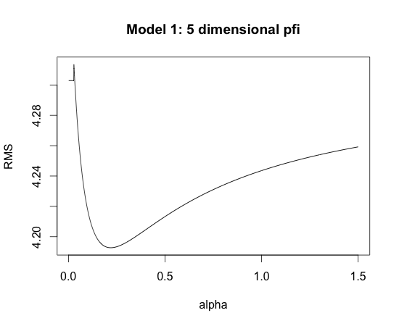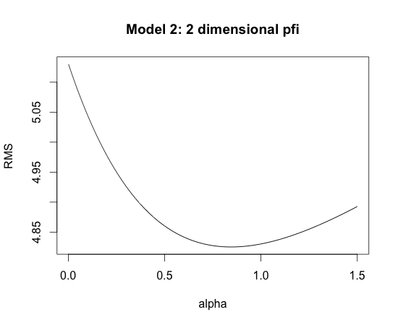

For the case charted above for model 1, the maximum likelihood estimate resulted in an RMS value of 4.41 relative to 4.19 using the MAP algorithm.

All reasonable alpha values resulted in lower RMS values than the ML equivalent (alpha interval 0 – 100 evaluated).

For the second model the corresponding values were 5.13 and 4.83 respectively.

We note that in this case, the ML solution corresponds to alpha=0. This feature was not observed for the active case of Model 1. For Model2 the MAP-based RMS values continue to be smaller than the ML-based equivalent for all values of alpha < 2.715.

While we note that MAP in this gave rise to smaller RMS values for both models, this is not a general feature of the data. In the majority of cases the model did not result in parabola between alpha and RMS(!)

