This screenshot shows the iris_analysis database in MySQL Workbench. The iris table contains the columns Id, SepalLengthCm, SepalWidthCm, PetalLengthCm, PetalWidthCm, and Species. The query SELECT * FROM iris LIMIT 10; displays the first 10 records from the table. This confirms that the data has been loaded successfully and can be retrieved using SQL.
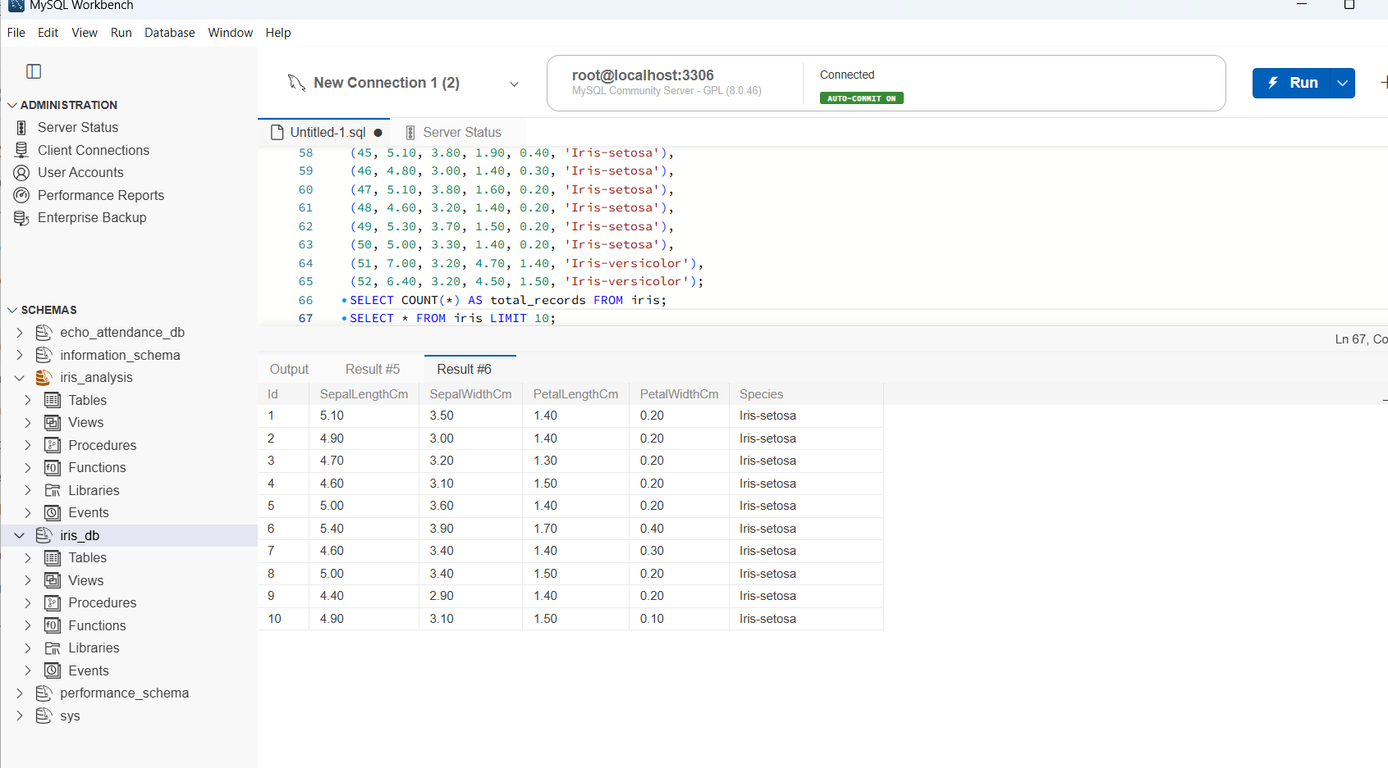
execution of an SQL query using WHERE and ORDER BY. The query filters flowers whose petal length is greater than 1.5 cm and sorts the results in descending order of petal length. The output displays the flower ID, species, petal length, and petal width. This analysis helps identify flowers with longer petals and compare their measurements across different species.
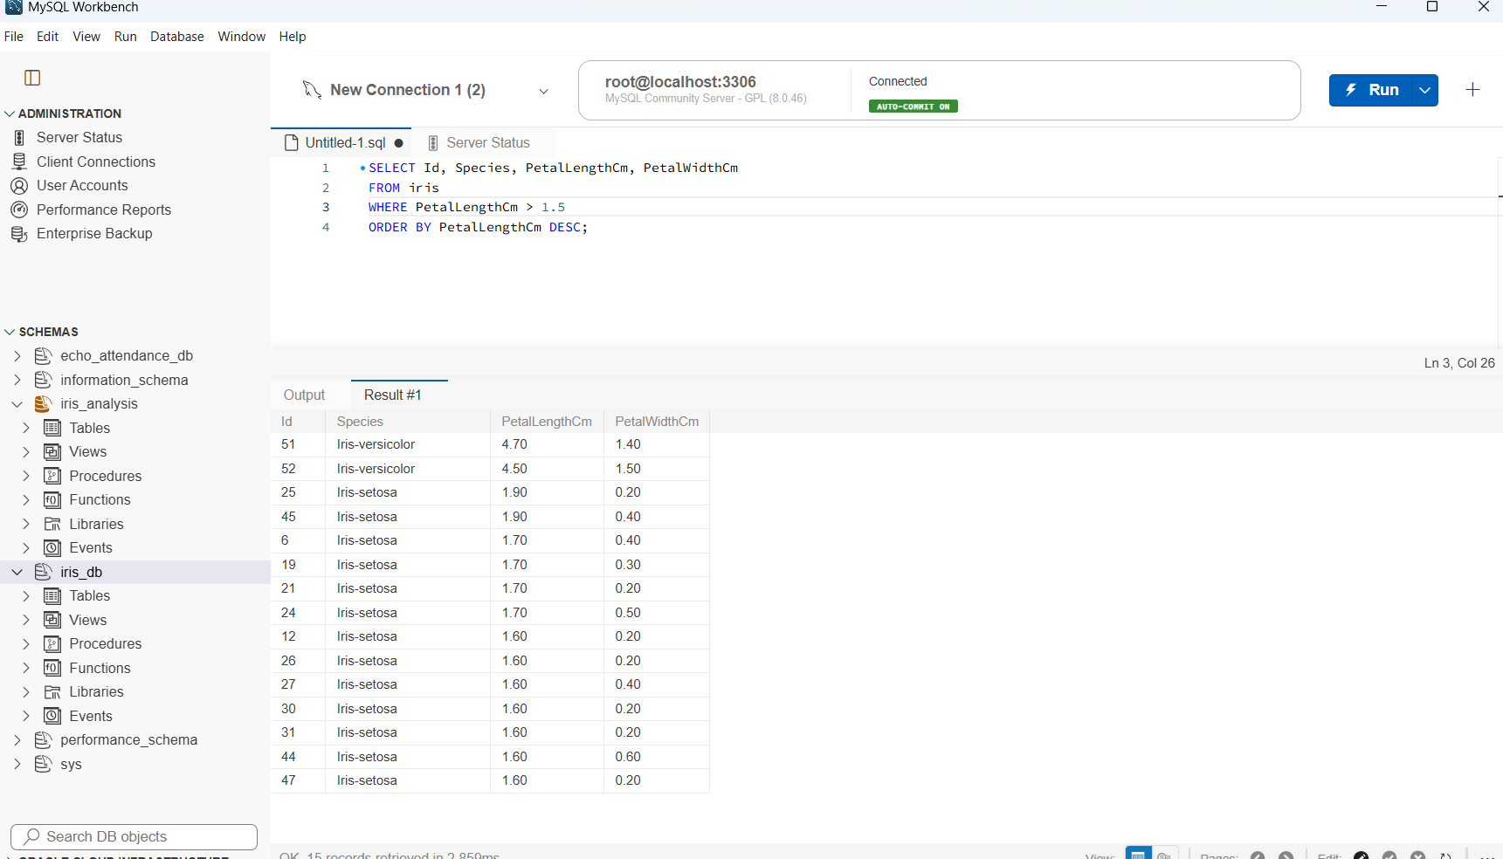
QL query using GROUP BY, COUNT(), and ORDER BY to count the number of flower records for each species. The results show 50 records for Iris-setosa and 2 records for Iris-versicolor. Iris-setosa has the highest count in the current dataset. This analysis helps compare the distribution of species among the 52 records currently stored in the database.
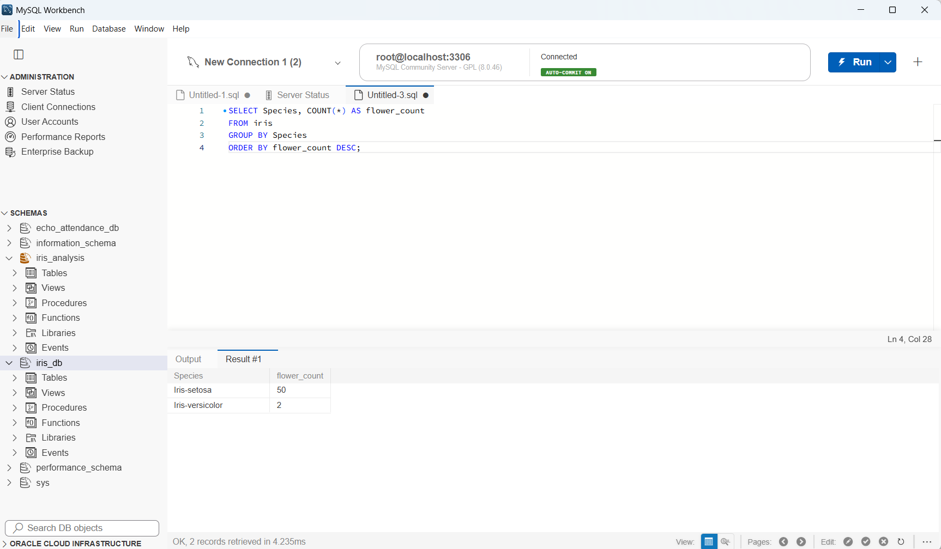
QL query using the AVG() aggregate function to calculate the average sepal length, sepal width, petal length, and petal width for each species. The GROUP BY clause groups the records by species, while ROUND() displays the averages to two decimal places and ORDER BY sorts the results by average petal length in descending order.
The results show that Iris-versicolor has an average petal length of 4.60 cm, while Iris-setosa has an average petal length of 1.46 cm. This indicates that Iris-versicolor has larger average petal measurements than Iris-setosa in the currently loaded dataset.
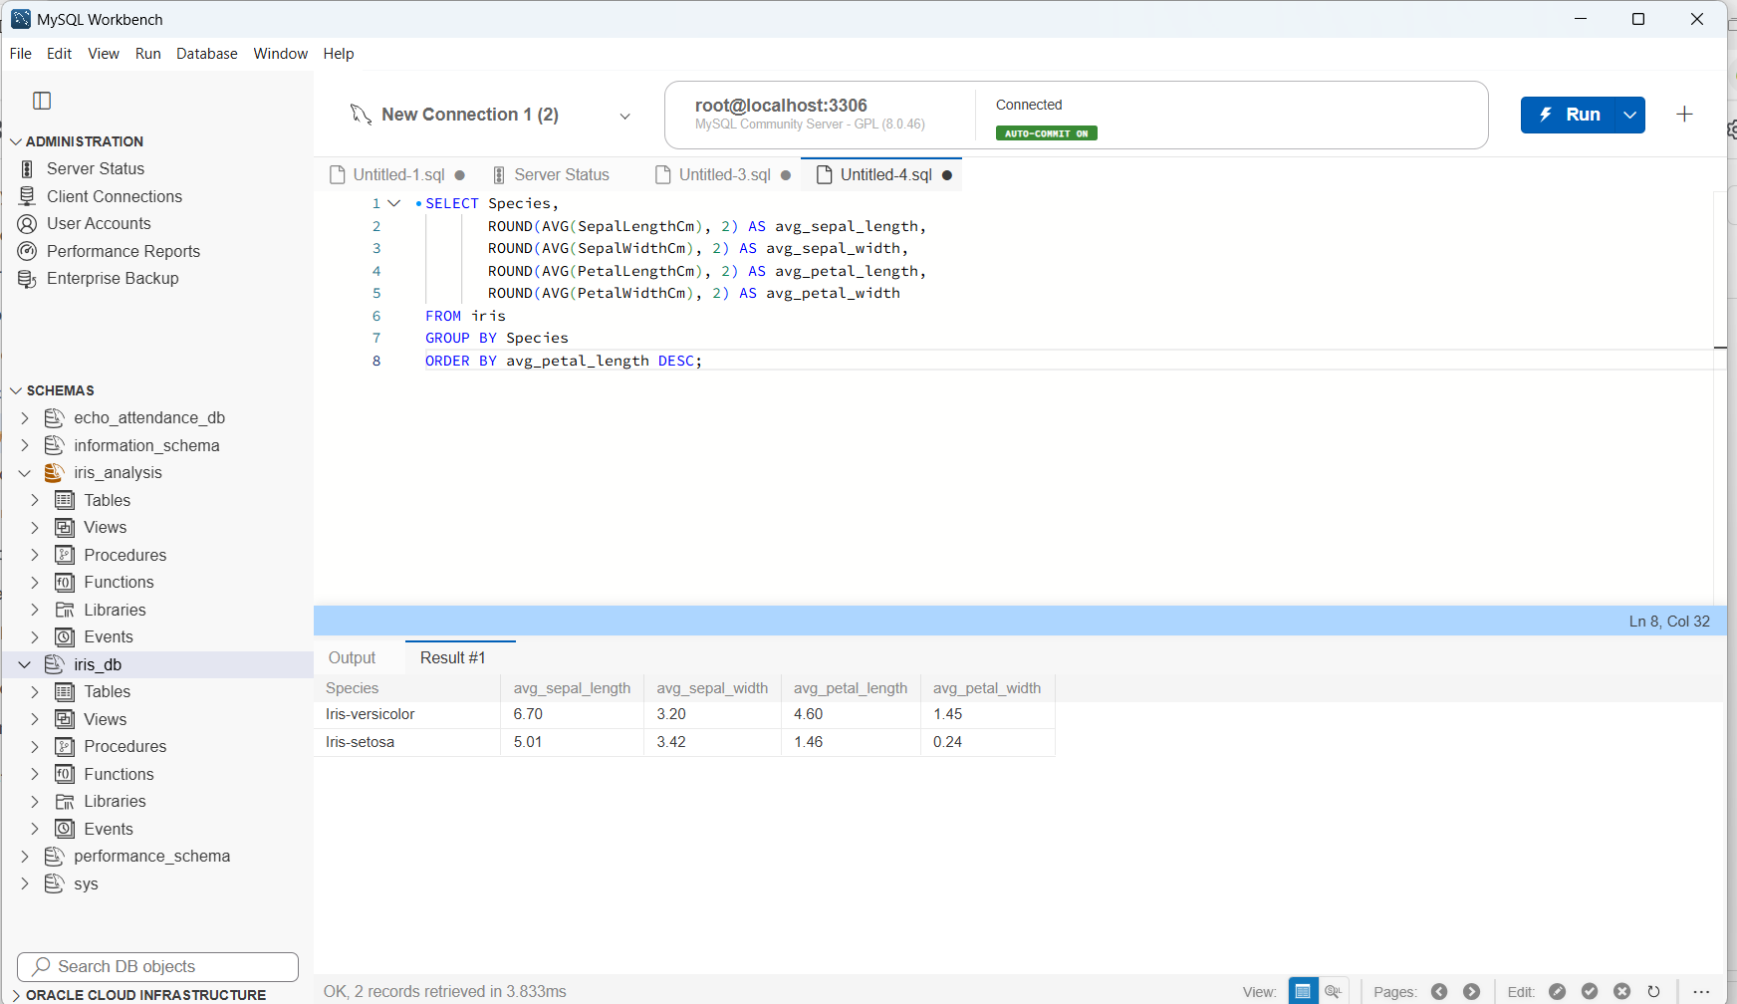
query that uses a subquery with the AVG() function to calculate the overall average petal length. The WHERE clause selects flowers whose petal length is greater than this average, and ORDER BY PetalLengthCm DESC sorts the results from the longest petals to the shortest.
The output displays 15 records that meet the condition. This analysis helps identify flowers with above-average petal lengths in the dataset and compare their measurements across species.
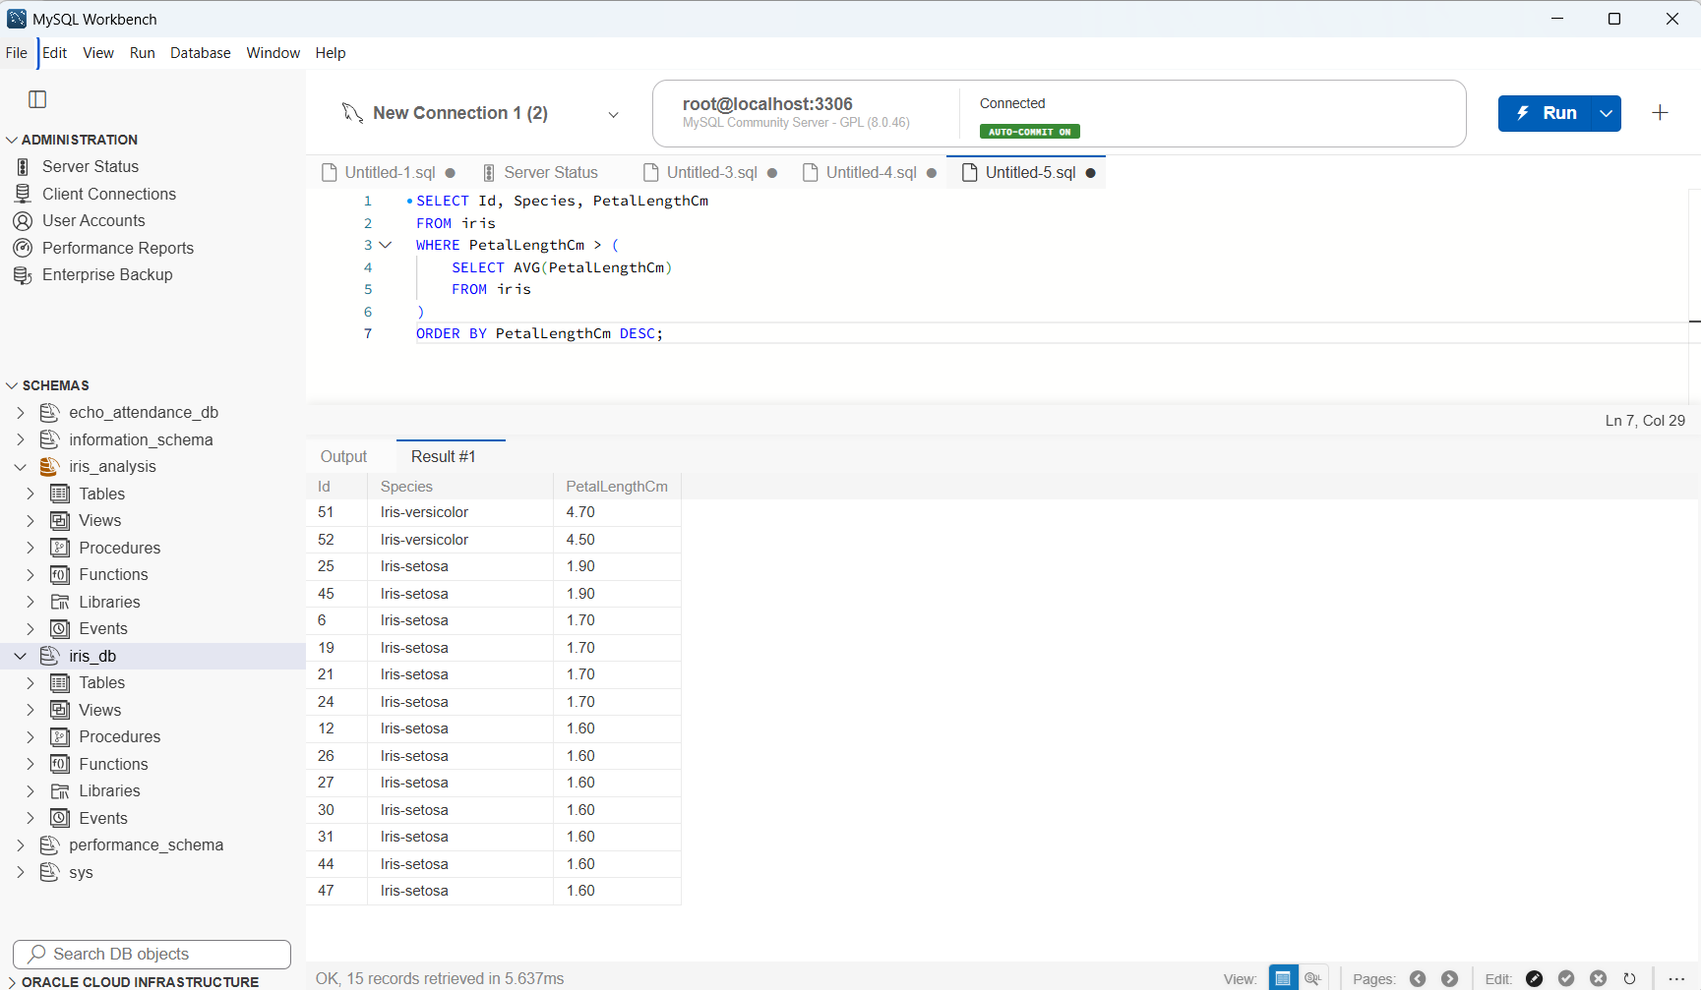
SQL query using the MIN() aggregate function to identify the smallest petal length in the Iris dataset. The query retrieves the minimum value from the PetalLengthCm column and displays it as minimum_petal_length.
The output shows a minimum petal length of 1.00 cm. This helps identify the smallest recorded petal measurement among the flowers currently stored in the database.
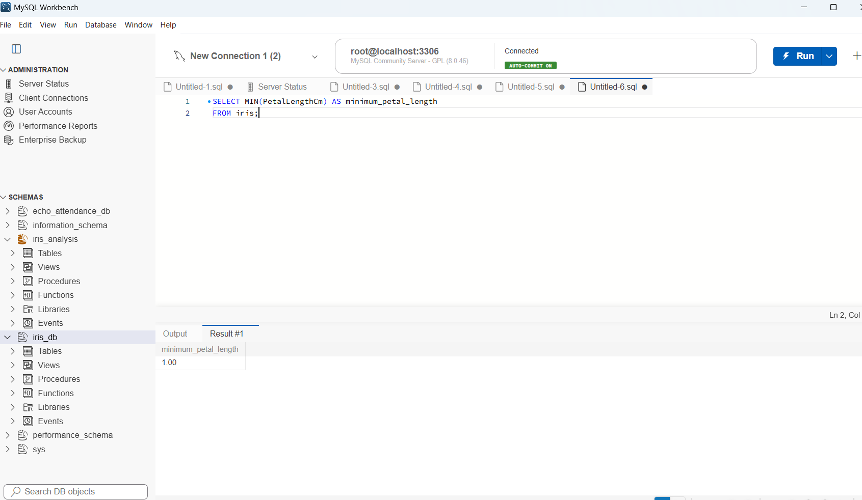
SQL query using the MIN() and MAX() aggregate functions to find the minimum and maximum petal lengths and widths for each flower species. The GROUP BY clause groups the records by species, while ORDER BY sorts the results alphabetically by species.
The results show that Iris-setosa has a minimum petal length of 1.00 cm and a maximum of 1.90 cm. Iris-versicolor has a minimum petal length of 4.50 cm and a maximum of 4.70 cm. This analysis helps compare the range of petal measurements between the two species currently present in the database.
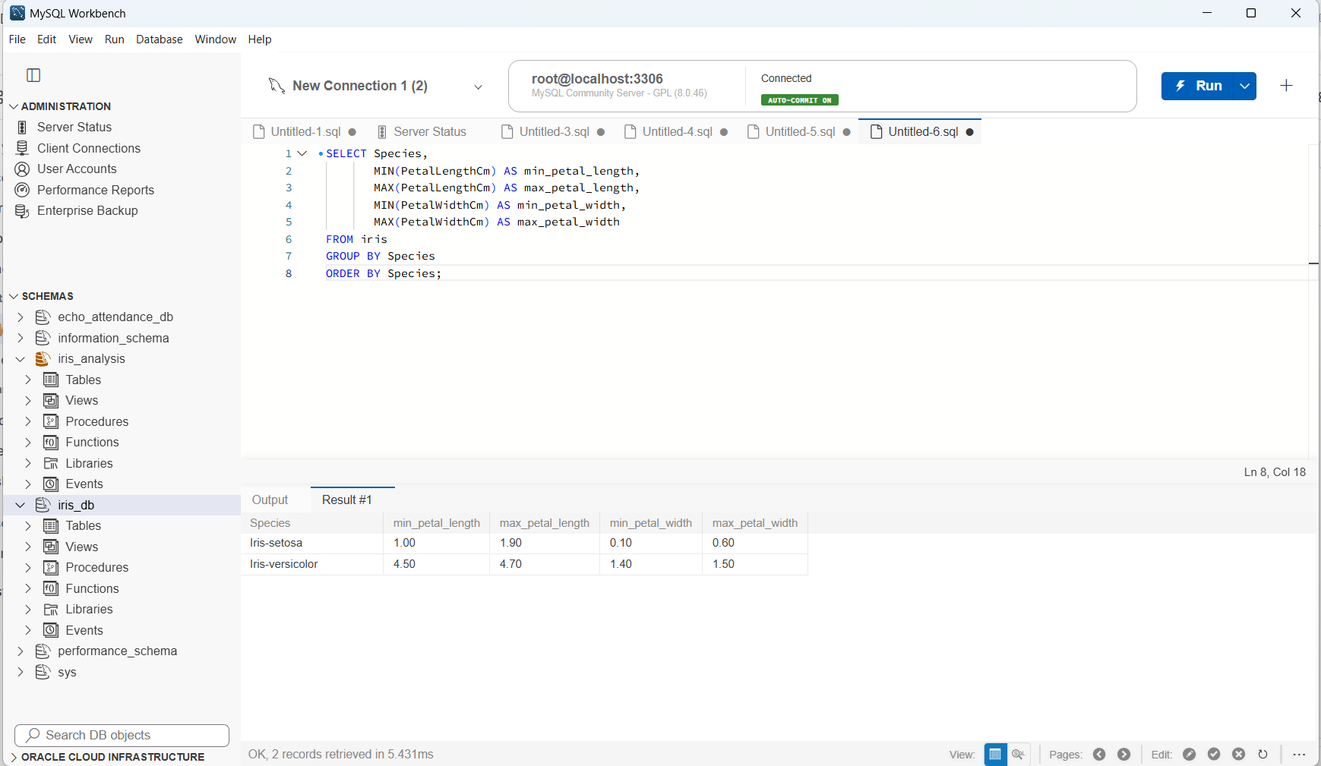
creation of a new table named species_info with two columns: Species and Flower_Type. The Species column is defined as the primary key to uniquely identify each species. The INSERT INTO statement adds three records containing descriptive names for Iris-setosa, Iris-versicolor, and Iris-virginica.
The output confirms that the table was created successfully and three rows were inserted. This table will be used in the next step to demonstrate how SQL joins combine data from two related tables.
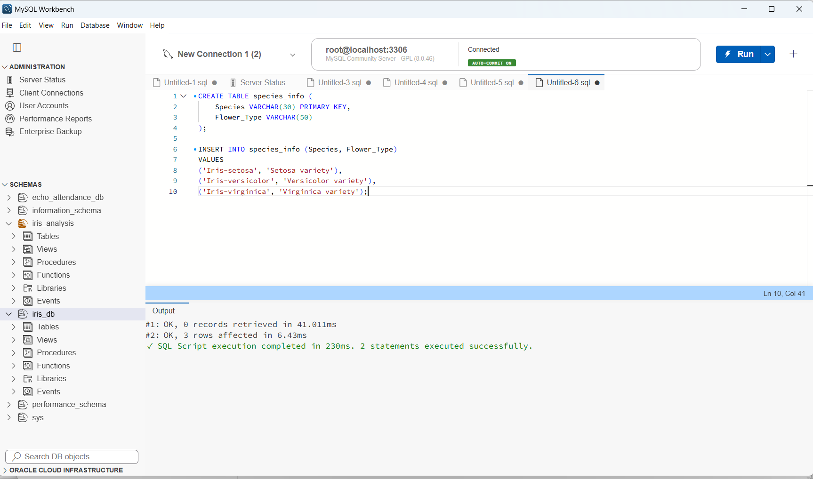
SQL query using INNER JOIN to combine data from the iris table and the species_info table. The ON clause matches records using the Species column in both tables. The query displays the flower ID, species, flower type, petal length, and petal width, with the results sorted by petal length in descending order.
The output shows 52 matching records, confirming that the join executed successfully. The species descriptions are displayed alongside the corresponding flower measurements, making the data easier to understand and compare.
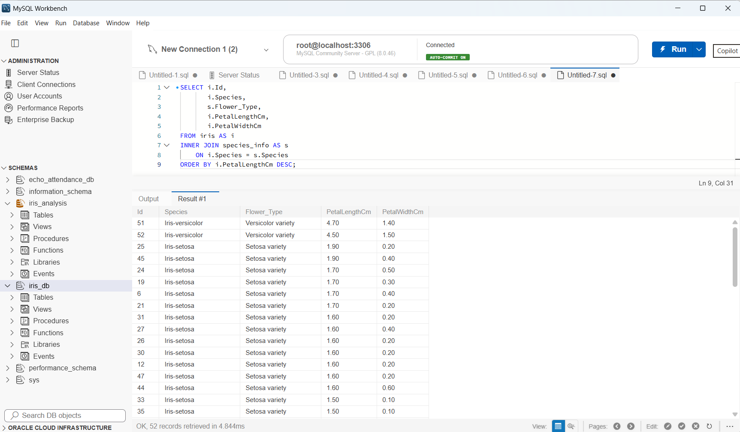
This shows the successful execution of the INNER JOIN query in MySQL Workbench. The query combines the iris and species_info tables using the common Species column. The result grid displays the flower ID, species name, flower type, petal length, and petal width.
The output confirms that 52 records were retrieved successfully. The flower measurements are displayed alongside their corresponding species descriptions, demonstrating how a JOIN can combine related information from multiple tables for easier analysis.
