

WIREFRAME DOCUMENT

PETROL PRICE FORECASTING



VIJAYA

CHANDAN KUMAR

USER INTERFACE

The user can view the following web page once entering the web application.

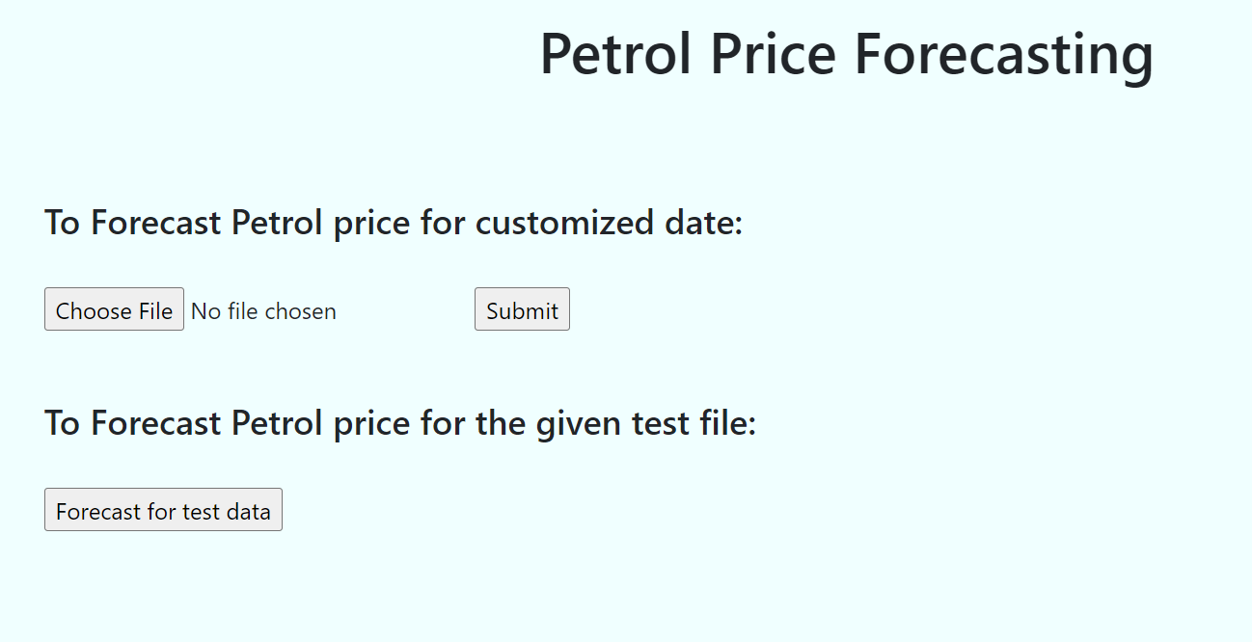

We have 2 options to forecast the data:

1. To forecast Petrol price for the customized date – A csv file should contain 2 columns, one column with the date that need to be forecasted and other empty column with the name Prediction.

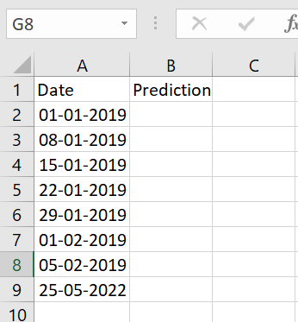

2. To forecast the Petrol price for the given test file – A csv file with date’s given that need to be forecasted.

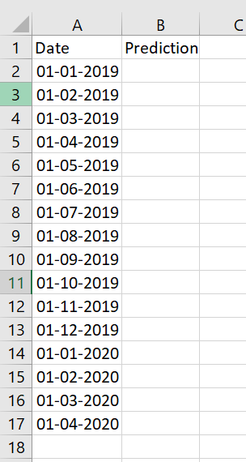

Choose a particular option and click either submit after uploading a csv file or select the Forecast for test data,once done user can view the forecast results:

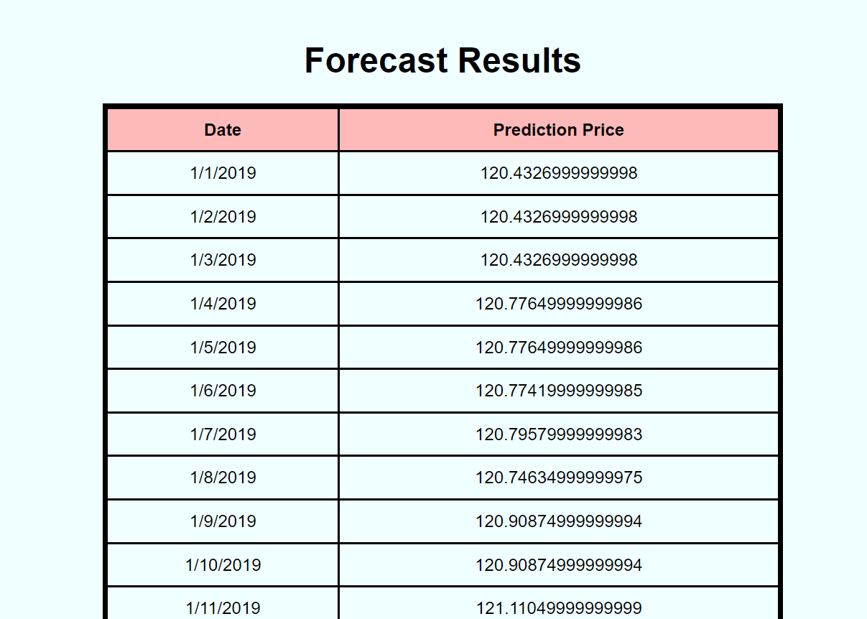

we get results as shown above.