PES UNIVERSITY
Department of Computer Science & Engineering

Database Management System

UE23CS351A
Mini Project – Report

Name of the Student | P Vishnupranav Reddy
SRN | PES1UG23CS415
Section | G
Name of the Student | Pavan K Aithal
SRN | PES1UG23CS420
Section | G

Indian Energy Monitoring System
The Indian Energy Monitoring System is a comprehensive web-based platform designed to track, analyse, and visualize India's energy generation landscape in real-time. The system aggregates live data from ‘meritindia.in’ and ‘cea.nic.in’, capturing daily generation statistics from renewable and conventional power plants across multiple states and regions. Built with a React-based frontend and Flask backend architecture, the platform provides users with interactive dashboards, analytical insights, and automated alert mechanisms for monitoring energy production patterns. The system maintains a structured database of power plants, companies, and regional metrics, enabling comparative analysis of energy mix, generation trends, and capacity utilization. By processing daily XLS and PDF reports through automated web scraping, the platform transforms raw energy data into actionable intelligence. The application serves as a centralized monitoring tool for understanding India's dynamic energy ecosystem and facilitating data-driven insights into the nation's power generation infrastructure.

User Requirement Specifications:
Functional Requirements:
- Data Acquisition and Preprocessing:

• Real-time Data Scraping: Automated web scraping from meritindia.in to fetch daily power generation reports
• Multi-format Support: Process XLS (plant generation) and PDF (renewable energy) reports
• Scheduled Updates: Daily synchronization of power plant generation data from GitHub repository
• Data Parsing Pipeline: Sequential execution of integrated_web_scrapping.py, parseall1.py, parseall2.py, and parseall3.py

- Dashboard and Visualisation:

Key Performance Indicators (KPIs):

The main dashboard focuses on several critical KPIs to ensure immediate insight into the current state of operations. These metrics include the Total number of power plants under management and the overall system performance, specifically Today's generation (MU - Million Units) and Today's demand (MU). Operational health is monitored through the Average efficiency percentage and the Total operational capacity (MW - Megawatts). Furthermore, the dashboard highlights potential immediate issues by tracking the Plants under outage count and Critical coal stock alerts. To facilitate historical review and flexible analysis, the dashboard incorporates a crucial Date-based filtering capability.

Interactive Charts:

A suite of interactive visualizations supports the raw KPI data, allowing users to delve deeper into performance. The Energy mix pie chart clearly illustrates the composition of the power portfolio by breaking down the generation sources into renewable versus non-renewable categories. Performance can be analysed geographically using Regional performance bar charts and a Map visualization for geographical distribution of the plants. For strategic and historical analysis, the dashboard features Trend line charts for historical analysis of key metrics. Finally, a dedicated visualization provides a Top performing plants comparison to benchmark and identify best-in-class operations.

- Plant Management:

Plant Listing:

The Plant Listing serves as the primary index for all power generating facilities. It uses a Paginated view (20 plants per page) to ensure quick loading and easy navigation across the entire fleet. To facilitate rapid location of specific facilities, the list includes Search functionality by plant name/ID. Advanced data segmentation is supported via several filters, allowing users to Filter by state, sector (State/Private/Central), and energy type. Each entry in the listing is designed to Display basic plant information for immediate identification and context.

Detailed Plant View:

Selecting a plant from the listing opens the Detailed Plant View, which aggregates all relevant operational and performance data. This view begins with Comprehensive plant information (name, location, sector, energy type). It provides an in-depth look at performance through the Production history with efficiency metrics and details the physical capability with Operational capacity and capability. For thermal plants, essential resource monitoring is provided via Coal stock levels. The operational status is shown at a granular level with Operational status by unit and critical Outage information with expected sync dates. All data within this view is supported by a Date-based historical data viewing feature, allowing users to analyse performance trends over time.

- Analytics and Insights:

Regional Performance Analysis:
This section offers a geographical perspective on the power system's operation. It starts by quantifying the infrastructure with the Region-wise total plants count. Core performance is measured by breaking down Generated energy (MU) and Demand (MU) by region. The financial and operational balance is determined through Surplus/deficit calculation. Further supply health is measured by Supply percentage metrics and a clear Energy status classification (e.g., meeting demand, low surplus, high deficit) for quick assessment of regional stability.

Efficiency Comparison:

The Efficiency Comparison provides a competitive and developmental perspective on plant operations. It ranks all facilities using a Plant-wise average efficiency ranking. A focused list highlights the high achievers with the Top 20 performing plants. To identify performance trends and the impact of operational changes, the feature includes a view of Efficiency percentage over time for individual plants.

Renewable Energy Mix:

Dedicated analysis of sustainable power generation is provided in the Renewable Energy Mix section. It breaks down the system's energy sources on a granular level with a State-wise renewable vs non-renewable breakdown. This data is then used to calculate the crucial Renewable percentage calculation to track sustainability goals. The raw contribution of these sources is quantified in Production values in MU. For recent trend analysis, all metrics in this section are based on Last 30-day aggregated data.

- Alert System:

Real-time Monitoring Alerts:

• Low Efficiency Alerts: Plants with <60% average efficiency (3-day window)
• Critical Coal Stock: Thermal plants with <7 days coal stock (WARNING: 4-7 days,
CRITICAL: <4 days)
• Plant Outage Alerts: Units under outage status (CRITICAL: ≥500 MW, WARNING: <500
MW)

Alert Dashboard:

The Alert Dashboard provides a focused, real-time view of system issues. The primary metric is the Total alerts count, giving a quick measure of overall system risk. Alerts are then prioritized through Critical vs warning categorization to guide immediate response efforts. Each notification is presented with Detailed alert information which includes the associated plant name, state, and the values that triggered the alert. Finally, a dedicated Coal stock table provides immediate context for thermal plant issues by displaying the current coal levels alongside the plant’s operational capacity, allowing operators to quickly assess the severity of fuel shortages relative to production capability.

- Regional/State Management;

This feature set is designed to offer a clear, structured view of how power generation and consumption are balanced across different geographical areas. Key metrics are reported at the state level:
- Plant count per state: The total number of operational power plants located within each state, providing context for the infrastructure base.
- Generated energy: The total power produced (typically measured in MU - Million Units) by all plants within a specific state.
- Demand: The total power consumed (MU) within the specific state.
- Energy status (surplus/deficit): A calculated metric showing the difference between the generated energy and demand (Generation - Demand), clearly indicating whether the state is an energy supplier (surplus) or a net importer (deficit).
- Regional grouping: States are aggregated into macro-regions—Northern, Southern, Eastern, Western, and North-Eastern—to provide a high-level overview of inter-regional performance and balance.
- Date-based filtering: A necessary tool that allows users to analyse these state and regional metrics over specific timeframes (e.g., daily, weekly, or monthly comparisons).

- Database Administration:

• Daily Report Generation: Generate comprehensive daily energy reports by date with
state-wise aggregated metrics
• Underperforming Plant Identification: Configurable efficiency threshold and time
window
• Data Pipeline Trigger: Manual trigger for complete ETL process with error handling.

Tech Stack:
Backend:
• Framework: Flask 3.0.0
• Database: MySQL with SQL Alchemy ORM
• API Architecture: RESTful APIs with Blueprint modularization
Frontend:
• Framework: React 18.3.1
• Routing: React Router DOM 7.9.5
• Charts: Recharts 3.3.0
• HTTP Client: Axios 1.13.2

E R Diagram:
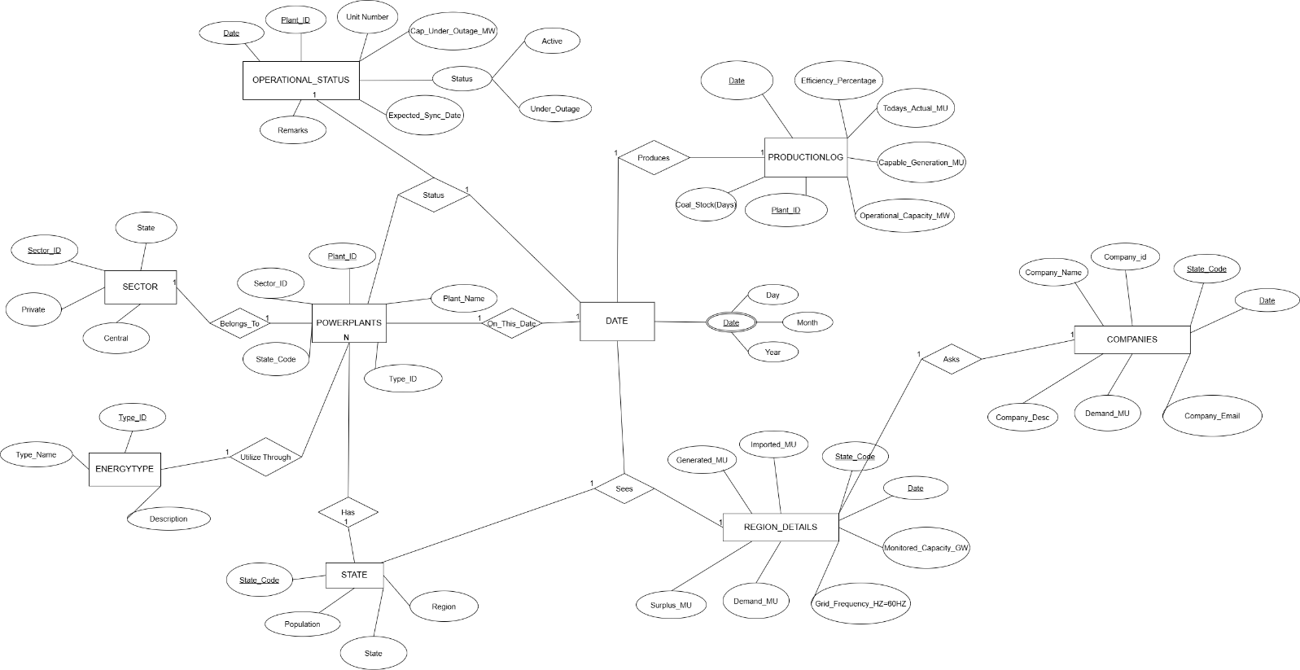
Relational Schema:
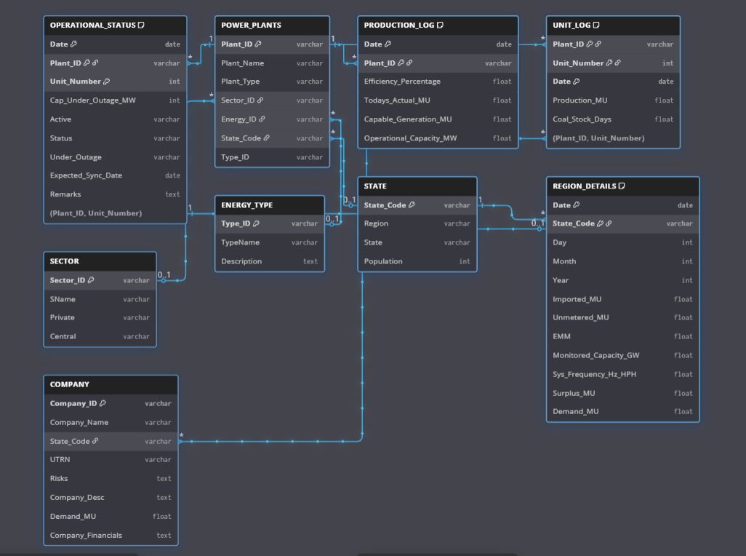

DDL Commands: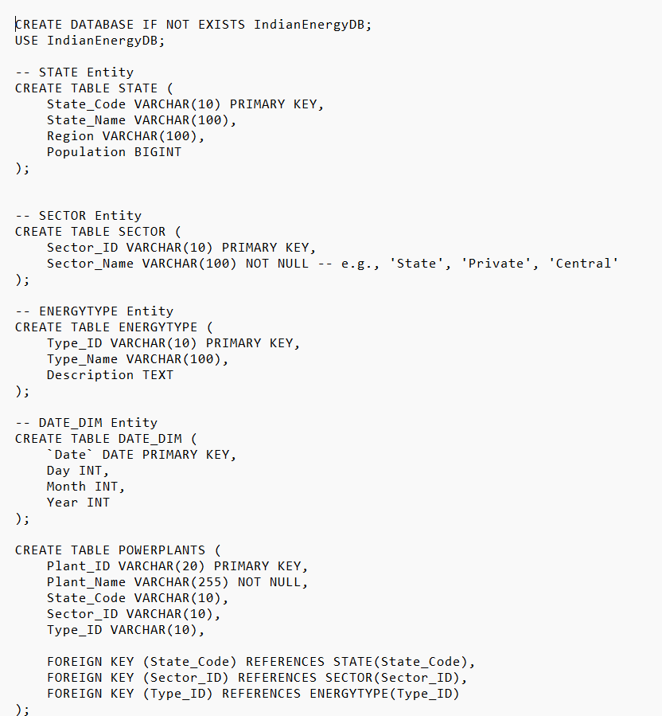 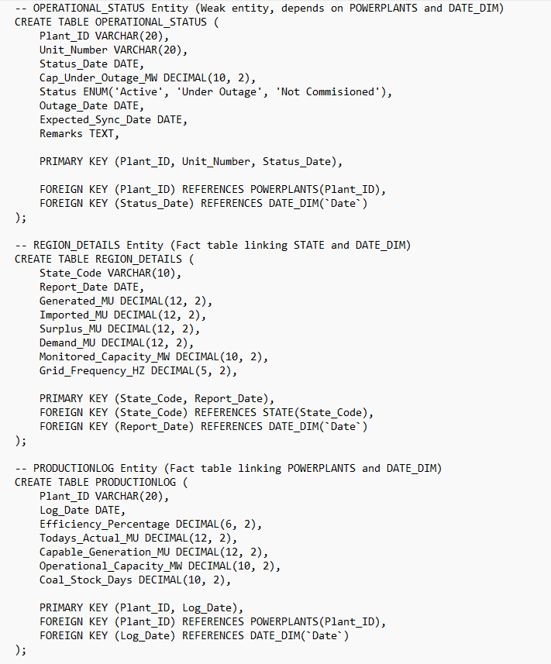

Triggers/Functions/Procedures: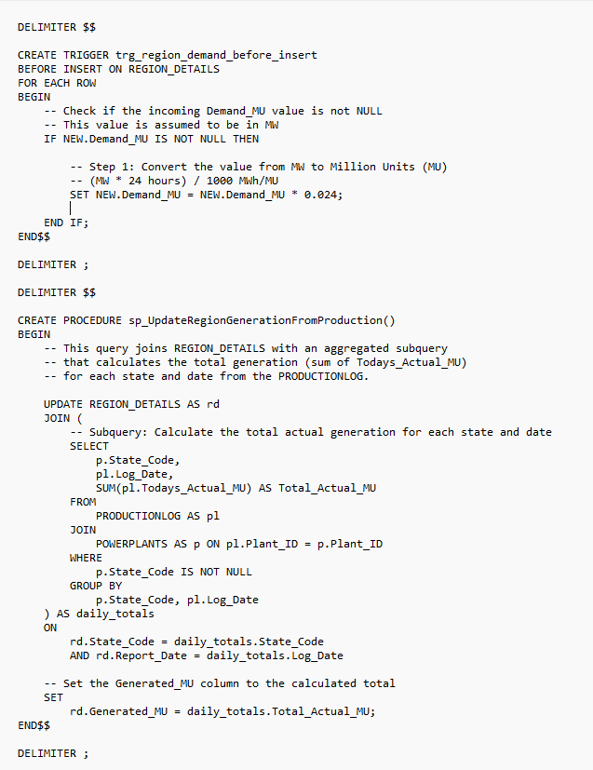 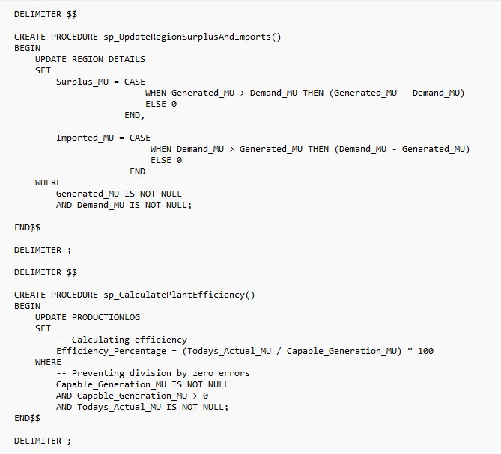
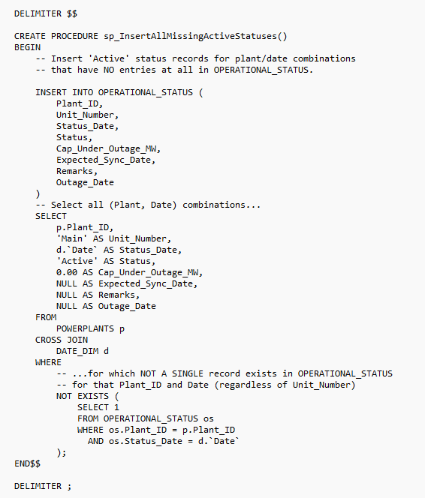
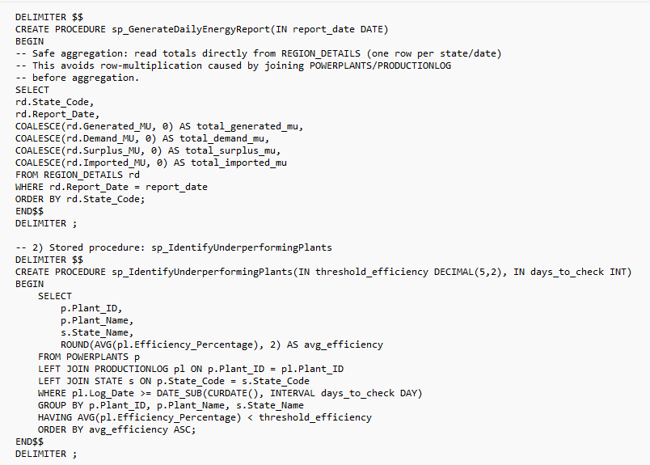
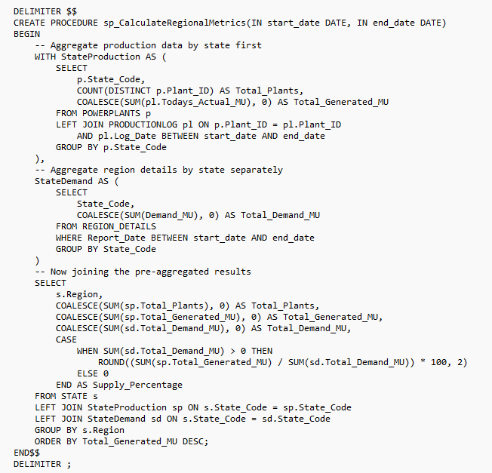

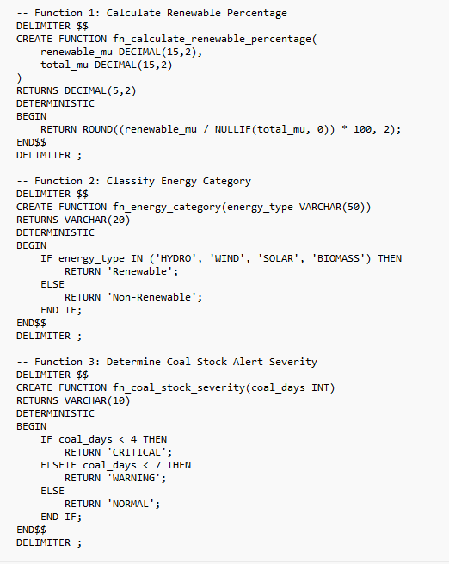

Nested Queries/Corelated Queries/Aggregate Queries/Joins:
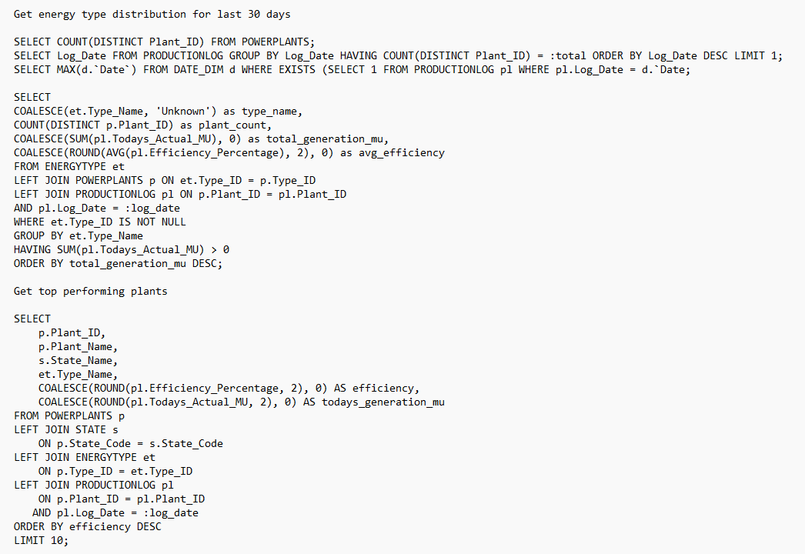
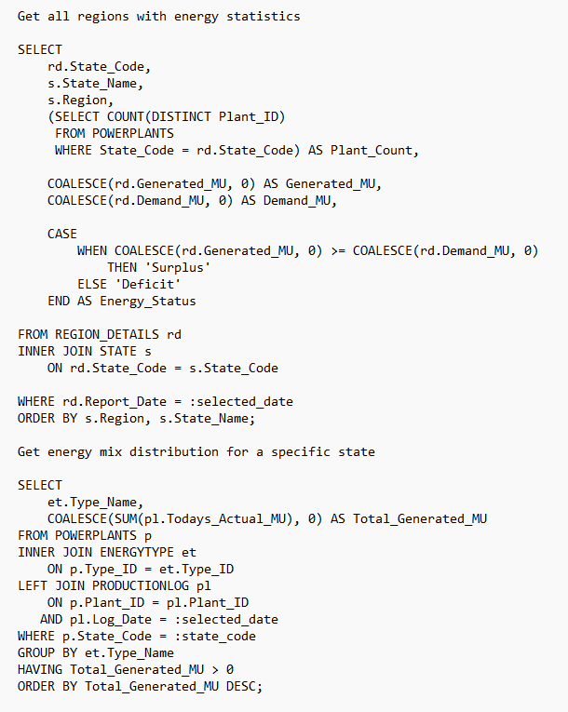
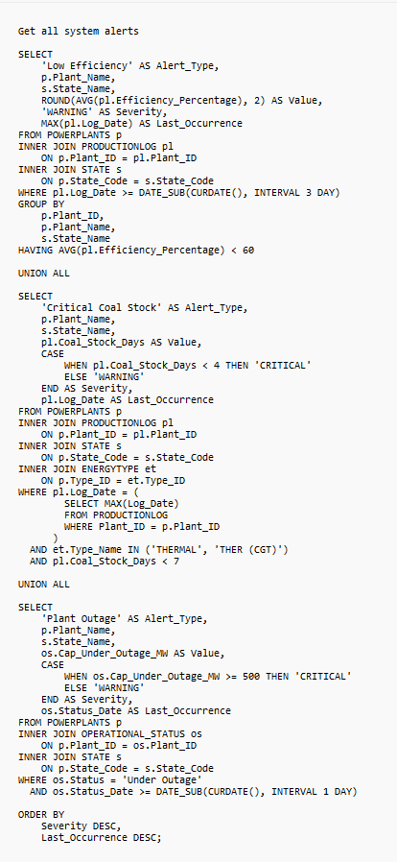
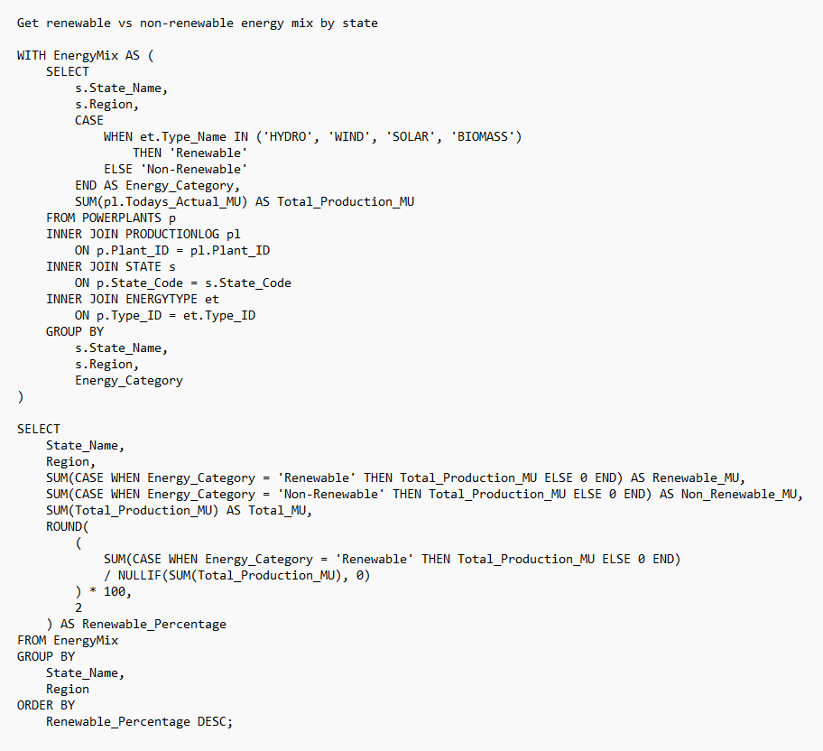

Features:
Main Dashboard:
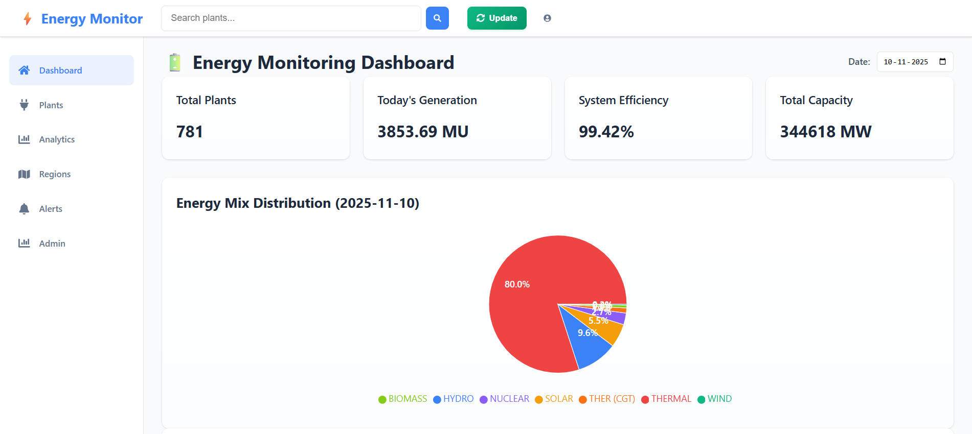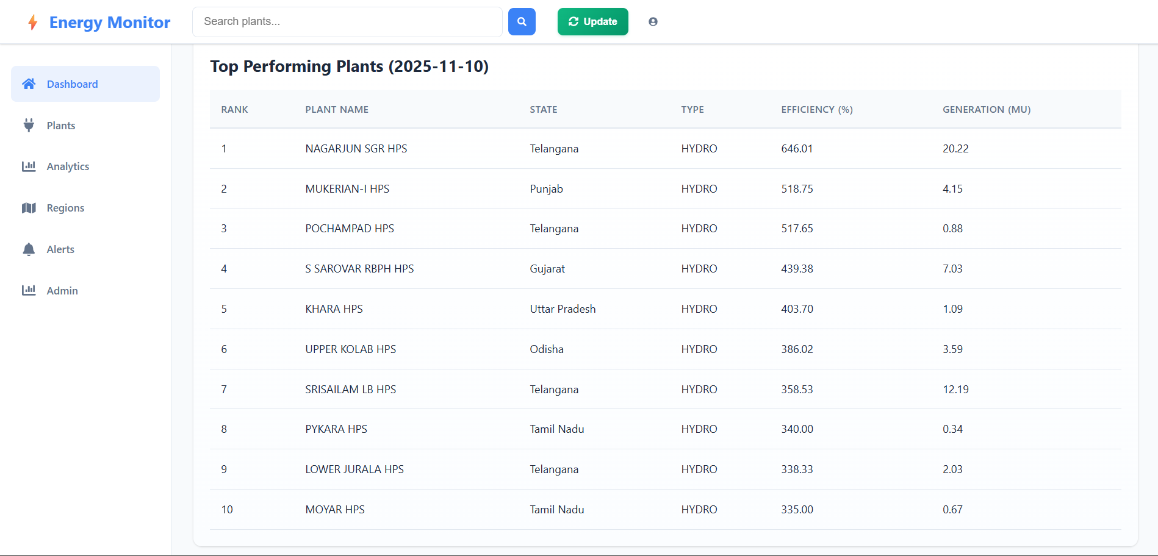

Plants Dashboard:
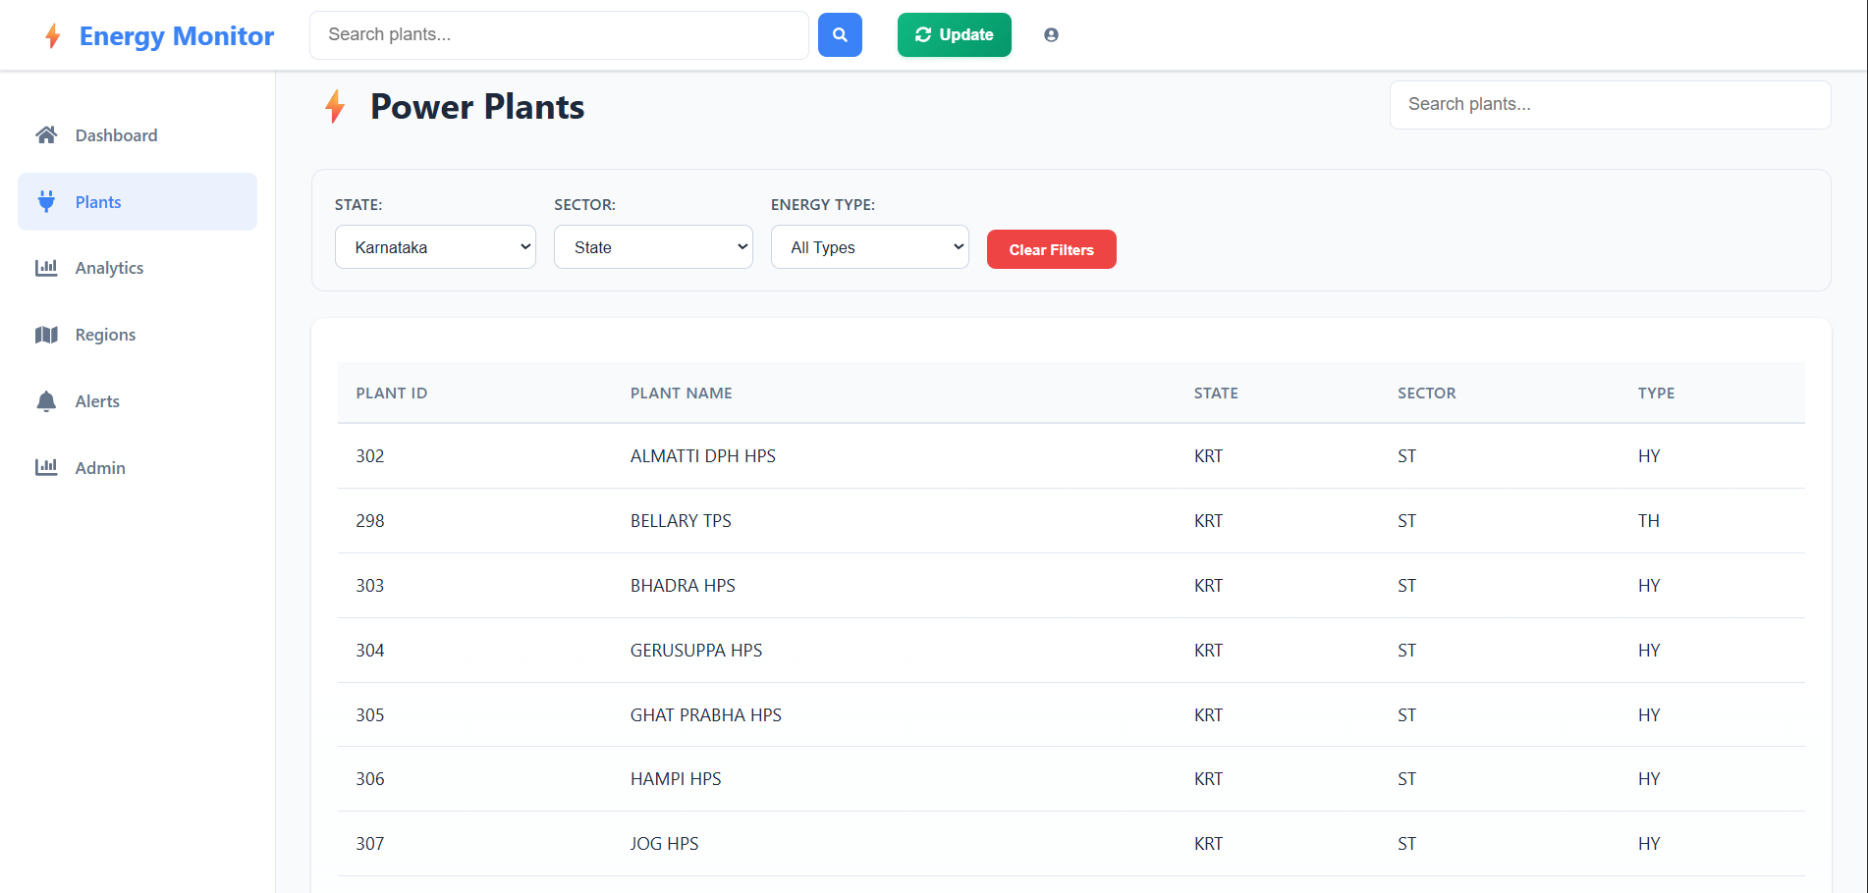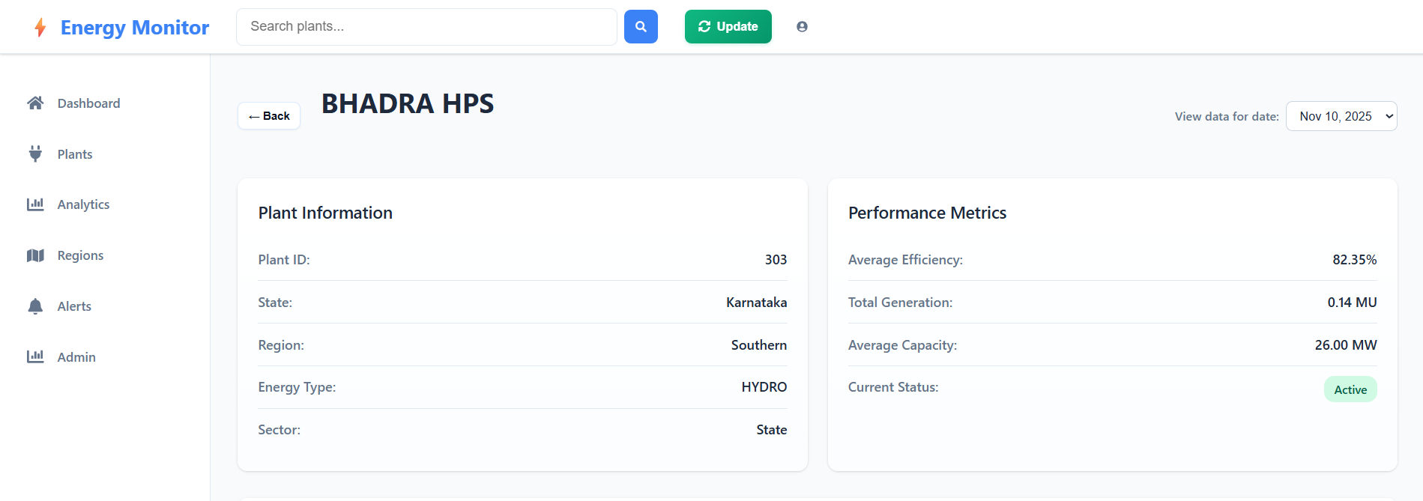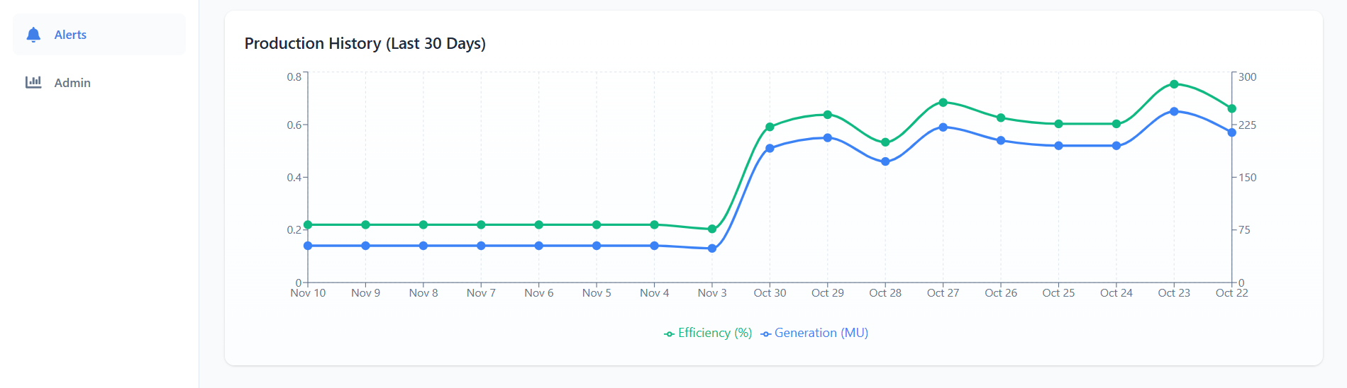

Analytics and Insights:
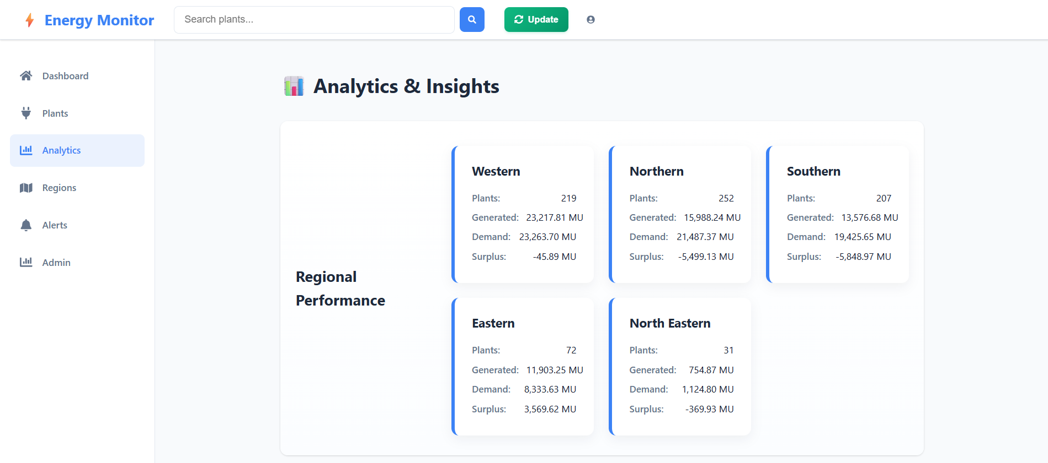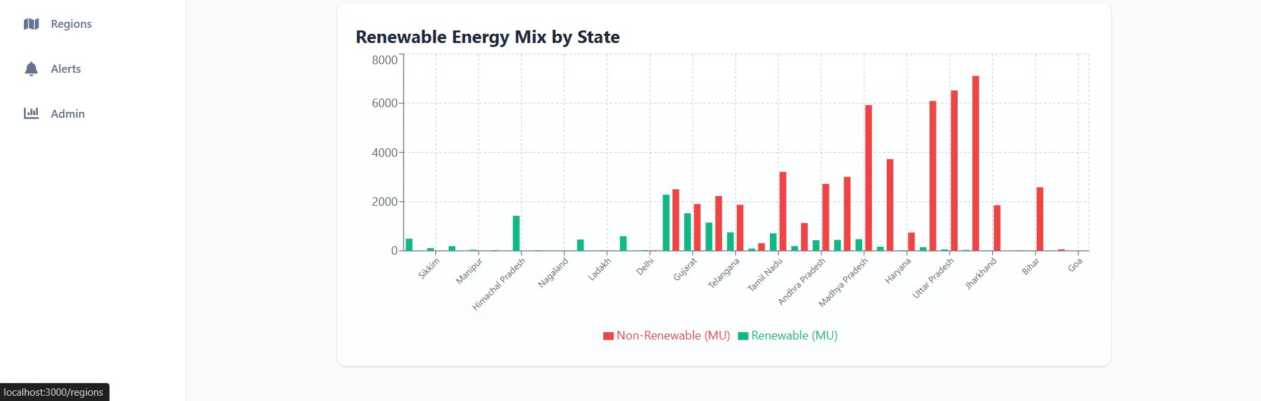

Regions Dashboard:
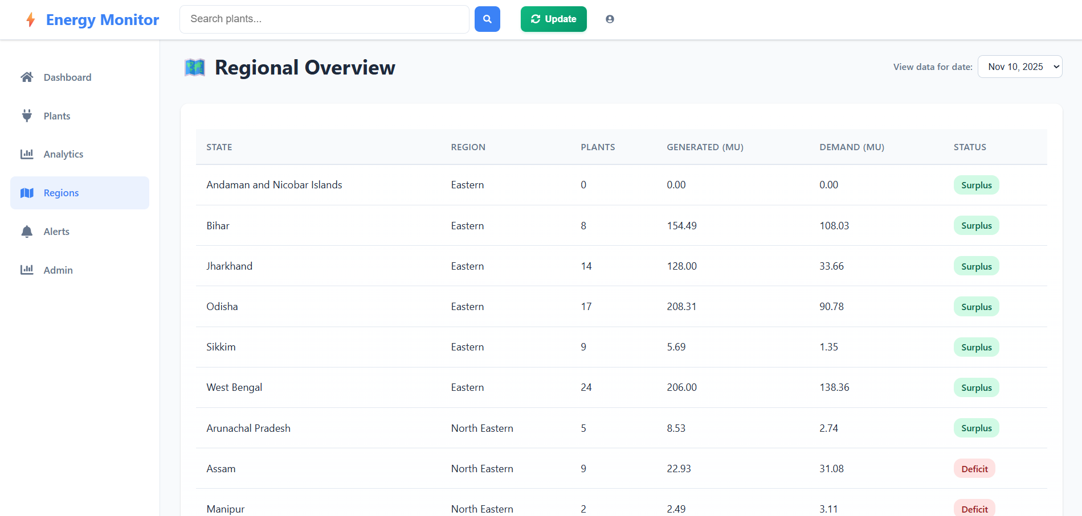
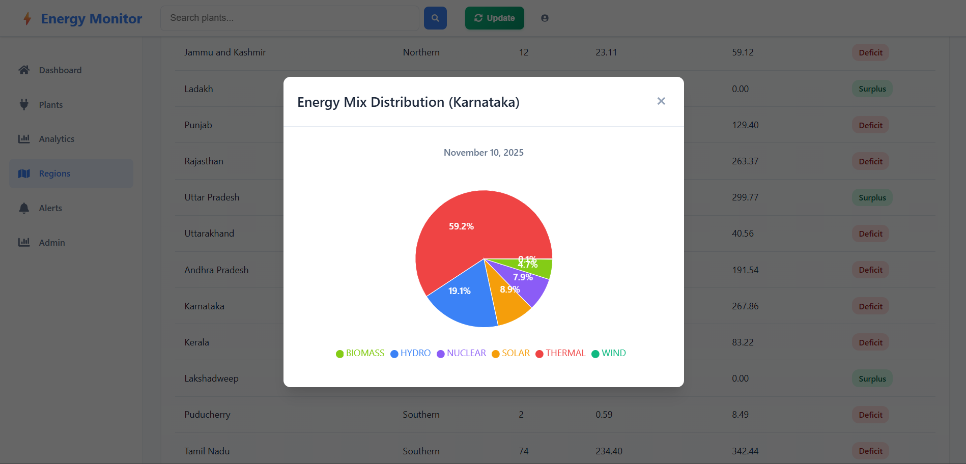

Alerts:
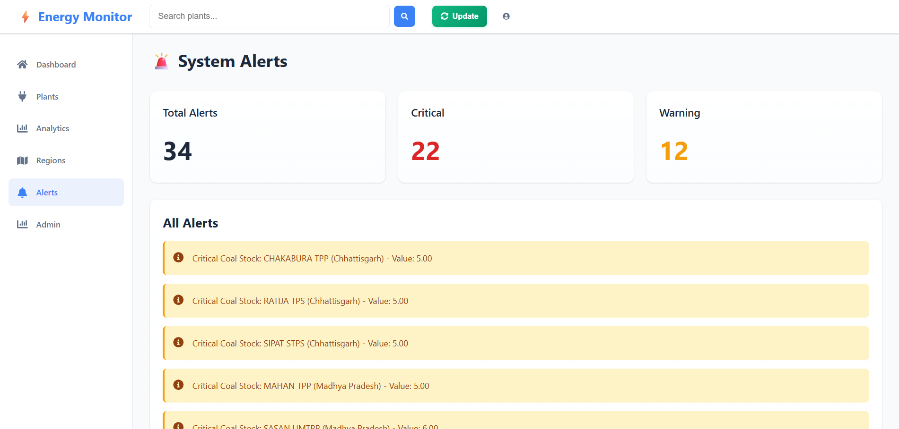
Admin Tools:
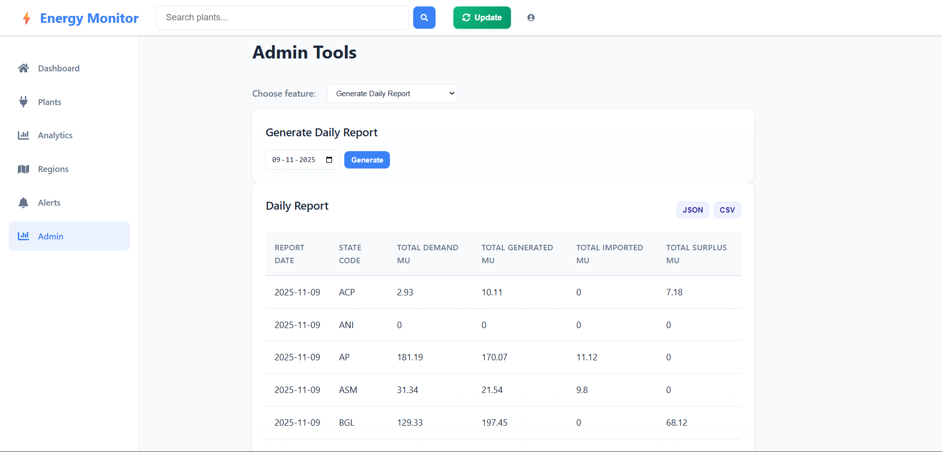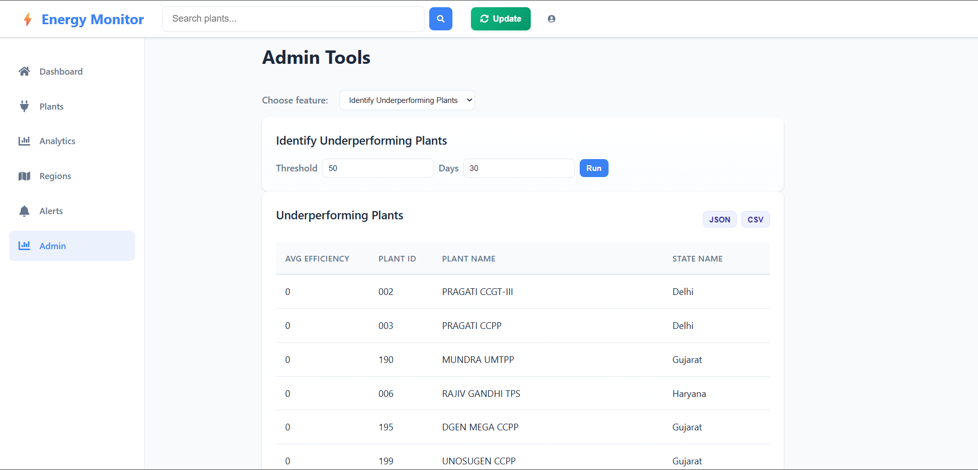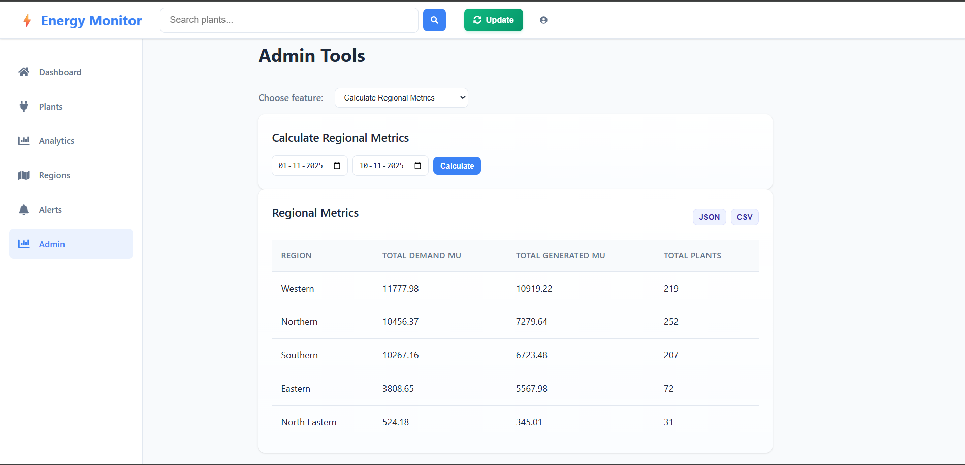
CRUD Operations:
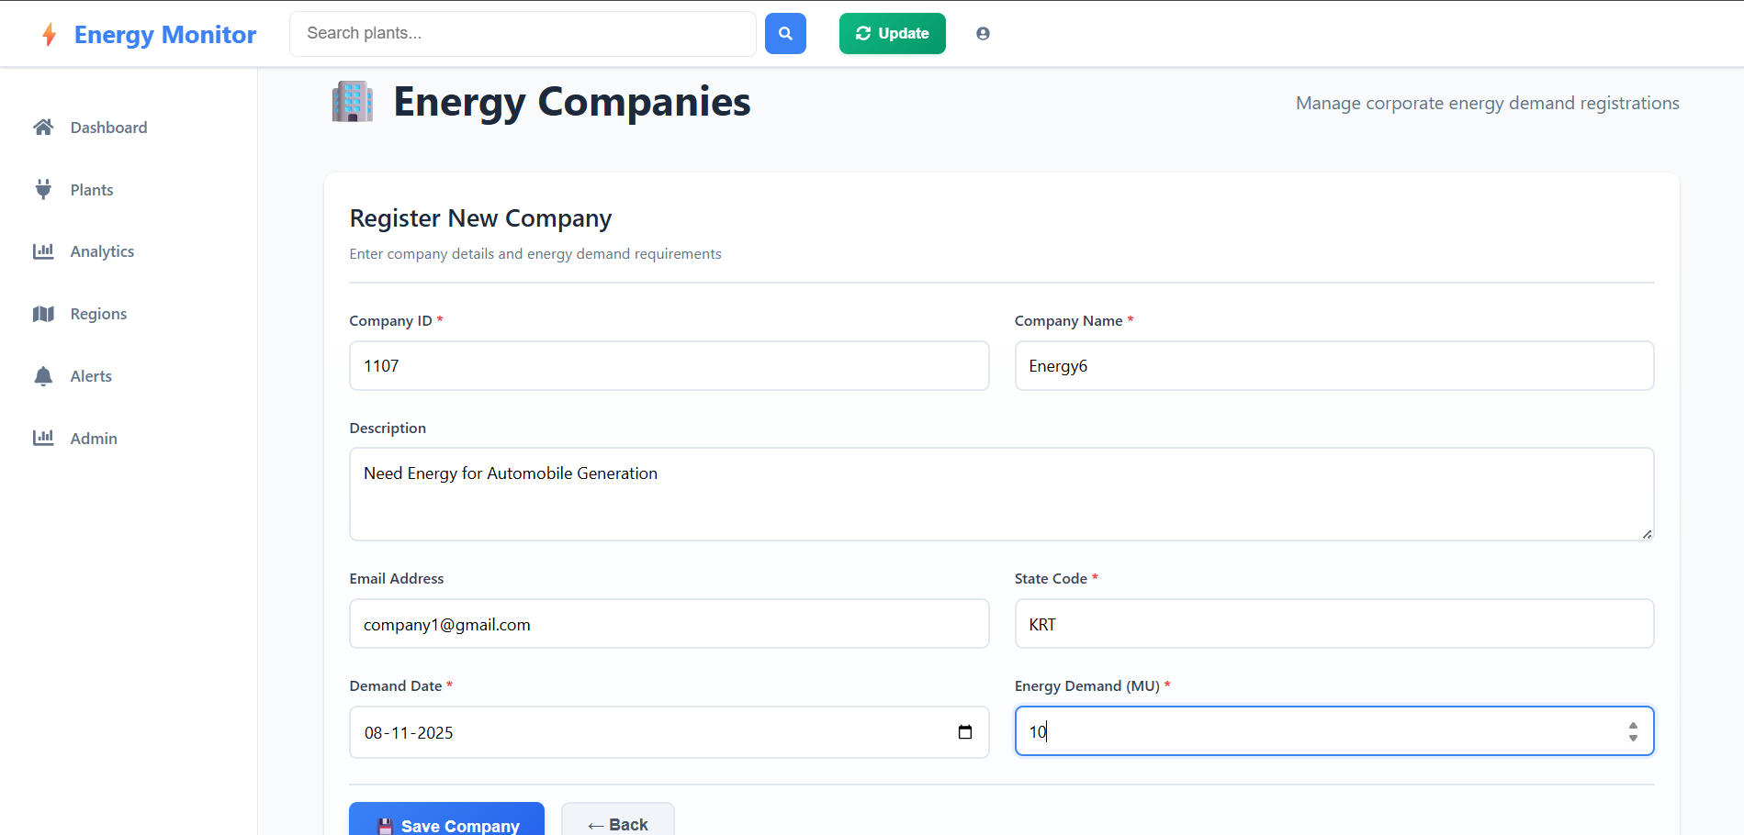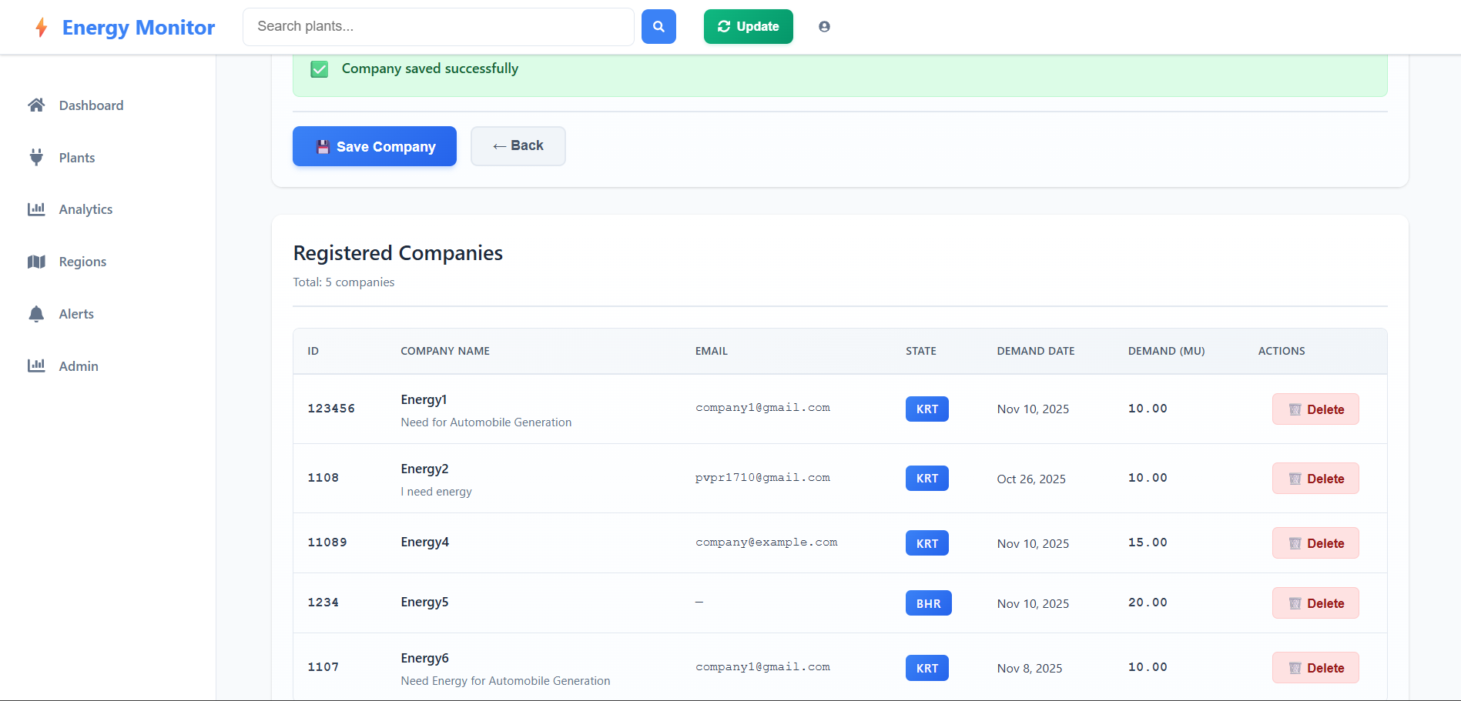

Code Snippets:
