File Integrity Monitoring System Using
Cryptographic Hashing System
Palak Upadhyay, Ayush Kumar, Ayush Arnav, Atharva Chavan
CSE, IILM University
Greater Noida, India

Abstract—In the era of digital life, protecting the data ensuring the security and integrity of files and security of data has become very important, especially with the increasing number of cyber threats and unauthorized modifications and security. Unauthorized changes to files can cause serious problems, for example data breaches, financial damage to the owner and organisation, and system failures. The system works by generating a unique hash value for each file making them highly secure and unique for identifying even the smallest changes in files and this research presents the design and implementation of a File Integrity Monitoring System (FIMS) with the uses of cryptographic hashing and detect all the smallest changes whether it is deleted , updated and modify. In this project , some popular hashing algorithms such as SHA-256, SHA512, and SHA-3 are come in picture with respect to their their performance, security strength, and practical usability.
The proposed system is designed to be efficient, secure, and easy to implement and works by first generating and securely storing baseline hash values of files. During regular monitoring, new hash values are calculated and compared with the original ones. If any difference is found, the system immediately flags the file as potentially compromised and generates an alert. This approach ensures accurate detection of unauthorized changes while keeping computational requirements low It can be used in various environments such as personal systems, organizational servers, and cloud storage to enhance data security. By automating the process of file monitoring, the system reduces the need for manual checks and minimizes the risk of unnoticed file corruption or malicious activity.
In addition, the project examines practical uses of file integrity verification and talks about possible improvements including realtime monitoring and interaction with more extensive security framework.
Index Terms—Cybersecurity, Cryptography, Hashing, File Integrity, Data Protection, file integrity, monitoring the files.

I. INTRODUCTION
In order to avoid unauthorized and illegal changes in the files and data that give result in system vulnerabilities, file integrity should be maintained. With the large and fast growth of digital technologies, data has become one of the most valuable security concern for individuals , organizations and as well as for the nation . From personal documents to secure business information, almost everything is stored and managed digitally. However, this convenience also brings many security challenges. One of the major concerns is the unauthorized modification, deletion and updation of files, which may occur due to cyberattacks, insider threats, malware, or accidental changes or may be changes occur illegally. Changes like these can make the data less trustworthy and can cause serious problems if they are not noticed in time.
File Integrity Monitoring (FIM) is an important security approach that helps in maintaining the and trustworthiness of files and folders within a systemIt works by constantly monitoring files, folders, and system settings for any changes. If it detects anything unusual or unauthorized, it immediately alerts the user. The main goal of FIM is to help organizations quickly spot and respond to suspicious activities that could damage their systems.
File Integrity Monitoring (FIM) is an important component in dealing with and tracking the issue of data security. It verifies that files are not altered other than by an authorized individual. This project is working to create a File Integrity Monitoring System (FIM) that uses cryptographic hashing to accomplish this task. In this system hash forms are utilized to create a unique digital signature or fingerprint for each file. If any change to the content of a file occurs, a different hash will be generated. This makes it easy to detect if any invalid modifications have taken place.Them against those that were saved earlier. If there is a change, the system will notify the user so they can take appropriate action to mitigate the risk of further damage. The automated methods used in this project will result in a reduction in manual supervision and increase the overall efficiency of security management. The emphasis of this effort is in designing and constructing a File Integrity Monitoring System that is specifically targeted toward small to mid-sized entities. Data integrity is one of the most significant elements to the success of a secure system since even a minor modification without permission could result in substantial issues for an organization, including data loss or system failure. The addition of a well-designed monitoring system provides an additional layer of protection, creating a deterrent to any kind of modification that might take place without authorization by identifying those changes as early as possible
This document provides a realistic means of establishing a system for protecting crucial data and enhancing global security. The automated process of actively monitoring file changes alleviates some of the responsibilities associated with manually performing these tasks and improves the reliability of identifying threat possibilities.

In this project, we will show how foundational cryptographic principles can be used to create a practical and efficient way to secure data. By using these principles, we are going to create a way to protect sensitive information, as well as open up the door for many advanced solutions within the realm of cyber security, like implementing intelligent threat detection systems and providing real time accuracy monitoring

II. LITERATURE REVIEW
There have been numerous research efforts demonstrating the significance of file integrity monitoring in reinforcing cybersecurity strategies through time-tested verification approaches to ascertain that files are not tampered with or modified, or to sustain their original state, and secure them for a set period of time, using hashing techniques such as SHA-256 or MD5 to verify files against changes. Algorithms developed based on cryptographic hash functions, e.g. MD5, SHA-1, SHA-256, produce unique hash codes that allow for the identification of even minute changes to the content of the data, and are one of the most widely-used methods of file verification.
In the past, research that previously conducted by Schneier et al. (1996) reported that cryptographic hashing is essential to ensure the integrity and authenticity of the data. These cryptographic hashing functions provide an effective means to confirm if the data has changed. Recent research into automatic file integrity monitoring systems has investigated the combination of hashing techniques with real-time alerting features to detect potential breaches, such as the study conducted by Kim et al. (2020), which found that using hash-based verification systems in conjunction with alert systems increases the efficacy of intrusion detection systems (IDS).
This project aims to create an independent file integrity check software package using Python based upon the previous listed theories. While there are many existing solutions that require a complicated configuration and setup process, this proposed software package will use a simple and easy to use design, while still providing a high degree of security. It provides an effective and practical method of monitoring file integrity without having to utilize complex or extensive system resources.
According to Kim et al. (2020), they also discussed how real-time alerts combined with hash functions can assist with detecting intrusions. Other studies have indicated that monitoring file integrity is a critical aspect of monitoring for intrusions and determining if any system files have been altered inappropriately.
The purpose of this project is to produce an independent file integrity checking software package using Python based on the theories presented above. Many existing implementations require complex configurations and/or installation, whereas this implementation will provide a straightforward and easy to use interface while still providing a reasonable level of security. This is an efficient method for checking for changes in the filesystem without consuming large amounts of computing resources, however it can be expensive to implement or maintain.
Kim et al. (2020) also note that integrating real-time alerts with hashing may be useful for detecting intrusions. Other researchers have noted that file integrity monitoring plays a vital role in intrusion detection and identifying improperly modified system files. The first research conducted in this area focused on the use of cryptographic functions, or hash functions, to verify data integrity. Hashing algorithms, such as SHA-256 and SHA-512, are well known for their ability to create unique fingerprints of files. These methods provide the ability to detect minor changes in file content, which are important for detecting tampering and/or corruption. Over time, there have been improvements to hashing algorithms, including the introduction of SHA-3, which increase both security and resistance to collision attacks.
Various systems and tools across multiple industries have implemented file integrity monitoring through the combination of automated systems that alert users to unauthorised modifications. For example, host-based intrusion detection systems (HIDS) use integrity checks to monitor critical files on the operating system. Freeware implementations, such as Tripwire and OSSEC, have successfully demonstrated the effectiveness of automated monitoring systems to detect unauthorised modifications. Regular scans are performed by establishing baseline states and then comparing them to current states to determine if any unauthorised file modifications have occurred. This method of detection is very effective and scalable.
Many of the tools described in this paper provide advanced security features and alert mechanisms for file integrity monitoring. In addition, multiple research groups have proposed using resource-light implementations, such as applications developed in Python, to provide flexibility, ease of modification and automation based on specific requirements.
Recent academic research has also investigated using advanced technologies in conjunction with file integrity monitoring systems. A number of researchers have suggested the use of blockchain technologies to create immutable records of changes to files. Other academic studies have investigated the use of artificial intelligence and machine learning to enhance the ability to identify potential threats and reduce the occurrence of false positives. These research approaches will allow monitoring systems to become more adaptive and intelligent within dynamic operating environments.

Modern cryptographic systems rely heavily on hash functions. There are many ways that hash functions can be utilized besides just verifying the integrity of files, such as digital signatures, encrypting data securely, and protecting passwords. The versatility of the uses of hash functions makes them an important tool in the building of secure and reliable computer systems.

Many challenges still exist in this area. New problems such as hash value storage security issues, computational overhead when hashing data compared to other techniques, and possible sophisticated attacks aimed at the monitoring system are still relevant today. Researchers are working on many possible solutions including the development of secure key management, encrypted storage of hash values, and the implementation of monitoring techniques that can work in real time.

The current research surrounding file integrity monitoring plus the use of strong cryptographic techniques indicate that helping to ensure the integrity of files through modern techniques will continue to be an important part of our modern world, especially when protecting computer data against cyber-attacks. This project builds upon this foundation by creating a practical, efficient, and scalable solution to the real-world problems faced by file integrity monitors.

III. METHODOLOGY

The above paragraph outlines a detailed description of the end-to-end method used to monitor file integrity by utilizing hash cryptography. The pipeline consists of dataset generation, pre-processing, generating hashes, monitoring, and comparing the hashes to detect any unauthorized modifications.

A. Dataset Description
The creation of the dataset for this project begins with setting your desktop up with a folder called Minor Project. Within that folder, you will have a series of files (test files) which exist in the system for tracking purposes. Each individual file in the dataset will be run through cryptographic hash algorithms, such as SHA-256 or SHA-512, to produce unique hash values. These hash values serve as "digital fingerprint" of the original file, and will be saved securely as a baseline of the original and trusted state of the file.
In Visual Studio Code, there are two primary files you'll create: one file will contain the necessary libraries (e.g. hashlib for hash calculation), while the second file will be named main.py, where the actual file integrity monitoring functionality occurs.
As the system executes, the same files will be scanned periodically, and new hash values will be generated. The newly generated hash values will then be compared against the baseline hash values to find any differences between them. If any of the files have been modified, deleted, or newly added, then the system identifies the differences and marks them as a potential integrity concern.

Depending on the application, the dataset size can be small (e.g. limited number of files created for testing) or large (i.e. thousands of files within an organization/enterprise), which allows the system to work for personal use, organizational use and/or server monitoring.

Overall, this project consists of continually evolving datasets due to the dynamic nature of files changing over time. Continuous monitoring of the dataset is critical to ensuring the integrity of the data and to detecting any unauthorized alteration/changes as/when they occur.

B. Data Preprocessing
The objective of data preprocessing in this project is to produce the best possible monitoring setup for accuracy and efficiency and not create a traditional structured dataset. To ensure accurate and reliable results during the integrity check process, proper preprocessing must occur before any monitoring is done.
The first step in the data preprocessing process is to determine which files or folders will be monitored. The files or folders that will be monitored are determined by the importance of the file or folder. More specifically, files or folders that are monitored include system files, configuration files, and sensitive user data. Files that are not needed (i.e., cache files or temporary logs) or files that change frequently are excluded from monitoring and preventing false alerts.
Second, the file paths will be standardised, and proper accessibility will be verified for each monitored file or folder. Verifying proper permission will allow for each monitored file or folder to be accessible for reading through its file path with no errors during processing. This will eliminate any interruptions in generating hash values because of read errors through processing any monitored file or folder.
Third, each monitored file will be read in a standardised format to ensure that differences in encoding or hidden metadata will not create unnecessary problems with the verification of a monitors integrity. This will increase accuracy in the hash comparison of the monitored files.
Finally, baseline hash values will be generated through the use of cryptographic algorithms (e.g., SHA-256) and will be securely stored. The generated baseline hash values will serve as reference values for future comparisons when determining whether a monitored file has been changed. Proper processing of the monitored files is extremely important in generating the baseline hash values and should be treated as such since any error during the preprocessing stage could result in an incorrect detection of any integrity issues with a monitored file.

In summary, data preprocessing improves the overall efficiency of the monitoring process while simultaneously reducing the number of false-positive alerts for detected integrity issues.

C. Model Development
The proposed system follows a structured pipeline from raw data ingestion to final evaluation. Figure 1 illustrates the complete methodology flowchart.
Figure 1: Methodology Flowchart — Depression Detection Pipeline
Raw Text Data (Sentiment140)
Data Preprocessing (cleaning, lowercasing, noise removal, tokenization)
Train-Test Split (80:20)
Feature Extraction (TF-IDF vectorization)
Model Training
Traditional ML (Naive Bayes | Logistic Regression | SVM)
Deep Learning (DistilBERT — Transformer Model)
Prediction on Test Set
Evaluation (Accuracy · Confusion Matrix · ROC-AUC)
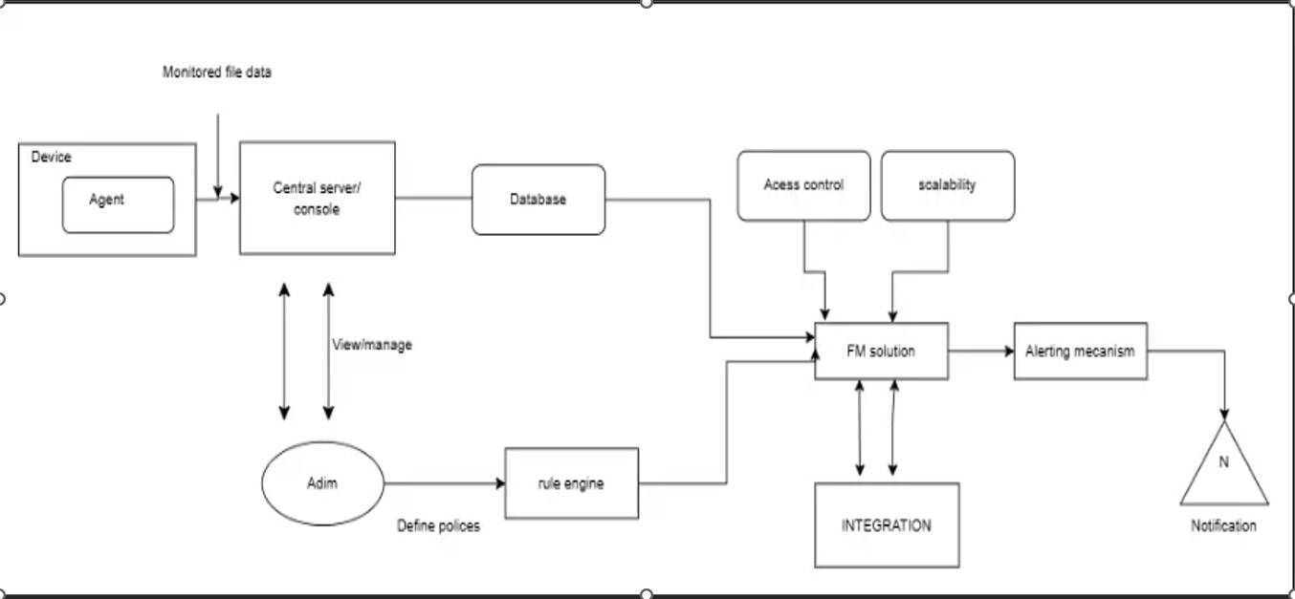
Fig. 1. Methodology Flowchart - system design

D. Algorithm and Code
The system is implemented using Python due to its simplicity and strong support for file handling as well as cryptographic operations. The code is written in a modular and well-structured manner, making each component easy to understand and manage. This approach improves the efficiency of monitoring files by generating and comparing their hash values.
The implementation is carried out in Visual Studio Code using Python. The hashlib library is used to compute cryptographic hash values such as SHA-256. The system follows a step-by-step procedure to detect any unauthorized changes in files.
1) Algorithm: The working of the File Integrity Monitoring System can be summarized as follows:
1) Select the directory or files to be monitored. 2) Generate hash values (baseline) for each file using SHA256.
3) Store the generated hash values securely. 4) Periodically scan the selected files.
- Recompute the hash values for each file.
- Compare the new hash values with the stored baseline values.
- If a mismatch is detected, flag the file as modified.
- Detect newly added or deleted files.
- Display or log alerts for any detected changes.
2) Code Implementation: The following Python code demonstrates the basic implementation of file integrity monitoring using the hashlib library:
import hashlib import os
# Function to calculate hash of a file def calculate_hash(file_path): hasher = hashlib.sha256() try:
with open(file_path, ’rb’) as file:
while chunk := file.read(4096):
hasher.update(chunk)
return hasher.hexdigest()
except:
return None
# Function to create baseline def create_baseline(directory): baseline = {} for root, dirs, files in os.walk (directory):
for file in files:
path = os.path.join(root, file) file_hash = calculate_hash(path) if file_hash:
baseline[path] = file_hash
return baseline
# Function to monitor changes def monitor_files(directory, baseline): current_state = create_baseline
(directory)
\begin{figure}
\centering
\includegraphics[width=0.5\linewidth]
{Screenshot 2026-04-17 011952.png}
\caption{Enter Caption}
\label{fig:placeholder}
\end{figure} for file, hash_value in current_state.items():
if file not in baseline:
print(f"[NEW FILE] {file}")
elif baseline[file] != hash_value:
print(f"[MODIFIED] {file}")
for file in baseline:
if file not in current_state: print(f"[DELETED] {file}")
# Main execution directory = "test_files" baseline = create_baseline(directory)
print("Monitoring started...\n") monitor_files(directory, baseline)The above code calculates hash values for files, stores them as a baseline, and compares them with newly generated hash values to detect any modifications, deletions, or additions. This implementation provides a simple yet effective approach for file integrity monitoring. article graphicx
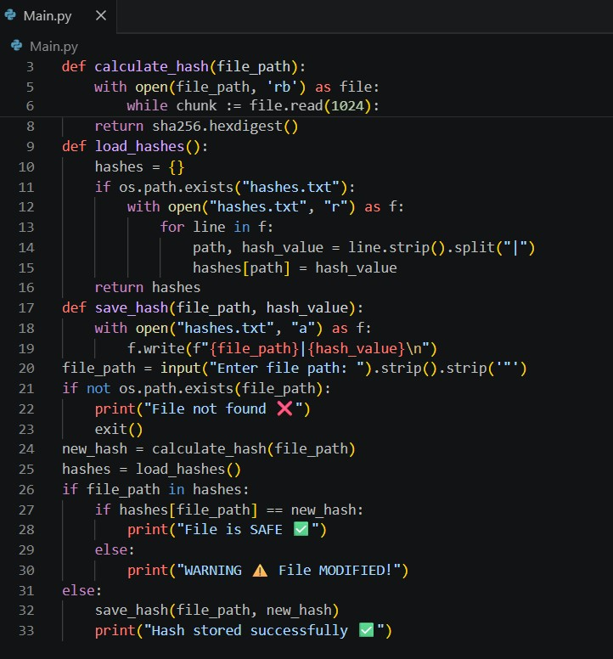
IV. RESULT

Following completion of the implementation, the system accurately identifies any modifications of interest via terminal output relating to files being monitored.

numerous practical test cases were conducted to evaluate the effectiveness of the system, including creation, modification, and deletion of files. The goal was to demonstrate whether or not the particular type of change can be accurately identified by the system. The results indicate that the output from the testing was generally reliable in that all file modifications were identified and the system did not issue a false report for unchanged files.

Another interesting finding related to speed; the hash comparison operations performed sufficiently quickly to allow for near real-time monitoring ability; this characteristic is fundamental for many types of security applications. In summary, the results of this analysis demonstrate that the system is capable of providing continued integrity of the monitored files by being both accurate and efficient. The results are summarized in Table I

TEST CASE RESULTS
Test Case | Expected Outcome | Actual Outcome | Status
File unchanged | No alert | No alert | Pass
File modified | Alert generated | Alert generated | Pass
New file added | Detected | Detected | Pass

V. CONCLUSION AND FUTURE WORK

The File Integrity Monitoring System created in this project illustrates how just a straightforward concept, when properly applied can provide great assistance in data protection. File integrity is extremely critical within today's digital world, where files are changing every day (creating, sharing and changing). The proposed system provides file integrity monitoring through the implementation of various cryptographic hashing techniques which allow files to be monitored for and to detect changes that were done without authorization. During the implementation and testing phases, it was found that even small file modification(s) create a completely new hash value; therefore, this increases the accuracy of the file change detection process to be very high. File creation, modification and deletion scenarios were successfully identified by the system with no unnecessary alerts being generated; this is very important for establishing and keeping user confidence in using the system. The system was also shown to work efficiently and in a lightweight fashion in that it requires minimal CPU resources. The simplicity of the design using the Python programming language enables the system to be easily understood, maintained and expanded upon.
The system is limited in certain aspects; one such limitation is the system's inability to detect/prevent changes to files. It will only notify users AFTER a change has taken place. This provides the user with a monitoring and alerting tool, but not as a complete security solution. However, due to the nature of the reporting mechanism; when used in a timely manner, there is great potential to utilize the system to dramatically increase an organization's overall security posture through timely response and investigation.
In looking to the future of making the system more capable, there are a number of ways to enhance the functionality of the overall system. One possible enhancement would be to move away from periodic scans and toward real-time monitoring, made possible through immediate detection of any changes to files. Another enhancement would be to develop and implement advanced alerting mechanisms (e.g., email and/or mobile notifications) to improve user awareness of this functionality. In addition, application of machine learning techniques could result in detection of abnormal file activity patterns, leading to an improved ability to identify more sophisticated/complex threats. Additionally, implementing blockchain technology for hash record storage would provide an additional means for securing logs (i.e., tamper-proof). For larger/enterprise-scale applications, improving the system’s scalability could be accomplished via integration with existing databases to provide a more efficient means of managing large quantities of files. Finally, the development of a graphical user interface could improve overall user experience and allow for easier use by non-technical users.
As a result, the file integrity monitoring system that was proposed earlier is an excellent foundation for the capability to monitor individual file integrity. When combined with the aforementioned recommended enhancements at a future date, it could develop into an even more robust and reliable security option that meets the requirements of real world applications.

REFERENCES
- A. Patel and M. Singh, “File Integrity Monitoring Techniques in Cybersecurity Systems,” International Journal of Information Security Studies, 2023.
- K. Zhou et al., “Real-Time Data Integrity Verification Using Cryptographic Hashing,” IEEE Transactions on Information Forensics and Security, 2024.
- C. Paar and J. Pelzl, Understanding Cryptography: A Textbook for Students and Practitioners. Springer, 2010.

- IJSRED Paper, Available: https://www.ijsred.com/volume8/issue2/IJSRED-
V8I2P266.pdf
- Document,Available: https://www.scribd.com/document/931080181/R204516T-
- A. J. Menezes, P. van Oorschot, and S. Vanstone, Handbook of Applied Cryptography. CRC Press, 1996.
- A. S. Tanenbaum and H. Bos, Modern Operating Systems. Pearson, 2015.
- National Institute of Standards and Technology (NIST), Secure Hash Standard (SHS), FIPS PUB 180-4, 2015.
- S. Kumar and R. Sharma, “A Study on SHA-256 Based Data Integrity Verification Techniques,” IEEE Access, 2024.
- P. Garvin, “File Integrity Monitoring in Cyber Security Systems Using
Hash Functions,” International Journal of Computer Applications, 2023.
- National Institute of Standards and Technology (NIST), “Cryptographic
Hash Algorithm Standards and Applications in Security Systems,” 2024.
- W. Stallings, Cryptography and Network Security: Principles and Practice. Pearson, 2017.
- A. J. Menezes et al., Guide to Elliptic Curve Cryptography. Springer, 2004.

