LAB 12 — Generation Data Groups (GDG)
Part 1 — Evidence
Original-quality screenshots for JCL_LABS portfolio evidence
This evidence document contains the original screenshots available from the validated Lab 12 workflow. The images are inserted without enlargement, redrawing, or AI reconstruction so the terminal text remains legible.
Evidence 01
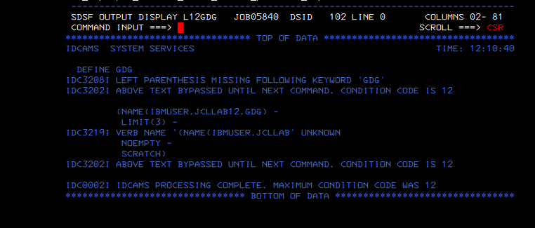
Initial IDCAMS DEFINE GDG syntax failure (CC 12).
Evidence 02
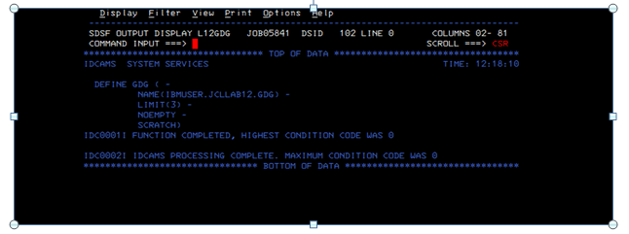
Corrected DEFINE GDG execution. IDCAMS completes with maximum condition code 0.
Evidence 03
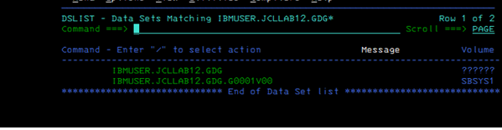
ISPF 3.4 evidence showing the GDG base and the first generation G0001V00.
Evidence 04
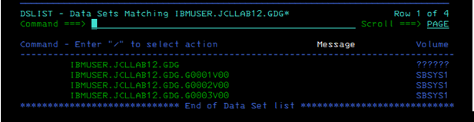
ISPF 3.4 evidence showing the GDG base plus G0001V00, G0002V00 and G0003V00 at LIMIT(3).

Validated scope
- Initial IDCAMS DEFINE GDG syntax error retained as troubleshooting evidence.
- Corrected GDG base definition completed with MAXCC 0.
- GDG base and first Generation Data Set verified in ISPF 3.4.
- GDG base plus G0001V00, G0002V00, and G0003V00 verified at LIMIT(3).

