D IPLINFO
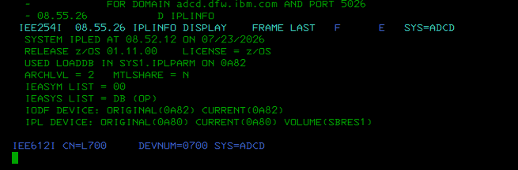
D SYMBOLS
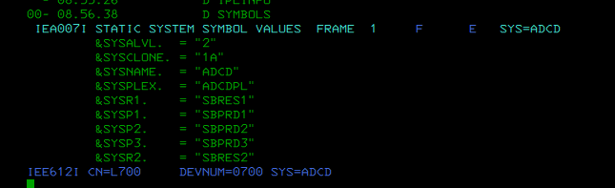
D IOS,CONFIG
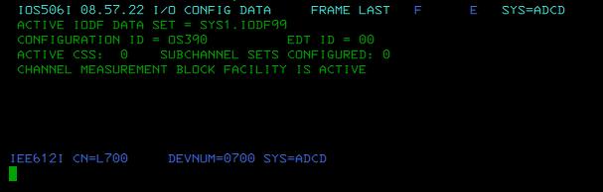
D U,DASD,OFFLINE
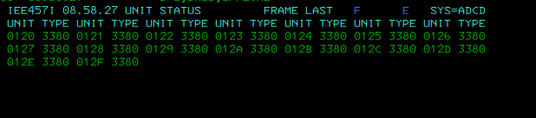
D U,,,0A80,16
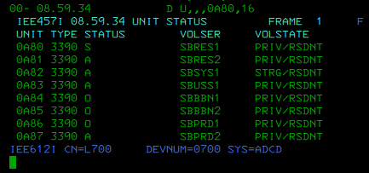
D U,,,0A82,16
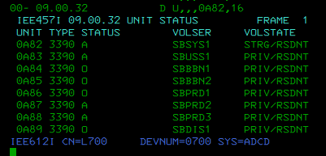
D M=DEV(0A80)
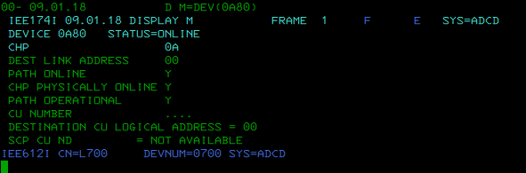
D M=DEV(0A82)
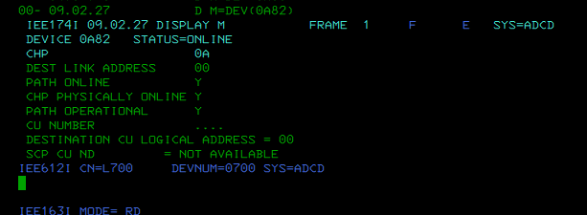
D PROG,LPA
