Lab 29 — SMP/E CSI Query and SYSMOD Inventory
Closure report — z/OS ADCD / Hercules
CSI: MVS.GLOBAL.CSI | Target zone: MVST | FMID: HBB7760

Objective
Interrogate the SMP/E CSI, select target zone MVST, locate HBB7760 and obtain its associated SYSMOD inventory while preserving the troubleshooting path required to execute the generated batch job.

Successful control statements
SET BOUNDARY(MVST).
LIST FUNCTIONS FORFMID(HBB7760) SYSMODS.

Result
SMPLIST identifies HBB7760 as a FUNCTION with description BCP Base. The evidence also shows JCLIN=YES and DELMID=YES and then enumerates the associated maintenance/SYSMOD relationships.

Troubleshooting
Initial generated jobs produced JCL diagnostics (IEFC621I / IEFC605I). The generated batch JCL and available SMP/E load-library path were inspected. The corrected execution used SYS1.MIGLIB for the SMP/E step and produced valid output.

Evidence policy
The complete 66-page evidence document is retained. 6 additional SMP/E screenshots from the same sequence, not visually identical to images embedded in that Word file, were also added to the evidence directory.

Key evidence
extra-774b25fd-dc40-4e98-beda-38ae08a92037.PNG
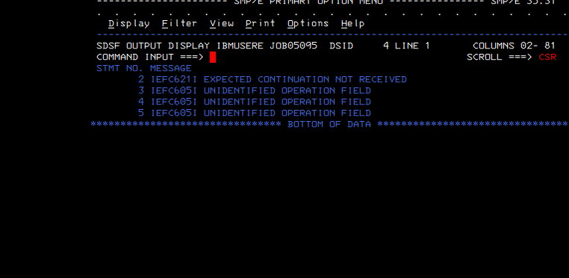
extra-8e73adaf-c432-4db7-96a8-7c4cf5f40f70.PNG
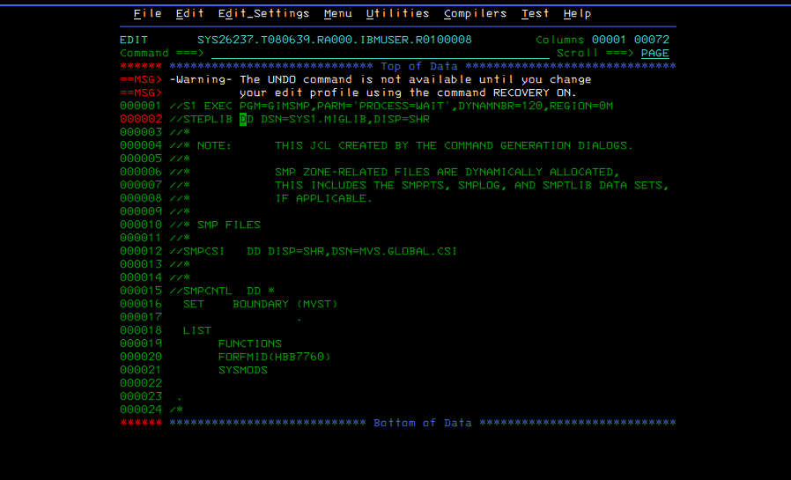
extra-75468c49-f437-4468-ab82-28be3da46ae5.PNG
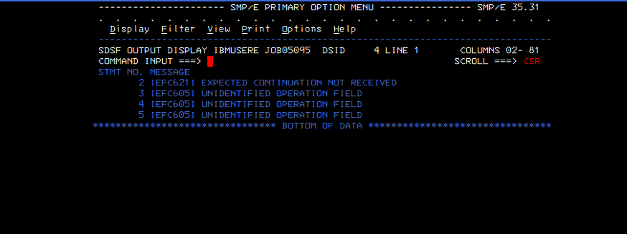
extra-56f88d3a-1fd8-4409-b17f-c702417b4935.PNG
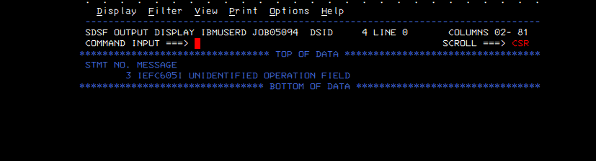
extra-3766846c-1661-4abd-9871-d8a1f37a775c.PNG
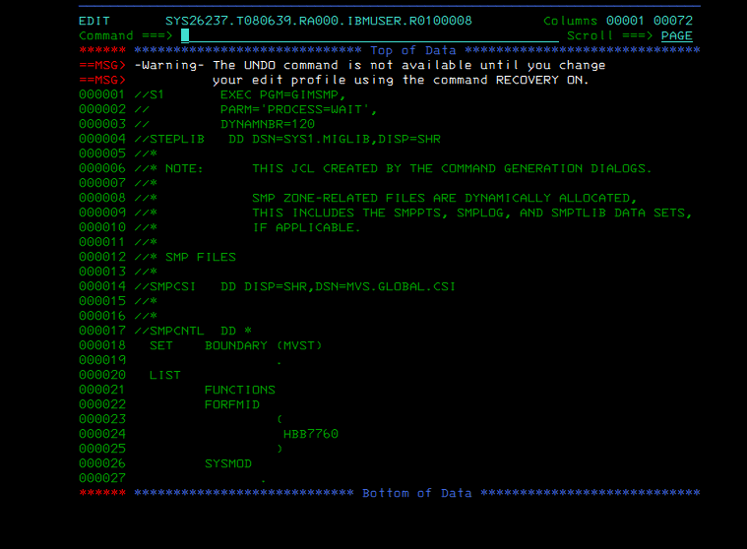
extra-719f00cb-763b-479c-b6ec-d7bea441eadf.PNG
