03 – Management System for Non-Profit
CS 4850, 04 & 01, Fall 2025, August 31, Sharon Perry

Project Team
Roles | Name | Role | Contact (Cell Phone)
Project owner | Georgia Laws of Life Essay | Sponsor of the project
Team leader | Evan Conley | Team Leader; Ensure deadlines are met and project is completed to standard | 404.977.0180
Team  Members | Ella Goode | Product/Documentation | 678.637.7634
Team  Members | Tyler Stroud | Programming/Testing | 770.880.7389
Team  Members | Fatih Kurt | Documentation/Programming | 770.814.1049
Advisor / Instructor | Sharon Perry | Facilitate project progress; advise on project planning and management. | 770-329-3895

  Evan Conley  Team Leader | Tyler Stroud  Programmer / Tester |   Ella Goode  Product/Documentation |   Fatih Kurt  Documentation/Programmer

Overview
Background
Georgia Laws of Life Essay Contest is a 25-year-old 501(c)(3) nonprofit that facilitates a statewide character education program in partnership with high schools and Rotary clubs. The program engages students through an annual essay contest, having collected over 800,000 essays to date. However, the organization currently manages its operations using disconnected spreadsheets, making it difficult to track student participants, school contacts, Rotary partners, donors, and overlapping events. They are uncertain whether a CRM, donor management, or project management tool best suits their needs. This project will evaluate available free/freemium tools, propose a suitable solution, and deliver a proof-of-concept system tailored to their operations.

Objectives
The primary objective of this project is to analyze the nonprofit’s operational workflows and stakeholder relationships and to identify, evaluate, and prototype a suitable centralized management solution. This will be achieved by assessing freemium Software-as-a-Service (Saas) platforms such as Zoho CRM, HubSpot CRM, Airtable, and Trello. These platforms will be utilized for CRM, donor management, and project/event management functionality. The project will deliver a proof-of-concept system configured to demonstrate centralized tracking of students, schools, Rotary clubs, and donors along with management of entity relationships and communications and coordination of event workflows. These functionalities will be integrated with the organization’s existing Google Workspace environment.

Scope
The project scope includes requirements analysis and entity mapping, comparative evaluation of SaaS platforms, and the development of a proof-of-concept utilizing a selected tool. The implementation will demonstrate core functionalities, including data import/export via the Google Sheets API and event tracking. Final deliverables will include a platform evaluation matrix, a configured proof-of-concept, and a complete implementation roadmap. The project explicitly excludes any custom software development or the use of paid software licenses. With that in mind, the focus will solely be on the evaluation and configuration of existing freemium SaaS solutions.

Deliverables

Expected Deliverables:
- Requirements and stakeholder/entity mapping document
- Platform evaluation matrix
- Proposed solution and configuration rationale
- Working proof-of-concept demonstrating student tracking, related entities (school, Rotary, lifecycle), and event workflows
- Implementation roadmap
- Cost breakdown and upgrade options
- User guide and documentation

Group Meeting Schedule Date/Time
The group will meet with the sponsor, Georgia Laws of Life Essay, on a biweekly basis on Wednesdays at 9am EST. The first meeting date will be on August 27th on Microsoft teams. Every meeting will take place with Microsoft Teams following the first meeting and will be done to ensure that accurate information and updates are given to the sponsors on how development is coming on the project.
Outside of meeting with the sponsor the group will also plan to meet with each other on the weeks that the meetings with the sponsors are not taking place through Discord. This is to ensure that everyone is staying on task and is able to complete their part of the project on time and to facilitate any group discussions that may arise during the time of working on the project.

Collaboration and Communication Plan
The plan to communicate as a team is to use GroupMe for reminders and things that do not require a physical meeting but require that the whole group is aware of important information. When it comes to meeting as a group, the group will use Discord to meet when it comes to collaboration that requires face-to-face meetings. This gives us more flexibility when it comes to scheduling and gives us a chance to meet and talk through things that otherwise would not be possible without Teams.
For communication from person to person we plan to use phone numbers as a way to send messages to each other if an individual question arises that does not require the whole group to be notified. If phone numbers are not available, the backup plan is to direct messages from GroupMe. In the case that a group member has something happen where they cannot use their number for text purposes, the ability to use GroupMe on mobile or desktop will provide us a failsafe to contact someone directly.

Project Schedule and Task Planning
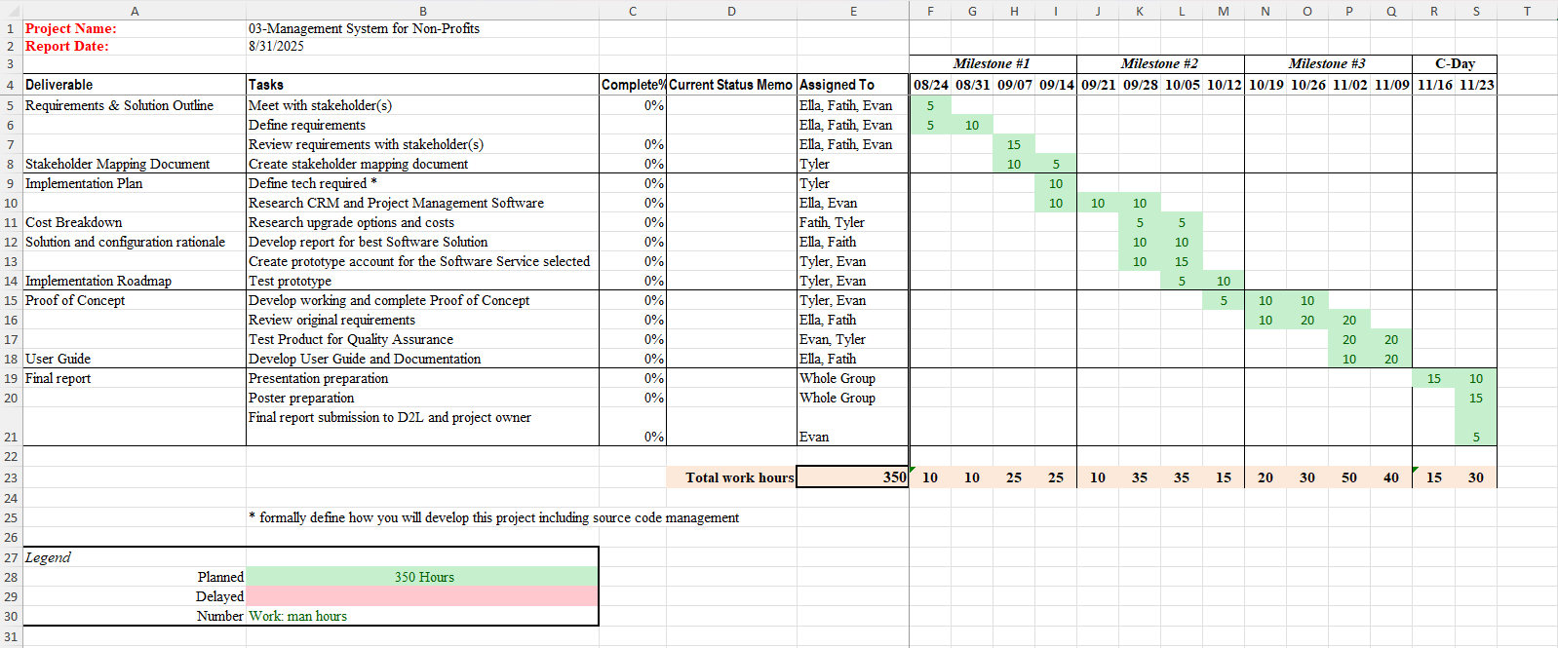

Risk Assessment
With budget concerns being an issue for Georgia Laws of Life Essay, the biggest risk that is associated with this project is unknown and unaware cost of the software. Because of the nature of Software as a Service, some products do carry hidden cost or pricing models that do not always give a clear idea of the total cost of ownership that comes with using the product.
To combat this issue certain practices will be implemented to ensure that cost overrun does not occur. First, when looking at the Software as a Service models, not only will the cost of the model be taking into account and how they are charging, but also looking at terms and conditions that these companies are required to provide, to get a better understanding of how pricing will work. Second, working with the non-profit, we will get a better understanding of their plans and growth. If they are looking to expand and get more employees in the next years, growth and scaling will also be used to determine the best option. Many Software as a Service accounts restrict the number of users for lower cost tiers, so growth of the non-profit will be taken into consideration.

Version Control Plan
The plan for version control is to establish a team Github page. After each iteration of the product that satisfies the group, we will save this version of the code into Github. This system will allow us to continuously develop the software, but if we reach a point in trying to upgrade the software where we are not successful and need to retreat to a previous version, we will have Github to wipe the unsuccessful software and revert back to the saved code, allowing us to have checkpoint instead of needing to restart the whole project. Github will also allow us checkpoints in the case that something happens when developing code, we have a saved version that we can access.
Every new version of the code will be saved separately and not overwritten when being saved in Github. Once the final version is developed, tested, and approved we will then archieve the code in Github so that the only version that is present is the final version, but still having access to the other version.

