**Mobile Networking Experiment 1**

Harry Deffebach, Sai Kukkadam, Robert Obendorf, Kerollin Francois

All code used for this assignment can be viewed at https://github.com/P0rth0s/Mobile_Networking_Experiments.

**Part 1**

NOTE: Y axis is number of events in interval. X axis in minutes elapsed in day according to EDT timezone (both provided traces take place in april). This graph shows events with a 15 minute interval time.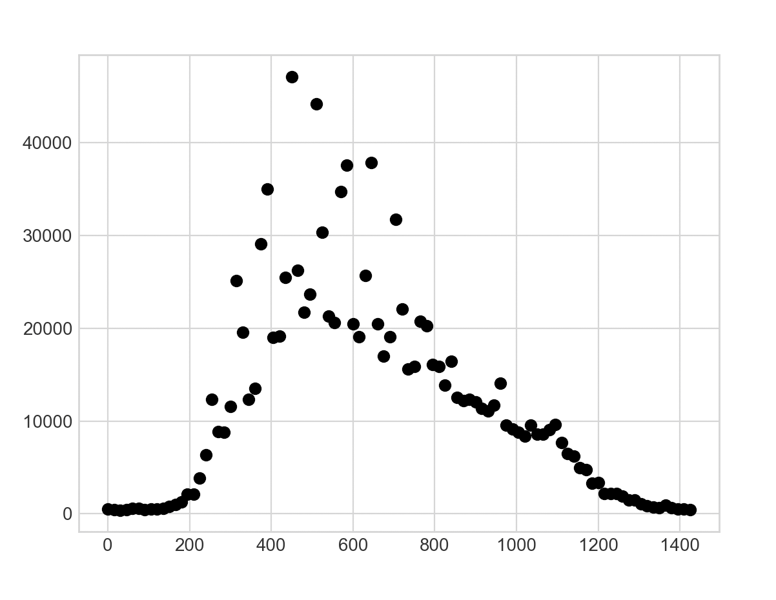

1A) The number of total records in the trace is 1150942, with 34978 unique users. The number of unique users was calculated by the number of unique Mac addresses included in the trace.

1B) Around the 480 minutes in day elapsed mark is the most busy, this translates to 8 AM. This makes sense because this is around the time people are usually coming to campus to begin work for the day. During this time they would make their initial connection to the access point.

1C) The least active times are before 200 minutes and after 1200 minutes elapsed is the least busy part of the day. These times translate to before 3:20 AM and after 8 PM.

1D) On the 15 minute interval graph yet is difficult to see the correlation between number of events and class times. If you look closely you will notice that every several intervals there is a sudden increase for one interval during which the class change is happening. If you view the other interval charts such as the 1 minute interval this trend becomes much more apparent. The 1 minute interval clearly shows spikes and depressions in the number of events which occur roughly whenever periods change.

2)

1 Minute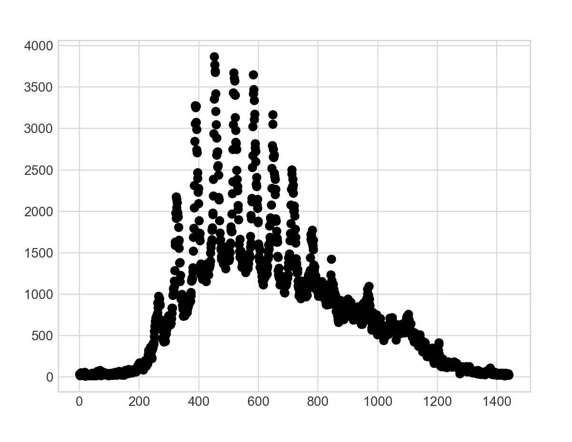

5 Minute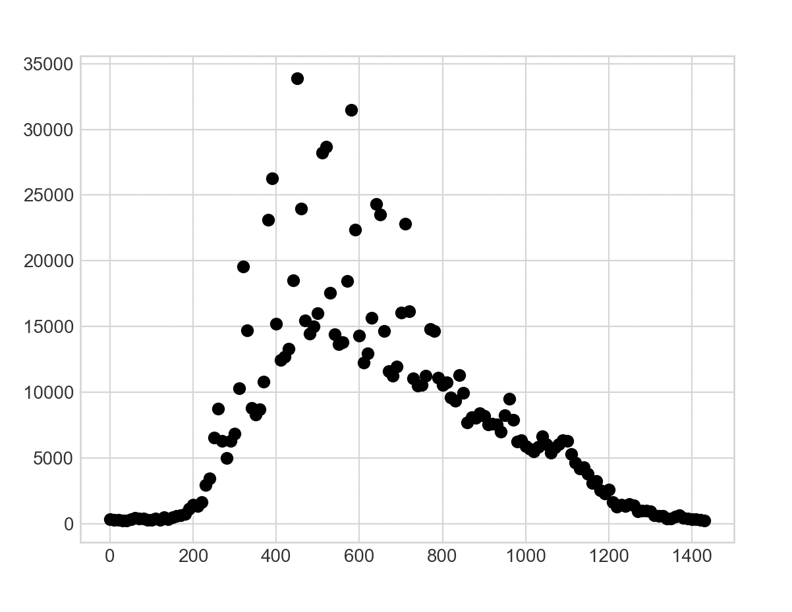

10 Min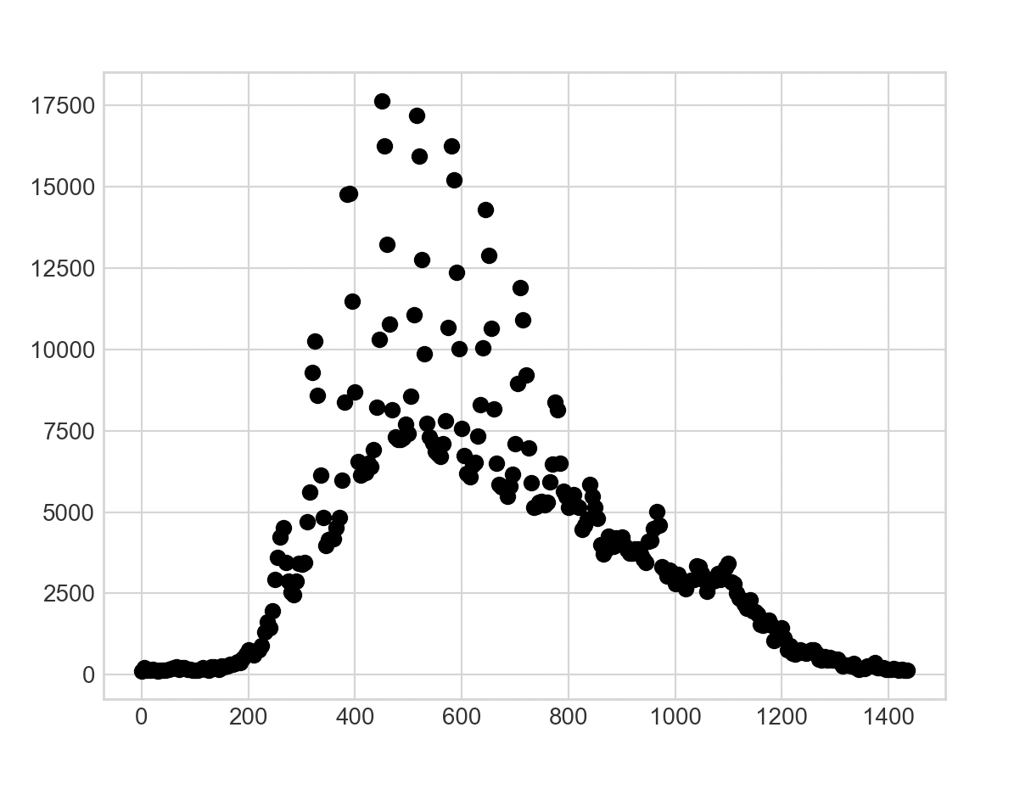ute

30 Minute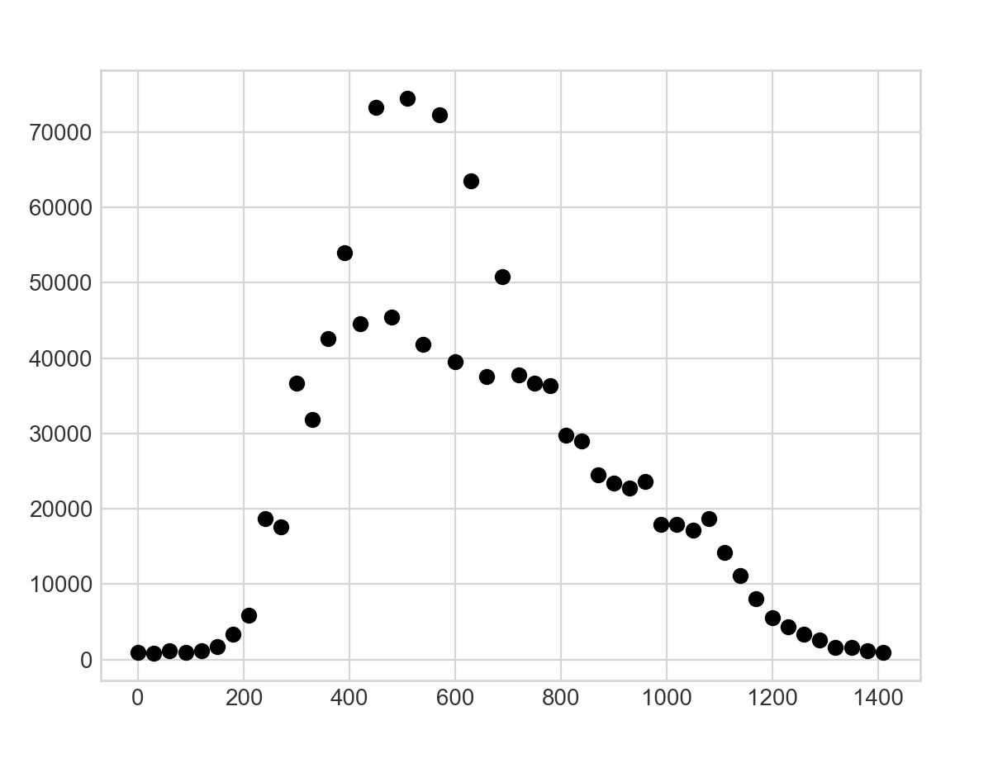

60 Minute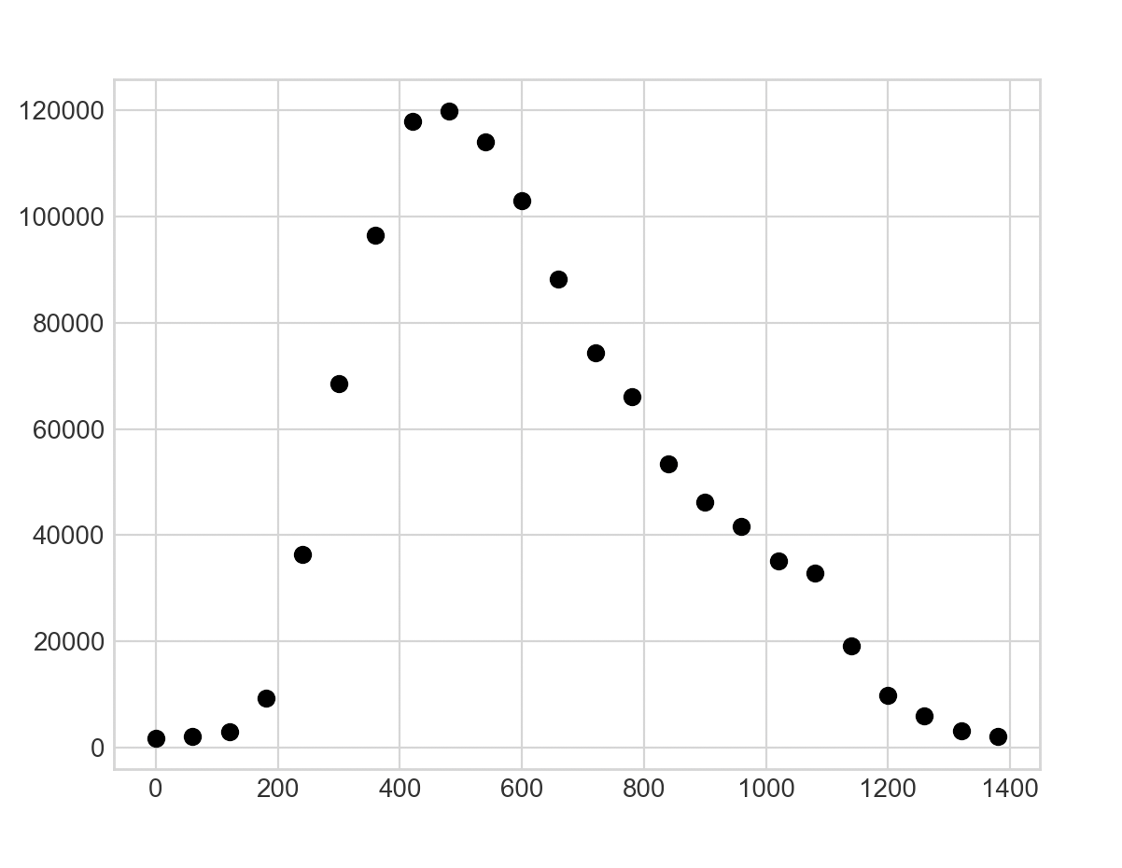

**Part 2**

1A)

1B)

1C)

1D)

2)

**Part 3**

**Part 4**