Namp -sV -O 192.168.229.0/24

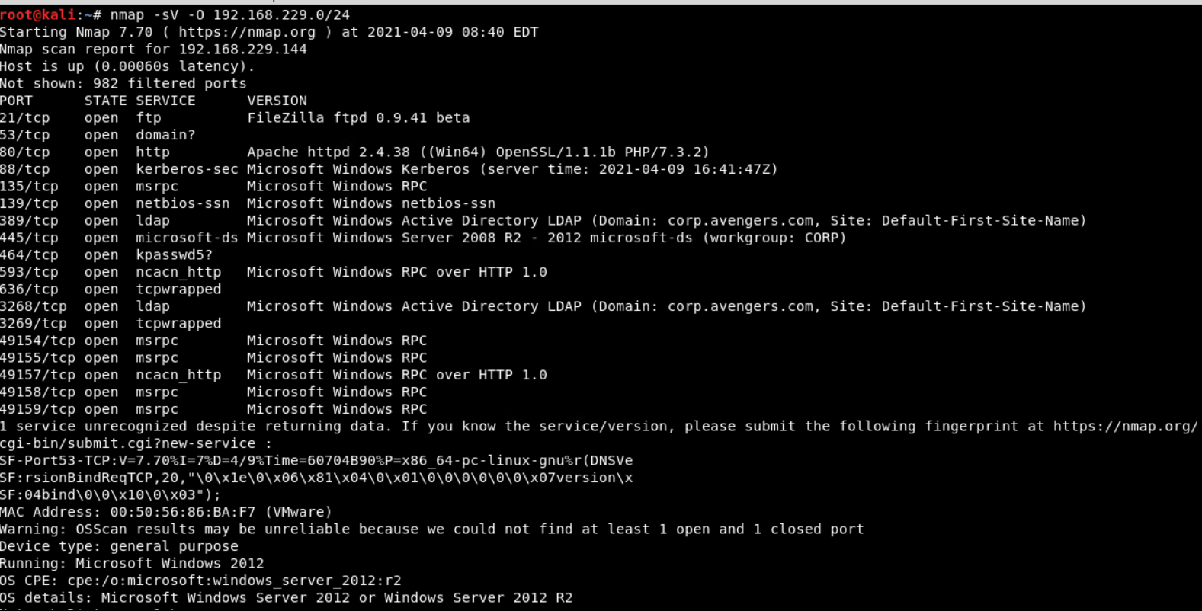

Filezilla ftpd 0.9.41 beta -suffers from heartblead



HTTP Apache httpd 2.138 ((Win64) OpenSSL/1.1.1b PHP/7.3.2)

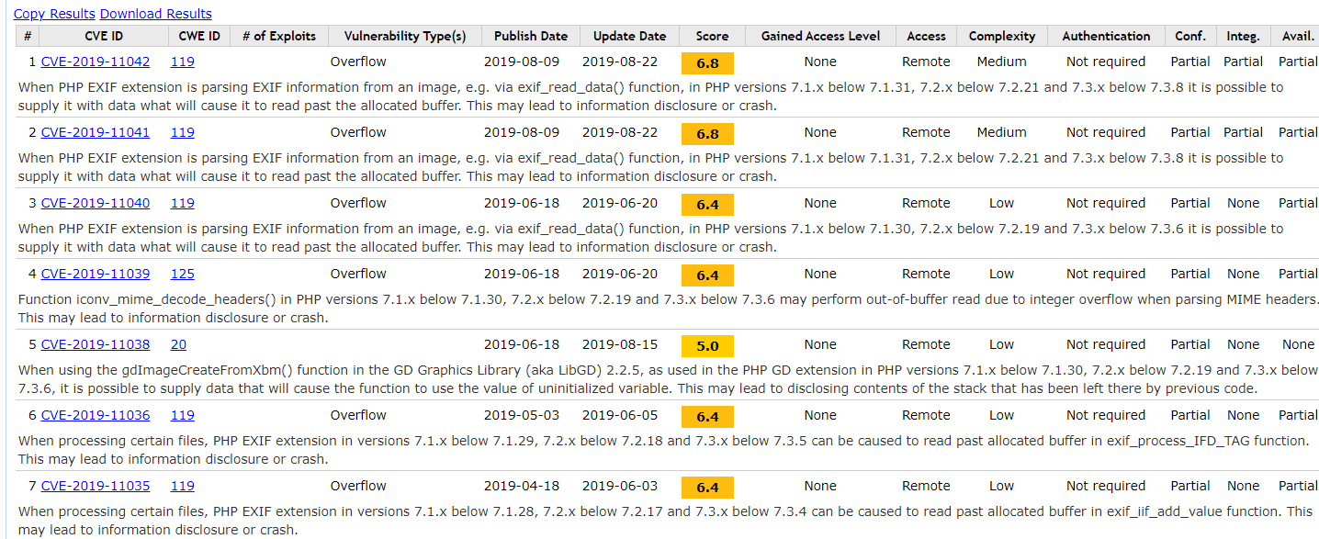

I was able to ftp without a password

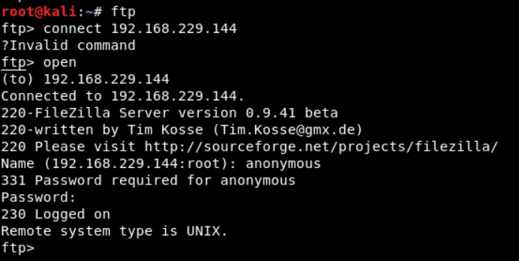

Was able to log in and find and download a text document “news_report.txt” It hinted to use Metasploit with the wanna cry exploit.

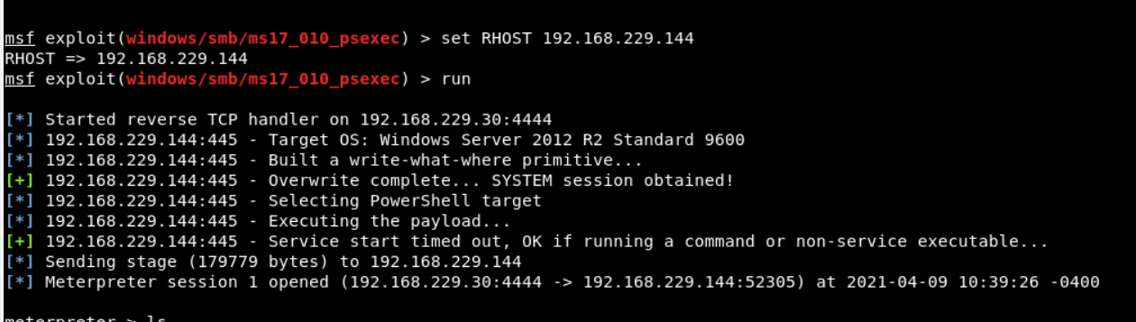

I was able to download and read the document located at C:\Users\administrator\Desktop\knowledge_test.txt

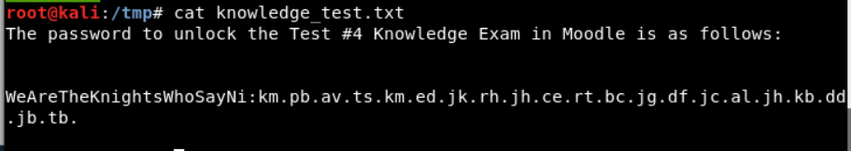

Ran nmap -sv –script=ssl-heartbleed 192.168.229.144 to check to make sure the machine was vulnerable to heart bleed.