I ran Namp -sV -O 192.168.229.0/24 and found the following services running:

21/tcp open ftp FileZilla ftpd 0.9.41 beta

53/tcp open domain?

80/tcp open HTTP Apache httpd 2.138 ((Win64) OpenSSL/1.1.1b PHP/7.3.2)

Those are the ones I found most interesting. The rest are attached in the appendix with my op note. When researching the interesting ports, I found that Filezilla ftpd 0.9.41 beta was vulnerable to Heartbleed.

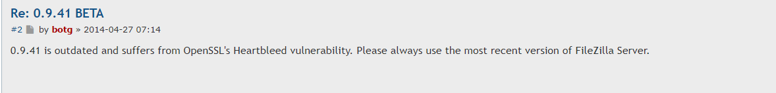

Apache httpd 2.4.38 looks to be vulnerable to a buffer overflow

