After logging in via ftp with anonymous user

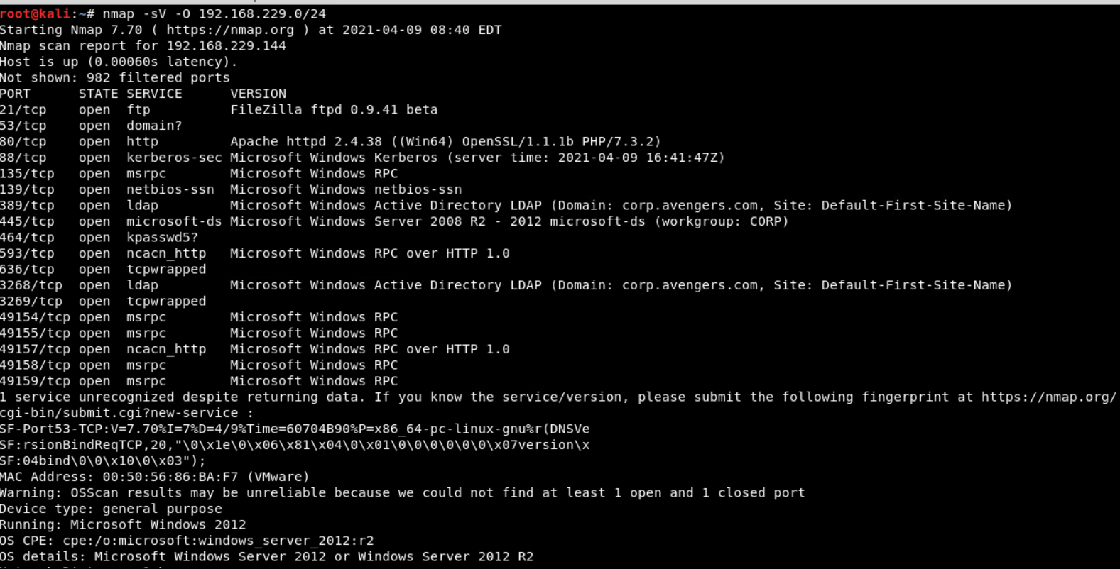

Was able to log in and find and download a text document “news_report.txt” It hinted to use Metasploit with the “wanna cry” exploit.

