static对象需在类外初始化

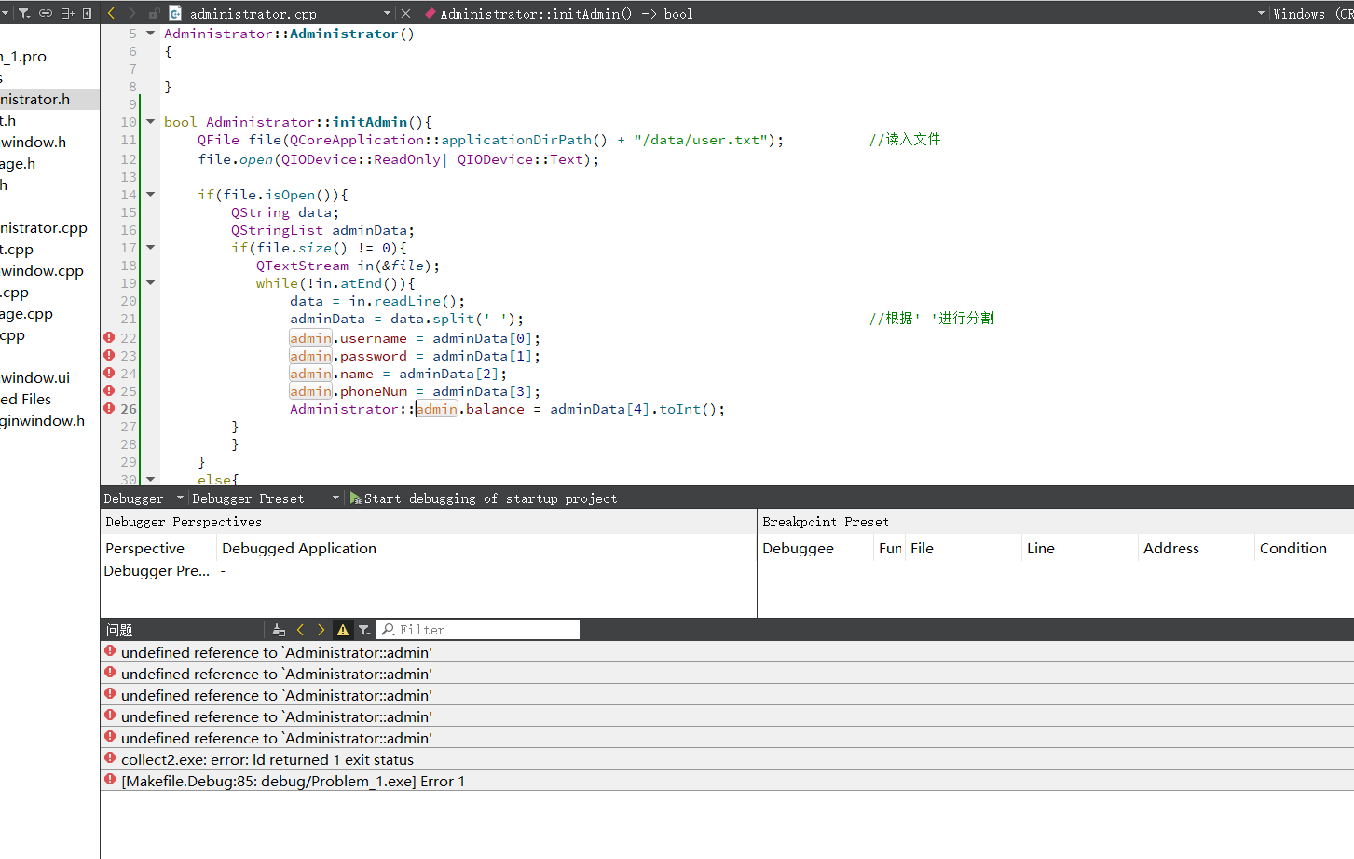

循环include问题

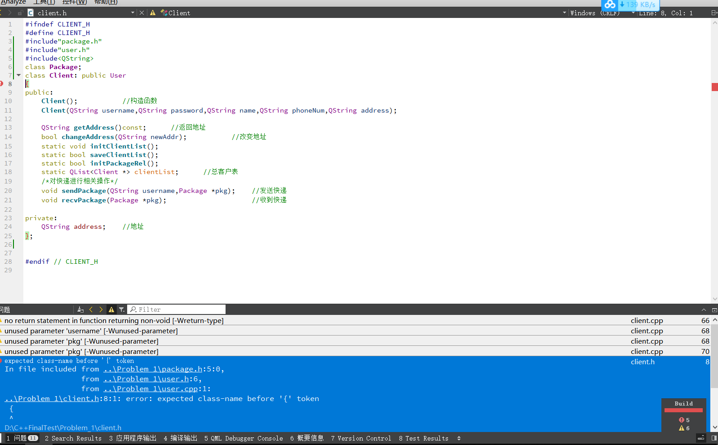

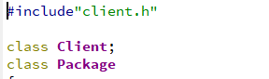

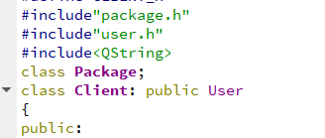

https://stackoverflow.com/questions/31953336/c-error-expected-class-name-before-token