

Cloud Manufacturing and Social Software Based Context Sensitive Product Service Engineering Environment for Globally Distributed Enterprise

Grant agreement no: 636692

FoF-05-2014: Innovative Product-Service design using manufacturing intelligence

V1.04 - User Manual

|  |  |
| --- | --- |
| Work package: WPX | Lead beneficiary: Short Name |
| Type: Other | Dissemination level: Public/Confidential |
| Due date: Mx | Submission date: dd MMM YYYY |

Index

1 Diversity Home Page 3

2 Opinion Extraction Page 4

3 Global Sentiment Page 7

4 Influence and Reach Page 8

5 Opinion Simulator 10

5.1 Sentiment Tab 10

5.2 Stakeholders Tab 12

6 Glossary 13

# Diversity Home Page

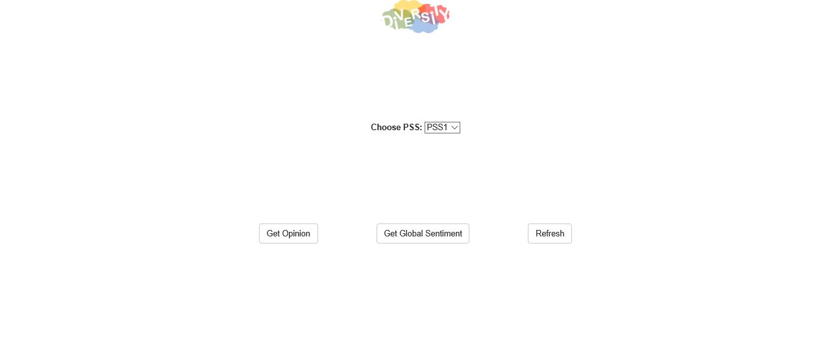

1. Diversity Home Page Screenshot

**Description:**

This is the initial page which is presented to the user upon startup. In this page, the user can choose a PSS/Product and visualize the global sentiment or opinion extraction pages for that specific PSS/Product and refresh the database if necessary.

**Procedures:**

1. To select PSS/Product, choose desired value from dropdown list.

2. After selecting the desired PSS/Product, click one of the following buttons for the desired effect:

2a. "Get Opinion" Button - redirects to Opinion Extraction page (B) according to selected PSS/Product

2b. "Get Global" Button - redirects to Global Sentiment page (C) according to selected PSS/Product

2c. “Refresh Button” - sends request to refresh data from database.

# Opinion Extraction Page

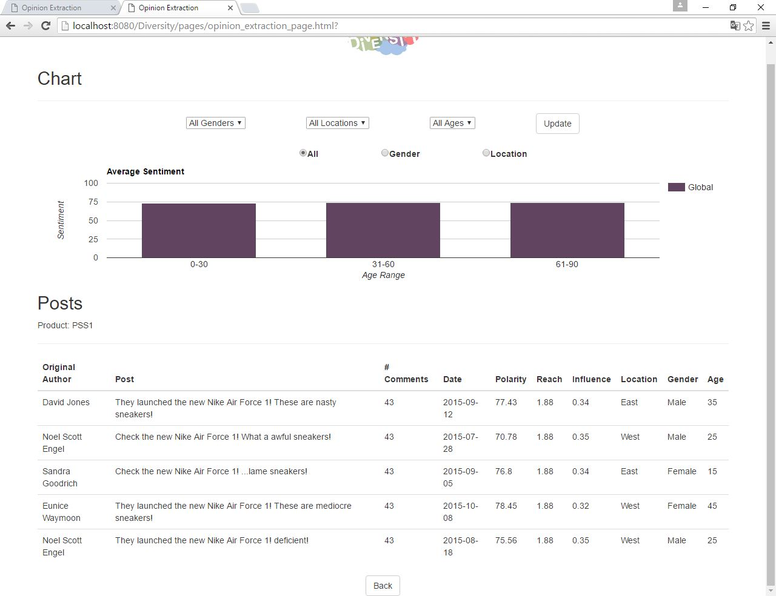

2. Opinion Extraction Page Screenshot

**Description:**

After clicking the “Get Opinion” button, the user is redirected to this page which displays the average sentiment from users according to age range in form of a column chart and a table containing the top 5 posts with the highest influence. The user is able to filter the columns/rows presented on the column chart according to a certain parameter (gender, location or age range) by changing one of the presented dropdowns or segment the presented data according to one of those parameters. When the user filters the data from the table, the post table is also updated accordingly. The associated product is shown under the “Posts” title.

**Procedures:**

1. When this page is opened, the user is presented with the global sentiment column chart and a table containing the top 5 posts with highest influence value.

2. To segment the data according to the desired parameter, choose one of the following radio buttons:

2a. "All" Button - displays global sentiment only.

2b. "Gender" Button - displays average sentiment according to gender.

2c. "Location" Button - displays average sentiment according to location.

3. To filter chart columns according desired parameter, the user should change the value from one of the following dropdowns:

3a. "Choose Gender" Dropdown

3a1. "All Genders" Value - displays average sentiment columns for all genders. This value is selected by default.

3a2. "Male" Value - displays average sentiment column for "Male" gender.

3a3. "Female" Value - displays average sentiment column for "Female" gender.

3b. "Choose location" Dropdown

3b1. "All Locations" Value - displays average sentiment columns for all locations. This value is selected by default.

3b2. "East" Value - displays average sentiment column for "East" location.

3b3. "West" Value - displays average sentiment column for "West" location.

After choosing the desired values from the dropdown lists, the user should click the “Update” button to update the chart accordingly. The post table is also updated according to the selected values (ex. if “Male” and “East” are chosen, the top 5 posts from male users located in the east are displayed).

4. To filter the chart according to age range, the user should change the value from the following dropdown:

4a. "Choose Age Range" Dropdown

4a1. "All Ages" Value - displays all age range rows. This value is selected by default.

4a2. "0-30" Value - displays average sentiment row of users with ages between 0 and 30.

4a3. "31-60" Value - displays average sentiment row of users with ages between 31 and 60.

4a4. "61-90" Value - displays average sentiment row of users with ages between 61 and 90.

5. To return to the home page, the user should click the “Back” button.

# Global Sentiment Page

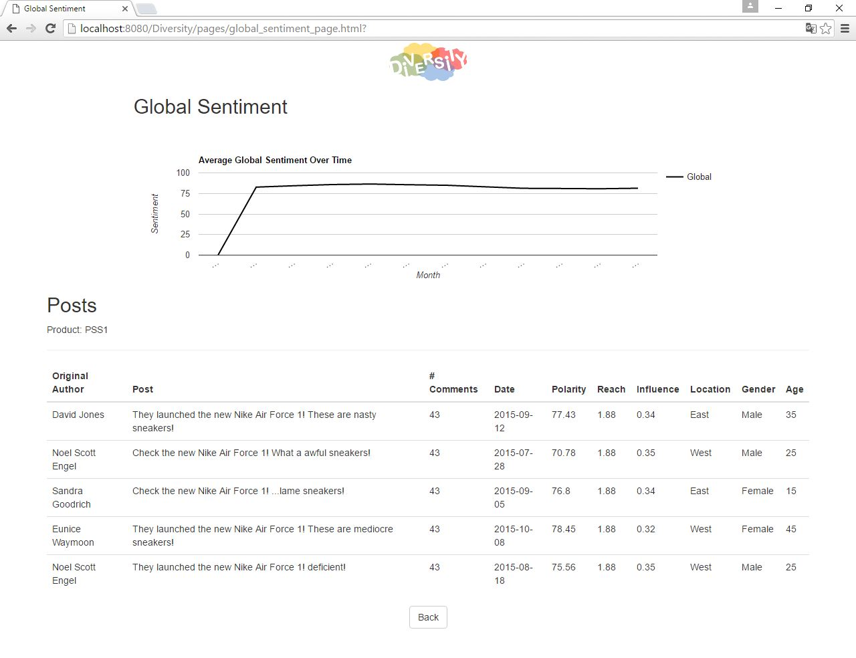

3. Global Sentiment Page Screenshot

**Description:**

After clicking the “Get Global” button, the user is directed to this page displays the global sentiment over time (measured by month) in form of a line chart. A table containing the top 5 posts with highest influence is also displayed. The associated product is shown under the “Posts” title.

**Procedures:**

1. When this page is opened, the user is presented with a line chart displaying the average global sentiment over time (by month) for a product. A table containing the top 5 posts with the highest influence is also displayed.

2. To return to the home page, the user should click the “Back” button.

# Influence and Reach Page

**To Be Updated**

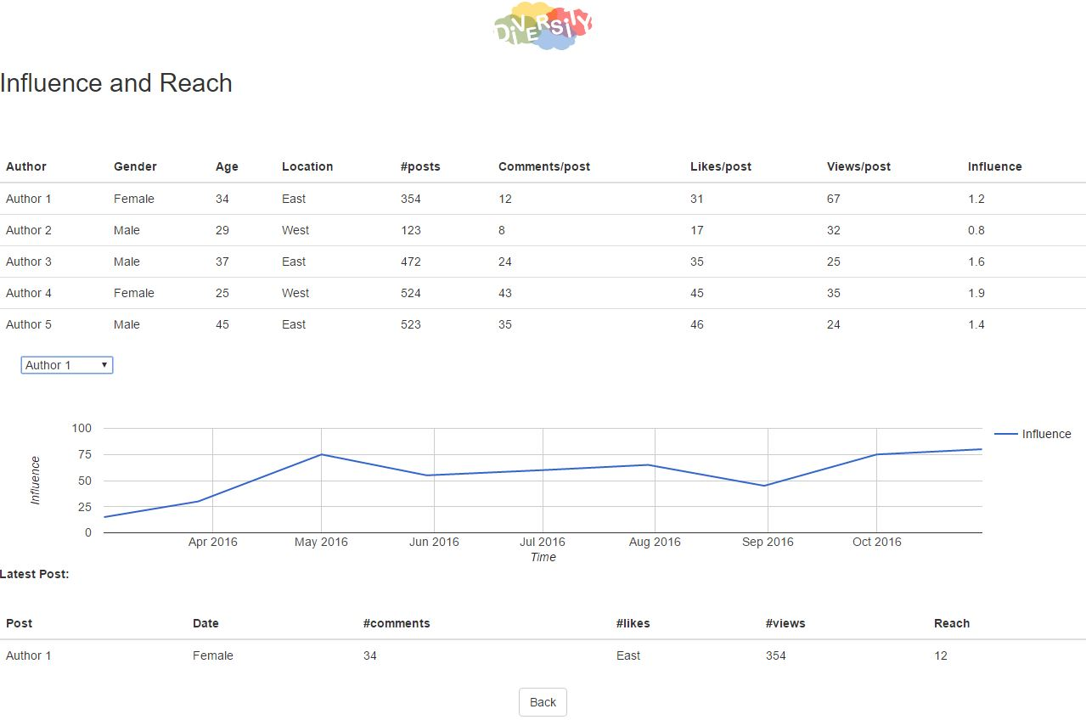

4. Influence and Reach Page Screenshot

**Description:**

This page displays a table containing the top 5 authors with the highest influence values. The user can visualize an author’s influence over time (by date) in form of a line chart by changing the value of the dropdown list containing the author’s names from the top 5 authors table. The latest post from that same author is also displayed on the table located below the chart.

**Procedures:**

1. When the user enters the page, he is presented with a table containing the top 5 authors with the highest influence and reach values.
2. In order to visualize an author’s influence over time, the user should change the value dropdown list containing the names of the authors presented on the previous table. Every time the dropdown value is changed, the influence line chart and latest post table are updated accordingly.
3. To return to the home page, the user should click the “Back” button.

# Opinion Simulator

Opinion Simulator is a Java based stand-alone application which is used to generate posts and authors. The sentiment of the posts and the influence of the authors can also be adjusted to the user’s liking.

## Sentiment Tab

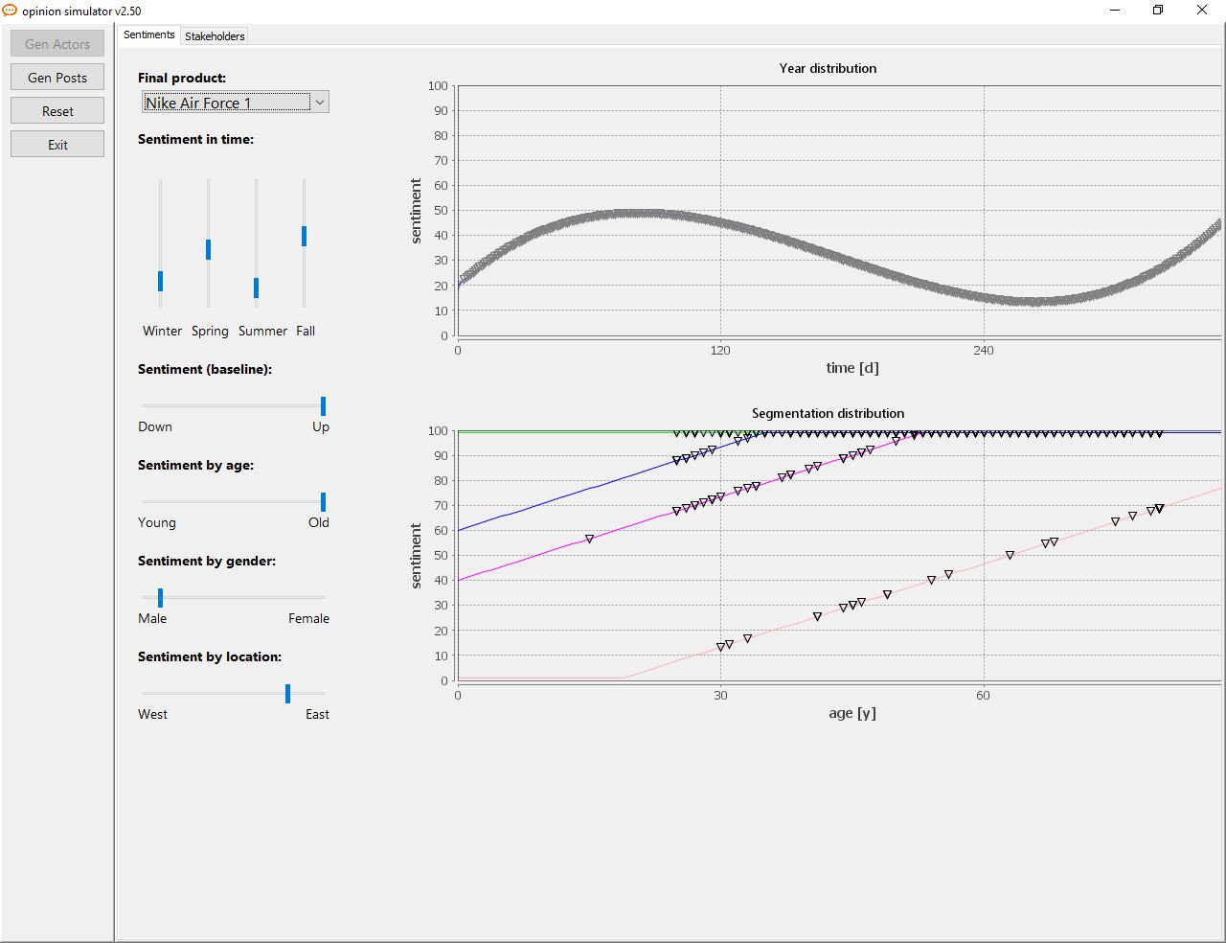

1. Opinion Simulator – Sentiments Tab Screenshot

**Description:**

When the user boots the application, this screen is presented by default. In the sentiment tab, the user can generate posts for a certain product. Each post will have a sentiment associated to it. The user can configure the sentiment distribution for the posts over time (by season), by age, gender or location. After configuring the desired parameters, posts will be generated and stored in a local database.

**Procedures:**

1. Choose product from “Final Product” dropdown.
2. Configure time distribution (by season) in the vertical slider panel titled “Sentiment in time”.
3. Configure the segmentation distribution of the sentiment in the horizontal slider titled “Sentiment (Baseline)”.
4. Configure the sentiment’s age distribution in the horizontal slider titled “Sentiment by age”.
5. Configure the sentiment’s gender distribution in the horizontal slider titled “Sentiment by gender”.
6. Configure the sentiment’s location distribution in the horizontal slider titled “Sentiment by location”.
7. After choosing the desired configurations, the user should click the “Gen Posts” button to generate posts with the chosen configurations. The posts will be generated in a local database.
8. To generate authors and configure their influence and gender, age or location distribution, the user should click the “Stakeholders” tab.
9. To exit the application, the user should click the “Exit” button.

## Stakeholders Tab

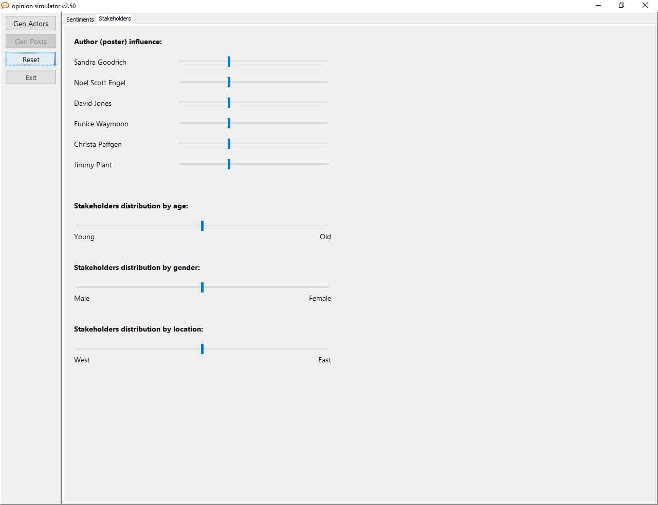

1. Opinion Simulator – Stakeholders Tab Screenshot

**Description:**

In this tab, the user can generate authors and configure the influence for each author. The age, gender and location distribution for the authors can be configured as well.

**Procedures:**

1. To configure an author’s influence, the user should use the horizontal slider panel titled “Author (post) influence”.
2. To configure the age distribution of the stakeholders, the user should use the horizontal slider titled “Stakeholders distribution by age”.
3. To configure the gender distribution of the stakeholders, the user should use the horizontal slider titled “Stakeholders distribution by gender”.
4. To configure the location distribution of the stakeholders, the user should use the horizontal slider titled “Stakeholders distribution by location”.
5. After choosing the desired configurations, the user should click the “Gen Authors” button to generate authors with the chosen configurations. The authors will be generated in a local database.
6. To return to the sentiment configuration screen, the user should click the “Sentiments” tab.
7. To exit the application, the user should click the “Exit” button.

# Glossary

* **Sentiment**: Numeric value between 0 and 100 which is extracted from an adjective presented in a post.
* **Average Sentiment**: Numeric value obtained by summing all the sentiment values for each user divided by the number of users.
* **Global sentiment**: Total average sentiment for all users.
* **Influence**: Numeric value which measures the influence that a certain author has towards other users. This value is calculated by dividing the total number of comments by the average number of comments, the total number of likes by the average number of likes, the total number of views by the average number of views and summing all of the values obtained from these divisions. To each of the divisions made, a constant value is multiplied.
* **Reach:** Numeric value which measures the reach that a certain author has towards other users. This value is calculated by dividing the total number of comments by the average number of comments, the total number of likes by the average number of likes, the total number of views by the average number of views and summing all of the values obtained from these divisions. To each of the divisions made, a constant value is multiplied.