R三件套的安装
R语言：https://cran.r-project.org/bin/windows/base/
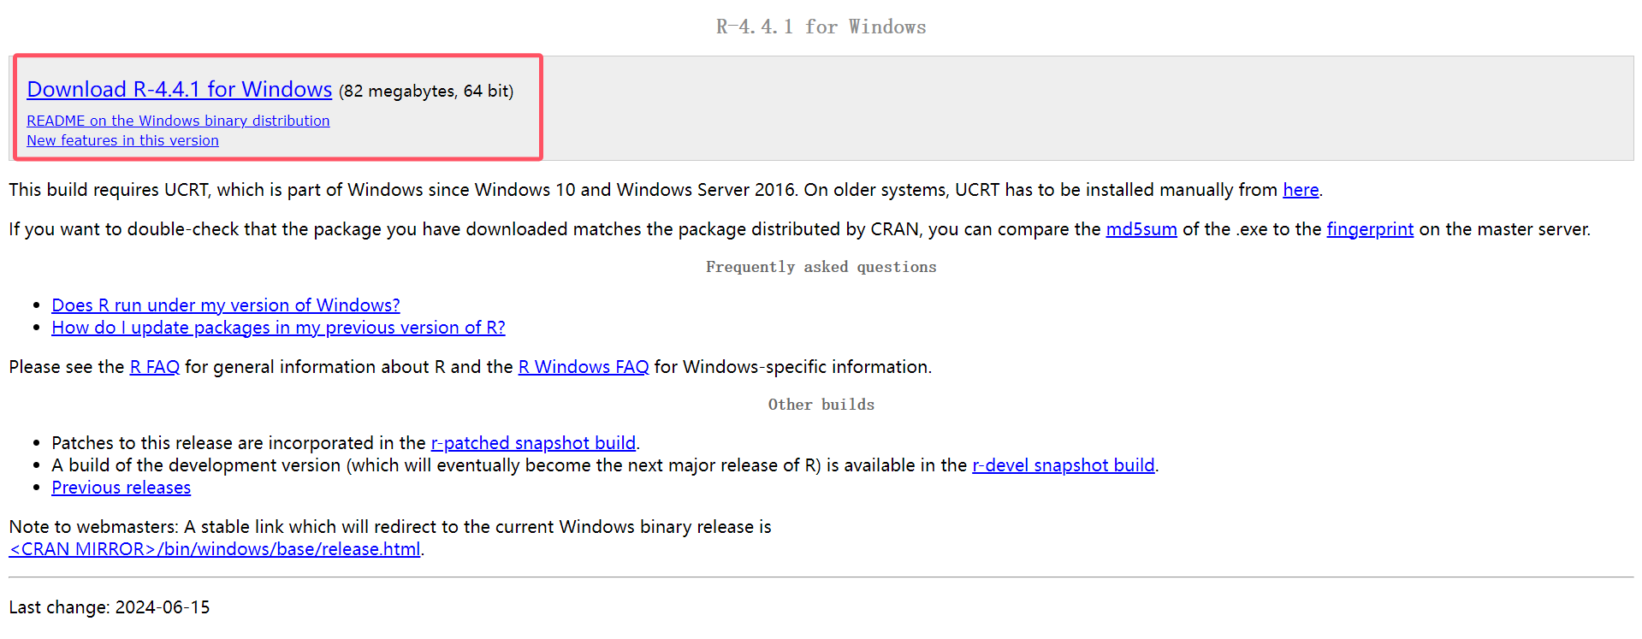
RStudio：https://posit.co/download/rstudio-desktop/
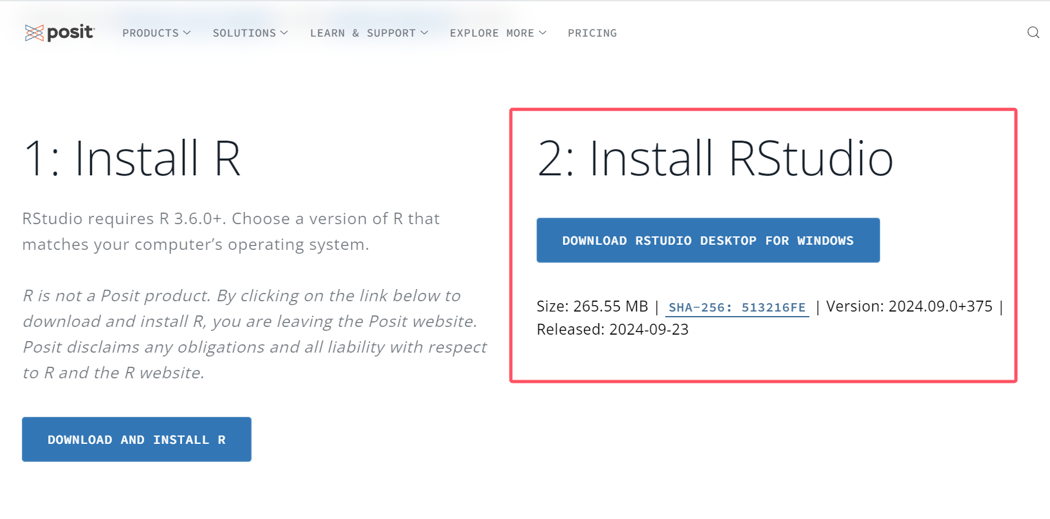
Rtools：https://cran.r-project.org/bin/windows/Rtools/
