ABOUT USINFRASTRUCTUREBEYOND ACADEMICSCURRICULUMWORKSHOPSVIDEOSOUR GALLERYACTIVITIESADMISSIONS[CAREERS](http://themauryaschool.com/careers.aspx)

* [ACHIEVEMENTS](http://themauryaschool.com/Topper_Result.aspx)

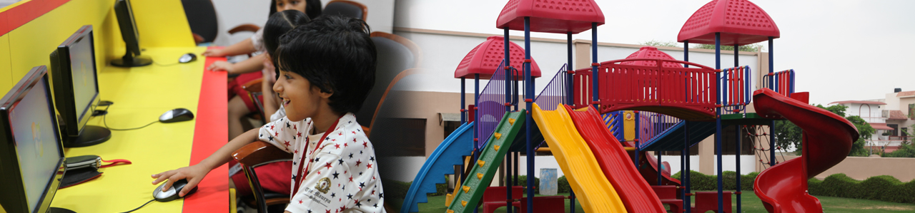

**Facilities and Services**

The School building connects with psychic- pedagogy of the child to nurture three dimensional learning experience. Our spacious campus which is fully equipped to provide a well-rounded, wholesome and stimulating environment for education.

* • Auditoriums
* • State of the art laboratories format the basis of scientific temper and propel a child’s mind towards innovation and invention
* - 3 Computer Labs
* - Biology Lab
* - Physics Lab
* - Chemistry Lab
* - Maths Lab
* - EVS Lab
* - 3D Printing
* - Robotics
* - 3D Maths & Science Lab
* - Concrete Lab
* • Cafeteria
* • 82 Digital Class Rooms
* • 2 Libraries
* • School buses with GPS and CCTV cameras
* • 225 CCTV cameras
* • 2 Junior Play Areas
* • 2 Multimedia Halls

Also, The Maurya School believe that physical growth of children is as important as their mental growth. We provide the students a number sports facilities in order to inculcate in them skills like self esteem, fair play, team-building, sportsmanship, healthy competitive spirit, which are not only important for the holistic development of a child but also to cope up in today’s competitive world. The training for these activities is conducted through the regular club and sport periods. Often, students get a chance to participate and win the various in-house as well as Inter School Competitions.

* • ATHLETICS, 200 MTS. TRACK
* • BADMINTON
* • BASKETBALL
* • CRICKET
* • FOOTBALL
* • LAWN TENNIS
* • CHESS
* • MARTIAL ART (KARATE)
* • SWIMMING
* • TABLE TENNIS
* • VOLLEY BALL
* • THROW BALL
* • CHESS
* • SKATING
* • YOGA
* • KHO-KHO
* • ARCHERY
* • SELF DEFENCE
* • SHOOTING